Supplementary material
Supplementary Table 1. STM measurements stratified by PD, SD and PR subgroups.
 | PD (N=35) | PR (N=128) | SD (N=100) | ALL (N=263)
CA 125 (U/mL)
Mean | 411.88 | 78.45 | 65.09 | 117.74
SD | 739.25 | 399.06 | 89.28 | 405.58
Median | 109.2 | 26.34 | 33.79 | 32.29
Min-Max | 5.23-3395.00 | 7.27-4528.00 | 6.29-529.60 | 5.23-4528.00
CA 15-3 (U/mL)
Mean | 120.56 | 37.69 | 54.74 | 55.2
SD | 117.19 | 38.89 | 67.49 | 70.41
Median | 58.47 | 30.26 | 31.8 | 32.74
Min-Max | 10.14-300.00 | 9.35-300.00 | 8.42-300.00 | 8.42-300.00
CEA (ng/mL)
Mean | 58.12 | 37.73 | 35.91 | 39.75
SD | 148.59 | 119.13 | 62.69 | 106.22
Median | 9.44 | 4.79 | 9.06 | 6.36
Min-Max | 1.11-675.30 | 0.31-1000.00 | 1.05-317.20 | 0.31-1000.00
CYFRA 21-1 (ng/mL)
Mean | 14.09 | 3.19 | 4.89 | 5.28
SD | 19.42 | 5.53 | 5.09 | 9.28
Median | 7.37 | 2.13 | 3.04 | 2.72
Min-Max | 1.11-71.26 | 0.50-60.49 | 0.38-34.53 | 0.38-71.26
NSE (ng/mL)
Mean | 23.36 | 17.33 | 18.4 | 18.54
SD | 14.28 | 7.55 | 8.29 | 9.16
Median | 17.67 | 15.47 | 17.02 | 16.35
Min-Max | 11.36-70.65 | 7.04-57.16 | 8.50-62.19 | 7.04-70.65
SCC (ng/mL)
Mean | 5.68 | 1.91 | 2.34 | 2.58
SD | 13.56 | 1.47 | 3.49 | 5.57
Median | 1.52 | 1.56 | 1.6 | 1.55
Min-Max | 0.10-70.00 | 0.20-9.55 | 0.34-33.12 | 0.10-70.00
proGRP (pg/mL)
Mean | 76.31 | 49.55 | 82.45 | 65.62
SD | 196.95 | 28.63 | 338.38 | 221.24
Median | 39 | 41.5 | 45 | 42
Min-Max | 12.00-1195.00 | 16.00-255.00 | 18.00-3427.00 | 12.00-3427.00
HE4 was excluded as we saw a strong influence of eGFR on biomarker values.

Supplementary Table 2. Results of univariate and combination analyses of the prognostic values of CYFRA 21-1, CA 125, CEA, CA 15-3, NSE, ProGRP and SCC in patients with stable disease (ADC + SCC with interaction term [n=100]) at the first CT scan after the second cycle for progression-free survival (A) and overall survival (B).
A) Progression-free survival
Biomarker | C-index | HR (high vs low risk SD)
 |  | Optimized cut-off | Median cut-off
Univariate analysis
CYFRA 21-1 | 0.67 | 3.73 | 2.48
CA 125 | 0.63 | 3.16 | 2.44
CEA | 0.59 | 2.23 | 1.53
CA 15-3 | 0.56 | 1.81 | 1.22
NSE | 0.54 | 1.73 | 1.16
ProGRP | 0.53 | 1.63 | 1.53
SCC | 0.55 | 1.45 | 1.09
Combination analysis
CA 125 + CA 15-3 | 0.63 | 3.21 | 1.95
CA 125 + CA 15-3 + CEA | 0.66 | 2.95 | 2.07
CA 125 + CA 15-3 + CYFRA 21-1 | 0.68 | 3.48 | 2.85
CA 125 + CA 15-3 + NSE | 0.63 | 3.02 | 1.89
CA 125 + CA 15-3 + ProGRP | 0.63 | 3.21 | 2.04
CA 125 + CA 15-3 + SCC | 0.64 | 2.97 | 2.19
CA 125 + CEA | 0.66 | 2.77 | 2.37
CA 125 + CEA + NSE | 0.66 | 2.68 | 2.51
CA 125 + CEA + ProGRP | 0.66 | 2.59 | 2.28
CA 125 + CEA + SCC | 0.67 | 3.04 | 2.42
CA 125 + CYFRA 21-1 | 0.68 | 3.78 | 2.92
CA 125 + CYFRA 21-1 + CEA | 0.70 | 4.17 | 2.41
CA 125 + CYFRA 21-1 + NSE | 0.69 | 3.58 | 2.81
CA 125 + CYFRA 21-1 + ProGRP | 0.68 | 3.78 | 2.92
CA 125 + CYFRA 21-1 + SCC | 0.68 | 4.27 | 2.65
CA 125 + NSE | 0.63 | 2.93 | 2.41
CA 125 + NSE + ProGRP | 0.63 | 2.94 | 2.30
CA 125 + NSE + SCC | 0.64 | 2.82 | 2.40
CA 125 + ProGRP | 0.63 | 2.94 | 2.22
CA 125 + SCC | 0.64 | 2.52 | 2.30
CA 125 + SCC + ProGRP | 0.64 | 3.02 | 2.24
CA 15-3 + CEA | 0.61 | 1.89 | 1.54
CA 15-3 + CEA + CYFRA 21-1 | 0.70 | 3.99 | 2.78
CA 15-3 + CEA + NSE | 0.61 | 1.94 | 1.56
CA 15-3 + CEA + ProGRP | 0.61 | 1.98 | 1.55
CA 15-3 + CEA + SCC | 0.62 | 2.50 | 1.86
CA 15-3 + CYFRA 21-1 | 0.67 | 3.24 | 2.69
CA 15-3 + CYFRA 21-1 + NSE | 0.68 | 3.37 | 2.25
CA 15-3 + CYFRA 21-1 + ProGRP | 0.67 | 3.24 | 2.75
CA 15-3 + CYFRA 21-1 + SCC | 0.67 | 3.04 | 2.23
CA 15-3 + NSE | 0.57 | 2.06 | 1.25
CA 15-3 + NSE + ProGRP | 0.57 | 2.31 | 1.27
CA 15-3 + NSE + SCC | 0.58 | 2.14 | 1.33
CA 15-3 + ProGRP | 0.55 | 2.14 | 1.17
CA 15-3 + SCC | 0.57 | 2.05 | 1.17
CA 15-3 + SCC + ProGRP | 0.56 | 1.90 | 1.09
CEA + CYFRA 21-1 | 0.69 | 4.05 | 2.79
CEA + CYFRA 21-1 + NSE | 0.70 | 3.61 | 3.04
CEA + CYFRA 21-1 + ProGRP | 0.69 | 4.33 | 2.68
CEA + CYFRA 21-1 + SCC | 0.70 | 4.32 | 2.91
CEA + NSE | 0.59 | 2.16 | 1.56
CEA + NSE + ProGRP | 0.60 | 2.31 | 1.51
CEA + NSE + SCC | 0.62 | 2.32 | 1.92
CEA + ProGRP | 0.59 | 2.57 | 1.45
CEA + SCC | 0.62 | 2.32 | 2.00
CEA + SCC + ProGRP | 0.62 | 2.68 | 1.89
CYFRA 21-1 + NSE | 0.68 | 3.28 | 2.58
CYFRA 21-1 + NSE + ProGRP | 0.68 | 3.28 | 2.58
CYFRA 21-1 + NSE + SCC | 0.68 | 3.21 | 2.58
CYFRA 21-1 + ProGRP | 0.67 | 3.73 | 2.54
CYFRA 21-1 + SCC | 0.67 | 3.97 | 2.48
CYFRA 21-1 + SCC + ProGRP | 0.68 | 3.97 | 2.16
NSE + ProGRP | 0.55 | 1.55 | 1.31
NSE + SCC | 0.56 | 1.47 | 1.01
NSE + SCC + ProGRP | 0.56 | 1.58 | 1.25
SCC + ProGRP | 0.54 | 1.47 | 1.13
B) Overall survival
Univariate analysis
CYFRA 21-1 | 0.69 | 3.91 | 2.31
CA 125 | 0.65 | 2.49 | 2.50
CEA | 0.55 | 1.64 | 1.38
CA 15-3 | 0.60 | 1.94 | 1.50
NSE | 0.53 | 1.69 | 1.25
ProGRP | 0.52 | 1.64 | 1.10
SCC | 0.54 | 1.45 | 1.31
Combination analysis
CA 125 + CA 15-3 | 0.66 | 2.68 | 2.16
CA 125 + CA 15-3 + CEA | 0.65 | 3.01 | 2.31
CA 125 + CA 15-3 + CYFRA 21-1 | 0.71 | 3.87 | 3.10
CA 125 + CA 15-3 + NSE | 0.65 | 2.68 | 2.08
CA 125 + CA 15-3 + ProGRP | 0.66 | 2.56 | 2.50
CA 125 + CA 15-3 + SCC | 0.66 | 2.91 | 2.95
CA 125 + CEA | 0.64 | 2.80 | 2.30
CA 125 + CEA + CYFRA 21-1 | 0.70 | 3.99 | 2.08
CA 125 + CEA + NSE | 0.64 | 2.59 | 2.52
CA 125 + CEA + ProGRP | 0.65 | 2.89 | 2.64
CA 125 + CEA + SCC | 0.65 | 2.82 | 2.82
CA 125 + CYFRA 21-1 | 0.70 | 3.51 | 2.49
CA 125 + CYFRA 21-1 + NSE | 0.71 | 3.90 | 2.49
CA 125 + CYFRA 21-1 + ProGRP | 0.69 | 3.55 | 2.55
CA 125 + CYFRA 21-1 + SCC | 0.71 | 3.44 | 3.10
CA 125 + NSE | 0.64 | 2.56 | 2.16
CA 125 + NSE + ProGRP | 0.65 | 2.75 | 2.22
CA 125 + NSE + SCC | 0.66 | 2.95 | 2.59
CA 125 + ProGRP | 0.66 | 2.93 | 2.63
CA 125 + SCC | 0.66 | 2.78 | 2.73
CA 125 + SCC + ProGRP | 0.66 | 2.81 | 2.39
CA 15-3 + CEA | 0.62 | 2.66 | 1.92
CA 15-3 + CEA + CYFRA 21-1 | 0.71 | 3.35 | 2.82
CA 15-3 + CEA + NSE | 0.62 | 2.10 | 1.91
CA 15-3 + CEA + ProGRP | 0.62 | 2.20 | 1.81
CA 15-3 + CEA + SCC | 0.62 | 2.29 | 1.67
CA 15-3 + CYFRA 21-1 | 0.70 | 4.17 | 2.56
CA 15-3 + CYFRA 21-1 + NSE | 0.71 | 3.39 | 2.48
CA 15-3 + CYFRA 21-1 + ProGRP | 0.70 | 3.75 | 2.15
CA 15-3 + CYFRA 21-1 + SCC | 0.70 | 4.17 | 2.32
CA 15-3 + NSE | 0.61 | 2.35 | 1.37
CA 15-3 + NSE + ProGRP | 0.62 | 2.19 | 1.60
CA 15-3 + NSE + SCC | 0.60 | 2.46 | 1.56
CA 15-3 + ProGRP | 0.62 | 2.85 | 1.90
CA 15-3 + SCC | 0.60 | 1.97 | 1.59
CA 15-3 + SCC + ProGRP | 0.61 | 1.78 | 1.66
CEA + CYFRA 21-1 | 0.70 | 4.32 | 2.61
CEA + CYFRA 21-1 + NSE | 0.71 | 3.77 | 2.53
CEA + CYFRA 21-1 + ProGRP | 0.69 | 3.53 | 2.51
CEA + CYFRA 21-1 + SCC | 0.70 | 3.69 | 2.80
CEA + NSE | 0.60 | 1.81 | 1.36
CEA + NSE + ProGRP | 0.56 | 1.69 | 1.52
CEA + NSE + SCC | 0.57 | 1.72 | 1.55
CEA + ProGRP | 0.56 | 1.63 | 1.57
CEA + SCC | 0.57 | 1.82 | 1.42
CEA + SCC + ProGRP | 0.57 | 1.76 | 1.55
CYFRA 21-1 + NSE | 0.70 | 3.33 | 2.38
CYFRA 21-1 + NSE + ProGRP | 0.70 | 3.62 | 2.88
CYFRA 21-1 + NSE + SCC | 0.71 | 3.89 | 2.31
CYFRA 21-1 + ProGRP | 0.69 | 3.84 | 2.00
CYFRA 21-1 + SCC | 0.69 | 3.91 | 2.31
CYFRA 21-1 + SCC + ProGRP | 0.68 | 3.84 | 2.13
NSE + ProGRP | 0.52 | 1.72 | 1.12
NSE + SCC | 0.55 | 1.62 | 1.42
NSE + SCC + ProGRP | 0.54 | 1.81 | 1.28
SCC + ProGRP | 0.55 | 1.61 | 1.57
HE4 was excluded as we saw a strong influence of eGFR on biomarker values.

Supplementary Table 3. Results of univariate and combination analyses of the prognostic values of CYFRA 21-1, CA 125 and CEA in patients with stable disease at the first CT scan after the second cycle for progression-free survival (A) and overall survival (B).
- Progression-free survival
 |  | ADC (n=76) |  |  |  |  | SCC (n=24) |  |  |  | ADC + SCC with interaction term (n=100)
 |  |  | C-index |  | HR (high vs low risk SD)ª | C-index |  |  | HR (high vs low risk SD)ª | C-index |  |  | HR (high vs low risk SD)ª
Median biomarker cutoff
Univariate analysis
CYFRA 21-1 |  | 0.69 |  | 2.30 |  |  | 0.61 | 2.58 |  |  | 0.67 | 2.48
CA 125 |  | 0.63 |  | 1.93 |  |  | 0.68 | 3.47 |  |  | 0.63 | 2.44
CEA |  | 0.60 |  | 1.61 |  |  | 0.51 | 0.76 |  |  | 0.59 | 1.53
Combination analysis
CYFRA 21-1 + CA 125 |  | 0.69 |  | 2.75 |  |  | 0.69 | 3.65 |  |  | 0.68 | 2.92
CYFRA 21-1 + CA 125 + CEA |  | 0.71 |  | 2.87 |  |  | 0.70 | 3.65 |  |  | 0.70 | 2.41
Optimized biomarker cut-off
Univariate analysis
CYFRA 21-1 |  | 0.69 |  | 4.04 |  |  | 0.61 | 2.93 |  |  | 0.67 | 3.73
CA 125 |  | 0.63 |  | 2.76 |  |  | 0.68 | 4.31 |  |  | 0.63 | 3.16
CEA |  | 0.60 |  | 2.359 |  |  | 0.51 | 0.60 |  |  | 0.59 | 2.23
Combination analysis
CYFRA 21-1 + CA 125 |  | 0.69 |  | 4.04 |  |  | 0.69 | 3.95 |  |  | 0.68 | 3.78
CYFRA 21-1 + CA 125 + CEA |  | 0.71 |  | 4.59 |  |  | 0.70 | 4.63 |  |  | 0.70 | 4.17
- Overall survival

 |  | ADC (n=76) |  |  |  |  | SCC (n=24) |  |  |  | ADC + SCC with interaction term (n=100)
 |  |  | C-index |  | HR (high vs low risk SD)ª | C-index |  |  | HR (high vs low risk SD)ª | C-index |  |  | HR (high vs low risk SD)ª
Median biomarker cutoff
Univariate analysis
CYFRA 21-1 |  | 0.71 |  | 2.53 |  |  | 0.61 | 1.36 |  |  | 0.69 | 2.31
CA 125 |  | 0.66 |  | 2.51 |  |  | 0.62 | 3.48 |  |  | 0.65 | 2.450
CEA |  | 0.56 |  | 1.12 |  |  | 0.51 | 1.06 |  |  | 0.55 | 1.38
Combination analysis
CYFRA 21-1 + CA 125 |  | 0.73 |  | 2.99 |  |  | 0.62 | 1.55 |  |  | 0.70 | 2.489
CYFRA 21-1 + CA 125 + CEA |  | 0.72 |  | 2.64 |  |  | 0.67 | 1.51 |  |  | 0.70 | 2.08
Optimized biomarker cut-off
Univariate analysis
CYFRA 21-1 |  | 0.71 |  | 3.94 |  |  | 0.61 | 1.52 |  |  | 0.69 | 3.91
CA 125 |  | 0.66 |  | 3.02 |  |  | 0.62 | 3.48 |  |  | 0.65 | 2.49
CEA |  | 0.56 |  | 1.877 |  |  | 0.51 | 1.49 |  |  | 0.55 | 1.64
Combination analysis
CYFRA 21-1 + CA 125 |  | 0.73 |  | 3.94 |  |  | 0.62 | 3.309 |  |  | 0.70 | 3.507
CYFRA 21-1 + CA 125 + CEA |  | 0.72 |  | 4.38 |  |  | 0.67 | 3.34 |  |  | 0.70 | 3.99
ªPatients with SD stratified according to biomarker value above or below median or optimized cut-offs. The C-index was calculated based on a model that included the continuous form of the biomarkers.
Supplementary Figure 1. Workflow for assessing the prognostic power of individual and combinations of biomarkers.
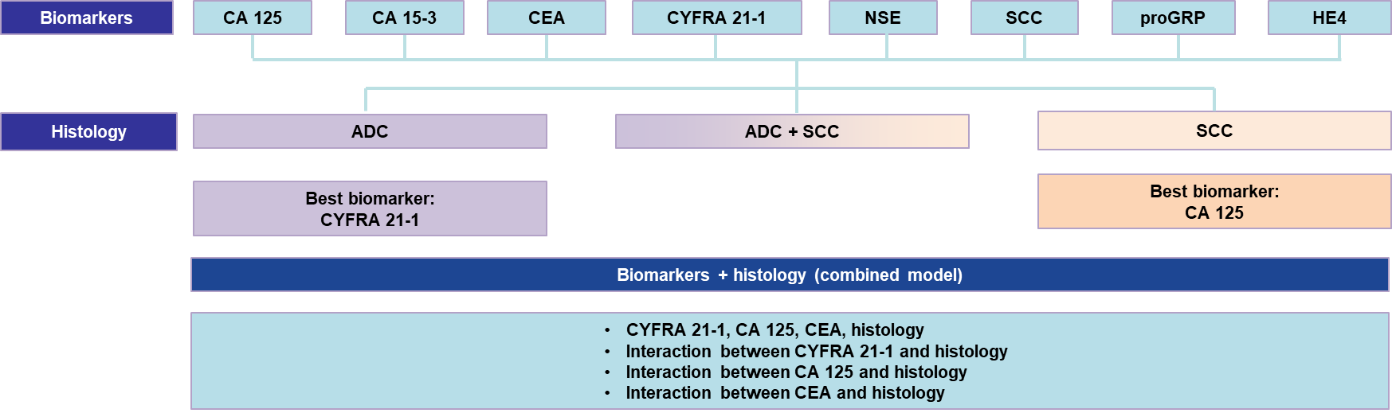
ADC, adenocarcinoma; CA 125, cancer antigen 125; CA 15-3, cancer antigen 15-3; CEA, carcinoembryonic antigen; CYFRA 21-1, cytokeratin 19 fragment 21-1; HE4, Human Epididymis Protein 4; NSE, neuron-specific enolase; ProGRP, progastrin-releasing peptide; SCC, squamous cell carcinoma.

Supplementary Figure 2. Best biomarker performance in the analysis of PFS in patients with SD after the first CT scan after Cycle 2. (A) Patients with ADC stratified by CYFRA 21-1 above or below median; (B) Patients with SCC stratified by CA 125 above or below median; (C) Patients with SD regardless of histology stratified by CYFRA 21-1 and CA 125 above or below median; (D) Patients with SD regardless of histology stratified by CYFRA 21-1, CA 125 and CEA above or below median.
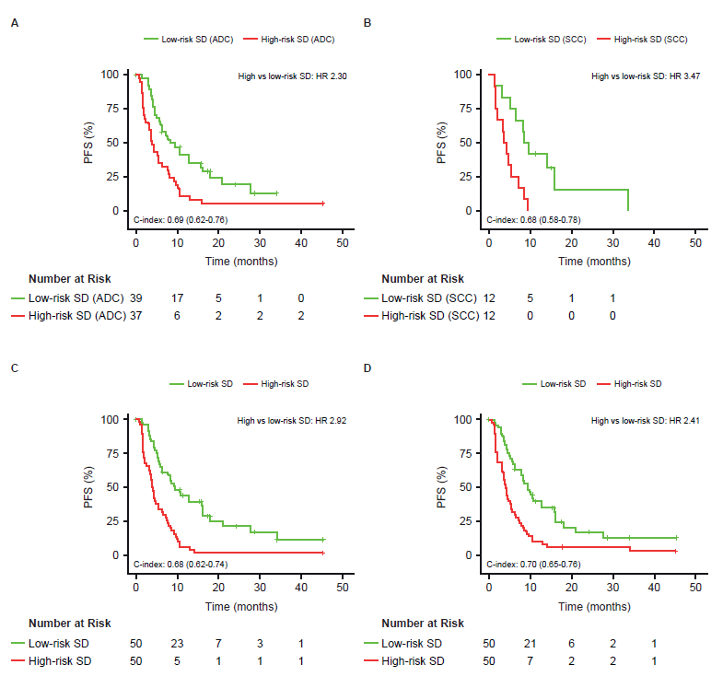

The C-index was calculated based on a model that included the continuous form of the biomarkers. ADC, adenocarcinoma; CI, confidence interval; HR, hazard ratio; PFS, progression-free survival; SCC, squamous cell carcinoma; SD, stable disease.

