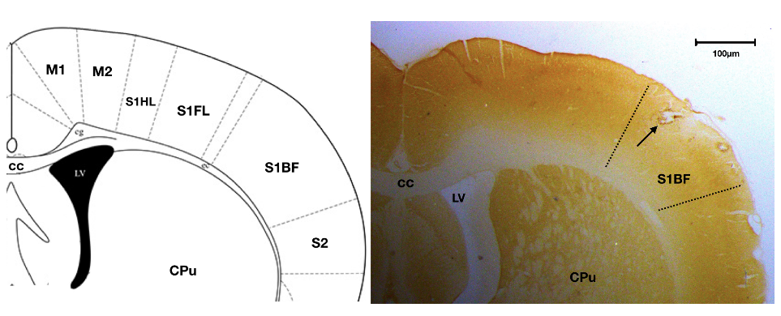
Supplementary Data

Supplementary Figure 1. The histological verification of recording sites in the barrel cortex. The brain slices were stained with cytochrome oxidase and the recording sites marked by micro-lesion in the barrel cortex (S1BF) (arrow). M1: primary motor cortex; M2: secondary motor cortex; S1HL: primary somatosensory cortex, hindlimb region; S1FL: primary somatosensory cortex, forelimb region; S2, secondary somatosensory cortex; cc: corpus callosum; CPu: caudate and putamen; LV: lateral ventricle.

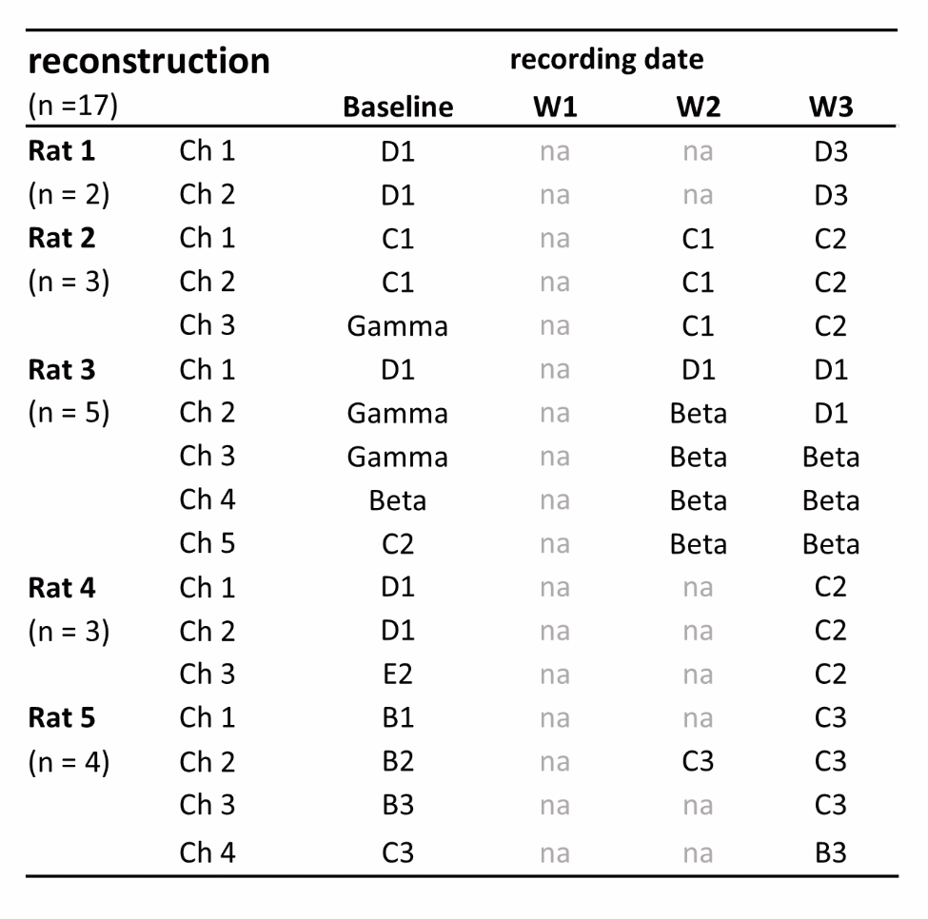
Supplementary Table 1. A list of the multi-units and their primary whiskers recorded in the reconstruction group
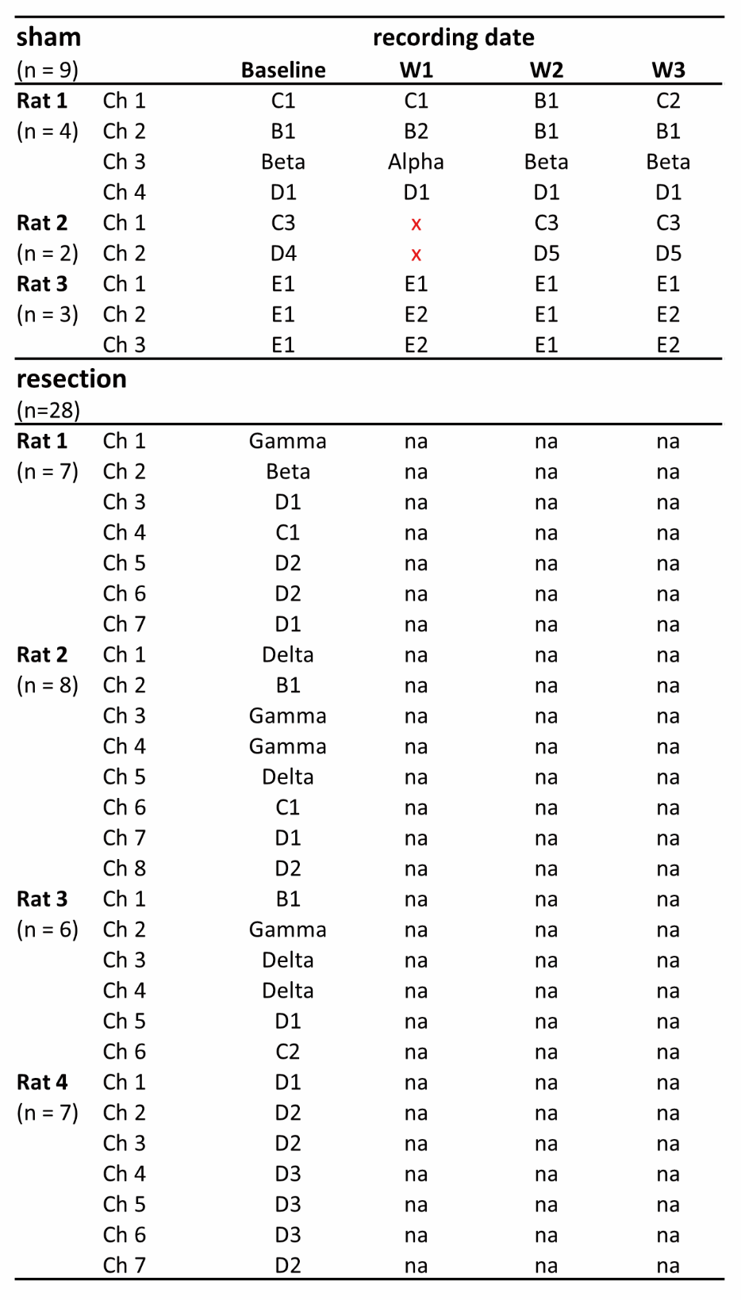
Supplementary Table 2. A list of the multi-units and their primary whiskers recorded in the sham and resection groups

