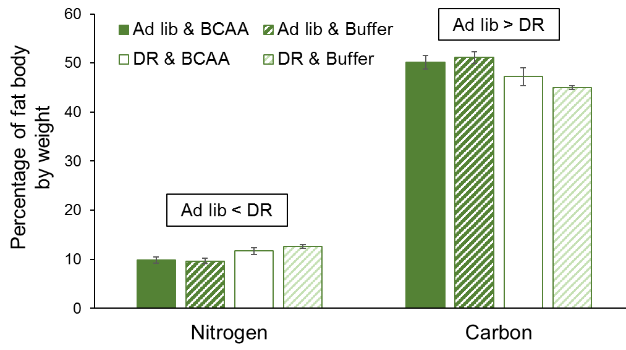
Supplemental Figure 2. Composition of fat body in female grasshoppers reared upon ad libitum or DR lettuce feeding and supplementation with BCAAs or buffer. Insect fat body has functions similar to vertebrate adipose tissue and liver, functioning both in fat storage and in metabolic reactions. Dietary restriction decreased fat body nitrogen content and increased fat body carbon content.

