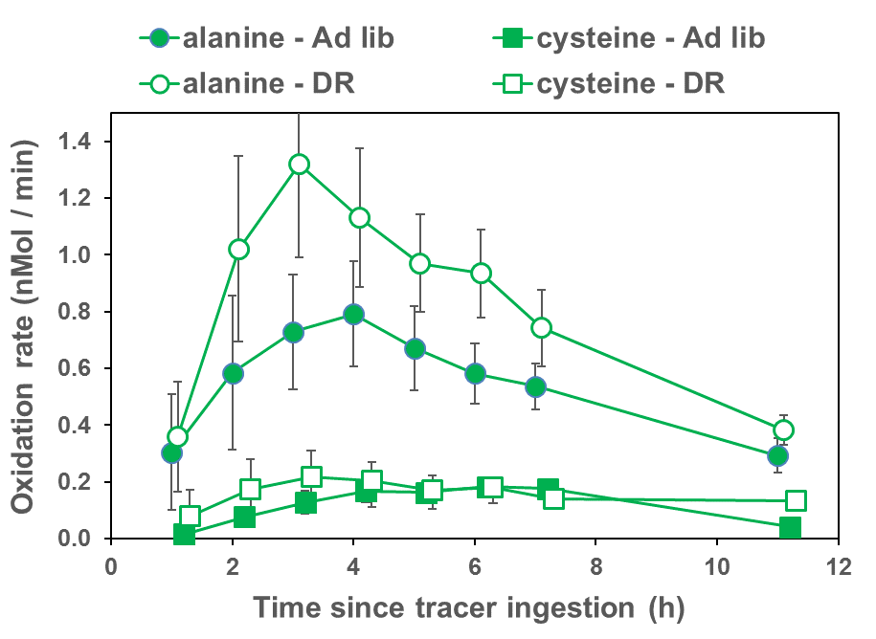
Supplemental Figure 2. Oxidation of alanine tends to increase upon dietary restriction, but not significantly. Oxidation of cysteine does not increase upon dietary restriction. Equimolar amounts of ¹³C-labeled alanine or cysteine were offered in this study, so alanine was oxidized ~5-fold more than cysteine. We view the increased oxidation of BCAAs upon dietary restriction as typical, but not universal, among amino acids. Error bars are one Standard Error.

