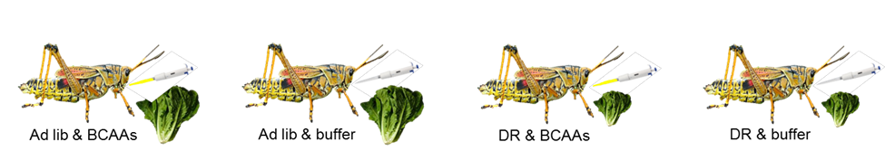
Supplemental Figure 1: Treatment groups for Experiment 1. Dietary restriction lettuce was 60% of ad libitum lettuce feeding. The amount of BCAAs to force feed was adjusted weekly, so that the total consumption of BCAAs (from lettuce + force-feeding) by the DR & BCAA group was equal to the total consumption by the Ad libitum & buffer group.

