Supplementary materials

Supplementary Figure 1. Changes in mean ratings for motor-Functional Independence Measure (M-FIM) items from admission to discharge

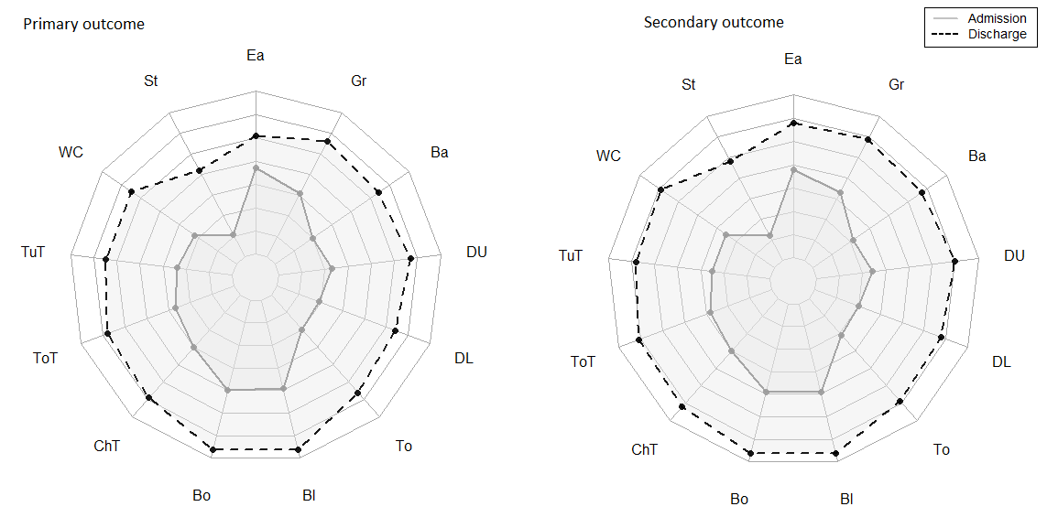
Legend: ADLs: Ea, eating; Gr, grooming; DU, dressing upper body; To, toileting; Ba, bathing; DL, dressing lower body; Sphincter management: Bl, bladder management; Bo, bowel management; Mobility: ChT, bed-tochair transfer; ToT, toilet transfer; TuT, tub transfer; WC, walking and wheelchair management; St, stair climbing.

Supplementary Table 1. Excluded and included patients baseline comparison
Variables | Excluded  (N=709) | Included  (N=710) | TOTAL  (N=1419) | p
Type |  |  |  | 0.001
Hemorrhagic | 396 (55.9%) | 335 (47.2%) | 731 (51.5%)
ischemic | 313 (44.1%) | 375 (52.8%) | 688 (48.5%)
Sex |  |  |  | 0.94
Female | 272 (38.4%) | 271 (38.2%) | 543 (38.3%)
Male | 437 (61.6%) | 439 (61.8%) | 876 (61.7%)
Age at injury |  |  |  | 0.026
Mean (SD) | 50 (10) | 52 (10) | 51(10)
Median (Q1- Q3) | 51 (44 - 57) | 52 (45-58) | 52 (44, 57)

Supplementary Table 2. Baseline Characteristics Additional information
 | Our dataset
 | Derivation Cohort (n=710)
Age <65 y, % | 90.7
Age ranges, %
21-34 | 5.1
35-44 | 19.0
45-54 | 34.2
55-64 | 32.4
65-74 | 7.2
75+ | 2.1
NIHSS severity
Mild stroke 0-3 | 2.4
Moderate stroke 4-10 | 24.5
Severe stroke > 10 | 73.1
Body mass index at admission median (IQR) | 24 (22 - 28)
Dyslipidemia | 23.9
TSO ranges,%
0-30 | 36.8
31-60 | 42.5
61-90 | 20.7
Living with, at admission,%
Life partner | 67.6
Alone | 13.9
Parents | 8.5
Other close relatives | 7.5
Institution | 0.4
Educational level,%
Illiterate | 1.0
Read and write | 3.0
Primary | 42.1
Secondary | 31.1
Superior | 22.8
Mortality,% | 7.7
TSO, Time from stroke occurrence to rehabilitation admission; FIM, Functional Independence Measure; FIS, Functional Independence Staging system; IQR, interquartile range; NA, not assessed; and NIHSS, National Institutes of Health Stroke

Supplementary Figure 2. Receiver operating characteristic curve for model 3 primary
outcome. AUC indicates the area under the curve
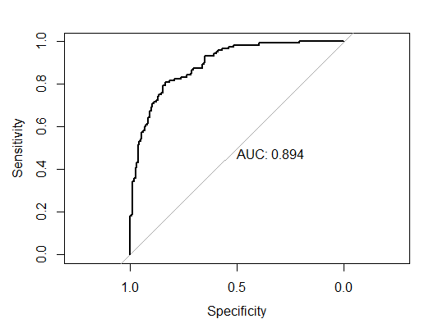

Supplementary Figure 3. Receiver operating characteristic curve for model 3 secondary outcome. AUC indicates the area under the curve
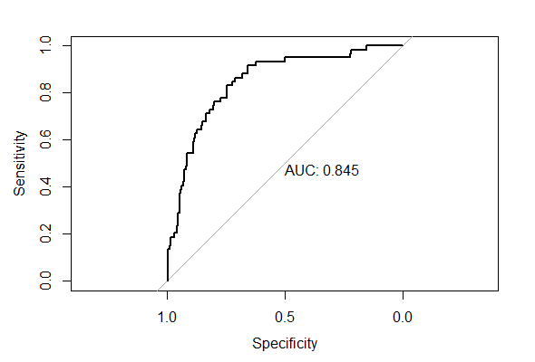

Supplementary Figure 4. Receiver operating characteristic curve for model 3 primary outcome admitted ≤ 30 days AUC indicates the area under the curve
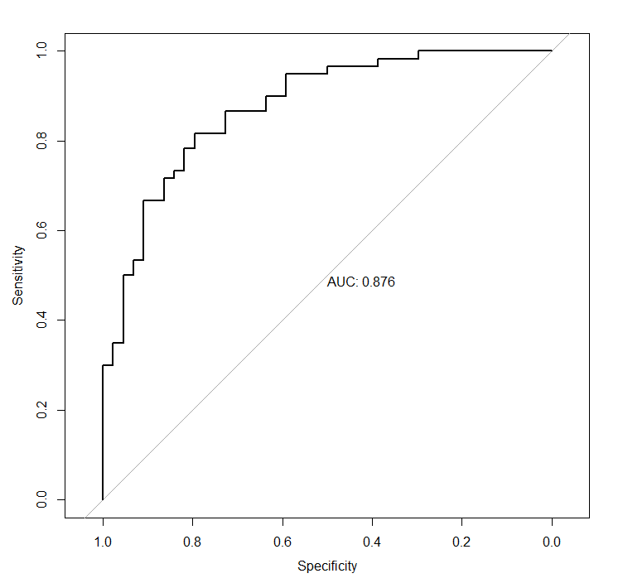

Supplementary Figure 5. Receiver operating characteristic curve for model 3 secondary outcome admitted ≤ 30 days AUC indicates the area under the curve
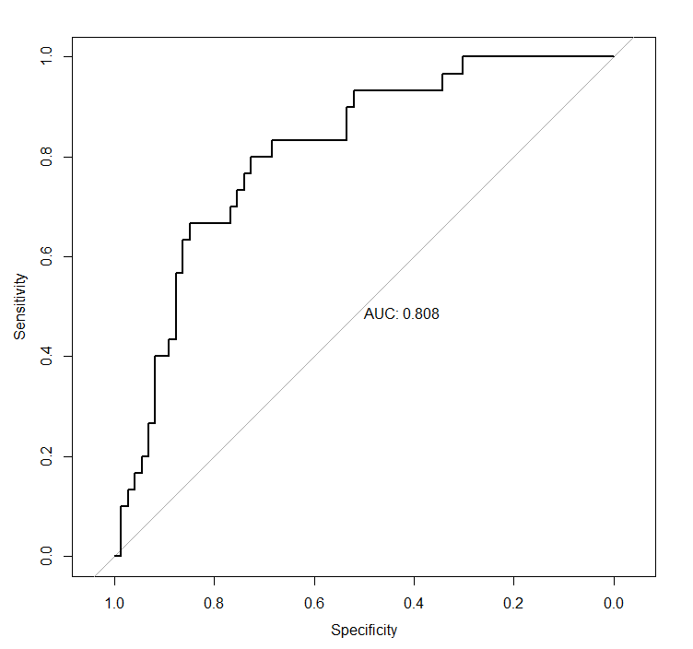

Supplementary Figure 6. Receiver operating characteristic curve for model 3 primary outcome severe motor FIM < 37 AUC indicates the area under the curve
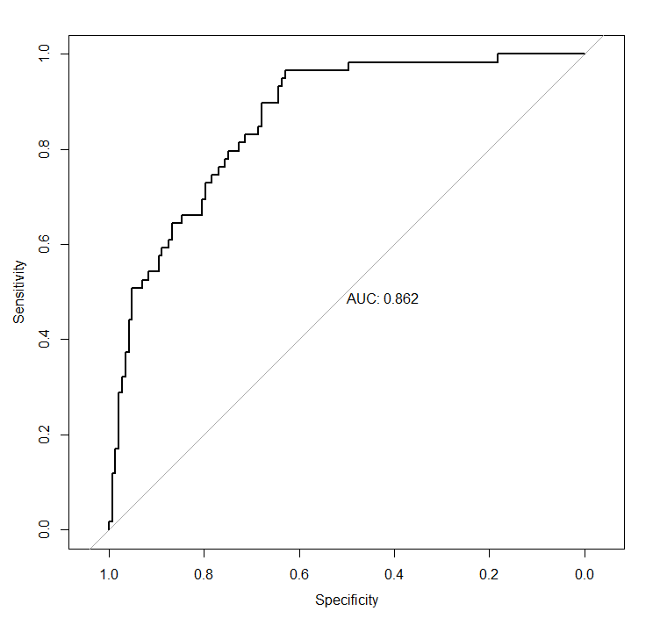

Supplementary Figure 7. Receiver operating characteristic curve for model 3 secondary outcome severe motor FIM < 37 AUC indicates the area under the curve
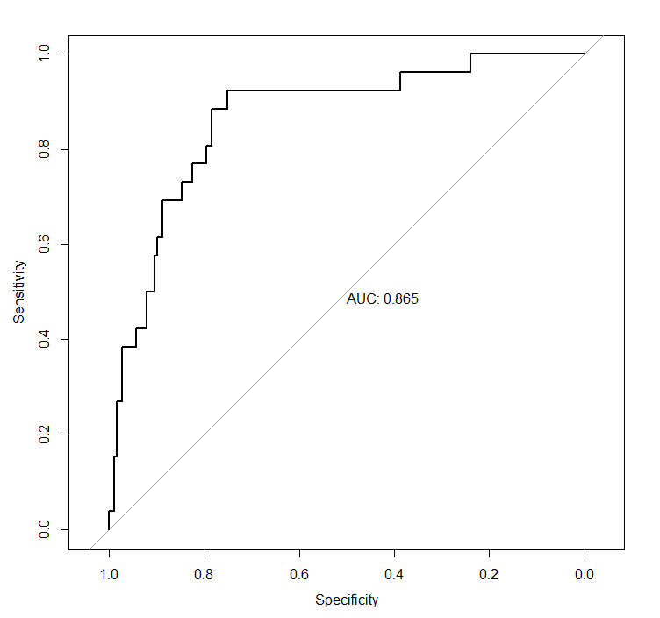

Supplementary Figure 8. Receiver operating characteristic curve for model 3 primary outcome LOS ≤ 66 days. AUC indicates the area under the curve
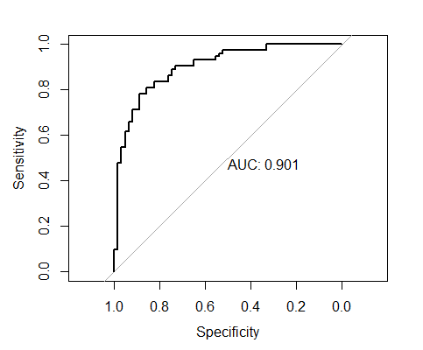

Supplementary Figure 9. Receiver operating characteristic curve for model 3 secondary outcome LOS ≤ 66 days. AUC indicates the area under the curve

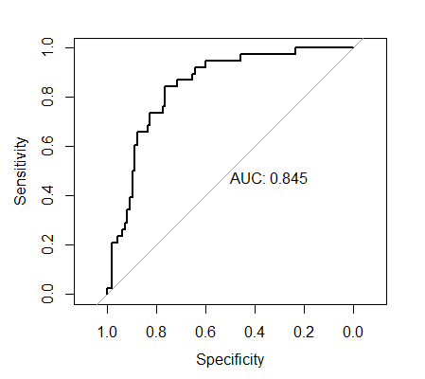

Supplementary Figure 10. Receiver operating characteristic curve for model 3 MCID M-FIM ≥ 25 . AUC indicates the area under the curve
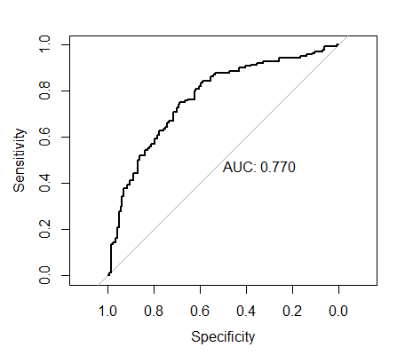

Supplementary Table 3. Selected baseline characteristics of the patients with severe motor stroke impairment (motor FIM < 37 at admission)
 | Our dataset
 | (n=507)
Age (years), mean (SD) | 53(10)
Age < 65, % | 89.3%
Age >75, % | 2.2%
Male gender, % | 61.7%
Hypertension, % | 52.1%
Diabetes, % | 15.4%
Dislipidemia | 24.5%
Atrial fibrillation | 2.8%
Neglect, % | 39.8%
Aphasia,% | 37.1%
NIHSS, mean(SD) | 14.8(5.6)
NIHSS severity - Severe stroke (NIHSS > 10) | 79.1%
Type of stroke
Ischemic,% | 49.9%
Hemorrhagic | 50.1%
Admission FIM score
Total FIM score, median (IQR) | 38 (25 - 49)
Motor FIM score, median (IQR) | 19 (14- 27)
Cognitive FIM score, median (IQR) | 16 (9 -25)
Discharge FIM score
Total FIM score, median (IQR) | 69 (47- 90)
Motor FIM score, median (IQR) | 47 (27.5- 65)
Cognitive FIM score, median (IQR) | 23 (14-29)
Motor FIM gain, median (IQR) | 24 (7.5- 41)
Admission FIS grade
Grade I-total assistance,% | 23.5%
Grade II-maximal assistance | 76.5%
Time from stroke occurrence to rehabilitation  admission (days), median (IQR) | 38 (25- 58)
LOS, mean(SD) | 81.7 (32.3)
Achieved primary outcome,% | 29.2
Achieved secondary outcome,% | 13.2
TSO, Time from stroke occurrence to rehabilitation admission; FIM, Functional Independence Measure; FIS, Functional Independence Staging system; IQR, interquartile range; NA, not assessed; and NIHSS, National Institutes of Health Stroke

Online calculator
The calculator is available online from the following URL: https://precise4q.guttmann.tech/fim-calculator/

Supplementary Figure 11. Screenshot of primary outcome calculator model 3
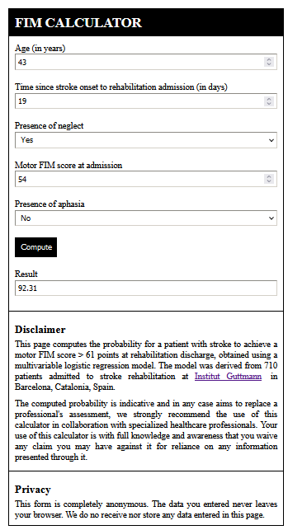

An online calculator was developed in HTML to allow calculation of the estimated probability of achieving the primary and secondary outcomes.

Equation to estimate the predicted probability of achieving the primary or secondary outcome.
Predicted probability = exp(β₀ + ∑ β_{i} X_{i}) / (1 + exp(β₀ + ∑ β₀ X_{i}))

Where β₀ is the constant of the model (0.99 for model 3), β_{i} is the estimated coefficient presented in Table 2 of each single factor, and Xi is the observed value
Neglect is coded as binary variable indicating the presence (xi=1) or the absence (xi=0), as well as Aphasia.

The HTML code implementation allows for a straightforward modification of the included variables and their corresponding β Coefficients in order to provide online calculators for new models

The following HTML file and CSS file must be included in the same folder.
HTML code for Supplementary Figure 11:

<!DOCTYPE html>
<html lang="en">
<head>
<meta charset="UTF-8">
<title>ANONYMIZED FIM Calculator</title>
<link rel="stylesheet" type="text/css" href="alestyle.css" media="screen"/>
</head>
<body>
<div id="container">
<h1 class="bg-dark">FIM CALCULATOR</h1>

<label> Age (in years) <input type="number" id="age" min="0"/> </label>

<label> Time since stroke onset to rehabilitation admission (in days) <input type="number" id="tso" min="0"/> </label>

<label>
Presence of neglect
<select id="neglect">
<option></option>
<option value="1">Yes</option>
<option value="0">No</option>
</select>
</label>

<label> Motor FIM score at admission <input type="number" id="fim" min="0"/> </label>

<label>
Presence of aphasia
<select id="aphasia">
<option></option>
<option value="1">Yes</option>
<option value="0">No</option>
</select>
</label>

<button id="btn">Compute</button>

<label>
Result
<input type="text" id="result" readonly/>
</label>

<h2>Disclaimer</h2>
<p>
This page computes the probability for a patient with stroke to achieve a motor FIM score > 61 points at rehabilitation discharge, obtained using a multivariable logistic regression model.
The model was derived from 710 patients admitted to stroke rehabilitation at <a href="https://www.guttmann.com">ANONYMIZED</a> in XXXXX.
</p>
<p>
The computed probability is indicative and in any case aims to replace a professional's assessment, we strongly recommend the use of this calculator in collaboration with
specialized healthcare professionals.
Your use of this calculator is with full knowledge and awareness that you waive any claim you may have against it for reliance on any information presented through it.

</p>

<h2>Privacy</h2>
<p>
This form is completely anonymous. The data you entered never leaves your browser. We do no receive nor store any data entered in this page.
</p>
</div>

<script>
const ageField = document.getElementById("age");
const tsoField = document.getElementById("tso");
const neglectField = document.getElementById("neglect");
const fimField = document.getElementById("fim");
const aphasiaField = document.getElementById("aphasia");
const resultField = document.getElementById("result");

const btn = document.getElementById("btn");

btn.addEventListener('click',
function () {
const age = ageField.value;
const tso = tsoField.value;
const fim = fimField.value;
var beta0 = 0.99;
var beta1 = -0.041;
var beta2 = -0.027;
var beta3 = -0.711;
var beta4 = 0.083;
var beta5 = -0.466;
var neg = document.getElementById('neglect').value;
var apha = document.getElementById('aphasia').value;

resultField.value = (((Math.exp(beta0 + age * beta1 + tso * beta2 + beta3 * neg + beta4 * fim + beta5 * apha)) / (1 + (Math.exp(beta0 + age * beta1 + tso * beta2 + beta3 * neg + beta4 * fim + beta5 * apha)))) * 100).toFixed(2);
});
</script>
</body>
</html>

CSS file

*, *:before, *:after {
box-sizing: border-box;
}

#container {
width: 500px;
border: 2px solid black;
padding: 0;
margin: 3rem auto;
}

h1 {
background: black;
color: white;
margin: 0;
font-size: 25px;
padding: 10px;
}

label {
display: block;
padding: 10px;
}

input, select {
width: 100%;
padding: 5px;
display: block;
border-width: 1px;
margin-top: 2px;
}

button {
margin: 10px;
background: black;
color: white;
border: none;
outline: none;
padding: 10px;
cursor: pointer;
transition: background-color 600ms;
}

button:hover {
background: #444444;
}

h2 {
font-size: 20px;
padding: 20px 10px 5px;
border-top: 1px solid black;
margin: 1rem 0 0;
}

p {
margin: 0 10px 10px;
text-align: justify;
}

Supplementary Figure 12. 95%CI of motor FIM score at discharge for
patients with aphasia and patients without aphasia by age range

