Supplementary Data

Supplementary Table 1. Circulating Biomarker Levels at Baseline, Prior to Cycle 2, and Prior to Cycle 3 in Each Arm. Results are reported as the median and the lower and upper quartiles (Q₁, Q₃). P value was from Wilcoxon Rank Sum test comparing the two arms in terms of the ratio of the post-treatment levels divided by the baseline.

 | Arm A |  |  |  |  |  |  | Arm B |  |  |  |  |  | P value
 | n | Median (Q₁, Q₃)  pg/mL |  |  |  |  |  | n |  | Median (Q₁, Q₃)  pg/mL
 | Markers of Angiopoietin-Tie2 Pathway
$$Angiopoietin-2$$
Baseline | 15 | 3,909 (3,246, 4,863) |  |  |  |  | 15 |  | 3,237 (2,424, 4,813)
Prior to cycle 2 | 14 | 132,156 (110,775, 160,316) |  |  |  |  | 15 |  | 120,956 (84,474, 131,643) |  |  |  | 0.86
Prior to cycle 3 | 9 | 125,928 (114,871, 141,528) |  |  |  |  | 11 |  | 96,075 (84,200, 150,486) |  |  |  | 0.76
$$Tie-2$$
Baseline | 15 | 803 (510, 1,035) |  |  |  |  | 15 |  | 835 (650, 1,094)
Prior to cycle 2 | 14 | 783 (535, 1,041) |  |  |  |  | 15 |  | 671 (571, 856) |  |  |  | 0.14
Prior to cycle 3 | 9 | 912 (263, 1,232) |  |  |  |  | 11 |  | 753 (424, 912) |  |  |  | 0.069
 | Markers of VEGF Pathway
$$VEGF-A$$
Baseline | 15 | 27.3 (10.5, 48.4) |  |  |  |  | 15 |  | 26.1 (19.6, 38.0)
Prior to cycle 2 | 14 | 21.3 (10.5, 29.0) |  |  |  |  | 15 |  | 33.4 (13.6, 48.2) |  |  |  | 0.19
Prior to cycle 3 | 9 | 20.7 (0.3, 34.2) |  |  |  |  | 11 |  | 41.2 (26.1, 56.7) |  |  |  | 0.046
$$PlGF$$
Baseline | 15 | 31.1 (26.1, 35.2) |  |  |  |  | 15 |  | 30.7 (28.3, 46.7)
Prior to cycle 2 | 14 | 30.5 (21.8, 36.0) |  |  |  |  | 15 |  | 33.6 (29.9, 39.2) |  |  |  | 0.029
Prior to cycle 3 | 9 | 31.4 (30.5, 34.3) |  |  |  |  | 11 |  | 31.5 (26.3, 41.8) |  |  |  | 0.20
$$VEGFR-3$$
Baseline | 15 | 873 (157, 1,073) |  |  |  |  | 15 |  | 489 (50, 898)
Prior to cycle 2 | 14 | 722 (117, 869) |  |  |  |  | 15 |  | 50 (50, 321) |  |  |  | 0.11
Prior to cycle 3 | 9 | 489 (362, 954) |  |  |  |  | 11 |  | 50 (50, 416) |  |  |  | 0.068
$$VEGF-C$$
Baseline | 15 | 255 (72, 425) |  |  |  |  | 15 |  | 283 (251, 380)
Prior to cycle 2 | 14 | 209 (67, 340) |  |  |  |  | 15 |  | 311 (247, 357) |  |  |  | 0.61
Prior to cycle 3 | 9 | 230 (45, 358) |  |  |  |  | 11 |  | 311 (154, 503) |  |  |  | 0.27
 | Markers of Alternative Pro-angiogenic Pathways
$$IL-8$$
Baseline | 15 | 0.1 (0.1, 12.6) |  |  |  |  | 15 |  | 0.1 (0.1, 4.0)
Prior to cycle 2 | 14 | 3.6 (0.1, 17.5) |  |  |  |  | 15 |  | 5.9 (0.1, 13.5) |  |  |  | 0.61
Prior to cycle 3 | 9 | 2.5 (0.1, 8.1) |  |  |  |  | 11 |  | 0.4 (0.1, 17.3) |  |  |  | 0.49
ICAM – 1
Baseline | 15 | 161,879 (103,645, 240,620) |  |  |  |  | 15 |  | 243,594 (185,653, 601,003)
Prior to cycle 2 | 14 | 193,335 (117,584, 247,434) |  |  |  |  | 15 |  | 239,027 (160,295, 318,968) |  |  |  | 0.82
Prior to cycle 3 | 9 | 262,636 (221,161, 266,594) |  |  |  |  | 11 |  | 200,959 (150,610, 276,615) |  |  |  | 0.069
$$VCAM-1$$
Baseline | 15 | 965,554 (738,499, 1,421,550) |  |  |  |  | 15 |  | 1,307,900 (982,643, 1,946,700)
Prior to cycle 2 | 14 | 1,336,300 (955,663, 1,903,550) |  |  |  |  | 15 |  | 1,850,000 (1,327,000, 2,555,600) |  |  |  | 0.34
Prior to cycle 3 | 9 | 982,488 (969,237, 1,581,000) |  |  |  |  | 11 |  | 1,666,200 (1,351,500, 2,091,050) |  |  |  | 0.046
$$FGF2$$
Baseline | 15 | 124 (105, 136) |  |  |  |  | 15 |  | 120 (105, 136)
Prior to cycle 2 | 14 | 112 (89, 131) |  |  |  |  | 15 |  | 110 (95, 132) |  |  |  | 0.11
Prior to cycle 3 | 9 | 131 (104, 136) |  |  |  |  | 11 |  | 120 (97, 133) |  |  |  | 0.23
$$PDGF-AA$$
Baseline | 15 | 351 (237, 788) |  |  |  |  | 15 |  | 478 (112, 647)
Prior to cycle 2 | 14 | 291 (190, 394) |  |  |  |  | 15 |  | 262 (213, 829) |  |  |  | 0.37
Prior to cycle 3 | 9 | 264 (119, 710) |  |  |  |  | 11 |  | 173 (105, 777) |  |  |  | 0.35

Supplementary Figure 1. Circulating Biomarkers Levels at Baseline, Prior to Cycle 2, and Prior to Cycle 3 in Each Arm. Results are reported as median and lower and upper quartiles (Q₁, Q₃).

A. Angiopoietin-2. | B. Tie-2
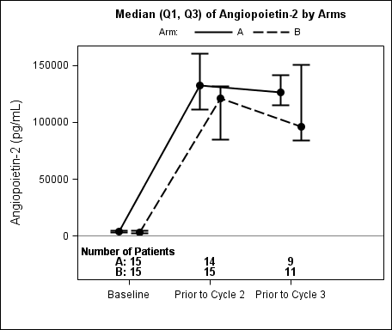 | 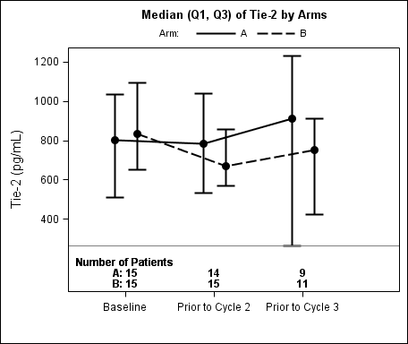
C. VEGF-A | D. PlGF
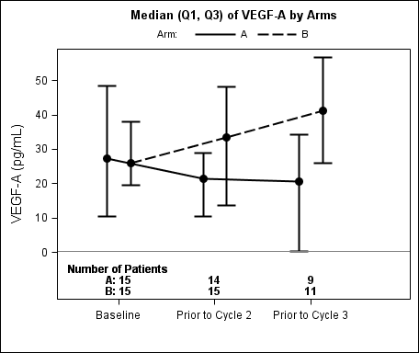 | 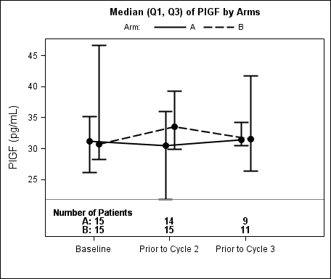

E. VEGFR-3 | F. VEGF-C
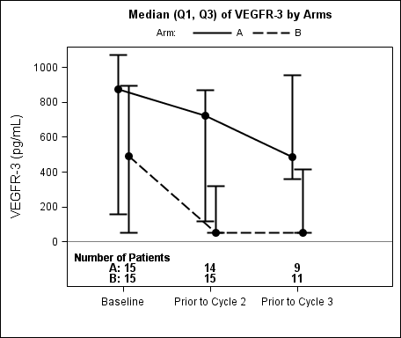 | 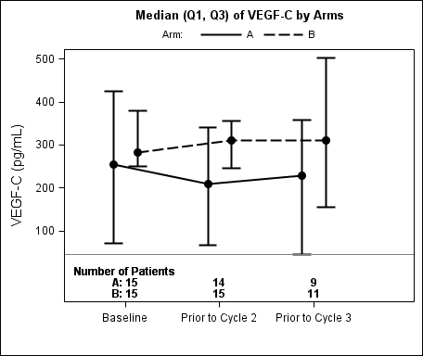
G. IL-8 | H. ICAM-1
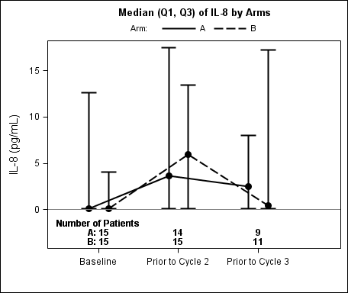 | 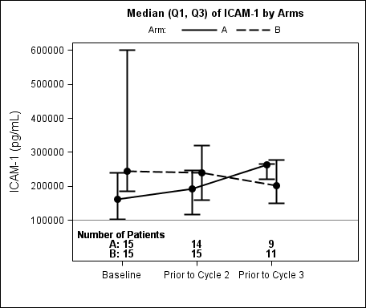

I. VCAM-1 | J. FGF2
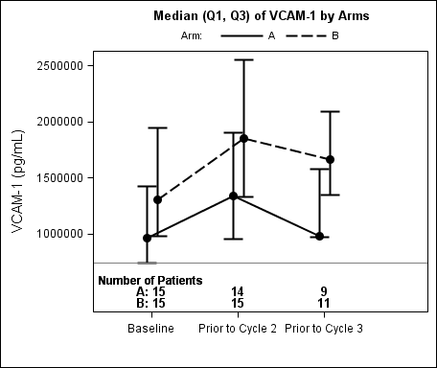 | 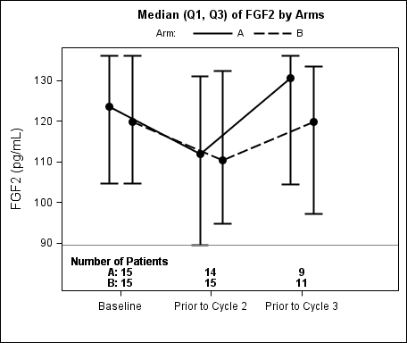
K. PDGF-AA
