Supplementary Tables and Figures:
Supplementary Table S1. Experience with MET, EGFR, VEGFR Inhibitors in Papillary RCC

Study | S1107 | DFC/NCI¹ | S0317² | GETUG³ | Astra Zeneca⁴
Drug | ARQ 197+/-  erlotinib | foretinib | erlotinib | sunitinib | savolitinib
Mechanism | MET/EGFR | VEGFR/MET | EGFR | VEGFR | MET
N | 50 | 68 (9 HPRC*) | 52 | 46/15 (type 2/1) | 109 (44 with MET alterations)
RR% | 0 | 13.5 (5% if HPRC excluded) | 11 | 11/13 (type 2/1) | 7  (18% in MET driven tumors
PFS months | 2.0/3.9 | 9.3 | 5 | 5.5/6.6 (type 2/1) | 6.2 for MET driven  1.4 for MET neg
OS months | 10.3/11.3 | NR (1 year-70%) | 27 | 12.4/17.8 (type 2/1) | Not reported

*Hereditary Papillary Renal Cell Carcinoma
- Choueri TK et al. Phase II biomarker study of the dual MET/VEGFR2 inhibitor foretinib in patients with papillary renal cell carcinoma J.Clin Oncol.2013 Jan 10;31 (2):181-6.
- Gordon M. et al. Phase II study of erlotinib in patients with locally advanced or metastatic papillary histology renal cancer: SWOG S0317. J.Clin Oncol 2009 Dec;27(34):5788-93.
- Ravaud A. et al. First-line treatment with sunitinib for type 1 and type 2 locally advanced or metastatic papillary renal cell carcinoma: a phase II study (SUPAP) by the French Genitourinary Group (GETUG). Ann Oncol.2015 Mar 23.
- Choueri TK et al. Biomarker-Based Phase II Trial of Savolitinib in Patients with Advanced Papillary Renal Cell Cancer. J Clin Oncol. 2017 Sep 10;35(26):2993-3001.

Supplementary Table S2. Number of Patients with a Reported Grade ≥ 3 Adverse Events Assessed as Being Possibly, Probably or Definitely Related to Treatment, By Treatment Arm
 | ARQ 197  (n=25)  Grade |  |  |  |  |  | ARQ 197 + Erlotinib  (n=25)  Grade
ADVERSE EVENTS |  | 3 | 4 | 5 |  | 3 |  | 4 | 5
ALT increased |  | 0 | 0 | 0 |  | 1 |  | 0 | 0
AST increased |  | 0 | 0 | 0 |  | 1 |  | 0 | 0
Anemia |  | 2 | 0 | 0 |  | 0 |  | 1 | 0
Dyspnea |  | 1 | 0 | 0 |  | 1 |  | 0 | 0
Erythema multiforme |  | 0 | 0 | 0 |  | 1 |  | 0 | 0
Fatigue |  | 0 | 0 | 0 |  | 1 |  | 0 | 0
Febrile neutropenia |  | 0 | 0 | 0 |  | 1 |  | 0 | 0
Hypertension |  | 1 | 0 | 0 |  | 0 |  | 0 | 0
Hypoxia |  | 0 | 0 | 0 |  | 1 |  | 0 | 0
Infections/infestations-Other |  | 0 | 0 | 0 |  | 1 |  | 0 | 0
Lung infection |  | 0 | 0 | 0 |  | 1 |  | 0 | 0
Lymphocyte count decreased |  | 1 | 0 | 0 |  | 0 |  | 0 | 0
Myocardial infarction |  | 0 | 0 | 0 |  | 0 |  | 0 | 1
Nausea |  | 1 | 0 | 0 |  | 0 |  | 0 | 0
Neutrophil count decreased |  | 1 | 0 | 0 |  | 0 |  | 0 | 0
Pain in extremity |  | 1 | 0 | 0 |  | 0 |  | 0 | 0
Pneumonitis |  | 0 | 0 | 0 |  | 1 |  | 0 | 0
Rash acneiform |  | 0 | 0 | 0 |  | 2 |  | 0 | 0
Rash maculo-papular |  | 0 | 0 | 0 |  | 1 |  | 0 | 0
Stroke |  | 0 | 1 | 0 |  | 0 |  | 0 | 0
Weight loss |  | 1 | 0 | 0 |  | 0 |  | 0 | 0
White blood cell decreased |  | 1 | 0 | 0 |  | 1 |  | 0 | 0
MAX. GRADE ANY ADVERSE EVENT |  | 6 | 1 | 0 |  | 7 |  | 1 | 1

Supplementary Table S3. Pathway analysis of mutated genes
Pathways | P-value | FDR | Genes
Wnt signaling pathway(P) | 1.05E-07 | 1.79E-05 | FAT1,PCDHB8,PCDHB6,CREBBP,PCDHB1,CELSR2,PCDH15,CTNNA2,EP400,CDH11
Cadherin signaling pathway(P) | 1.72E-07 | 1.79E-05 | FAT1,PCDHB8,PCDHB6,PCDHB1,CELSR2,PCDH15,CTNNA2
Mitotic G2-G2/M phases(R) | 3.46E-07 | 2.39E-05 | AKAP9,TUBGCP3,TUBGCP6,CEP131,ALMS1,CENPJ,PLK1
Assembly of the primary cilium(R) | 7.11E-05 | 3.70E-03 | AKAP9,CEP131,ALMS1,CENPJ,PLK1,IFT88
Urokinase-type plasminogen activator (uPA) and uPAR-mediated signaling(N) | 7.08E-04 | 0.029 | NCL,LRP1,PLAU
Chromatin modifying enzymes(R) | 1.07E-03 | 0.0363 | KDM6A,KMT2C,CREBBP,SMARCC2,EP400
Activation of anterior HOX genes in hindbrain development during early embryogenesis(R) | 2.57E-03 | 0.0744 | KDM6A,KMT2C,CREBBP
Myogenesis(R) | 4.47E-03 | 0.1161 | MEF2A,CTNNA2
the information processing pathway at the ifn beta enhancer(B) | 6.87E-03 | 0.1464 | IRF6,SMARCC2
amb2 Integrin signaling(N) | 7.32E-03 | 0.1464 | LRP1,PLAU

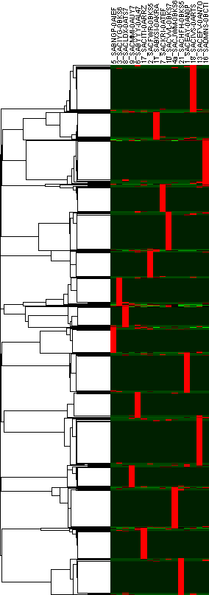
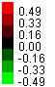
Supplementary Fig. S1. Clustering genes with variants by sample

