**Supplemental Table 1: IMPACT Genes**

Targeted gene panel used for MSK-IMPACT. Panel of 341 genes was used from approximately 1/1/2014 until 1/31/2015. Since 2/1/2015 a panel of 410 genes (additional genes **bolded**) has been employed.



**Supplemental Table 2: Mutation frequencies**

|  |  |  |  |  |
| --- | --- | --- | --- | --- |
|  | Total Samples (N=105, %) | Primary Tumor (N=69, %) | Metastatic Site (N=36, %) | TCGA |
| Gene |  |  |  |  |
| *VHL* | 87 (82.9%) | 53 (76.8%) | 34 (94.4%) | 52.3% |
| *PBRM1* | 53 (50.5%) | 33 (47.8%) | 20 (55.6%) | 32.9% |
| *SETD2* | 37 (35.2%) | 21 (30.4%) | 16 (44.4%) | 11.5% |
| *BAP1* | 25 (23.8%) | 18 (26.1%) | 7 (19.4%) | 10.1% |
| *KDM5C* | 17 (16.2%) | 9 (13.0%) | 8 (22.2%) | 6.7% |
| *TERT* | 15 (14.3%) | 13 (18.8%) | 3 (8.3%) | NA |
| *mTOR* | 13 (12.4%) | 8 (11.6%) | 2 (5.6%) | 6.0% |
| *PTEN* | 13 (12.4%) | 6 (8.7%) | 0 (0.0%) | 4.3% |
| *TP53* | 11 (10.5%) | 8 (11.6%) | 5 (13.9%) | 2.2% |
| *PIK3CA* | 8 (7.6%) | 4 (5.8%) | 7 (19.4%) | 2.9% |

* TCGA, The Cancer Genome Atlas[12]; Patients who had both the primary tumor and a metastatic site sequenced, only the primary tumor was included

**Supplemental Table 3: Characteristics of *TERT* mutant and *BAP1* mutant vs. wildtype**

|  |  |  |  |  |  |  |
| --- | --- | --- | --- | --- | --- | --- |
|  | *TERT* MT (N= 15) | *TERT* WT (N= 90) | *BAP1* MT (N= 25) | *BAP1* WT (N= 80) | *PBRM1* MT (N= 48) | *PBRM1* WT (N= 46) |
| Age (median) | 56 | 58 | 59 | 57 | 57 | 57 |
| Stage at Presentation |  |  |  |  |  |  |
| I-III | 6 (40.0%) | 41 (45.6%) | 11 (44.0%) | 36 (45.0%) | 18 (37.5%) | 21 (45.7%) |
| IV | 9 (60.0%) | 48 (53.3%) | 14 (56.0%) | 43 (53.8%) | 29 (60.4%) | 25 (54.3%) |
| Not available | 0 (0%) | 1 (1.1%) | 0 (0%) | 1 (1.3%) | 1 (2.1%) | 0 (0%) |
| Sarcomatoid |  |  |  |  |  |  |
| Yes | 8 (53.3%) | 22 (24.4%) | 11 (44.0%) | 19 (23.8%) | 10 (20.8%) | 18 (39.1%) |
| No | 6 (40.0%) | 59 (65.6%) | 13 (52.0%) | 52 (65.0%) | 30 (62.5%) | 26 (56.5%) |
| Not available | 1 (6.7%) | 9 (10%) | 1 (4.0%) | 9 (11.3%) | 8 (16.7%) | 2 (4.3%) |
| Grade |  |  |  |  |  |  |
| G1-G3 | 5 (33.3%) | 46 (51.1%) | 8 (32.0%) | 43 (53.8%) | 26 (54.2%) | 18 (39.1%) |
| G4 | 10 (66.7%) | 35 (38.9%) | 16 (64.0%) | 29 (36.3%) | 15 (31.3%) | 26 (56.5%) |
| Not available | 0 (0.0%) | 9 (10.0%) | 1 (4.0%) | 8 (10.0%) | 7 (14.6%) | 2 (4.3%) |
| MSKCC Risk Status |  |  |  |  |  |  |
| Favorable | 5 (33.3%) | 26 (28.9%) | 5 (20.0%) | 26 (32.5%) | 16 (33.3%) | 13 (28.3%) |
| Intermediate | 5 (33.3%) | 41 (45.6%) | 11 (44.0%) | 35 (43.8%) | 20 (41.7%) | 22 (47.8%) |
| Poor | 3 (20.0%) | 9 (10.0%) | 6 (24.0%) | 6 (7.5%) | 5 (10.4%) | 5 (10.9%) |
| Not available | 2 (13.3%) | 14 (15.6%) | 3 (12.0%) | 13 (16.3%) | 7(14.6) | 6 (13.0%) |

*MT, mutant; WT, wild-type; MSKCC, Memorial Sloan Kettering Cancer Center

**Supplemental Figure 1: Overall survival stratified by presence of TERT promoter and *BAP1* mutation and sarcomatoid features on pathology**

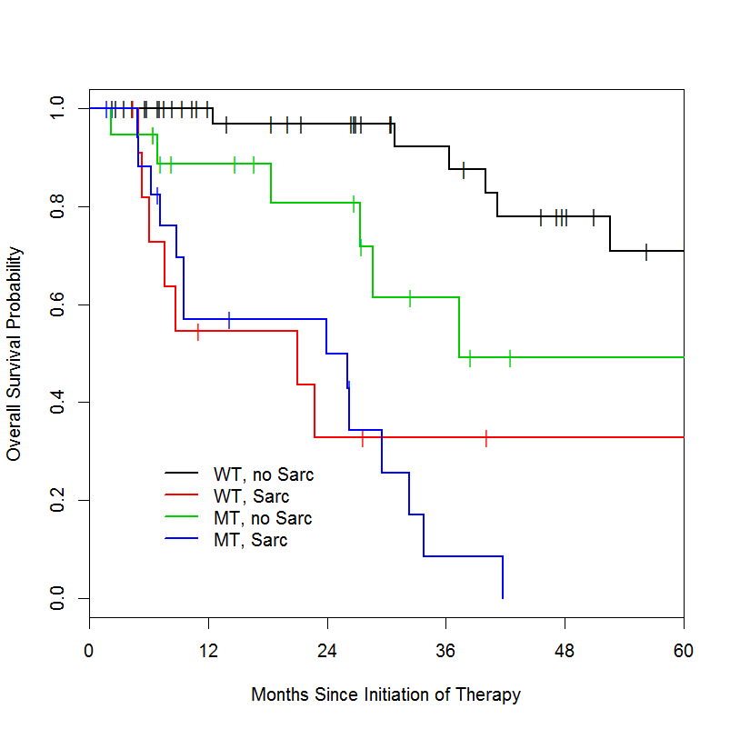

log rank p= <0.0001