Supplementary Material 8. NIH study quality assessment.
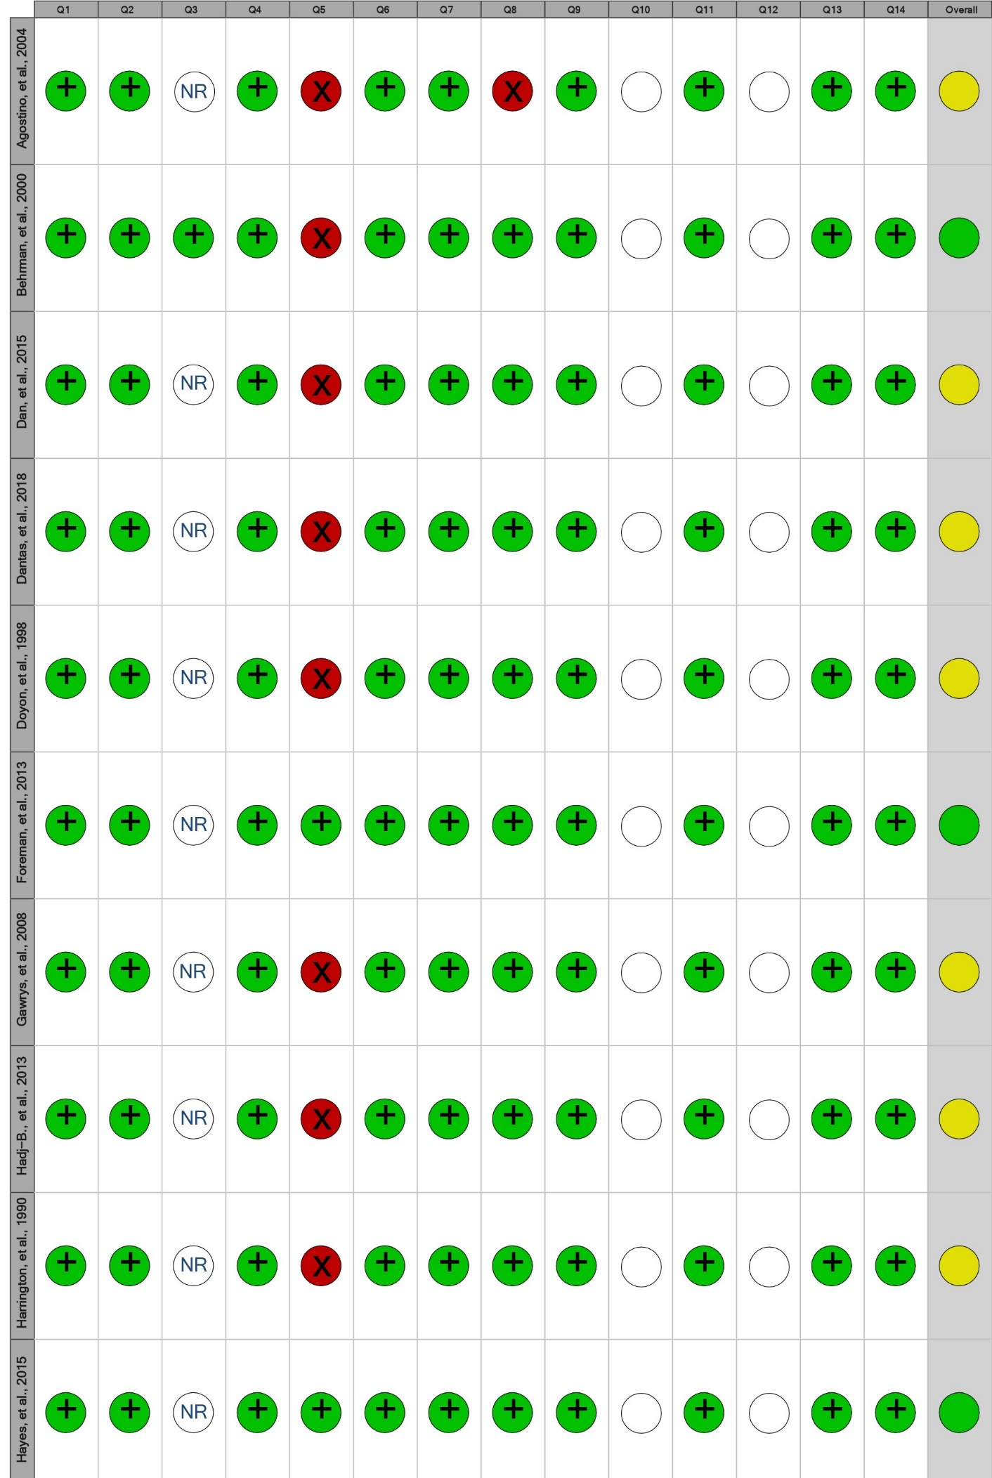
• = No/Poor; • = Fair; • = Yes/Good; NR= not reported; " " = not applicable.
Supplementary 8. Continued
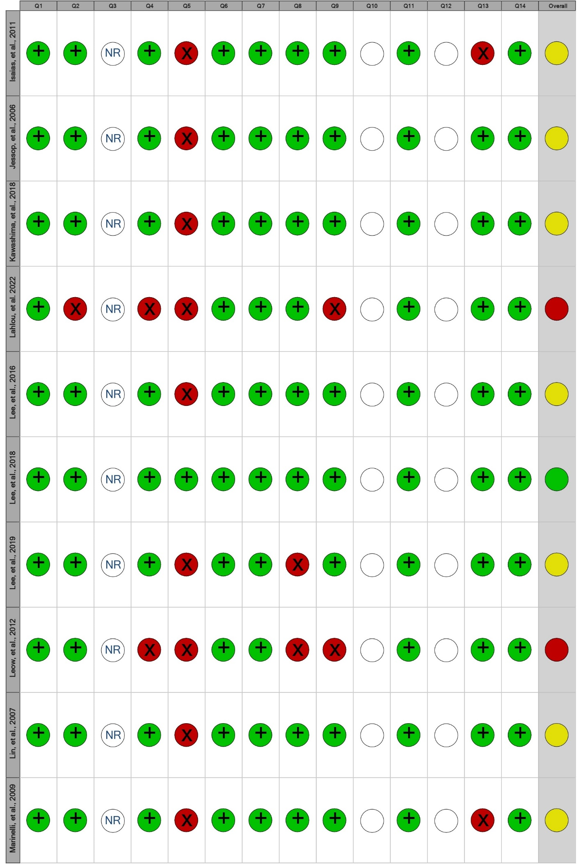
• = No/Poor; • = Fair; • = Yes/Good; NR= not reported; " " = not applicable.
Supplementary 8. Continued
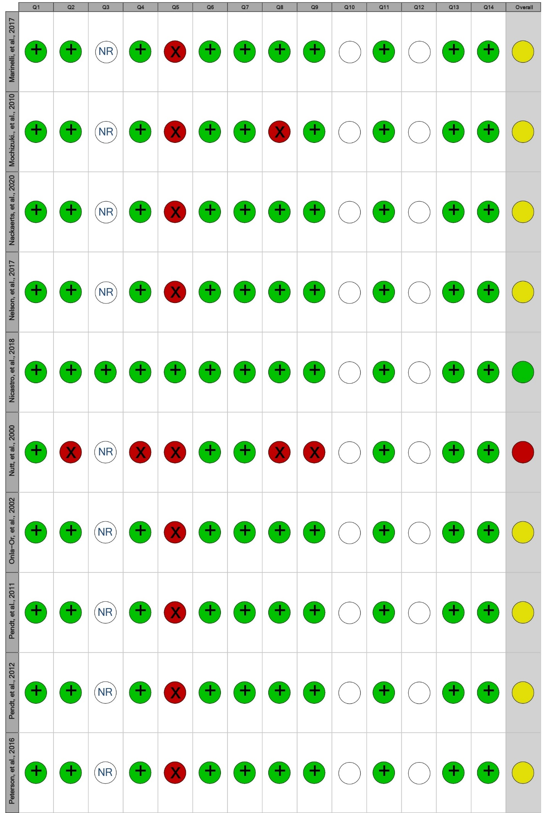
• = No/Poor; • = Fair; • = Yes/Good; NR= not reported; " " = not applicable.

Supplementary 8. Continued
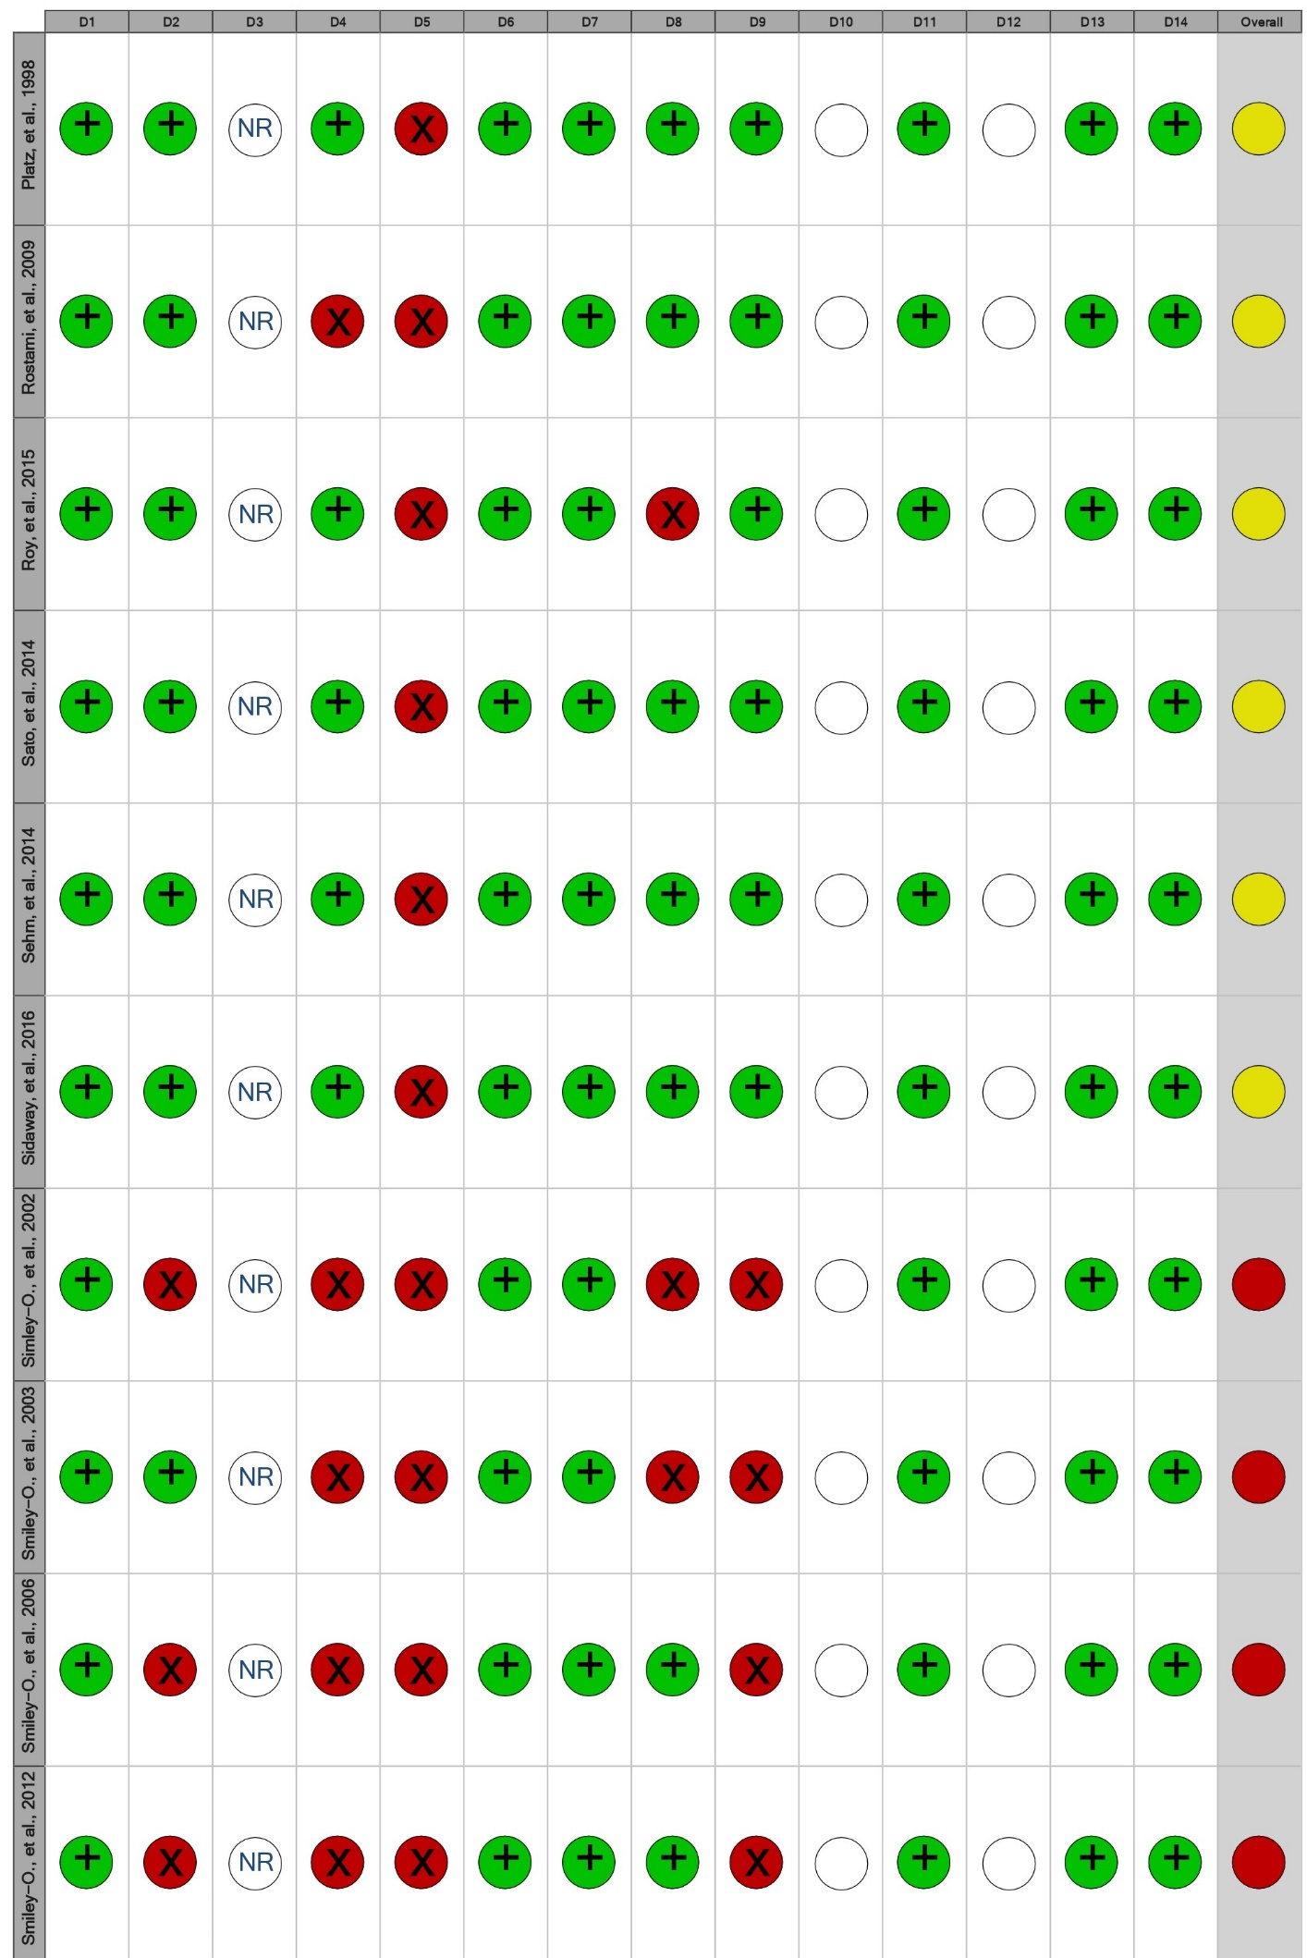
• = No/Poor; • = Fair; • = Yes/Good; NR= not reported; " " = not applicable.

Supplementary 8. Continued
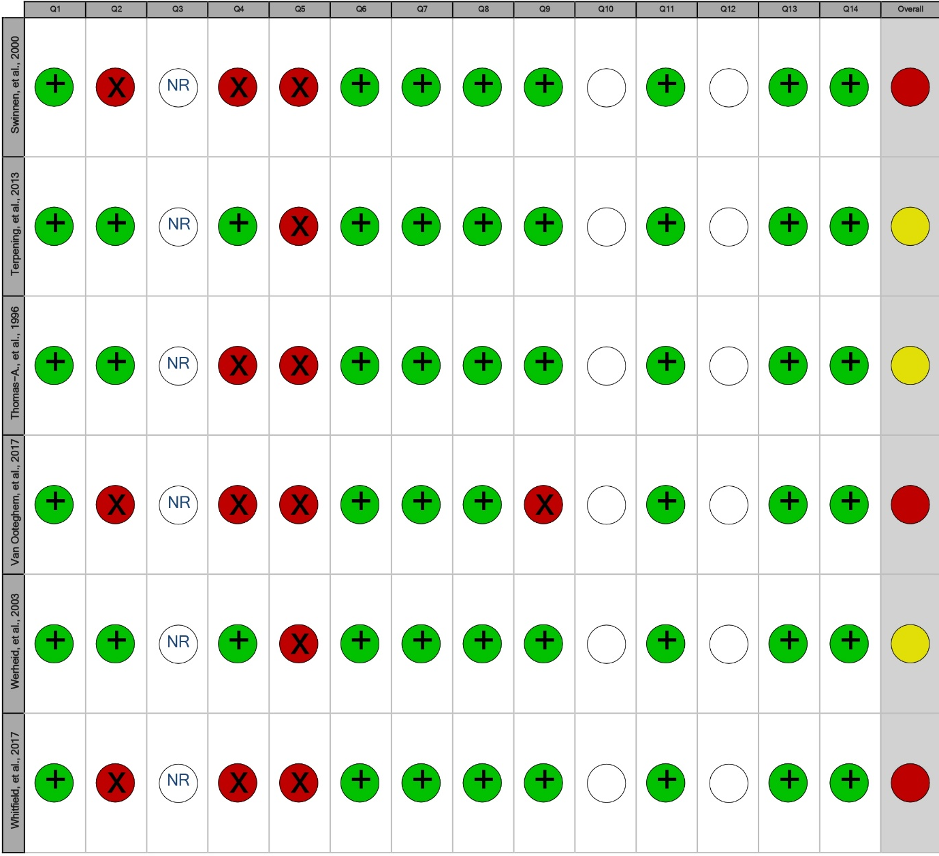
• = No/Poor; • = Fair; • = Yes/Good; NR= not reported; " " = not applicable.

