Supplementary Material 5. Motor skill transfer after single practice.
Methods: Motor skill transfer, which is an approach to investigate motor skill retention from the perspective of generalization [1], was investigated by grouping studies according to the number of practice sessions performed during acquisition (single vs. extended practice). To investigate the transfer of acquired motor skills to untrained tasks, we calculated group mean differences using consecutive retention and transfer test scores (e.g., transfer score 24 h – retention score 24 h). This method was adopted to reduce the influence that memory reactivation may have on motor memory processes [2, 3]. Analyses were performed following the same procedures implemented in the main meta-analyses. However, we did not perform meta-regression analyses due to the limited effect sizes available.
Results: Motor skill transfer was investigated in seven [4-10] and one [11] studies after a single session and extended motor practice, respectively. Funnel and forest plots pertaining to motor skill transfer are reported below.
Motor skill transfer: Funnel plot.
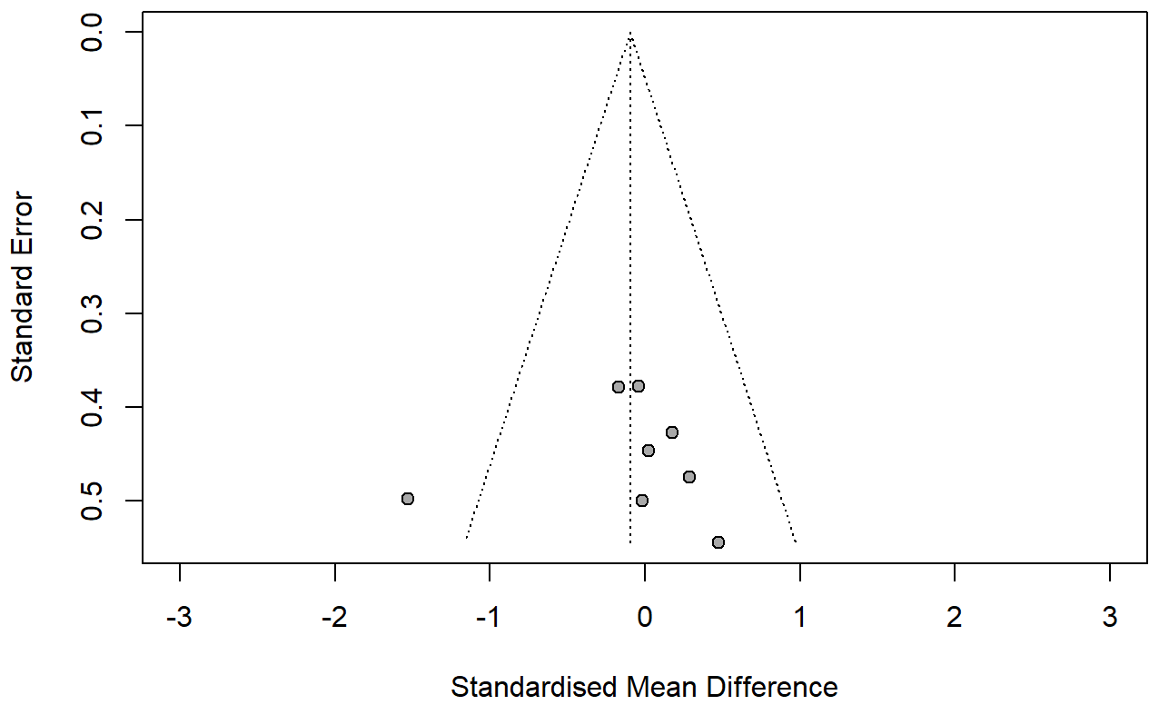

Motor skill transfer: Forest plot.
Discussion: Our results pertaining motor skill transfer following a single practice showed no difference between persons with the PD and NI group (SMD = -0.09; 95% CI = -0.46; 0.27; p = 0.6117; N = 8; I² = 34.0%). These findings are relevant given that successful motor skill transfer would enable persons with PD to generalize and implement their motor skills in different contexts and tasks of daily living. However, our results should be considered preliminary and interpreted with caution for several reasons. First, only a limited number of effect sizes were available for the analysis (N = 8). Second, a few studies included in our review that observed motor skill transfer deficits in persons with PD [4, 12-14] could not be used in our analysis since it was not possible to obtain the data. For example, Isaias et al. [14] using a VAT, found deficits in motor skill transfer in persons with PD relative to NI individuals. Similarly, Onla-Or et al. [13] observed that persons with PD have greater contextual interference than NI individuals in a SMT. Third, it is also plausible that our results were influenced by other factors such as the type of task implemented and the type of feedback provided. In addition to these considerations, previous studies have consistently observed that persons with PD have important deficits in performing acquired motor skills in new contexts and task-switching [15-17]. Since motor skill transfer and generalization are important in PD, further research is needed to confirm and expand our preliminary results.

REFERENCES
[1] Schmidt RA, Lee TD, Winstein C, Wulf G, Zelaznik HN (2018) Motor control and learning: A behavioral emphasis, Human Kinetics.
[2] Dudai Y (2004) The neurobiology of consolidations, or, how stable is the engram? Annu Rev Psychol 55, 51-86.
[3] Tronson NC, Taylor JR (2007) Molecular mechanisms of memory reconsolidation. Nat Rev Neurosci 8, 262-275.
[4] Marinelli L, Trompetto C, Canneva S, Mori L, Nobili F, Fattapposta F, Currà A, Abbruzzese G, Ghilardi MF (2017) Learning “how to learn”: super declarative motor learning is impaired in Parkinson’s disease. Neural Plast 2017, 3162087.
[5] Mochizuki-Kawai H, Mochizuki S, Kawamura M (2010) A flexible sequential learning deficit in patients with Parkinson's disease: a 2 x 8 button-press task. Exp Brain Res 202, 147-153.
[6] Nackaerts E, Ginis P, Heremans E, Swinnen SP, Vandenberghe W, Nieuwboer A (2020) Retention of touchscreen skills is compromised in Parkinson's disease. Behav Brain Res 378, 112265.
[7] Platz T, Brown RG, Marsden CD (1998) Training improves the speed of aimed movements in Parkinson's disease. Brain 121, 505-514.
[8] Sidaway B, Ala B, Baughman K, Glidden J, Cowie S, Peabody A, Roundy D, Spaulding J, Stephens R, Wright DL (2016) Contextual interference can facilitate motor learning in older adults and in individuals with Parkinson's disease. J Mot Behav 48, 509-518.
[9] Van Ooteghem K, Frank JS, Horak FB (2017) Postural motor learning in Parkinson's disease: The effect of practice on continuous compensatory postural regulation. Gait Posture 57, 299-304.
[10] Smiley-Oyen AL, Worringham CJ, Cross CL (2003) Motor learning processes in a movement-scaling task in olivopontocerebellar atrophy and Parkinson's disease. Exp Brain Res 152, 453-465.
[11] Smiley-Oyen AL, Hall SA, Lowry KA, Kerr JP (2012) Effects of extensive practice on bradykinesia in Parkinson's disease: improvement, retention and transfer. Motor Control 16, 1-18.
[12] Lee Y-Y, Winstein CJ, Gordon J, Petzinger GM, Zelinski EM, Fisher BE (2016) Context-dependent learning in people with Parkinson's disease. J Mot Behav 48, 240-248.
[13] Onla-Or S, Winstein CJ (2008) Determining the optimal challenge point for motor skill learning in adults with moderately severe Parkinson’s disease. Neurorehabil Neural Repair 22, 385-395.
[14] Isaias IU, Moisello C, Marotta G, Schiavella M, Canesi M, Perfetti B, Cavallari P, Pezzoli G, Ghilardi MF (2011) Dopaminergic striatal innervation predicts interlimb transfer of a visuomotor skill. J Neurosci 31, 14458-14462.
[15] Nieuwboer A, Rochester L, Müncks L, Swinnen SP (2009) Motor learning in Parkinson's disease: limitations and potential for rehabilitation. Parkinsonism Relat Disord 15 Suppl 3, S53-58.
[16] Abbruzzese G, Trompetto C, Marinelli L (2009) The rationale for motor learning in Parkinson's disease. Eur J Phys Rehabil Med 45, 209-214.
[17] Olson M, Lockhart TE, Lieberman A (2019) Motor learning deficits in Parkinson's disease (PD) and their effect on training response in gait and balance: a narrative review. Front Neurol 10, 62.

