Supplementary Material 9. Funnels plots for motor memory consolidation after single and extended practice.
Funnel plot – Motor memory consolidation after single practice.
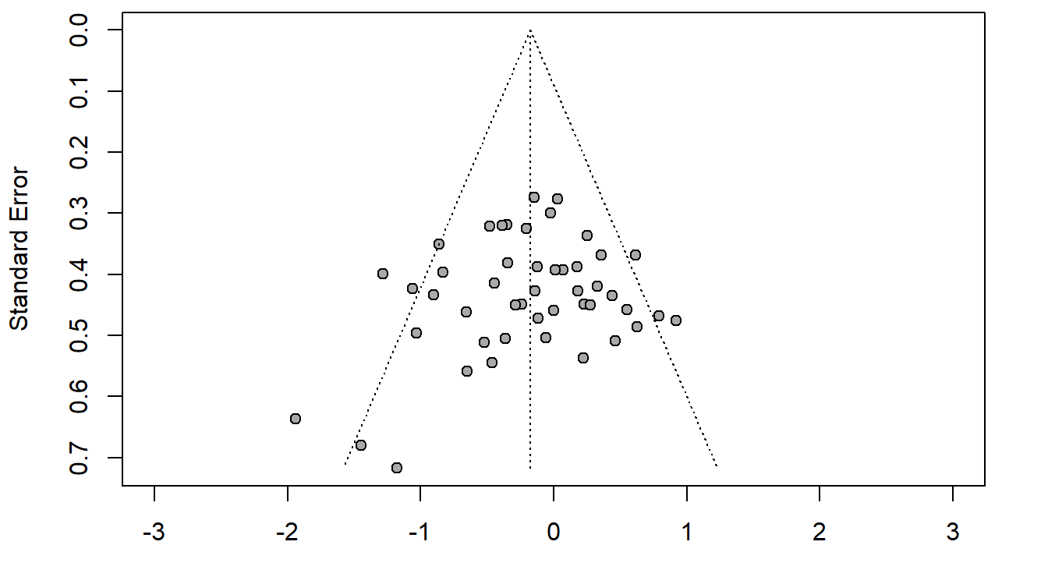
SMD

Funnel plots – Motor memory consolidation after extended practice.
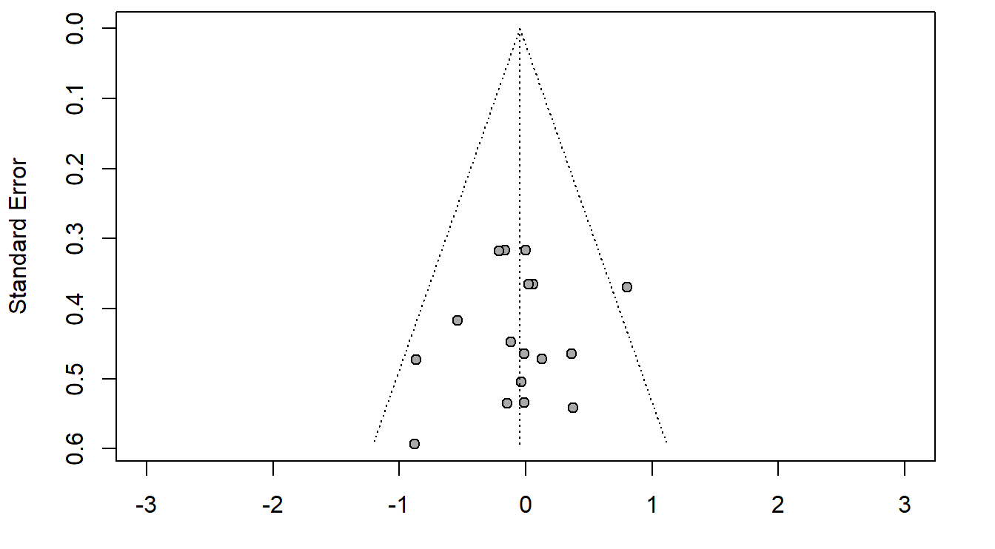
SMD

