Supplementary Material

Spinal Cord Stimulation for Gait Disorders in Parkinson’s Disease

Supplementary Figure 1. Prisma checklist for systematic reviews & meta-analyses
Section/topic | # | Checklist item | Reported on page #
TITLE
Title | 1 | Identify the report as a systematic review, meta-analysis, or both. | 1
ABSTRACT
Structured summary | 2 | Provide a structured summary including, as applicable: background; objectives; data sources; study eligibility criteria, participants, and interventions; study appraisal and synthesis methods; results; limitations; conclusions and implications of key findings; systematic review registration number. | 2
INTRODUCTION
Rationale | 3 | Describe the rationale for the review in the context of what is already known. | 3-6
Objectives | 4 | Provide an explicit statement of questions being addressed with reference to participants, interventions, comparisons, outcomes, and study design (PICOS). | 6
METHODS
Protocol and registration | 5 | Indicate if a review protocol exists, if and where it can be accessed (e.g., Web address), and, if available, provide registration information including registration number. | X
Eligibility criteria | 6 | Specify study characteristics (e.g., PICOS, length of follow-up) and report characteristics (e.g., years considered, language, publication status) used as criteria for eligibility, giving rationale. | 9
Information sources | 7 | Describe all information sources (e.g., databases with dates of coverage, contact with study authors to identify additional studies) in the search and date last searched. | 7
Search | 8 | Present full electronic search strategy for at least one database, including any limits used, such that it could be repeated. | 32-37
Study selection | 9 | State the process for selecting studies (i.e., screening, eligibility, included in systematic review, and, if applicable, included in the meta-analysis). | 6-8
Data collection process | 10 | Describe method of data extraction from reports (e.g., piloted forms, independently, in duplicate) and any processes for obtaining and confirming data from investigators. | 7-8
Data items | 11 | List and define all variables for which data were sought (e.g., PICOS, funding sources) and any assumptions and simplifications made. | X
Risk of bias in individual studies | 12 | Describe methods used for assessing risk of bias of individual studies (including specification of whether this was done at the study or outcome level), and how this information is to be used in any data synthesis. | 15, 38-47
Summary measures | 13 | State the principal summary measures (e.g., risk ratio, difference in means). | X
Synthesis of results | 14 | Describe the methods of handling data and combining results of studies, if done, including measures of consistency (e.g., I²) for each meta-analysis. | X

Section/topic | # | › | Reported on page #
Risk of bias across studies | 15 | Specify any assessment of risk of bias that may affect the cumulative evidence (e.g., publication bias, selective reporting within studies). | 15
Additional analyses | 16 | Describe methods of additional analyses (e.g., sensitivity or subgroup analyses, meta-regression), if done, indicating which were pre-specified. | X
RESULTS
Study selection | 17 | Give numbers of studies screened, assessed for eligibility, and included in the review, with reasons for exclusions at each stage, ideally with a flow diagram. | 16
Study characteristics | 18 | For each study, present characteristics for which data were extracted (e.g., study size, PICOS, follow-up period) and provide the citations. | 11-13
Risk of bias within studies | 19 | Present data on risk of bias of each study and, if available, any outcome level assessment (see item 12). | 38-47
Results of individual studies | 20 | For all outcomes considered (benefits or harms), present, for each study: (a) simple summary data for each intervention group (b) effect estimates and confidence intervals, ideally with a forest plot. | 16-17
Synthesis of results | 21 | Present results of each meta-analysis done, including confidence intervals and measures of consistency. | X
Risk of bias across studies | 22 | Present results of any assessment of risk of bias across studies (see Item 15). | X
Additional analysis | 23 | Give results of additional analyses, if done (e.g., sensitivity or subgroup analyses, meta-regression [see Item 16]). | X
DISCUSSION
‹Summary of evidence | 24 | Summarize the main findings including the strength of evidence for each main outcome; consider their relevance to key groups (e.g., healthcare providers, users, and policy makers). | 18-22
Limitations | 25 | Discuss limitations at study and outcome level (e.g., risk of bias), and at review-level (e.g., incomplete retrieval of identified research, reporting bias). | 18-22
Conclusions | 26 | Provide a general interpretation of the results in the context of other evidence, and implications for future research. | 23
FUNDING
Funding | 27 | Describe sources of funding for the systematic review and other support (e.g., supply of data); role of funders for the systematic review. | X
From: Moher D, Liberati A, Tetzlaff J, Altman DG, The PRISMA Group (2009). Preferred Reporting Items for Systematic Reviews and Meta-Analyses: The PRISMA Statement. PLoS Med 6(7): e1000097. doi:10.1371/journal.pmed1000097
For more information, visit: www.prisma-statement.org.

Supplementary Figure 2. Primary Search – ‘Gait’ Focused.
A table showing search period and results yielded by individual databases during the primary database search. For the specific search strategy and key terms applied, see Supplementary Figure 4.

Database | Search Period - Start | Search Period - End | Studies - Total
Medline (OvidSP) | 1946 | 1/2020 | 90
Embase (OvidSP) | 1974 | 1/2020 | 226
Web of Sciences | 1990 | 1/2020 | 154
All Databases Combined | N/A | N/A | 470
All Databases - Deduplicated | N/A | N/A | 404
All Databases - Manual Check of Eligibility | N/A | N/A | 39
All Databases - Studies Included for Analysis | N/A | N/A | 15

Supplementary Figure 3. Secondary Search – ‘Pain’ Focused.
A table showing search period and results yielded by individual databases during the secondary database search. For the specific search strategy and key terms applied, see Supplementary Figure 5.

Database | Search Period - Start | Search Period - End | Studies - Total
Medline (OvidSP) | 1946 | 3/2020 | 63
Embase (OvidSP) | 1974 | 3/2020 | 232
Web of Sciences | 1990 | 3/2020 | 132
All Databases Combined | N/A | N/A | 427
All Databases - Deduplicated | N/A | N/A | 315
All Databases - Manual Check of Relevance | N/A | N/A | 26
AllDatabases - Studies Included in Analysis | N/A | N/A | 4

Supplementary Figure 4. Search strategies used for primary literature search
1. Medline
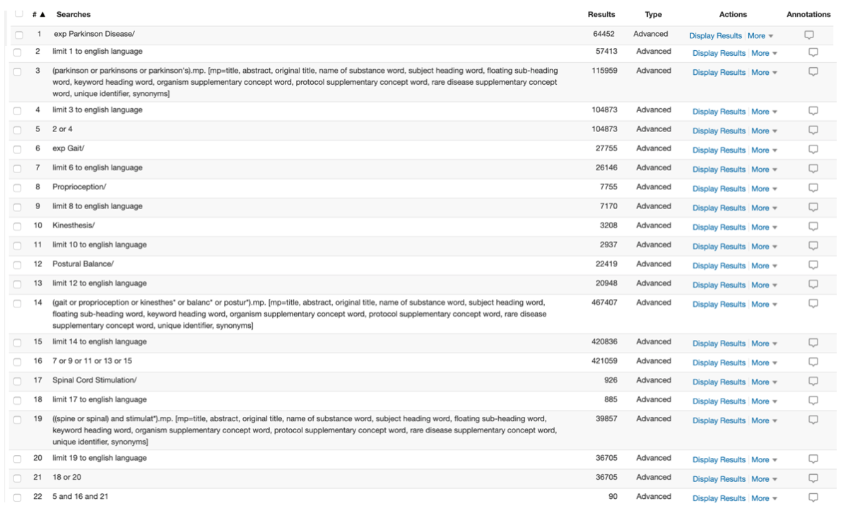

- Embase

2. Embase
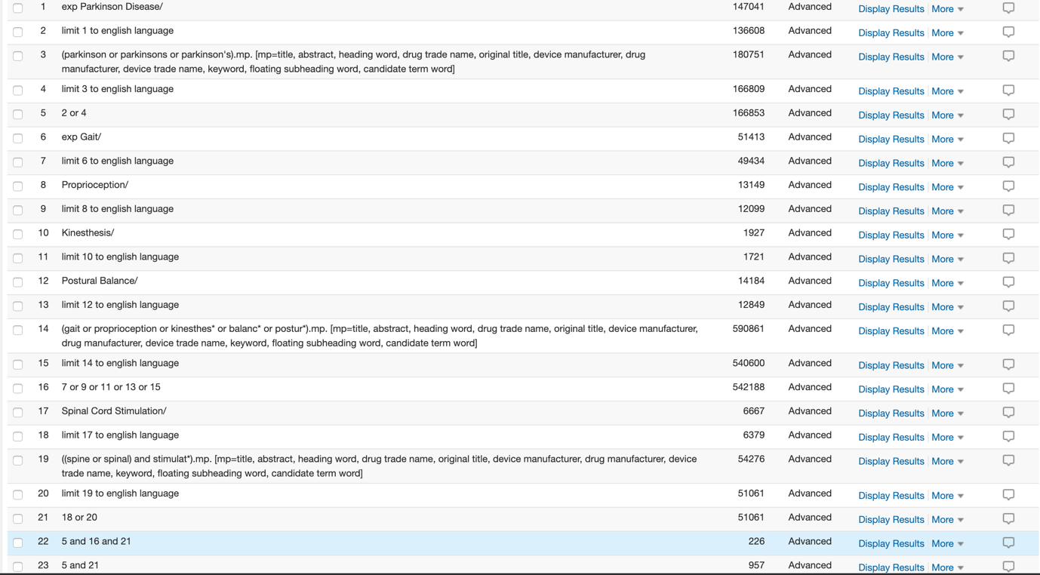

3. Web of Science

Supplementary Figure 5. Search strategies used for secondary literature search
1. Medline
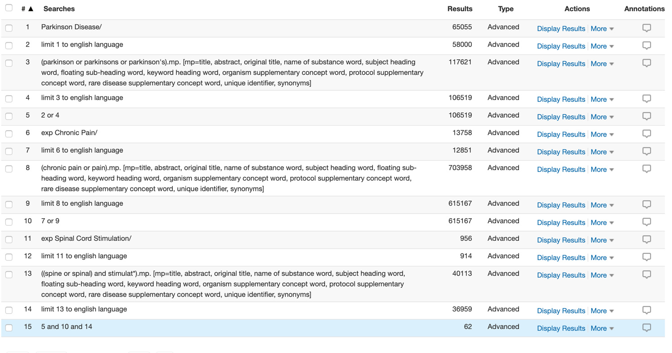

2. Embase
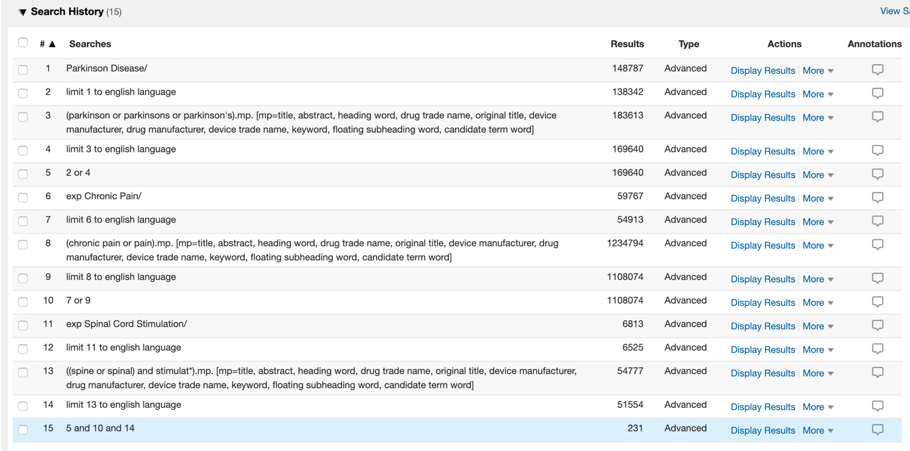

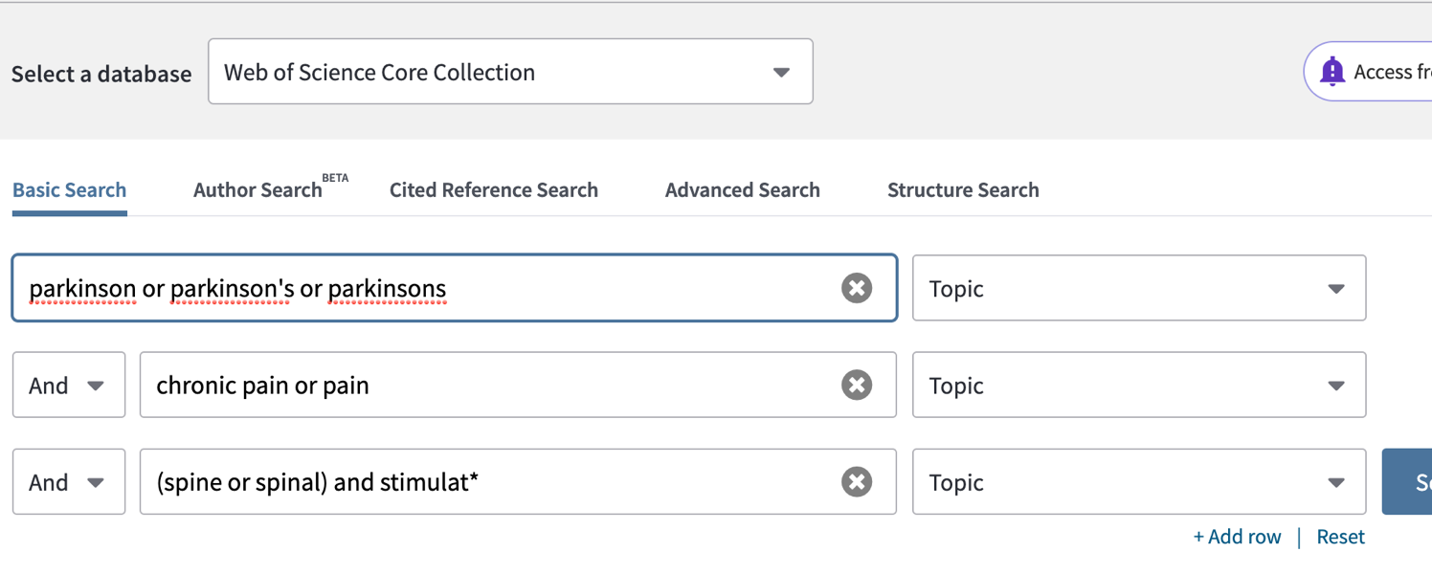
3. Web of Science

Supplementary Figure 6. Critical appraisal of individual case series included in this systematic review

JBI Critical Appraisal Checklist for Case Series
© Joanna Briggs Institute 2017

Author: Agari and Date Year: 2012 Yes No Unclear NA*

- Were there clear criteria for inclusion in the case series?
- Was the condition measured in a standard, reliable way for
all participants included in the case series?
- Were valid methods used for identification of the condition for
all participants included in the case series?
- Did the case series have consecutive inclusion of participants?
- Did the case series have complete inclusion of participants?
- Was there clear reporting of the demographics of the
participants in the study?
- Was there clear reporting of clinical information of the participants?
- Were the outcomes or follow up results of cases clearly reported?
- Was there clear reporting of the presenting
site(s)/clinic(s) demographic information?
- Was statistical analysis appropriate?
*NA = Not applicable

Author: Cécile et al. Year: 2017 Yes No Unclear NA
- Were there clear criteria for inclusion in the case series?
- Was the condition measured in a standard, reliable way for
all participants included in the case series?
- Were valid methods used for identification of the condition for
all participants included in the case series?
- Did the case series have consecutive inclusion of participants?
- Did the case series have complete inclusion of participants?
- Was there clear reporting of the demographics of the
participants in the study?
- Was there clear reporting of clinical information of the participants?
- Were the outcomes or follow up results of cases clearly reported?
- Was there clear reporting of the presenting
site(s)/clinic(s) demographic information?
- Was statistical analysis appropriate?

Author: De Lima Pardini et al./De Souza et al. Year: 2018/2017 Yes No Unclear NA
- Were there clear criteria for inclusion in the case series?
- Was the condition measured in a standard, reliable way for
all participants included in the case series?
- Were valid methods used for identification of the condition for
all participants included in the case series?
- Did the case series have consecutive inclusion of participants?
- Did the case series have complete inclusion of participants?
- Was there clear reporting of the demographics of the
participants in the study?
- Was there clear reporting of clinical information of the participants?
- Were the outcomes or follow up results of cases clearly reported?
- Was there clear reporting of the presenting
site(s)/clinic(s) demographic information?
- Was statistical analysis appropriate?

Author: Hubsch et al. Year: 2019 Yes No Unclear NA
- Were there clear criteria for inclusion in the case series?
- Was the condition measured in a standard, reliable way for
all participants included in the case series?
- Were valid methods used for identification of the condition for
all participants included in the case series?
- Did the case series have consecutive inclusion of participants?
- Did the case series have complete inclusion of participants?
- Was there clear reporting of the demographics of the
participants in the study?
- Was there clear reporting of clinical information of the participants?
- Were the outcomes or follow up results of cases clearly reported?
- Was there clear reporting of the presenting
site(s)/clinic(s) demographic information?
- Was statistical analysis appropriate?

Author: Ichikawa et al. Year: 2013 Yes No Unclear NA
- Were there clear criteria for inclusion in the case series?
- Was the condition measured in a standard, reliable way for
all participants included in the case series?
- Were valid methods used for identification of the condition for
all participants included in the case series?
- Did the case series have consecutive inclusion of participants?
- Did the case series have complete inclusion of participants?
- Was there clear reporting of the demographics of the
participants in the study?
- Was there clear reporting of clinical information of the participants?
- Were the outcomes or follow up results of cases clearly reported?
- Was there clear reporting of the presenting
site(s)/clinic(s) demographic information?
- Was statistical analysis appropriate?

Author: Mazzone et al. Year: 2019 Yes No Unclear NA
- Were there clear criteria for inclusion in the case series?
- Was the condition measured in a standard, reliable way for
all participants included in the case series?
- Were valid methods used for identification of the condition for
all participants included in the case series?
- Did the case series have consecutive inclusion of participants?
- Did the case series have complete inclusion of participants?
- Was there clear reporting of the demographics of the
participants in the study?
- Was there clear reporting of clinical information of the participants?
- Were the outcomes or follow up results of cases clearly reported?
- Was there clear reporting of the presenting
site(s)/clinic(s) demographic information?
- Was statistical analysis appropriate?

Author: Mitsuyama et al. Year: 2013 Yes No Unclear NA
- Were there clear criteria for inclusion in the case series?
- Was the condition measured in a standard, reliable way for
all participants included in the case series?
- Were valid methods used for identification of the condition for
all participants included in the case series?
- Did the case series have consecutive inclusion of participants?
- Did the case series have complete inclusion of participants?
- Was there clear reporting of the demographics of the
participants in the study?
- Was there clear reporting of clinical information of the participants?
- Were the outcomes or follow up results of cases clearly reported?
- Was there clear reporting of the presenting
site(s)/clinic(s) demographic information?
- Was statistical analysis appropriate?

Author: Nishioka and Nakajima Year: 2015 Yes No Unclear NA
- Were there clear criteria for inclusion in the case series?
- Was the condition measured in a standard, reliable way for
all participants included in the case series?
- Were valid methods used for identification of the condition for
all participants included in the case series?
- Did the case series have consecutive inclusion of participants?
- Did the case series have complete inclusion of participants?
- Was there clear reporting of the demographics of the
participants in the study?
- Was there clear reporting of clinical information of the participants?
- Were the outcomes or follow up results of cases clearly reported?
- Was there clear reporting of the presenting
site(s)/clinic(s) demographic information?
- Was statistical analysis appropriate?

Author: Rohani et al. Year: 2017 Yes No Unclear NA
- Were there clear criteria for inclusion in the case series?
- Was the condition measured in a standard, reliable way for
all participants included in the case series?
- Were valid methods used for identification of the condition for
all participants included in the case series?
- Did the case series have consecutive inclusion of participants?
- Did the case series have complete inclusion of participants?
- Was there clear reporting of the demographics of the
participants in the study?
- Was there clear reporting of clinical information of the participants?
- Were the outcomes or follow up results of cases clearly reported?
- Was there clear reporting of the presenting
site(s)/clinic(s) demographic information?
- Was statistical analysis appropriate?

Author: Samotus et al. Year: 2018 Yes No Unclear NA
- Were there clear criteria for inclusion in the case series?
- Was the condition measured in a standard, reliable way for
all participants included in the case series?
- Were valid methods used for identification of the condition for
all participants included in the case series?
- Did the case series have consecutive inclusion of participants?
- Did the case series have complete inclusion of participants?
- Was there clear reporting of the demographics of the
participants in the study?
- Was there clear reporting of clinical information of the participants?
- Were the outcomes or follow up results of cases clearly reported?
- Was there clear reporting of the presenting
site(s)/clinic(s) demographic information?
- Was statistical analysis appropriate?

Author: Thevathasan et al. Year: 2010 Yes No Unclear NA
- Were there clear criteria for inclusion in the case series?
- Was the condition measured in a standard, reliable way for
all participants included in the case series?
- Were valid methods used for identification of the condition for
all participants included in the case series?
- Did the case series have consecutive inclusion of participants?
- Did the case series have complete inclusion of participants?
- Was there clear reporting of the demographics of the
participants in the study?
- Was there clear reporting of clinical information of the participants?
- Were the outcomes or follow up results of cases clearly reported?
- Was there clear reporting of the presenting
site(s)/clinic(s) demographic information?
- Was statistical analysis appropriate?

Supplementary Figure 7. Critical appraisal of individual case reports included in this systematic review

JBI Critical Appraisal Checklist for Case Reports
© Joanna Briggs Institute 2017

Author: Akiyama et al. Year: 2017 Yes No Unclear NA*
- Were patient’s demographic characteristics clearly described?
- Was the patient’s history clearly described
and presented as a timeline?
- Was the current clinical condition of the patient on
presentation clearly described?
- Were diagnostic tests or methods and the results
clearly described?
- Was the intervention(s) or treatment procedure(s)
clearly described?
- Was the post-intervention clinical condition clearly described?
- Were adverse events (harms) or unanticipated events
identified and described?
- Does the case report provide takeaway lessons?

*NA = Not applicable

Author: Fénelon et al. Year: 2011 Yes No Unclear NA
- Were patient’s demographic characteristics clearly described?
- Was the patient’s history clearly described
and presented as a timeline?
- Was the current clinical condition of the patient on
presentation clearly described?
- Were diagnostic tests or methods and the results
clearly described?
- Was the intervention(s) or treatment procedure(s)
clearly described?
- Was the post-intervention clinical condition clearly described?
- Were adverse events (harms) or unanticipated events
identified and described?
- Does the case report provide takeaway lessons?

Author: Hassan et al. Year: 2013 Yes No Unclear NA
- Were patient’s demographic characteristics clearly described?
- Was the patient’s history clearly described
and presented as a timeline?
- Was the current clinical condition of the patient on
presentation clearly described?
- Were diagnostic tests or methods and the results
clearly described?
- Was the intervention(s) or treatment procedure(s)
clearly described?
- Was the post-intervention clinical condition clearly described?
- Were adverse events (harms) or unanticipated events
identified and described?
- Does the case report provide takeaway lessons?

Author: Kobayashi et al. Year: 2018 Yes No Unclear NA
- Were patient’s demographic characteristics clearly described?
- Was the patient’s history clearly described
and presented as a timeline?
- Was the current clinical condition of the patient on
presentation clearly described?
- Were diagnostic tests or methods and the results
clearly described?
- Was the intervention(s) or treatment procedure(s)
clearly described?
- Was the post-intervention clinical condition clearly described?
- Were adverse events (harms) or unanticipated events
identified and described?
- Does the case report provide takeaway lessons?

Author: Lai et al. Year: 2020 Yes No Unclear NA
- Were patient’s demographic characteristics clearly described?
- Was the patient’s history clearly described
and presented as a timeline?
- Was the current clinical condition of the patient on
presentation clearly described?
- Were diagnostic tests or methods and the results
clearly described?
- Was the intervention(s) or treatment procedure(s)
clearly described?
- Was the post-intervention clinical condition clearly described?
- Were adverse events (harms) or unanticipated events
identified and described?
- Does the case report provide takeaway lessons?

Author: Landi et al. Year: 2013 Yes No Unclear NA
- Were patient’s demographic characteristics clearly described?
- Was the patient’s history clearly described
and presented as a timeline?
- Was the current clinical condition of the patient on
presentation clearly described?
- Were diagnostic tests or methods and the results
clearly described?
- Was the intervention(s) or treatment procedure(s)
clearly described?
- Was the post-intervention clinical condition clearly described?
- Were adverse events (harms) or unanticipated events
identified and described?
- Does the case report provide takeaway lessons?

Author: Soltani and Lalkhen Year: 2013 Yes No Unclear NA
- Were patient’s demographic characteristics clearly described?
- Was the patient’s history clearly described
and presented as a timeline?
- Was the current clinical condition of the patient on
presentation clearly described?
- Were diagnostic tests or methods and the results
clearly described?
- Was the intervention(s) or treatment procedure(s)
clearly described?
- Was the post-intervention clinical condition clearly described?
- Were adverse events (harms) or unanticipated events
identified and described?
- Does the case report provide takeaway lessons?

Author: Weise et al. Year: 2010 Yes No Unclear NA
- Were patient’s demographic characteristics clearly described?
- Was the patient’s history clearly described
and presented as a timeline?
- Was the current clinical condition of the patient on
presentation clearly described?
- Were diagnostic tests or methods and the results
clearly described?
- Was the intervention(s) or treatment procedure(s)
clearly described?
- Was the post-intervention clinical condition clearly described?
- Were adverse events (harms) or unanticipated events
identified and described?
- Does the case report provide takeaway lessons?

