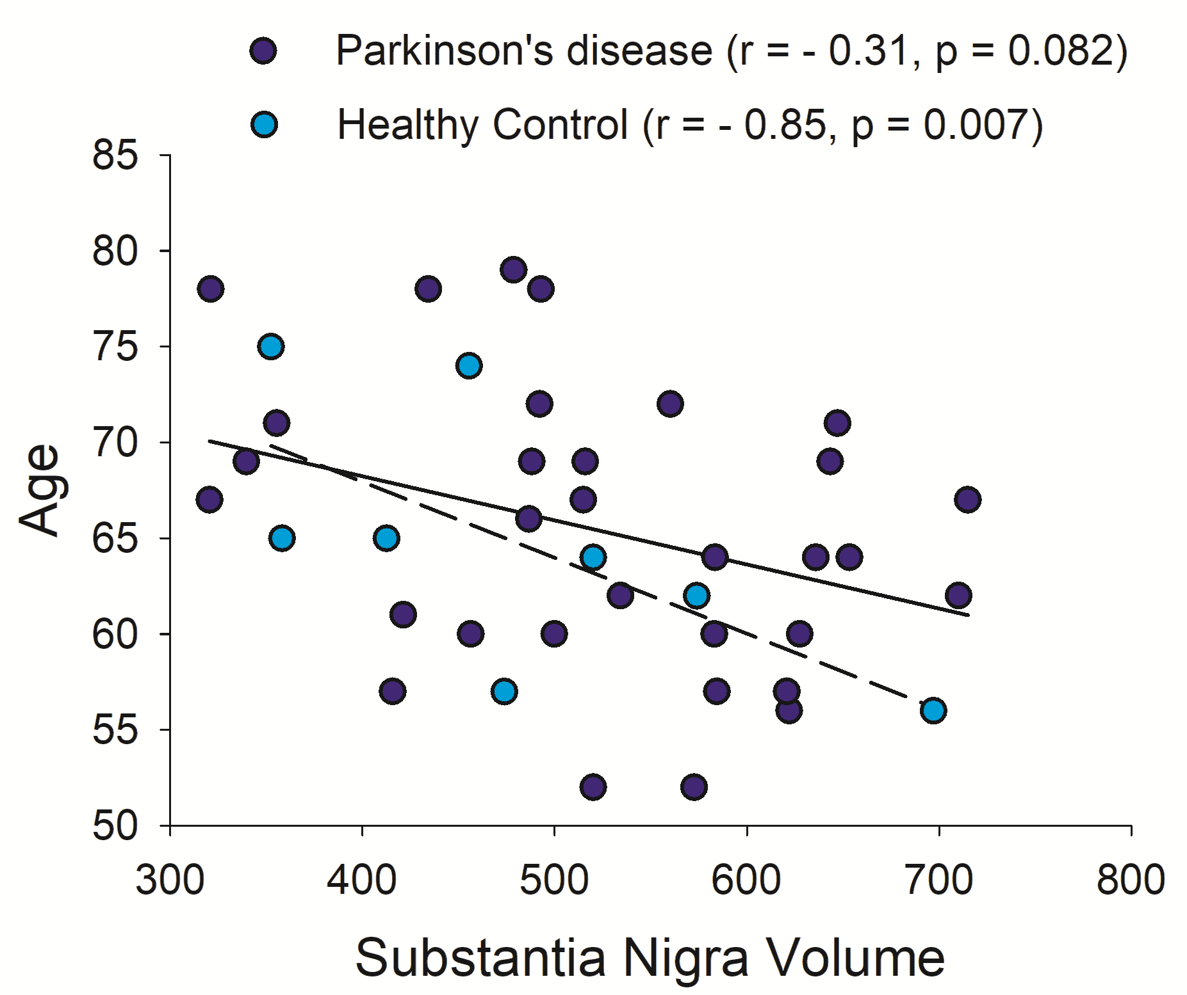

Supplementary Figure 1. Scatterplot of Substantia Nigra volume versus age in Parkinson’s disease (dark blue, solid line) and Healthy controls (light blue, dashed line). r, Spearman’s rho correlation coefficient.

