Supplementary Material

Delayed Clinical Manifestation of Parkinson’s Disease Among Physically Active: Do Participants in a Long-Distance Ski Race Have a Motor Reserve?

Extended Method Description

Exclusion criteria and matching procedure
In the Vasaloppet study, individuals with severe disease were excluded since such diseases are likely to hinder participation in a demanding long-distance race. A flow diagram describing numbers excluded due to severe disease can be seen in Supplementary Figure 1. The exact diagnoses have been stated previously [11]. We additionally excluded participants with diagnoses listed in Table 1.

In the first matching process, a control individual from the general population was assigned for every ski race, so that skiers participating in Vasaloppet several times got several controls. We performed a re-matching procedure to get equally many skiers as non-skiers. Since we only used the index race for each skier, the non-skiers would have been older as a group if we had included one control for every time a skier participated in the race.

Vasaloppet Study population

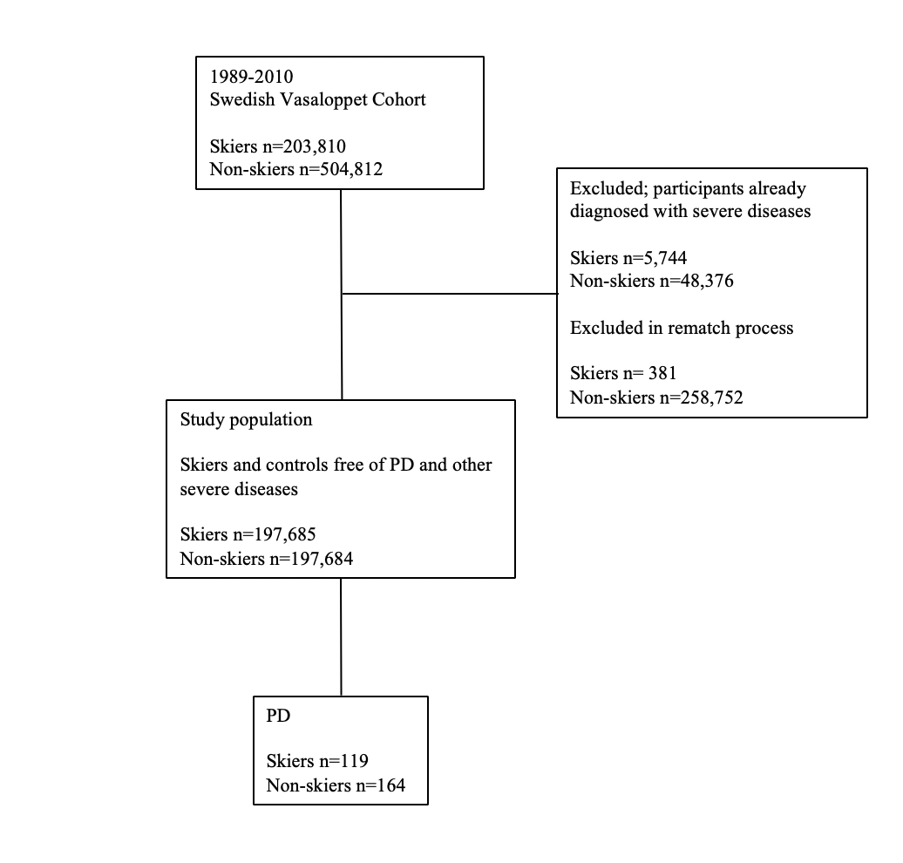
Supplementary Figure 1. Flow diagram describing the Vasaloppet Study population.

Supplementary Table 1. Additional exclusion criteria

Diagnosis | ICD-9 | ICD-10
Alzheimer’s disease | 331A/3310, 29010 | F00, G30
vascular dementia | 290E, 2904, 2930 | F01
all-cause dementia | 290, F070, 294C, 294B, 331A, 310A, G318A | F00, F01, F02, F03, G30
Lewy body dementia | 331X, G318A, 33182 | F028
dementia in Parkinson disease | 294B, 332A | F023
Parkinson disease | 332A, 3420 | G20
meningitis/encephalitis | 3200, 320A, 320B, 320C, 320D, 320W 320X, 321A, 321B, 321C, 321D, 321E, 321X, 322A, 322B, 322C, 320X, 323, 3230 | G00, G01, G03, G04, G05
epilepsy | 345, 3450 | G40
depressive episode | F399, 296B, 296X, 29620, 29800 | F32, F33, F34, F38
anxiety disorders | 300A, 300B, 300C, 300D, 300D, 3000, 3001, 3002, 3003 | F40, F41, F42
bipolar disorder | 296A, 29610 ,296C, 296D, 296E, 29600, 29610, 29620, 29630, 29688, 29699 | F30, F29, F310, F311, F312, F313, F314, F315, F316, F317, F318, F319
schizophrenia | 295, 297, 2970, 2979, 29999 | F20, F21, F22, F23, F24, F25, F28, F29
mental disorders due to the use of alcohol | 291, 2910, 2919 | F10

