Supplementary Material

HSP90 and Its Novel Co-Chaperones, SGT1 and CHP-1, in Brain of Patients with Parkinson’s Disease and Dementia with Lewy Bodies

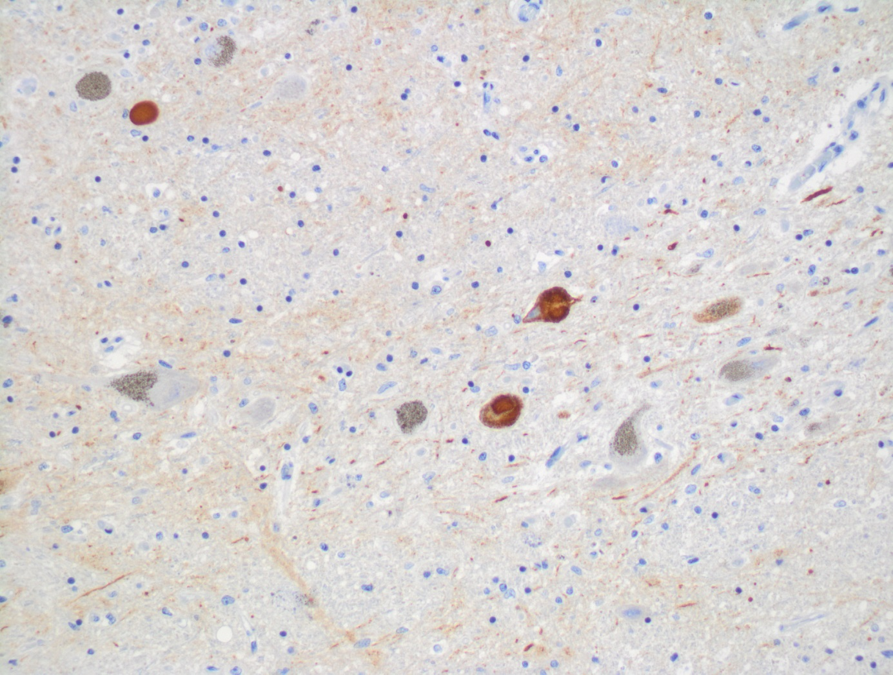

Supplementary Figure 1. Immunohistochemical staining of α-synuclein in the substantia nigra of a PD patient showing Lewy bodies. Microscope image with 20x magnification is shown.

Supplementary Figure 2. Level of HSP90 in the substantia nigra, frontal and temporal cortex. (A) Western blot (upper panel) and densitometric analysis of HSP90 level (lower panel). (B) RT-qPCR of HSP90 mRNA level. In (A) and (B) samples from 3 control and 3 DLB patients were analyzed. White and blue bars represent control and DLB cases, respectively. Error bars indicate mean ± SEM; ***p<0.001.

Supplementary Figure 3. Level of SGT1 in the substantia nigra, frontal and temporal cortex. (A) Western blot (upper panel) and densitometric analysis of SGT1 level (lower panel). (B) RT-qPCR of SGT1 mRNA level. In (A) and (B) samples from 3 control and 3 DLB patients were analyzed. White and orange bars represent control and DLB cases, respectively. Error bars indicate mean ± SEM; ***p<0.001.

Supplementary Figure 4. Level of CHP-1 in the substantia nigra, frontal and temporal cortex. (A) Western blot (upper panel) and densitometric analysis of CHP-1 level (lower panel). (B) RT-qPCR of CHP-1 mRNA level. In (A) and (B) samples from 3 control and 3 DLB patients were analyzed. White and yellow bars represent control and DLB cases, respectively. Error bars indicate mean ± SEM; *p<0.05; **p<0.01; ***p<0.001.

Supplementary Table 1. Data regarding control patients. PM, postmortem delay in hours; Braak & Braak, neurofibrillary tangle staging after Braak & Braak [34]; CERAD [35, 36]; Braak et al. [37]; NIA Montine et al. 2012 [38, 39]; McKeith et al. [40]; CAA, cerebral amyloid angiopathy; LB-FC, LB-TC, LB-SN; presence of Lewy bodies in the frontal cortex, temporal cortex, and in the substantia nigra, respectively. 0, absent; NA, not applicable; NSTEMI, Non ST-segment elevation myocardial infarction; M, male, F, female.

Controls | Sex | Age | PM delay | Clinical Diagnosis | Neuropathology Diagnoses | Braak & Braak Neurofibrillary Tangle Stages | CERAD | NIA- Montine et al. 2012 | CAA | Braak et al. | McKeith et al. | LB-FC | LB-TC | LB-SN
10032- | M | 59.4 | 24.00 | Dilatative cardiomyopathy, Chronic alcoholism | Braak & Braak stage II | I-II | 0 | NA | 0 | NA | NA | 0 | 0 | 0
10087- | M | 74.3 | 20.00 | Aspiration pneumonia, Dysphagia of unknown cause | Braak & Braak stage I | I-II | 0 | NA | 0 | NA | NA | 0 | 0 | 0
10089- | M | 60.9 |  | Coronary heart disease,  Non ST-segment elevation myocardial infarction (NSTEMI) | Braak & Braak stage I,  microinfarct in the globus pallidus, microcalcifications in the globus pallidus and hippocampal CA1 | I-II | 0 | NA | 0 | NA | NA | 0 | 0 | 0
10112- | M | 69.1 | 24.00 | Arrosion bleeding of the common hepatic arteria, Duodenal ulcer | Braak & Braak stage II,  microinfarcts | I-II | 0 | NA | 0 | NA | NA | 0 | 0 | 0
10116- | F | 77.3 | 24.00 | Pulmonal embolism, Hypertension | Braak & Braak stage II | I-II | 0 | NA | 0 | NA | NA | 0 | 0 | 0

Supplementary Table 2. Data regarding PD patients. PM, postmortem delay in hours; Braak & Braak, neurofibrillary staging after Braak & Braak [34]; CERAD [35, 36]; Braak et al., [37]; NIA Montine et al. 2012 [38, 39]; McKeith et al. [40]; CAA, cerebral amyloid angiopathy; LB-FC, LB-TC, LB-SN; presence of Lewy bodies in the frontal cortex, temporal cortex, and in the substantia nigra, respectively. 0, absent; Low, low neuropathological changes; L, low density; M, moderate density; H, high density; NA, not applicable; M, male, F, female.

PD | Sex | Age | PM delay | Clinical Diagnosis | Neuropathology Diagnoses | Braak & Braak Neurofibrillary Tangle Stages | CERAD | NIA- Montine et al. 2012 | CAA | Braak et al. | McKeith et al. | LB-FC | LB-TC | LB-SN
10082 | F | 82.4 | 30.00 | PD,  Chronic subdural hematoma | PD, AD possible Subdural hematoma, Cerebral amyloid angiopathy | III-IV | C | Low | 1 | 6 | NA | H | H | H
10163 | M | 88.6 | 24.00 | Dementia, PD | PD, Microinfarcts | III-IV | 0 | NA | 1 | 3 | NA | 0 | 0 | M
10210 | M | 80.5 | 24.00 | PD | PD | III-IV | 0 | NA | 0 | 5 | NA | L | L | L
10228- | F | 75.6 | 24.00 |  | PD | I-II | 0 | NA | 0 | 5 | NA | L | L | H
10240- | M | 84.7 | 12.00 | PD, Diabetes mellitus, Cardiac decompensation | PD | III-IV | 0 | NA | 0 | 4 | NA | 0 | 0 | H

Supplementary Table 3. Data regarding DLB patients. PM, postmortem delay in hours; Braak & Braak, neurofibrillary staging after Braak & Braak [34]; CERAD [35, 36]; Braak et al. [37]; NIA Montine et al. 2012 [38, 39]; McKeith et al. [40]; CAA, cerebral amyloid angiopathy; LB-FC, LB-TC, LB-SN; presence of Lewy bodies in the frontal cortex, temporal cortex, and in the substantia nigra, respectively. 0, absent; Intermediate, intermediate neuropathological changes; High, high neuropathological changes; M, moderate density; H, high density; NA, not applicable; M, male, F, female.

DLB | Sex | Age | PM delay | Clinical Diagnosis | Neuropathology Diagnoses | Braak & Braak Neurofibrillary Tangle Stages | CERAD | NIA- Montine et al. 2012 | CAA | Braak et al. | McKeith et al. | LB-FC | LB-TC | LB-SN
10026- | F | 90.8 | 16.00 | Mixed dementia,  PD syndrome | DLB-limbic stage | III-IV | B | Intermediate | 0 | NA | limbic | 0 | 0 | M
10036- | M | 76.5 | 24.00 | Suspected CJD, Herpes encephalitis | DLB-diffuse neocortical stage | V-VI | C | High | 1 | NA | neocortical | M | H | H
10190-3 | M | 78.3 | 12.00 | PD, Urothelial carcinoma of the urinary bladder | DLB-diffuse neocortical stage | III-IV | B | Intermediate | 1 | NA | neocortical | M | H | H
10283- | M | 74.9 | 30.00 | Pneumonia, Renal insufficiency | DLB-brain stem stage | III-IV | B | Intermediate | 1 | NA | brain stem | 0 | 0 | M

Supplementary Table 4. The sequences of primers used for real time/quantitative PCR (RT-qPCR).
18S | 5’CGC CGC TAG AGG TGA AAT TC 3’  5’TTG GCA AATGCT TTC GCT C 3’
HSP90 | 5’CCG TTT CTG AGA AGC AGGG CA 3’  5’CTG TCT GAA GGC CAG TGA CG 3’
CHORDC1 (CHP-1) | TagMan Gene Expression Assay Thermo Fisher Scientific  Assay ID: Hs01083564_g1
SGT1 | TagMan Gene Expression Assay Thermo Fisher Scientific  Assay ID: Hs00993001_g1
GAPD (GAPDH) | TagMan Gene Expression Assay Thermo Fisher Scientific  Catalog number: 4310884E

