Supplemental data

Subgroup analysis of DBS effect inside the FoG group
To better explore the role of the covariates (namely DBS and disease duration), we performed a sub-analysis: as DBS was overrepresented in the FoG group, we compared attentional performances only in the FoG group, according the presence or not of DBS.
The FoG subgroup with DBS (n=26) had a longer disease duration (F=25.935, p<0.001) than the FoG subgroup without DBS (n=16): respectively (mean (SD)) 17.6 (5.9) years vs. 8.2 (5.7) years. There was no differences neither for LEDD (p>0.05) nor motor UPDRS (p>0.05), nor FoG characteristics (FoG-questionnary or score at FoG-trajectory, p>0.05). For RTs data, only the divided RT differed (F=4.073, p=0.05) between FoG with DBS and FoG without DBS subgroups: respectively (mean (SD)) 664 (127) msec vs. 587 (104) msec.
By adding disease duration as a covariate to this new analysis (at lower effective), no RT was significant any more.

Supplemental Figure
Different modalities used for studying visual attention are presented here, from the most basic level (top) to the more complex (bottom), with involvement of executive functions. We did not represent more complex models of visuo-spatial exploration, such as visual search, analysis of moving stimulus or spatial neglect.
Examples of tests exploring these different levels are shown.
We chose to focus on low-level attentional processes (boxes at double outline in the schema), whereas other studies on attention and FoG used tests involving higher levels like the attention network test [1] or the Stroop test [2]: regulation of external factors [3], orientation [4], focalisation [5], set-shifting [5–7], conflict resolution [8], error monitoring [9] and maintaining/disengaging attention [10]. Here, we investigated if FoG patients had an impairment in visual filtering [11] and feature-recognition [12].
The model was also simplified by the single motor response (just a button press, with no pointing or reaching). The only difference in reaction times between the different explored subcomponents (related to the perception-action coupling), was then only due to the additional process between stimulus perception and response selection with poor motor planning after decision making [13–16].
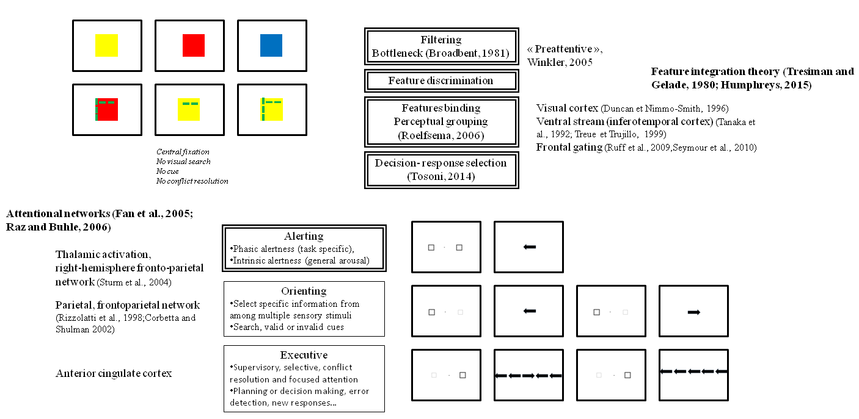

References
[1] Fan J, Posner M (2004) Human attentional networks. Psychiatr Prax 31 Suppl 2, S210–214.
[2] Stroop JR (1935) Studies of interference in serial verbal reactions. J Exp Psychol 18, 643–662.
[3] Hallett M (2008) The intrinsic and extrinsic aspects of freezing of gait. Mov Disord 23 Suppl 2, S439–443.
[4] Wright MJ, Burns RJ, Geffen GM, Geffen LB (1990) Covert orientation of visual attention in Parkinson’s disease: an impairment in the maintenance of attention. Neuropsychologia 28, 151–159.
[5] Moretti R, Torre P, Antonello RM, Esposito F, Bellini G (2011) The on-freezing phenomenon: cognitive and behavioral aspects. Parkinsons Dis 2011, 746303.
[6] Naismith SL, Shine JM, Lewis SJG (2010) The specific contributions of set-shifting to freezing of gait in Parkinson’s disease. Mov Disord 25, 1000–1004.
[7] Shine JM, Naismith SL, Palavra NC, Lewis SJG, Moore ST, Dilda V, Morris TR (2012) Attentional set-shifting deficits correlate with the severity of freezing of gait in Parkinson’s disease. Parkinsonism Relat Disord 19, 388-390.
[8] Vandenbossche J, Deroost N, Soetens E, Spildooren J, Vercruysse S, Nieuwboer A, Kerckhofs E (2011) Freezing of gait in Parkinson disease is associated with impaired conflict resolution. Neurorehabil Neural Repair 25, 765-773.
[9] Walton CC, Shine JM, Mowszowski L, Gilat M, Hall JM, O’Callaghan C, Naismith SL, Lewis SJG (2014) Impaired cognitive control in Parkinson’s disease patients with freezing of gait in response to cognitive load. J Neural Transm, doi: 10.1007/s00702-014-1271-6.
[10] Partiot A (1996) Delayed response tasks in basal ganglia lesions in man: Further evidence for a striato-frontal cooperation in behavioural adaptation. Neuropsychologia 34, 709–721.
[11] Broadbent DE (1981) Selective and control processes. Cognition 10, 53–58.
[12] Treisman AM, Gelade G (1980) A feature-integration theory of attention. Cogn Psychol 12, 97–136.
[13] Battaglia-Mayer A, Caminiti R, Lacquaniti F, Zago M (2003) Multiple levels of representation of reaching in the parieto-frontal network. Cereb Cortex 13, 1009–1022.
[14] Corbetta M, Akbudak E, Conturo TE, Snyder AZ, Ollinger JM, Drury HA, Linenweber MR, Petersen SE, Raichle ME, Van Essen DC, Shulman GL (1998) A common network of functional areas for attention and eye movements. Neuron 21, 761–773.
[15] Corbetta M, Shulman GL (2002) Control of goal-directed and stimulus-driven attention in the brain. Nat Rev Neurosci 3, 201–215.
[16] Tosoni A, Corbetta M, Calluso C, Committeri G, Pezzulo G, Romani GL, Galati G (2014) Decision and action planning signals in human posterior parietal cortex during delayed perceptual choices. Eur J Neurosci 39, 1370–1383.

