Supplementary Material
Supplemental Figure 1. Comparison of physical activity/HRV parameters between controls and patients with DMD

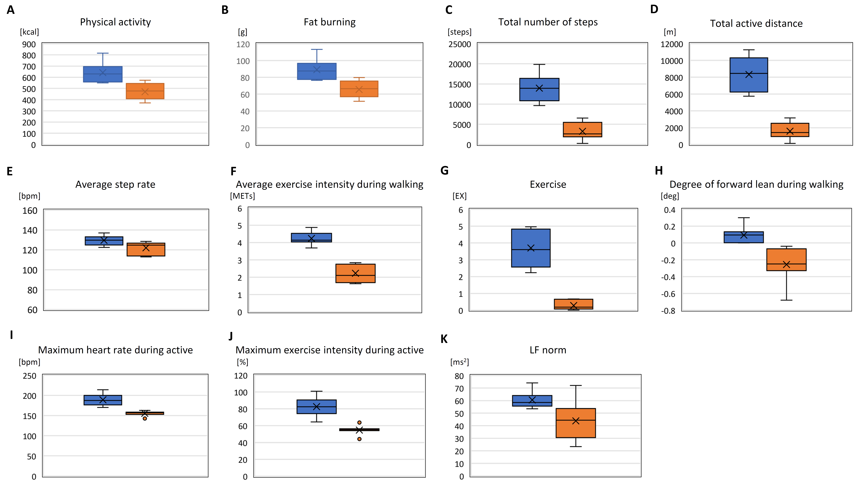

Physical activity and HRV parameters that showed significant differences between controls and patients with DMD are shown in box-and-whisker plots. (A) Physical activity; (B) Fat burning; (C) Total number of steps; (D) Total active distance; (E) Average step rate; (F) Average exercise intensity during walking; (G) Exercise; (H) Degree of forward lean during walking; (I) Maximum heart rate during active; (J) Maximum exercise intensity during active; (K) LF norm during arousal. Blue box, controls; Red box
, patients with DMD. Each statistical significance was shown in corresponding parameter in Table 3 or 4.

Supplemental Figure 2. Correlation between the timed motor function tests in patients with DMD and physical activity parameters

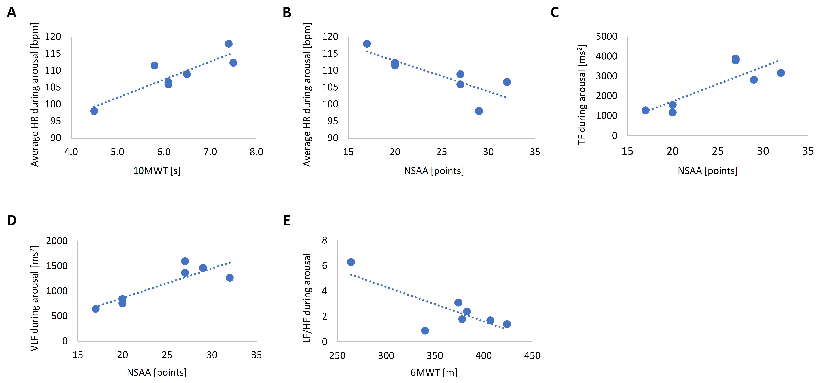

Correlation between the timed motor function tests (10MWT, NSAA, and 6MWT) and HRV parameters during arousal that showed significant differences in patients with DMD are shown in linear regression analysis. (A) Correlations between 10MWT and (A) Average heart rate, between NSAA and (B) Average heart rate, (C) TF, and (D) VLF. Correlations between 6MWT and (E) LF/HF. Each correlation coefficient and p value was shown in Table 7.
Supplemental Table 1. Correlation between physical activity parameters and timed motor function tests in patients with DMD
 | Time to stand from supine |  | 10MWT |  | NSAA |  | 6MWT
 | COR | p value | COR | p value | COR | p value | COR | p value
Basal metabolism | -0.308 | 0.501 | -0.011 | 0.982 | 0.654 | 0.111 | 0.448 | 0.314
Physical activity | 0.639 | 0.122 | 0.093 | 0.843 | -0.156 | 0.738 | 0.070 | 0.882
Fat burning | 0.640 | 0.122 | 0.093 | 0.843 | -0.157 | 0.737 | 0.068 | 0.884
Total energy consumption | -0.027 | 0.953 | 0.030 | 0.950 | 0.575 | 0.176 | 0.471 | 0.286
Total number of steps | -0.152 | 0.746 | 0.378 | 0.404 | -0.610 | 0.146 | -0.565 | 0.186
Total active distance | -0.164 | 0.725 | 0.363 | 0.424 | -0.576 | 0.176 | -0.603 | 0.152
Average step rate | 0.217 | 0.640 | 0.566 | 0.185 | -0.334 | 0.464 | -0.610 | 0.145
Average exercise intensity during walking (METs) | -0.506 | 0.246 | -0.053 | 0.911 | 0.332 | 0.468 | -0.399 | 0.375
Exercise | -0.478 | 0.278 | 0.032 | 0.947 | -0.067 | 0.887 | -0.467 | 0.290
Degree of forward lean when walking | -0.729 | 0.063 | -0.192 | 0.680 | 0.230 | 0.620 | 0.236 | 0.611
10MWT, 10-meter walk test; NSAA, North Star Ambulatory Assessment; 6MWT, 6-minute walk test; COR, correlation coefficient calculated by Pearson’s linear regression; ns, not significant

