Graphical abstract
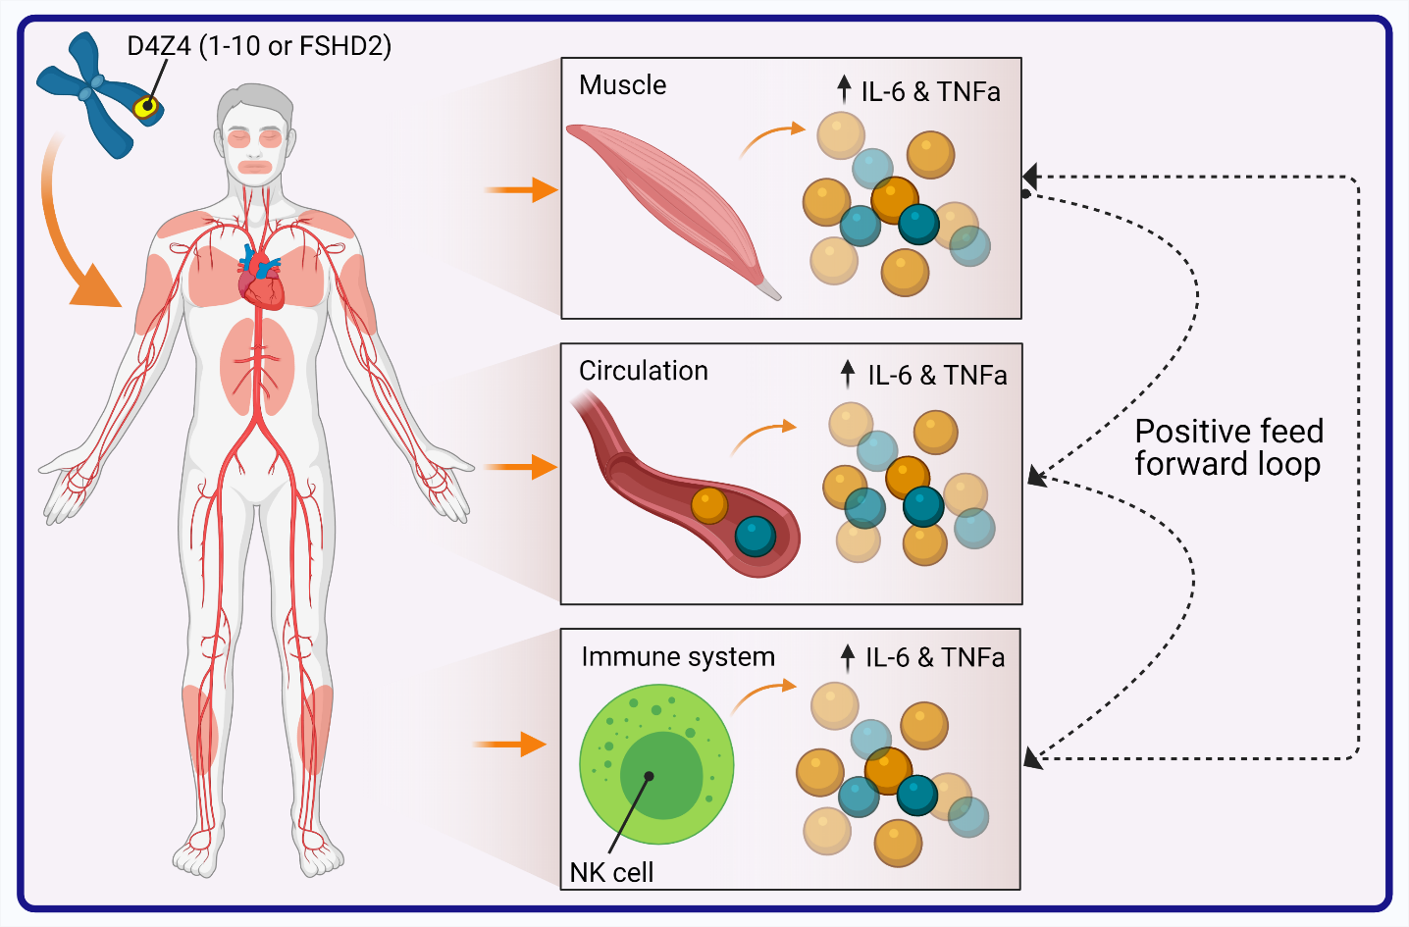

Supplementary Data
Supplemental Methods
MRI protocol and MRI guided muscle biopsies procedure
All MRI exams were conducted using a 3 Tesla MR system (MAGNETOM Prisma, Siemens, Erlangen, Germany). MRI screening exams consisted of transversal Dixon and Turbo Inversion Recovery Magnitude (TIRM) sequences made using a phased array bird cage coil around the upper and lower legs. Patients were positioned feet first supine in the scanner. First, 3-plane localizer images were acquired for positioning of subsequent scans. The following adjustments were made for the DIXON sequence: field of view (FOV) 435 mm, slice thickness 5 mm, gap 5 mm, repetition time (TR) 10 ms, time to echo (TE1 / TE2) 1,26 / 2,49 ms, number of slices per slab 72, flip angle (FA) 3 degree, base resolution 320. For the TIRM sequence, an inversion time of 240 ms was selected to suppress the fat signal and the following parameters were set: FOV 435 mm, slice thickness 5 mm, gap 10 mm, TR 4140 ms, TE 41 ms, number of slices per slab 28, FA 150 degree, base resolution 320. Prior to all MRI guided muscle biopsy procedures, the area of biopsy was selected based on the MRI screening information: presence of TIRM hyperintensity, degree of fatty infiltration, amount, and location of normal appearing muscle. Then, the estimated muscle biopsy site was marked on the skin with a fish oil marker. The marker was positioned on a reference line connecting the anterior superior iliac spine with the tibial tuberosity for the upper leg, and the tibial tuberosity with the lateral malleolus for the lower leg. Transversal 3D T1-weighted high resolution images (FOV 269 mm, slice thickness 1 mm, TR 759 ms, TE 2,61 ms, number of slices per slab 160, FA 13 degree, base resolution 384), TIRM (FOV 175 mm, slice thickness 4 mm, TR 4100 ms, TE 42 ms, number of slices per slab 23, FA 150 degree, base resolution 256), and DIXON images (FOV 500 mm, slice thickness 5 mm, TR 9,18 ms, TE1 / TE2 1,27 / 2,5 ms, number of slices per slab 52, FA 8 degree, base resolution 384), were made to confirm and determine the exact area of biopsy. An experienced intervention radiologist determined the needle trajectory and insertion site. The skin was cleaned with chlorhexidine in alcohol or other suitable disinfectant. The biopsy site was infiltrated with 5 ml of 2% lidocaine taking care to inject skin and subcutaneous tissue, but avoiding to inject the muscle itself. A 5 mm skin incision was made, and the skin layer penetrated with a scalpel blade. A coaxial needle containing a plastic introduction sheath and inner cutting stylet was introduced (ATEC, Hologic, Bedford, USA). After introduction, the inner needle was retracted and replaced by a blunt plastic obturator whereafter localizing images were obtained to confirm a correct needle position. I If needed, the trajectory of the needle guide was adjusted towards the desired target area. After adjustment, fast verification images were made in at least two planes. Once a satisfactory position was achieved, the biopsy was taken using a MR compatible 9 gauge vacuum-assisted needle (ATEC, Hologic, Bedford, USA) and a verification image with the plastic obturator in situ was obtained to confirm the biopsy site and evaluate possible complications. Finally, the sheath was removed and pressure was applied over the biopsy area to prevent bleeding. Steri-strips and a bandage were applied to close the incision site.

Supplemental Tables
Supplementary Table 1
Correlations of circulating IL-6 with age and BMI in the healthy control group
 |  | sIL-6
Age | r_{s} | -0.039
Gender | r_{s} | -0.009
BMI | r_{s} | 0.073
Correlations of IL-6 produced by LPS restimulated trained monocytes of HC with age and BMI
 |  | IL-6 (-) LPS | IL-6 (+) LPS
Age | r_{s} | 0.540* | 0.683**
Gender | r_{s} | 0.340 | 0.062
BMI | r_{s} | -0.339 | -0.329
Correlation of IL-6 produced by ex vivo stimulated NK Cells of HC with age and BMI
 |  | IL-6  LPS | IL-6  P3C | IL-6  Candida
Age | r_{s} | 0.281 | 0.331 | 0.228
Gender | r_{s} | 0.302 | 0.300 | 0.294
BMI | r_{s} | 0.641** | 0.662** | 0.599**
Correlations of IL-6 produced by ex vivo stimulated muscle samples of HC with age and BMI
 |  | IL-6  DMEM | IL-6  LPS | IL-6  P3C
Age | r_{s} | -0.108 | 0.707 | 0.156
Gender | r_{s} | -0.252 | -0.378 | -0.630
BMI | r_{s} | -0.347 | -0.048 | -0.096

Supplementary Table 2. Serum circulating inflammatory cytokines
Cytokine | Raw p-value (Mann-Whitney test) | Adjusted p-values after Bonferroni correction
IL-6 | < 0.0001 | 0.0004
TNF | 0.0174* | 0.0696
IL-1a | < 0.0001 | 0.0004
IL-1b | 0.9830 | 3.932
MCP-1 | < 0.0001 | 0.0002
VEGF-A | 0.0079 | 0.0158

Supplementary Table 3. Ex vivo β-glucan induction of trained immunity in monocytes and NK cells of patients with FSHD and sex and age matched healthy controls
IL-6 production from monocytes not trained with β-glucan
Condition tested | Raw p-value (Mann-Whitney test) | Adjusted p-values after Bonferroni correction
RPMI control vs RPMI patient | > 0.9999 | 1.9998
LPS control vs LPS patient | 0.3469 | 0.6938
IL-6 production from monocytes trained with β-glucan
Condition tested | Raw p-value (Mann-Whitney test) | Adjusted p-values after Bonferroni correction
RPMI control vs RPMI patient | > 0.9999 | 1.9998
LPS control vs LPS patient | 0.5125 | 1.025
TNF production from monocytes not trained with β-glucan
Condition tested | Raw p-value (Mann-Whitney test) | Adjusted p-values after Bonferroni correction
RPMI control vs RPMI patient | 0.1732 | 0.3464
LPS control vs LPS patient | 0.2496 | 0.4992
TNF production from monocytes trained with β-glucan
Condition tested | Raw p-value (Mann-Whitney test) | Adjusted p-values after Bonferroni correction
RPMI control vs RPMI patient | 0.2008 | 0.4016
LPS control vs LPS patient | 0.3657 | 0.7314
IL-6 production from NK not trained with β-glucan
Condition tested | Raw p-value (Mann-Whitney test) | Adjusted p-values after Bonferroni correction
RPMI control vs RPMI patient | > 0.9999 | 1.9998
LPS control vs LPS patient | 0.0437* | 0.0874
IL-6 production from NK trained with β-glucan
Condition tested | Raw p-value (Mann-Whitney test) | Adjusted p-values after Bonferroni correction
RPMI control vs RPMI patient | > 0.9999 | 1.9998
LPS control vs LPS patient | 0.0138* | 0.0276*
TNF production from NK not trained with β-glucan
Condition tested | Raw p-value (Mann-Whitney test) | Adjusted p-values after Bonferroni correction
RPMI control vs RPMI patient | > 0.9999 | 1.9998
LPS control vs LPS patient | 0.0180* | 0.036*
TNF production from NK trained with β-glucan
Condition tested | Raw p-value (Mann-Whitney test) | Adjusted p-values after Bonferroni correction
RPMI control vs RPMI patient | > 0.9999 | 1.9998
LPS control vs BG+LPS patient | 0.0139* | 0.0278*

Supplementary Table 4. NK cells 24 h ex vivo TLRs ligands stimulation
IL-6
Condition tested | Raw p-value (Mann-Whitney test) | Adjusted p-values after Bonferroni correction
RPMI control vs RPMI patient | > 0.9999 | 1.9998
LPS control vs LPS patient | 0.0151* | 0.03202*
P3C control vs P3C patient | 0.0138* | 0.0276*
Candida control vs Candida patient | 0.0049** | 0.0098*
TNF
Condition tested | Raw p-value (Mann-Whitney test) | Adjusted p-values after Bonferroni correction
RPMI control vs RPMI patient | 0.2867 | 0.5734
LPS control vs LPS patient | 0.0018** | 0.0036**
P3C control vs P3C patient | 0.3468 | 0.6936
Candida control vs Candida patient | 0.0023** | 0.0046**

Supplementary Table 5. Whole muscle ex vivo stimulation
IL-6 FSHD TIRM+ vs FSHD TIRM-
Condition tested | Raw p-value (Mann-Whitney test) | Adjusted p-values after Bonferroni correction
DMEM TIRM- vs DMEM TIRM+ | 0.0181* | 0.0362*
LPS TIRM- vs LPS TIRM+ | 0.0008*** | 0,0016**
P3C TIRM- vs P3C TIRM+ | 0.01308* | 0,02616*
TNF FSHD TIRM+ vs FSHD TIRM-
Condition tested | Raw p-value (Mann-Whitney test) | Adjusted p-values after Bonferroni correction
DMEM TIRM- vs DMEM TIRM+ | 0.8014 | 1.6028
LPS TIRM- vs LPS TIRM+ | 0.0051** | 0.0102*
P3C TIRM- vs P3C TIRM+ | 0.5764
IL-6 FSHD TIRM+ vs HC
DMEM control - vs DMEM patient | 0.2941 | 0.5882
LPS control vs LPS patient | 0.1839 | 0.3678
P3C control vs P3C patient | 0.0380* | 0.076
TNF FSHD TIRM+ vs HC
DMEM control - vs DMEM patient | 0.075 | 0.15
LPS control vs LPS patient | 0.0246* | 0.0492*
P3C control vs P3C patient | 0.1892 | 0.3784

Supplemental Figures

Supplementary Figure 1. Differences in circulating serum marker between FSHD MRI TIRM+ and FSHD MRI TIRM- patient sera
The concentrations (pg/ml) of circulating IL-6, TNF, IL-1α, and IL-1β were compared within the patient group between sera of patients with inflamed muscles (MRI TIRM+) and sera of patients with non-inflamed muscles (MRI TIRM-). (A) Mean ± SD of IL-6 measured in serum samples of 58 patients with MRI TIRM+ muscles and 62 patients with MRI TIRM- muscles. (B) Mean ± SD of TNF measured in serum samples of 58 patients with MRI TIRM+ muscles and 62 patients with MRI TIRM- muscles. (C) Mean ± SD of IL-1α measured in in serum samples of 58 patients with MRI TIRM+ muscles and 62 patients with MRI TIRM- muscles. (D) Mean ± SD of IL-1β measured in serum samples of 58 patients with MRI TIRM+ muscles and 62 patients with MRI TIRM- muscles. Groups were compared with the non-parametric Mann Whitney test. Differences were not significant.

Supplementary Figure 2. Gating strategy for whole blood flow cytometry analysis. First, single cells were identified by plotting the FS Time Of Flight (FS TOF) against FS. Then, the leukocyte population was gated on the CD45+ leucocytes. Granulocytes and lymphocytes were discriminated by forward and side scatter. Monocytes were characterized by CD14 expression. Within the monocytes, classical, non-classical, and intermediate monocytes were differentiated by CD14 and CD16 expression. Within the lymphocytes, NK cells (CD56+CD3-), NKT cells (CD56+CD3+), T Cells (CD3+CD56-), and B Cells (CD19+, HLA-DR+) were characterized. Finally, subpopulations within NK cells and T Cells were discriminated by CD16, CD8, CD4, and CD25 expression respectively. Percentages of cell subpopulations are indicated on each plot.

Supplementary Figure 3. Flow cytometry gating strategy for determination of purity of MACS-isolated NK Cells. MACS-isolated NK cells were fluorescently stained with CD45-KO52A-A, CD56-PC7-A and CD3-FITC-A antibodies and analyzed by flow cytometry. (A) Cell debris and dead cells were excluded from the analysis based on forward- and side scatter signals (FCS and SSC) and then gated on the lymphocyte population by staining with anti-CD45 K052-A. To define the NK cell population, the lymphocyte population CD45+ was gated on CD56+. Finally, the CD56+ cells population was gated on CD3+ in order to discriminate between NK cells (CD56+CD3-) and NKT cells (CD56+CD3+). Percentages of cell subpopulations are indicated on each plot.

Supplementary Figure 4. Flow cytometry gating strategy for NK cytotoxicity and degranulation assay. (A) K562 cells are initially gated based on forward- and side scatter signals (FCS and SSC). Dead K562 cells are gated in the subsequent dead cell stain plot by Ann V and PI expression respectively. (B) To identify degranulating NK cells, cells were first gated on the lymphocyte population by staining with anti-CD45 K052-A. NK cells were then discriminated by CD45 and CD3 expression respectively. Finally, NK cells CD56+ CD3- were gated on degranulation markers plots, CD107a+ and Granzyme B+ respectively. Percentages of cell subpopulations are indicated on each plot.

