Appendix tables and figures
Appendix Figure A.1: An illustration of example patient trajectories, and the impact of the observational period per patient

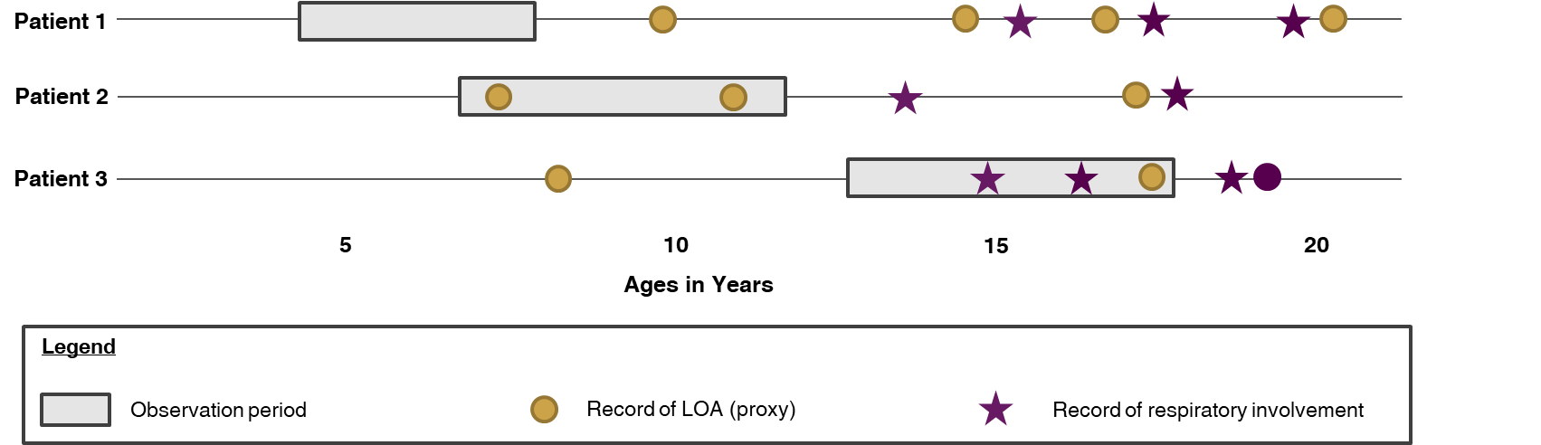 Example: Patient 1 does not have any observed outcomes before or during their observation period, but has events afterwards, indicating that the milestones captured in the data would accurately reflect the patient’s progression. Patient 2 has initial and subsequent documentation of LOA during their observation period, also indicating that the milestones captured in the data would accurately reflect the patient’s progression. Patient 3 has initial documentation of respiratory involvement as well as subsequent events of respiratory involvement and LOA during their observation period, but the initial documentation of LOA occurred before the observation period, indicating that the data would accurately capture the age at respiratory involvement, but overestimate the age at LOA.
Abbreviations: LOA = loss of ambulation
Appendix Figure A.2: Corticosteroid use by age at cohort entry
- Proportion of patients with any CS use

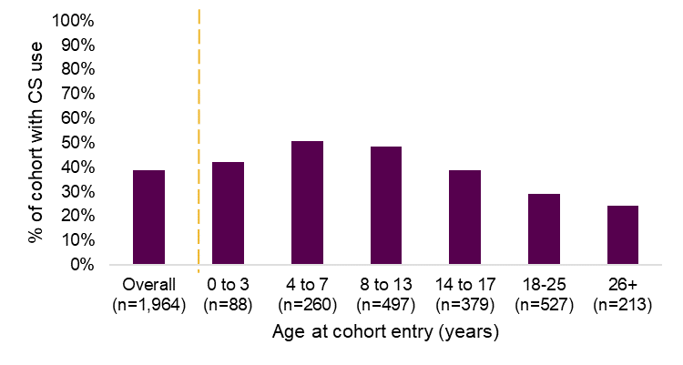
- Mean proportion of days covered by corticosteroid use, upon initiation
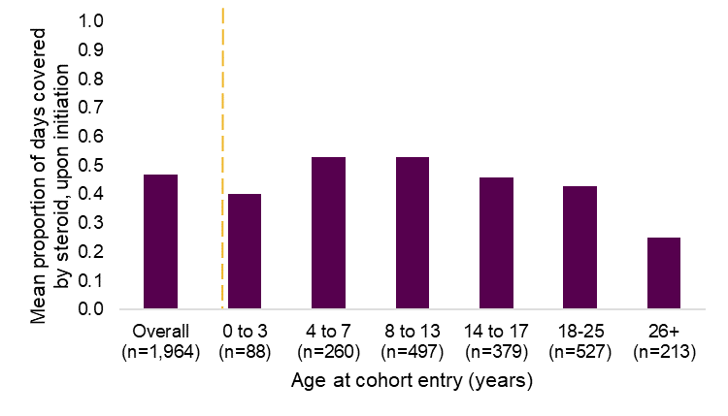

Appendix Table A.1: ICD-9-CM, ICD-10-CM, and HCPCS codes for exclusion criteria
Key clinical outcome | Code type | Codes
Assisted ventilation | ICD-9-CM | V46.11-V46.14  Procedure: 93.90, 96.70, 96.71, 96.72
 | ICD-10-CM | Z99.11, Z99.12, J95.850
 | ICD-10-PCS | 5A09357, 5A09358, 5A09359, 5A0935B, 5A0935Z, 5A09457, 5A09458, 5A09459, 5A0945B, 5A0945Z, 5A09557, 5A09558, 5A09559, 5A0955B, 5A0955Z, 5A19054, 5A1935Z, 5A1945Z, 5A1955Z
 | CPT | 94002-94005, 94656, 94657, 99504, 94660, 94662
 | HCPCS | A4611-A4613 (battery)  E0463, E0464 (volume control or negative pressure, stationary or portable)  E0465-E0466 (home, any type, used with non-invasive interface)  E0470-E0471 (respiratory assist device)
Tracheostomy* | ICD-9-CM | 519.00, 519.01, 519.02, 519.09, V440, V550  Procedure: 31.1, 31.21, 31.29, 31.74, 31.72, 31.73, 97.37, 96.55, 97.23
 | ICD-10-CM | Z93.0, Z43.0, J95.00, J95.01, J95.02, J95.03, J95.04, J95.09
 | ICD-10-PCS | 0B21XFZ, 0BP100Z, 0BP102Z, 0BP107Z, 0BP10CZ, 0BP10DZ, 0BP10FZ, 0BP10JZ, 0BP10KZ, 0BP1XFZ, 0B110F4, 0B110Z4, 0B113F4, 0B113Z4, 0B114F4, 0B114Z4
 | CPT | 31600, 31601, 31603, 31605, 31610, 31613, 31614, 31820, 31825, 31830
 | HCPCS | A4623, A4625, A4626, A4629, A7501-A7509, A7520, A7521, A7522, A7523- A7527, E0450, E0463, E0465, E0472, L8501, S8189
Leg/ankle and foot/toe surgery (used for exclusion criteria only) | CPT | 27870, 27871, 29891, 29892, 29894, 29895, 29897, 29898, 29899, 27613, 27614, 27615, 27616, 27618, 27619, 27620, 27625, 27626, 27630, 27632, 27634, 27635, 27637, 27638, 27640, 27641, 27645, 27646, 27647, 27750, 27756, 27758, 27759, 27760, 27766, 27769, 27780, 27784, 27786, 27792, 27808, 27814, 27816, 27822, 27823, 27824, 27826, 27827, 27828, 27829, 27832, 27846, 27848, 27600, 27601, 27602, 27603, 27604, 27605, 27606, 27607, 27610, 27612, 27648, 27752, 27762, 27781, 27788, 27810, 27818, 27825, 27830, 27831, 27840, 27842, 29581, 27650, 27652, 27654, 27656, 27658, 27659, 27664, 27665, 27675, 27676, 27680, 27681, 27685, 27686, 27687, 27690, 27691, 27692, 27695, 27696, 27698, 27700, 27702, 27703, 27704, 27705, 27707, 27709, 27712, 27715, 27720, 27722, 27724, 27725, 27726, 27727, 27730, 27732, 27734, 27740, 27742, 27745, 28705, 28715, 28725, 28730, 28735, 28737, 28740, 28750, 28755, 28760, 29904, 29905, 29906, 29907, 28039, 28041, 28043, 28045, 28046, 28047, 28050, 28052, 28054, 28060, 28062, 28070, 28072, 28080, 28086, 28088, 28090, 28092, 28100, 28102, 28103, 28104, 28106, 28107, 28108, 28110, 28111, 28112, 28113, 28114, 28116, 28118, 28119, 28120, 28122, 28124, 28126, 28130, 28140, 28150, 28153, 28160, 28171, 28173, 28175, 28400, 28406, 28415, 28420, 28430, 28436, 28445, 28450, 28456, 28465, 28470, 28476, 28485, 28490, 28496, 28505, 28510, 28525, 28530, 28531, 28546, 28555, 28576, 28585, 28606, 28615, 28636, 28645, 28666, 28675, 28001, 28002, 28003, 28005, 28008, 28010, 28011, 28020, 28022, 28024, 28035, 28055, 28405, 28435, 28455, 28475, 28495, 28515, 28540, 28545, 28570, 28575, 28600, 28605, 28630, 28635, 28660, 28665, 20696, 20697, 28200, 28202, 28208, 28210, 28220, 28222, 28225, 28226, 28230, 28232, 28234, 28238, 28240, 28250, 28260, 28261, 28262, 28264, 28270, 28272, 28280, 28285, 28286, 28288, 28290, 28292, 28293, 28294, 28296, 28297, 28298, 28299, 28300, 28302, 28304, 28305, 28306, 28307, 28308, 28309, 28310, 28312, 28313, 28315, 28320, 28322, 28340, 28341, 28344, 28345, 28360
Ankle foot orthosis | HCPCS | L1900, L1902, L1904, L1906, L1907, L1910, L1920, L1930, L1932, L1940, L1945, L1950, L1951, L1971
Manual wheelchairs | ICD-9-CM | V46.3, V53.8
 | ICD-10-CM | Z46.89, Z99.3
 | ICD-10-PCS | F01ZFEZ, F01ZFFZ, F01ZFUZ, F01ZFZZ, F07Z4DZ, F07Z4EZ, F07Z4FZ, F07Z4UZ, F07Z4YZ, F07Z4ZZ, F0FZ6EZ, F0FZ6FZ, F0FZ6UZ, F0FZ6ZZ
 | CPT | 97542
 | HCPCS | E1088, E1130, E1140, E1150, E1160, E1161, E1240, E1250, E1260, E1270, K0001-K0009, K0015, K0017- K0020, K0037-K0047, K0050-K0053, K0056, K0065, K0069-K0073, K0077, K0105, K0195, K0669, E1020, E1028- E1031, E1035-E1039, E1050, E1060, E1070, E1083-E1087, E1089, E1090, E1092, E1093, E1100, E1110, E1170, E1171, E1172, E1180, E1190, E1195, E1200, E1220-E1229, E1231-E1238, E1240, E1250, E1260, E1270, E1280, E1285, E1290, E1295-E1298, E0950, E0951, E0952, E0955- E0961, E0966-E0971, E0973, E0974, E0978, E0980-E0982, E0985, E0988, E0990, E0992, E0994, E0995, E1009, E1011, E1014, E1015, E1017, K0108, E2213, E2607, E2620, E2624
Power-assist wheelchair | HCPCS | E0986
Motorized wheelchairs | HCPCS | K0010-K0014, K0098, E0983, E0984, E1002-E1010, E1012, E1016, E1018, E1239, E2300, E2301, E2310-E2313, K0861, E2321-E2331, E2340-E2343, E2351, E2358-E2378, E2381-E2392, E2394-E2397, K0813-K0816, K0820-K0831, K0835-K0843, K0848-K0864, K0868-K0871, K0877-K0880, K0884-K0886, K0890, K0891, K0898, K0899
Abbreviations: CPT = Current Procedural Terminology; HCPCS=Healthcare Common Procedure Coding System; ICD-9-CM = International Classification of Diseases, Ninth Revision, Clinical Modification; ICD-10-CM = International Classification of Diseases, Tenth Revision, Clinical Modification; ICD-10-PCS = International Classification of Disease, 10th revision, Procedure Classification System; NDC = National Drug Code

Appendix Table A.1: ICD-9-CM, ICD-10-CM, and procedural codes to identify key clinical milestones and comorbidities of interest
Key clinical milestones | Contributing diagnoses/ milestones | Code type | Codes
Loss of ambulation | Manual wheelchairs | ICD-9-CM | V46.3, V53,8
 |  | ICD-10-CM | Z46.9, Z99.3
 |  | ICD-10-PCS | F01ZFEZ, F01ZFFZ, F01ZFUZ, F01ZFZZ, F07Z4DZ, F07Z4EZ, F07Z4FZ, F07Z4UZ, F07Z4YZ, F07Z4ZZ, F0FZ6EZ, F0FZ6FZ, F0FZ6UZ, F0FZ6ZZ
 |  | CPT | 97542
 |  | HCPCS | E1088, E1130, E1140, E1150, E1160, E1161, E1240, E1250, E1260, E1270, K0001-K0009, K0015, K0017- K0020, K0037-K0047, K0050-K0053, K0056, K0065, K0069-K0073, K0077, K0105, K0195, K0669, E1020, E1028- E1031, E1035-E1039, E1050, E1060, E1070, E1083-E1087, E1089, E1090, E1092, E1093, E1100, E1110, E1170, E1171, E1172, E1180, E1190, E1195, E1200, E1220-E1229, E1231-E1238, E1240, E1250, E1260, E1270, E1280, E1285, E1290, E1295-E1298, E0950, E0951, E0952, E0955- E0961, E0966-E0971, E0973, E0974, E0978, E0980-E0982, E0985, E0988, E0990, E0992, E0994, E0995, E1009, E1011, E1014, E1015, E1017, K0108, E2213, E2607, E2620, E2624
 | Power-assist wheelchair | HCPCS | E0986
 | Scooter | HCPCS | E1230, K0800, K0801, K0802, K0806, K0807, K0808, K0812
 | Motorized wheelchairs | HCPCS | K0010-K0014, K0098, E0983, E0984, E1002-E1010, E1012, E1016, E1018, E1239, E2300, E2301, E2310-E2313, K0861, E2321-E2331, E2340-E2343, E2351, E2358-E2378, E2381-E2392, E2394-E2397, K0813-K0816, K0820-K0831, K0835-K0843, K0848-K0864, K0868-K0871, K0877-K0880, K0884-K0886, K0890, K0891, K0898, K0899
Scoliosis | Scoliosis/spinal surgery* | ICD-9-CM | 737.3x, 737.4, V54.9, V53.7  Procedure: 81.62, 81.6, 81.6, 84.5, 84.5
 |  | ICD-10-CM | M41.x, Z47.8
 |  | ICD-10-PCS | 0RGxxx, 0SGxxx
 |  | CPT* | 22800, 22802, 22804, 22806, 22808, 22810, 22812
 |  | HCPCS | E0744, L1000-L1499
Respiratory involvement | Respiratory failure | ICD-9-CM | 518.8, 518.8, 518.8
 |  | ICD-10-CM | J96
 | Pulmonary management | HCPCS | A7034, A7035, A7037, A7038
 | Tracheostomy* | ICD-9-CM | 519.0, 519.0, 519.0, 519.1, V440, V550  Procedure: 31.1, 31.21, 31.3, 31.74, 31.7, 31.7, 97.4, 96.6, 97.2
 |  | ICD-10-CM | Z93.0, Z43.0, J95.0, J95.0, J95.0, J95.0, J95.0, J95.1
 |  | ICD-10-PCS | 0B21XFZ, 0BP100Z, 0BP102Z, 0BP107Z, 0BP10CZ, 0BP10DZ, 0BP10FZ, 0BP10JZ, 0BP10KZ, 0BP1XFZ, 0B110F4, 0B110Z4, 0B113F4, 0B113Z4, 0B114F4, 0B114Z4
 |  | CPT | 31600, 31601, 31603, 31605, 31610, 31613, 31614, 31820, 31825, 31830
 |  | HCPCS | A4623, A4625, A4626, A4629, A7501-A7509, A7520, A7521, A7522, A7523- A7527, E0450, E0463, E0465, E0472, L8501, S8189
 | Assisted ventilation | ICD-9-CM | V46.11-V46.1  Procedure: 93.9, 96.7, 96.7, 96.7
 |  | ICD-10-CM | Z99.11, Z99.12, J95.90
 |  | ICD-10-PCS | 5A09357, 5A09358, 5A09359, 5A0935B, 5A0935Z, 5A09457, 5A09458, 5A09459, 5A0945B, 5A0945Z, 5A09557, 5A09558, 5A09559, 5A0955B, 5A0955Z, 5A19054, 5A1935Z, 5A1945Z, 5A1955Z
 |  | CPT | 94002-94005, 94656, 94657, 99504, 94660, 94662
 |  | HCPCS | A4611-A4613 (battery)  E0463, E0464 (volume control or negative pressure, stationary or portable)  E0465-E0466 (home, any type, used with non-invasive interface)  E0470-E0471 (respiratory assist device)
Cardiomyopathy | Cardiomyopathy | ICD-9-CM | 425.x
 |  | ICD-10-CM | I42.x
 |  | NDC | ACE inhibitors, ARBs, beta blockers, diuretics (spironolactone or eplerenone)
 | Heart failure | ICD-9-CM | 428.x
 |  | ICD-10-CM | I50
Neurologic/neuropsychiatric involvement | Behavioral disorders | ICD-9-CM | 312
 |  | ICD-10-CM | F63, F91
 | Learning disabilities | ICD-9-CM | 315, 317-319
 |  | ICD-10-CM | R48, F81, F70-F79
 | Neuropsychologist testing | CPT | 96105, 96125, 96110, 96112, 96113, 96127, 96116, 96118, 96119, 96121, 96130-96133, 96136-96139, 96146
 | Hyperkinetic syndrome of childhood (incl. ADHD) | ICD-9-CM | 314.0x
 |  | ICD-10-CM | F90
 | Pervasive development disorder | ICD-9-CM | 299
 |  | ICD-10-CM | F84
Comorbidities
Anxiety, dissociative or somatoform |  | ICD-9-CM | 300.0 or 300.3
 |  | ICD-10-CM | F41 or F42
Respiratory infectious diseases |  | ICD-9-CM | 46x, 48x
 |  | ICD-10-CM | J0x, J1x, J2x
Depression |  | ICD-9-CM | 296.2, 296.3, 311.x
 |  | ICD-10-CM | F32, F33
Epilepsy |  | ICD-9-CM | 345
 |  | ICD-10-CM | G40
Asthma |  | ICD-9-CM | 493
 |  | ICD-10-CM | J45
Osteoporosis |  | ICD-9-CM | 733.0
 |  | ICD-10-CM | M80, M81
 |  | NDCs | All NDCs for bisphosphonates
Fracture |  | ICD-9-CM | 733.1, 733.9-733.98, 800-829, E887
 |  | ICD-10-CM | M84.4, M84.3, S02, S12, S22, S32, S42, S52, S62, S72, S82, S92
Type 2 diabetes mellitus |  | ICD-9-CM | 250.x0, 250.x2
 |  | ICD-10-CM | E11.x
Cystic fibrosis |  | ICD-9-CM | 277.0x
 |  | ICD-10-CM | E84.x
Note: As records of clinical milestones were not always available in the databases, proxy milestones were used where necessary (e.g. using wheelchair codes to identify likely loss of ambulation).[44]
Abbreviations: CPT = Current Procedural Terminology; HCPCS=Healthcare Common Procedure Coding System; ICD-9-CM = International Classification of Diseases, Ninth Revision, Clinical Modification; ICD-10-CM = International Classification of Diseases, Tenth Revision, Clinical Modification; ICD-10-PCS = International Classification of Disease, 10th revision, Procedure Classification System; NDC = National Drug Code.

Appendix Table A.3: Comparing outcomes between the DMD cohort definitions used in the primary analysis and sensitivity analyses
 | Primary analysis cohort  (n=1,964) | Sensitivity analyses cohorts varying DMD cohort definitions
 |  | <18 years old at index  (n=1,224) | ≥1 diagnosis from a specialist  (n=1,721) | Excluding those with other conditions*  (n=1,867)
Median (IQR) duration of follow-up (years) per person | 1.9 (1.0 to 3.6) | 2 (1.0 to 3.6) | 2.1 (1.1 to 3.7) | 1.9 (1.0 to 3.6)
Age at index, median (IQR) | 15 (9 to 21) | 11 (7 to 14) | 15 (9 to 20) | 15 (9 to 21)
Treatment over the period
% ever- treated with CS | 762 (38.8%) | 557 (45.5%) | 713 (41.4%) | 731 (39.2%)
Median (IQR) Elixhauser | 1 (0 to 3) | 1 (0 to 3) | 2 (0 to 3) | 1 (0 to 3)
Record of key clinical milestones, n(%)
LOA/need for a wheelchair | 888 (45.2%) | 539 (44.0%) | 791 (46.0%) | 821 (44.0%)
Onset of respiratory involvement | 672 (34.2%) | 300 (24.5%) | 592 (34.4%) | 615 (32.9%)
Onset of cardiomyopathy | 893 (45.5%) | 496 (40.5%) | 831 (48.3%) | 852 (45.6%)
Diagnosis of scoliosis | 580 (29.5%) | 403 (32.9%) | 520 (30.2%) | 525 (28.1%)
Neurologic/neuropsychiatric involvement | 525 (26.7%) | 440 (35.9%) | 480 (27.9%) | 495 (26.5%)
Median (IQR) age at record of key clinical milestones
LOA/need for a wheelchair | 16 (12 to 22) | 13 (10 to 16) | 16 (12 to 21) | 16 (12 to 22)
Onset of respiratory involvement | 19 (15 to 24) | 14 (11 to 16) | 19 (15 to 23) | 19 (15 to 24)
Onset of cardiomyopathy | 17 (13 to 22) | 13 (10 to 16) | 17 (13 to 21.5) | 17 (13 to 22)
Diagnosis of scoliosis | 16 (12 to 20) | 14 (11 to 16) | 16 (12 to 20) | 16 (12 to 20)
Neurologic/neuropsychiatric involvement | 11 (8 to 16) | 10 (7 to 14) | 11 (8 to 16) | 11 (8 to 16)
* ≥2 claims for any of the following: myoneural disorder (358.x or G70.x), Guillain-Barre syndrome (357.0 or G61.0), or hereditary motor and sensory neuropathy (356.2 or G60.0)
Abbreviations: IQR = interquartile range, LOA = loss of ambulation

