SUPPLEMENTARY INFORMATION

Dowling JJ, et al. INCEPTUS Natural History, Run-in Study for Gene Replacement Clinical Trial in X-Linked Myotubular Myopathy

Contents
Supplementary Methods 28
Supplementary Table 1. INCEPTUS Study Sites and Investigators 29
Supplementary Table 2. Participant Genotypes in the INCEPTUS Study. 31
Supplementary Table 3. Respiratory Serious Adverse Events Reported in the INCEPTUS Study. 33
Supplementary Table 4. Ventilator Dependence from Baseline to End of Study in the INCEPTUS study by Type of Ventilator Support and Mutation Classification 34
Supplementary Figure 1. Individual Participant Time in the INCEPTUS study. 35
Supplementary Figure 2. Post-mortem muscle pathology results in the three deceased INCEPTUS participants. 36
Supplementary Figure 3. Mean (SD) CHOP INTEND Individual Item Scores. 37
Supplementary Figure 4. Parental Global Impression of Secretion Severity (PGIS-S) over time for individual participants by mutation type. 38
Supplementary Figure 5. Caregiver Experiences and Health-related Quality of Life over time for individual participants by mutation type. 39
Plain Language Summary 40

Supplementary Methods

ACEND¹
The Assessment of Caregiver Experience with Neuromuscular Disease (ACEND) questionnaire (ACEND) comprises two domains with seven subdomains, each reported on a scale from 0 to 100.1 Domain 1 examines physical impact in four subdomains: feeding/grooming/dressing (6 items), sitting/play (5 items), transfers (5 items), and mobility (7 items); Domain 2 examines general caregiver impact, included 3 subdomains: time (4 items), emotion (9 items), and finance (5 items).

PedsQL-NM^{2,3}
The Pediatric Quality of Life Inventory Neuromuscular Module (PedsQL-NM) is a 25-item questionnaire encompassing three scales: (1) About My/My Child’s Neuromuscular Disease (17 items related to the disease process and associated symptomatology), (2) Communication (3 items related to the patient’s ability to communicate with health care providers and others about his/ her illness), and (3) About Our Family Resources (5 items related to family financial and social support systems). Items are linearly transformed to a 0 to 100 scale (0=100, 1=75, 2=50, 3=25, and 4=0) so that higher scores indicate better health-related quality of life. PedsQL-NM is validated in patients with spinal muscular atrophy and Duchenne muscular dystrophy.

PGIS-S⁴
The Parental Global Impression of Secretion Severity (PGIS-S) is a global index used to rate severity on a Likert scale of 1 (not affected) to 7 ("worst he's ever been") in response to the question: “Taking into consideration the experience and understanding you have of your child, in terms of secretion management (i.e., volume and thickness of secretions, and how often you need to suction your child), how affected has your child been over the past 7 days?” Scale: 1 – not affected, 2 – borderline affected , 3 – mildly affected, 4 – moderately affected, 5 – markedly affected, 6 – severely affected, 7 – among the worst he has ever been.

References:
- Matsumoto H, Clayton-Krasinski DA, Klinge SA, et al. Development and initial validation of the assessment of caregiver experience with neuromuscular disease. J Pediatr Orthop. Apr-May 2011;31(3):284-292.
- Iannaccone ST, Hynan LS, Morton A, et al. The PedsQL in pediatric patients with Spinal Muscular Atrophy: feasibility, reliability, and validity of the Pediatric Quality of Life Inventory Generic Core Scales and Neuromuscular Module. Neuromuscul Disord. Dec 2009;19(12):805-812.
- Davis SE, Hynan LS, Limbers CA, et al. The PedsQL in pediatric patients with Duchenne muscular dystrophy: feasibility, reliability, and validity of the Pediatric Quality of Life Inventory Neuromuscular Module and Generic Core Scales. J Clin Neuromuscul Dis. Mar 2010;11(3):97-109.
- Guy W (ed). ECDEU Assessment Manual for Psychopharmacology. Rockville, MD: US Department of Health, Education, and Welfare Public Health Service Alcohol, Drug Abuse, and Mental Health Administration, 1976

Supplementary Table 1. INCEPTUS Study Sites and Investigators

Sites | Investigators and Study Staff
UCLA Medical Center, Los Angeles, CA | Perry Shieh, MD, PhD Principal Investigator  Francy Shu, MD, Sub-Investigator  Ummulwara R. Qasim, Study Coordinator  Loretta Staudt, Physiotherapist  Oscar Marquez, Respiratory Therapist
Ann & Robert H. Lurie Children’s Hospital of Chicago, IL | Nancy Kuntz, MD, Principal Investigator  Vamshi Rao MD, Sub-Investigator  Hannah Munson, Study Coordinator  Duncan Schulte, Study Coordinator  Laura Brown, Physiotherapist  Christa Weigel, Physiotherapist  Katie Hoffman, Physiotherapist  Carlos Rodriguez, Respiratory Therapist
Powell Center for Rare Disease Research, University of Florida, Gainesville, FL | Barbara Smith, MD, Principal Investigator  Barry J. Byrne, MD, PhD, Sub-Investigator  Lee Kugelmann, Study Coordinator  Cristina Liberati, MD, Site Coordinator  Jennifer Wood, Physiotherapist  Jenna Lammers, Physiotherapist
Neuromuscular and Neurogenetic Disorders of Childhood Section, NINDS, Bethesda, MD | Carsten G. Bönnemann, MD, Principal Investigator  A. Reghan Foley, MD, Associate Investigator  Sarah Neuhaus MD, Sub Investigator  Christine Jones, RN, Research Nurse  Christopher Mendoza, Study Coordinator  Minal Jain, Physiotherapist  Melissa Waite, Physiotherapist  Mark Barton, Respiratory Therapist  Renee Granrud, Respiratory Therapist
The Hospital for Sick Children, Toronto, ON, Canada | James Dowling, MD, PhD, Principal Investigator  Etsuko Tsuchiya, PhD, Study Coordinator  Hernan Gonorazky, MD, Sub-Investigator  Reshma Amin, MD, Sub-Investigator  Blythe Dalziel, Physiotherapist  Renee Haldenby, Physiotherapist  Stephanie So, Physiotherapist  Faiza Syed, Respiratory Therapist  Nadia Snow, Respiratory Therapist
Great Ormond Street Hospital, London, United Kingdom | Prof. Dr. Francesco Muntoni, Principal Investigator  Dr. Federica Trucco, Sub-Investigator  Hinal Patel, Study Coordinator  Amy Wolfe, Physiotherapist  Catherine Rye, Physiotherapist  Marion Main, Physiotherapist  Mario Iodice, Physiotherapist  Evelin Milev, Physiotherapist  Lisa Edel, Respiratory Therapist
I-Motion, Armand Trousseau Hospital, Paris, France | Andreea Seferian MD, Principal Investigator  Virginie Che, Study Coordinator  Arnaud Jollet, Study Coordinator  Alison Grange, Physiotherapist  Charlotte Lilien, Physiotherapist
Klinikum der Universität München (LMU), Munich, Germany | Prof. Dr. Wolfgang Müller-Felber, Principal Investigator  Dr. Astrid Blaschek, Sub-Investigator  Christiane Eder, Study Coordinator  Birgit Warken-Madelung, Physiotherapist  Therese Well, Physiotherapist

Supplementary Table 2. Participant Genotypes in the INCEPTUS Study.

Patient number | Genomic location (hg19) | cDNA change (NM_000252.3) | Predicted protein change (NP_000243.1) | Molecular consequence | Mutation impact | ClinVar Variation ID | dbSNP ID | Exon
01 | chr23:149783173G>A | c.342+1G>A | p.? | Splicing | IFED | 435903 | rs1557413092 | 5
02 | chr23:149818270dupA | c.949dupA | p.(Met317Asnfs*15) | Frameshift | LOF | 211538 | rs797045722 | 10
03 | chr23:149831975_149832002delinsAACTGGA | c.1537_1564delinsAACTGGA | p.(Phe513_Leu522delinsAsnTrpIle) | Indel | PLOF | 92674 | rs398123271 | 14
04 | chr23:(?_149737047)_(149767150_?)del | c.(?_-76)_(231+1_232-1)del | p.(0) | Deletion exons 1-4 | LOF | n/a | n/a | 1-4
05 | chr23:149826349C>G | c.1109C>G | p.(Ser370*) | Nonsense | LOF | n/a | n/a | 11
06 | chr23:149828138G>A | c.1262G>A | p.(Arg421Gln) | Missense | PLOF | 158914 | rs587783772 | 12
07 | chr23:149814198C>T | c.721C>T | p.(Arg241Cys) | Missense | PLOF | 11059 | rs132630305 | 9
08 | chr23:149783046T>G | c.232-16T>G | p.(Asp78_Lys114del) | Splicing | IFED | n/a | n/a | 5
09 | chr23:(?_149737047)_(149841616_?)del | c.(?_-76)_(*1548_?)del | p.(0) | Gene deletion | LOF | n/a | n/a | 1-15
10 | chr23:149831943T>A | c.1505T>A | p.(Ile502Lys) | Missense | PLOF | 435904 | rs1557414802 | 14
11 | chr23:149831943T>A | c.1505T>A | p.(Ile502Lys) | Missense | PLOF | 435904 | rs1557414802 | 14
12 | chr23:149828138G>A | c.1262G>A | p.(Arg421Gln) | Missense | PLOF | 158914 | rs587783772 | 12
13 | chr23:149764968C>T | c.70C>T | p.(Arg24*) | Nonsense | LOF | 92678 | rs398123275 | 3
14 | chr23:149818236_149818236delA | c.915delA | p.(Glu305Aspfs*5) | Frameshift | LOF | n/a | n/a | 10
15 | chr23:149832049C>G | c.1611C>G | p.(Tyr537*) | Nonsense | LOF | 280453 | n/a | 14
16 | chr23:149831928C>A | c.1490C>A | p.(Ser497Tyr) | Missense | PLOF | 158945 | rs587783800 | 14
17 | chr23:149831996C>T | c.1558C>T | p.(Arg520*) | Nonsense | LOF | 158950 | rs587783805 | 14
18 | chr23:149826468G>T | c.1228G>T | p.(Glu410*) | Nonsense | LOF | n/a | n/a | 11
19 | chr23:149828138G>T | c.1262G>T | p.(Arg421Leu) | Missense | PLOF | 599006 | rs587783772 | 12
20 | chr23:(?_149807416)_(149809891_?)del | c.(444+1_445-1)_(678+1_679-1)del | p.(Pro149_Pro226del) | Deletion exons 7-8 | IFED | n/a | n/a | 7-8
21 | chr23:149767116C>T | c.197C>T | p.(Thr66lle) | Missense | PLOF | n/a | n/a | 4
22 | chr23:149765007C>T | c.109C>T | p.(Arg37*) | Nonsense | LOF | 158895 | rs587783753 | 3
23 | chr23:149826418dupT | c.1178dupT | p.(Leu393Phefs*3) | Frameshift | LOF | 435902 | rs1557414513 | 11
24 | chr23:149765007C>T | c.109C>T | p.(Arg37*) | Nonsense | LOF | 158895 | rs587783753 | 3
25 | chr23:149826468G>C | c.1228G>C | p.(Glu410Gln) | Missense | PLOF | n/a | n/a | 11
26 | chr23:(?_149826294)_(149826500_?)del | c.(1053+1_1054-1)_(1260+1_1261-1)del | p.(Leu352_Ser420del) | Deletion exon 11 | IFED | n/a | n/a | 11
27 | chr23:149764968C>T | c.70C>T | p.(Arg24*) | Nonsense | LOF | 92678 | rs398123275 | 3
28 | chr23:149767060-149767063delAGAA | c.141_144delAGAA | p.(Glu48Leufs*24) | Frameshift | LOF | 11057 | rs587783791 | 4
29 | chr23:149814165T>C | c.688T>C | p.(Trp230Arg) | Missense | PLOF | 92677 | rs398123274 | 9
30 | chr23:149828127A>G | c.1261-10A>G | p.Ser420_Arg421insPheIleGln | Splicing | PLOF | 11058 | rs397518445 | 11
31 | chr23:(?_149807406-149807509_?)del | c.(444+1_445-1)_(528+1_529-1)del | p.(Pro149_Gln176del) | Deletion exon 7 | IFED | n/a | n/a | 7
32 | chr23:149828946C>T | c.1456C>T | p.(Arg486*) | Nonsense | LOF | 158938 | rs587783795 | 13
33 | chr23:149814291delT | c.814delT | p.(Ser272Leufs*12) | Frameshift | LOF | 817134 | rs1603192748 | 9
35 | chr23:149814234C>T | c.757C>T | p.(Arg253*) | Nonsense | LOF | 159001 | rs587783854 | 9
IFED: in-frame exon deletions, defined as splice site variants and whole exon deletions predicted to result in in-frame loss of one or more internal exons. LOF: loss of function, defined as predicted nonsense variants and any frame-shifting variants or deletions. PLOF: partial loss of function variants, defined as all missense and small in-frame indel variants.

Supplementary Table 3. Respiratory Serious Adverse Events Reported in the INCEPTUS Study.

Characteristic | INCEPTUS Participants  (N=34)  n (%)
Number of Participants Reporting at Least One Event | 18 (52.9%)
Total Number of Events | 52
Infections and infestations | 17 (50.0%)
Pneumonia | 6 (17.6%)
Rhinovirus infection | 4 (11.8%)
Lower respiratory tract infection | 3 (8.8%)
Respiratory tract infection viral | 3 (8.8%)
Bacterial tracheitis | 2 (5.9%)
Adenovirus infection | 1 (2.9%)
Coronavirus infection | 1 (2.9%)
Lower respiratory tract infection viral | 1 (2.9%)
Parainfluenzae virus infection | 1 (2.9%)
Pneumonia moraxella | 1 (2.9%)
Pneumonia streptococcal | 1 (2.9%)
Pneumonia viral | 1 (2.9%)
Respiratory syncytial virus infection | 1 (2.9%)
Investigations | 2 (5.9%)
Human rhinovirus test positive | 1 (2.9%)
Pseudomonas test positive | 1 (2.9%)
Respiratory syncytial virus test positive | 1 (2.9%)
Respiratory, thoracic and mediastinal disorders | 8 (23.5%)
Respiratory distress | 4 (11.8%)
Bronchial secretion retention | 2 (5.9%)
Pneumonia aspiration | 2 (5.9%)
Acute respiratory distress syndrome | 1 (2.9%)
Atelectasis | 1 (2.9%)
Participants could have more than one event.

Supplementary Table 4. Ventilator Dependence from Baseline to End of Study in the INCEPTUS study by Type of Ventilator Support and Mutation Classification

 | Nonsense Mutation |  | Missense Mutation |  | In-frame Exonic Deletion
Ventilator Dependence (h) | Non-invasive | Invasive | Non-invasive | Invasive | Invasive
Baseline (n) | 5 | 12 | 2 | 10 | 5
Mean (SD) | 15.4 (5.3) | 23.3 (1.7) | 13.8 (2.5) | 23.6 (0.9) | 21.4 (3.7)
End of Study (n) | 3 | 9 | 2 | 9 | 4
Mean (SD) | 12.3 (1.5) | 24.0 (0.1) | 14.0 (2.8) | 23.6 (0.6) | 23.5 (1.0)

Supplementary Figure 1. Individual Participant Time in the INCEPTUS study.
Each bar represents enrollment and follow-up for a single participant. The start of the bar represents the participant’s age at INCEPTUS enrollment and the length represents follow-up time. Red arrows represent participant deaths during INCEPTUS (Study Participants 04, 14, 15). Green arrows represent the point at which participants transitioned to the ASPIRO study.

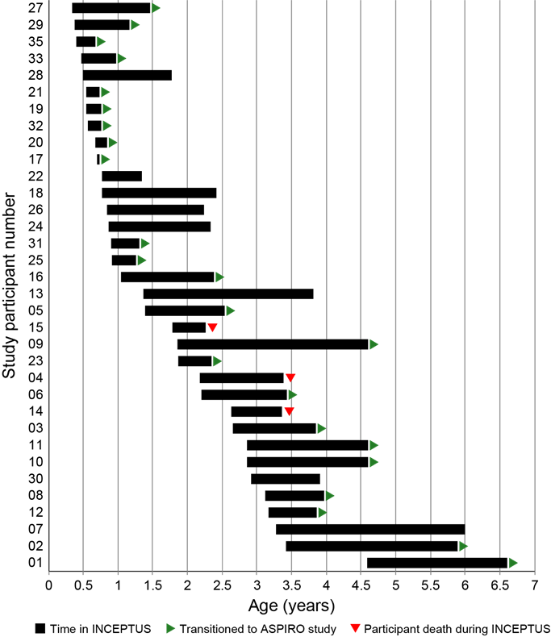

Supplementary Figure 2. Post-mortem muscle pathology results in the three deceased INCEPTUS participants.

- 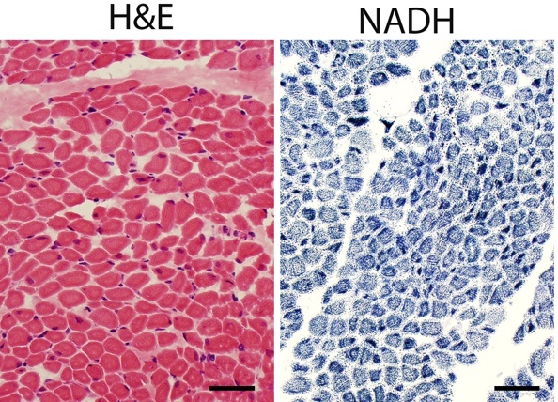
(A) Patient 15: Left thigh muscle. Essentially all fibers were small. Central nucleation in 11.42% of fibers. Organelle mislocalization in 30-50% of fibers. Average minferet diameter 11.5 μm, largest 30.82 μm. Overall >80% of fibers were small. Bar = 40 μm.

- 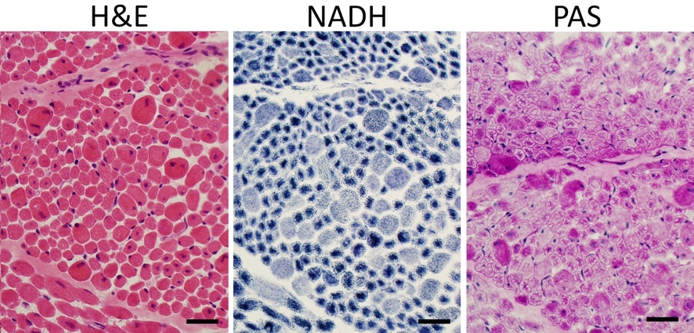
(B) Patient 14. Triceps brachii. Myofiber smalless in a marked majority of fibers sampled. Average minferet diameter 12.41μm, maximum 57.60 μm. Percentage of internally nucleated fibers was 29.33%. Marked slow fiber predominance (>90%, although 30% of fibers overall positive for fast myosin). Overall >80% of fibers were small. Bar = 40 μm.

- 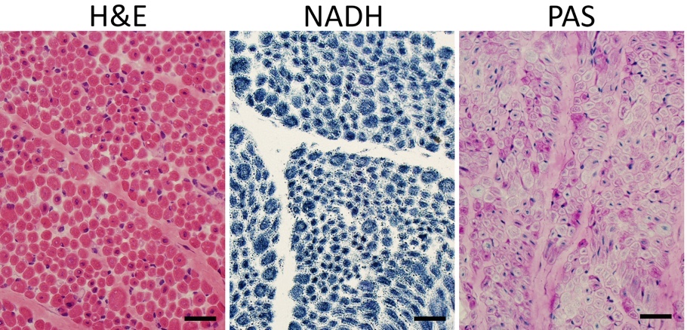
(C) Patient 04. Rectus femoris. Myofiber smallness in a marked majority of fibers sampled. Average minferet diameter 10.73 μm, maximum 32.94 μm. Percentage of internally nucleated fibers was 22.07%. Marked slow fiber performance (>95%, although 20% of fibers overall positive for fast myosin). Overall, nearly 100% of fibers were small. Bar = 40 μm.

H&E, hematoxylin and eosin; NADH, nicotinamide adenine dinucleotide; PAS, periodic acid-Schiff.

Supplementary Figure 3. Mean (SD) CHOP INTEND Individual Item Scores.

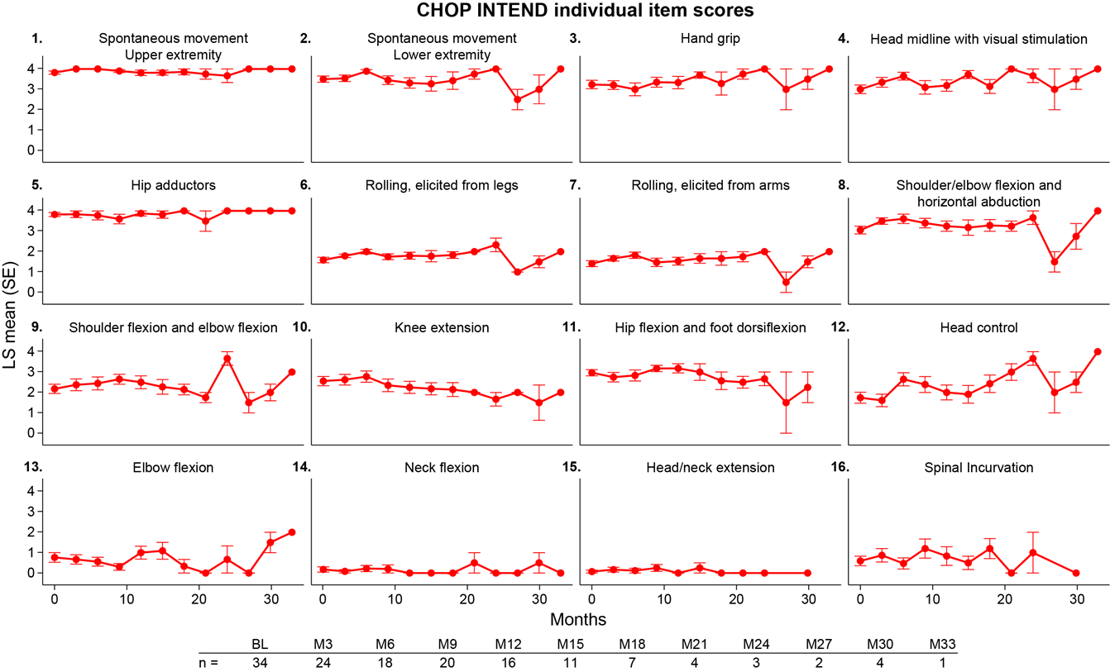

Supplementary Figure 4. Parental Global Impression of Secretion Severity (PGIS-S) over time for individual participants by mutation type.
Seven-point Likert scale in response to the question: “Taking into consideration the experience and understanding you have of your child, in terms of secretion management (i.e., volume and thickness of secretions, and how often you need to suction your child), how affected has your child been over the past 7 days?” Scale: 1 – not affected, 2 – borderline affected , 3 – mildly affected, 4 – moderately affected, 5 – markedly affected, 6 – severely affected, 7 – among the worst he has ever been. The thick red line represents LS means and standard errors from a mixed-effect model with fixed effect of time.

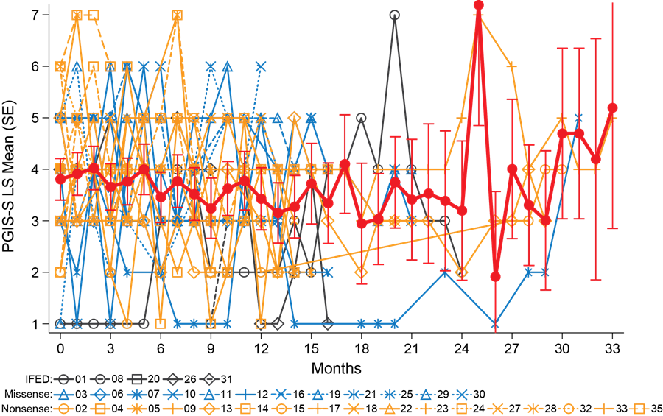

Supplementary Figure 5. Caregiver Experiences and Health-related Quality of Life over time for individual participants by mutation type.
(A) ACEND total scores rated by caregivers (N=34) standardized to a scale of 0% (full caregiver support required) to 100% (no support required. (B) PedsQL-NM total scores. Scale from 0 (lowest QoL) to 100 (optimal QoL). The thick red lines represent LS means and standard errors from a mixed-effect model with fixed effect of time. IFED: in-frame exonic deletion.
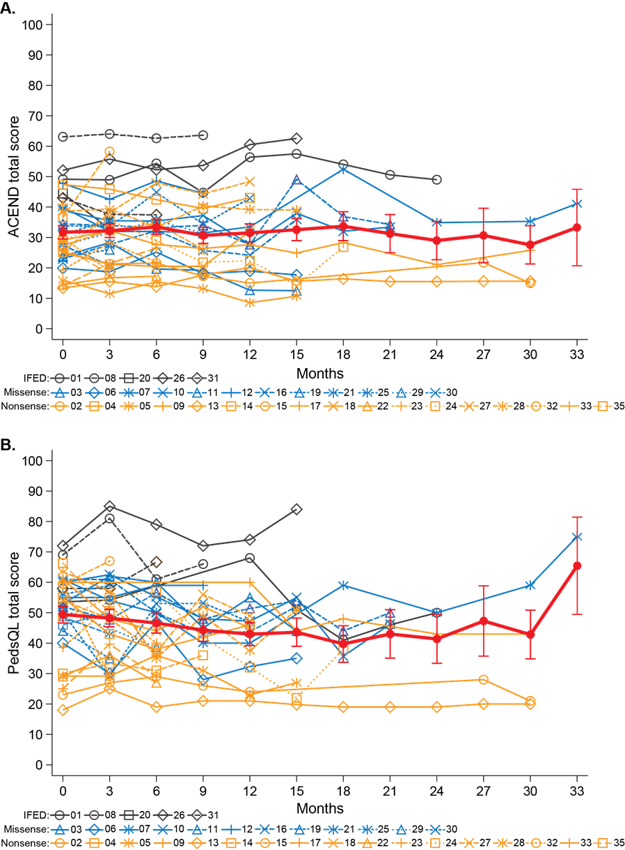

Plain Language Summary

Why was this study done?
- X-linked myotubular myopathy (XLMTM) is an ultra-rare, life-threatening genetic disease caused by mutations in the MTM1 gene.
- Children with XLMTM may have profound muscle weakness, chronic invasive mechanical ventilation for respiratory weakness, feeding support due to swallowing difficulties, and absent or delayed motor milestone attainment.
- These children often die in childhood, usually from respiratory failure.
- There are few studies to understand the natural course of the disease and no approved therapies to treat XLMTM.
What was the study?
- INCEPTUS was a prospective, non-interventional study to evaluate boys with genetically confirmed XLMTM.
- INCEPTUS was designed to obtain data over time on XLMTM natural history. No experimental treatment was given to the participants as part of the study.
- INCEPTUS began in 2016 in preparation for ASPIRO, the first-in-human clinical trial of an investigational gene replacement therapy in children with XLMTM.
Who took part in the study?
- Thirty-four (34) children <4 years old with XLMTM from 8 clinics in North America and Europe participated in INCEPTUS.
What did the researchers do?
- The participants were evaluated every 3 months through 21 months, and every 6 months thereafter for up to 33 months.
- The data collected included disease-related adverse events, daily ventilator hours, respiratory and motor function, use of a feeding tube, management of secretions and quality of life.
- The data were used to guide selection of health outcomes to measure in the ASPIRO gene replacement therapy trial, and the participants served as an untreated control group for ASPIRO.
What did the researchers find?
- Most participants were permanently dependent on ventilator support, unable to achieve motor milestones appropriate for their ages, and suffered several life-threatening medical events.
- All participants had severe deficits in respiratory and motor function and quality of life that did not improve over time.
What do these findings mean?
- The high ventilator dependence, poor respiratory function, and severely limited motor function in INCEPTUS participants helped determine which outcomes to measure in the ASPIRO gene replacement therapy trial.
- Based on this study, daily ventilator hours was selected as the main result to be measured (primary efficacy endpoint) in ASPIRO.

