Supplementary Data
Supplementary Figure 1: Proliferation of Mss51-disrupted cells (red) compared to control (black). Cells were plated at indicated densities in 96-well plates and proliferation was measured over 1.5 days using the alamarBlue assay (Life Technologies, n = 12).

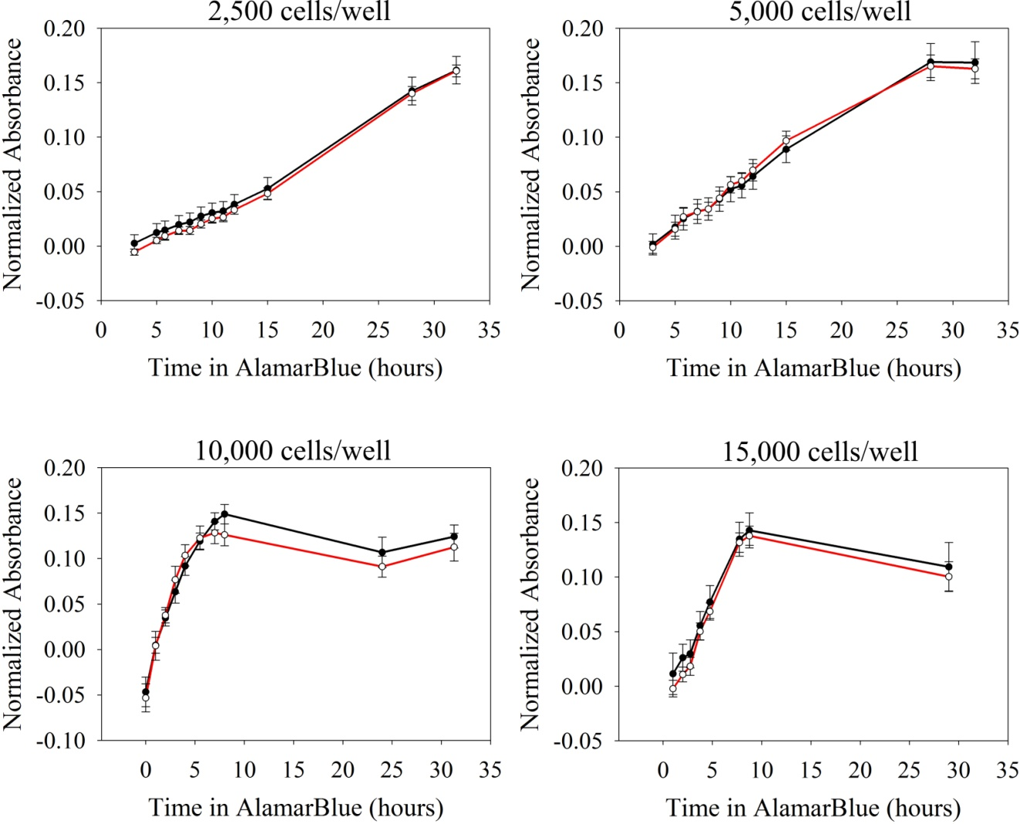
Supplementary Figure 2: PGC1α expression. PGC1a mRNA expression was measured in control and Mss51-disrupted myotubes through the first 6 days of differentiation. Expression was normalized to expression levels in proliferating (Day 0) control cells using reference genes TBP and Tfam (n=3). * p < 0.05.

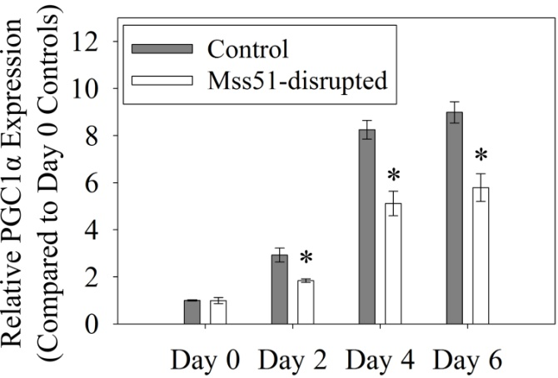

Supplementary Figure 3: Expression of several metabolic proteins in control versus Mss51-disrupted myotubes. Protein levels were compared by Western blot in control and Mss51-disrupted myotubes differentiated for 6 days.

