Supplementary Figure 1A. Evans and Stoddart Framework of Determinants of Health.
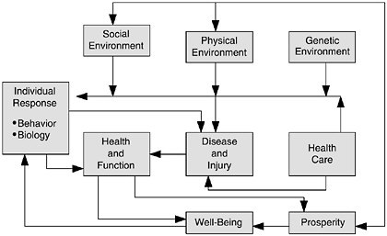
Source: Evans RG, Stoddart GL. Producing health, consuming health care. Social science & medicine (1982) 1990;31(12):1347-1363.

Supplementary Figure 1B. Multilevel Approach to Epidemiology.
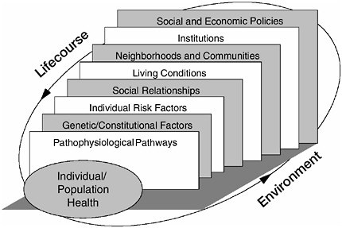
Source: Kaplan, G.A., Everson, S.A., Lynch, J.W. (2000). The contribution of social and behavioral research to an understanding of the distribution of disease: a multilevel approach. In Smedley BD, Syme SL (eds), Promoting Health: Intervention Strategies from Social and Behavioral Research. Washington, DC: National Academies Press.

Supplementary Figure 1C. The Dahlgren-Whitehead model.
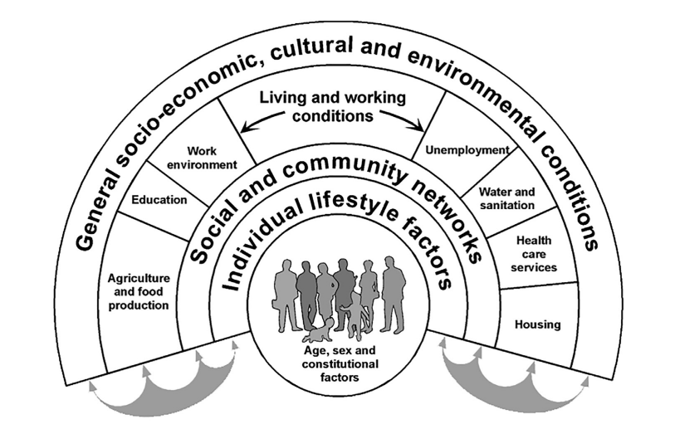
Source: Dahlgren G, Whitehead M. Policies and strategies to promote social equity in health. Background document to WHO - Strategy paper for Europe. Institute for Futures Studies, Arbetsrapport 1991;14

Supplementary Table 1. The main characteristic of NCI-funded transcapillary projects
ID | Years funded | Cancer types | Cancer Care Continuum | PI discipline | Team disciplines (non-exhaustive) | Evaluation
1 | 1999-2003 | Mixed | Primary prevention | Community & Global Health, Social Psychology | Psychology, Anthropology, Epidemiology, Biostatistics, Education, Demography, Environmental science, Respiratory science, public Health | N/A
2 | 2003-2011 | Prostate cancer | Risk assessment, Primary prevention | Epidemiology | Molecular biology, Genetic Epidemiology, Sociology, Behavioral science, Health policy | N/A
3 | 2004-2008 | Mixed | Primary Prevention | Cancer prevention, Pharmacogenetics | Neuroscience, Genomics, Pharmacology, Population science | N/A
4 | 2005-2006 | Mixed | Risk assessment, Primary prevention | Biochemistry, Genetics, Cancer Prevention | Energetics, Cancer prevention | Yes
5 | 2005-2009 | Mixed | Risk assessment, Primary prevention | Energetics, Preventative Medicine | Cancer metabolomics, Energetics | Yes
6 | 2005-2011 | Mixed | Risk assessment; primary prevention | Epidemiology; Public Health | Epidemiology; Public health | N/A
7 | 2005-2017 | Mixed | Risk assessment, Primary Prevention | Public Health; Energetics | Energetics | Yes
8 | 2006-2010 | Gastrointestinal cancer | Primary prevention, Detection, Diagnosis | Genetics, Cancer | Biologic and  behavioral research, Energy balance, Cancer | Yes
9 | 2010-2014 | Breast cancer | Risk assessment, Survivorship | Epidemiology | Cancer prevention | N/A
10 | 2010-2014 | Lung cancer | Risk assessment | Epidemiology, Bioinformatics | Cancer genomics, Molecular genetics | N/A
11 | 2010-2014 | Mixed | Risk assessment, Primary prevention | N/A | Cancer prevention, Cancer control, Tobacco control, Energy balance | N/A
12 | 2011-2012 | Breast cancer | Risk assessment, Detection |  | Epigenetics, Cancer prevention | N/A
13 | 2011-2015 | Breast cancer | Risk assessment, Detection | N/A | Epigenetics, Metabolomics, Cancer Prevention | N/A
14 | 2011-2016 | Breast cancer | Risk assessment | Nutrition, Breast cancer prevention | Energetics, Cancer prevention | Yes
15 | 2011-2016 | Breast cancer | Survivorship | Exercise oncology | Energetics, Cancer biology, Cancer prevention | Yes
16 | 2011-2016 | Mixed | Risk assessment, Primary Prevention | Epidemiology; Public Health | Epidemiology, Social work, Clinician, Public health, Basic scientist, Engineering, Anthropology, Economics | N/A
17 | 2011-2017 | Prostate and Colorectal Cancer | Risk Assessment | Energetics, Metabolomics | Energetics, Cancer prevention | N/A
18 | 2013-2016 | Acute Myeloid Leukemia | Treatment, Survivorship | N/A | Physical sciences, Cancer | N/A
19 | 2015-2017 | Prostate cancer | Treatment | Diagnostic Radiology | Medical oncology, Radiation oncology, Molecular imaging | N/A
20 | 2015-2022 | Colorectal cancer | Primary prevention | Pathology | Molecular pathology, epidemiology | N/A
21 | 2016-2017 | Endometrial cancer | Treatment, Survivorship | Epidemiology, Biostatistics | Behavioral science, Neuroscience, Physical rehabilitation | N/A
22 | 2016-2020 | Colorectal cancer | Treatment, Survivorship | Epidemiology, Population health | Epidemiology, Cancer genomics | N/A
23 | 2018-2021 | Colorectal Cancer | Risk assessment, Primary prevention | Genomics, Population health | Epigenetic epidemiology | N/A
24 | 2019-2022 | Mixed | Risk assessment | Molecular oncology | Molecular oncology, biochemistry, functional genomics | N/A
25 | 2020-2025 | Breast cancer | Risk assessment, Primary prevention | Endocrinology | Biology, Endocrinology, Biopsychology | N/A

