Supplementary Material

Rac1 Activity Is Modulated by Huntingtin and Dysregulated in Models of Huntington’s Disease

Supplementary Figure 1. Phosphorylation of AKT and ERK in WT and HD fibroblasts with adult onset CAG lengths and Huntingtin lowering. (a) Western blot of total cell lysates from control fibroblasts treated with PDGF at indicated concentrations for 7 minutes shows increased phosphorylation of AKT at Serine473 with PDGF concentration. Blots were re-probed with β-tubulin. Cells were plated at equal density in 24 well plates and equal volumes were separated by SDS-PAGE immediately after harvest. (b) Pixel intensity quantification results from 2 control and 3 HD fibroblast cell lines shows all cell lines activate AKT in response to PDGF similarly. The HD line with 69 CAG had an attenuated response compared to all other cell lines. Signals for phospho-AKT were standardized to β-tubulin signals. Blots were also re-probed with anti-AKT to look at total AKT, but the signal for AKT was significantly reduced in lanes where phospho-AKT had been high suggesting interference with normal antibody binding so tubulin was chosen as a loading control to prevent over-estimation of the phosphorylated species. Bars = mean ratio +SD, *p<0.05 compared to other cell lines at same concentration, n=6 for each cell line at each concentration of PDGF, unpaired t-test. All cell lines responded significantly compared to themselves in control medium. (c) Western blot of total cell lysates from control fibroblasts treated with PDGF at indicated concentrations for 7 minutes shows increased phosphorylation of ERK with PDGF treatment. Blots were re-probed with β-tubulin. (d) Pixel intensity quantification results from 1 control and 1 HD fibroblast cell lines (N=3 independent experiments) shows both cell lines phosphorylate ERK with PDGF treatment. (e) Huntingtin lowering with siRNA. Western blot analysis shows reduction of Huntingtin protein levels in fibroblasts treated with siRNA E1-4 targeting Huntingtin mRNA compared to a control siRNA targeting GFP mRNA. Blots were re-probed with β-tubulin as a loading control. Pixel intensity quantification results are shown in Figure 1b. 20µg protein was loaded per lane. (f ) Western blot of total cell lysates from untreated control and HD fibroblasts shown in Figure 1a probed for Rac1 and GAPDH. No significant differences were observed in Rac1 levels between the control and HD cell lines (N=4, One way ANOVA with Tukey’s Multiple Comparison test). (g) Western blot analysis of Rac1 levels in fibroblasts treated with siRNA E1-4 targeting Huntingtin mRNA compared to a control siRNA targeting GFP mRNA. Blots were probed for Rac1 and re-probed with GAPDH. Pixel intensity quantification results are shown in Figure 1b. 10µg protein was loaded per lane.

Supplementary Figure 2. Characterization of human NSCs and human neuronal cultures. (a) PCR results from genomic DNA confirm increasing CAG length in HD IPSC lines (HD48, HD51, and HD4). (b) Western blot analysis of cell lysates from NSCs shows expression of normal Huntingtin in control lines WT54 and WT97 detected with N-terminal Huntingtin polyclonal antibody, Ab1. A genetically corrected cell line (116c) isogenic to HD4 also expresses normal Huntingtin. Mutant expression was confirmed in HD48, HD51, and HD4 using a monoclonal antibody specific for expanded polyglutamine (1C2). Note that the isogenic corrected line 116c is negative for mutant Huntingtin. Blots were also probed with a neuronal differentiation marker (BetaIII-Tubulin), an astrocytic marker (GFAP). The same lysates were run on a separate gel and probed for Rac1 and GAPDH as a loading control. Lysates from total mouse brain used as a positive control. Black lines indicate where lanes were removed from the same gel. Spaces indicate different gels. (c) Immunofluorescence for the NSC marker, Nestin, shows >95 percentage of positive cells in all established NSCs. (d) Western blot analysis of cell lysates from neuronal cultures differentiated from IPSCs shows expression of normal Huntingtin in WT54 and HD51 cultures detected with Ab1 and mutant Huntingtin expression was confirmed in HD51 using anti-polyglutamine antibody 3B5H10. Neuronal cultures showed comparable levels of the neuronal differentiation marker BetaIII Tubulin, markers for medium spiny striatal projection neurons (DARPP32 and ISLET1) and for levels of Rac1. Cultures had low levels of Nestin and the astrocytic marker (GFAP). Black lines indicate where lanes were removed from the same gel. *On bottom, lysates from another experiment using HD51 neurons run on a 3-8% Tris-acetate gel run for several hours shows separation of WT and mutant Huntingtin. (e) Immunofluorescence and confocal microscopy of human neuronal cultures shows high percentage of cells with neuronal morphologies expressing BetaIII-Tubulin and low expression of Nestin in the culture (top). High levels of DARPP32 is expressed in many fewer cells compared to BetaIII-Tubulin, although low staining for DARPP32 was observed in about 30% of cells with neuronal morphology. Nuclei are labeled with DAPI in blue.

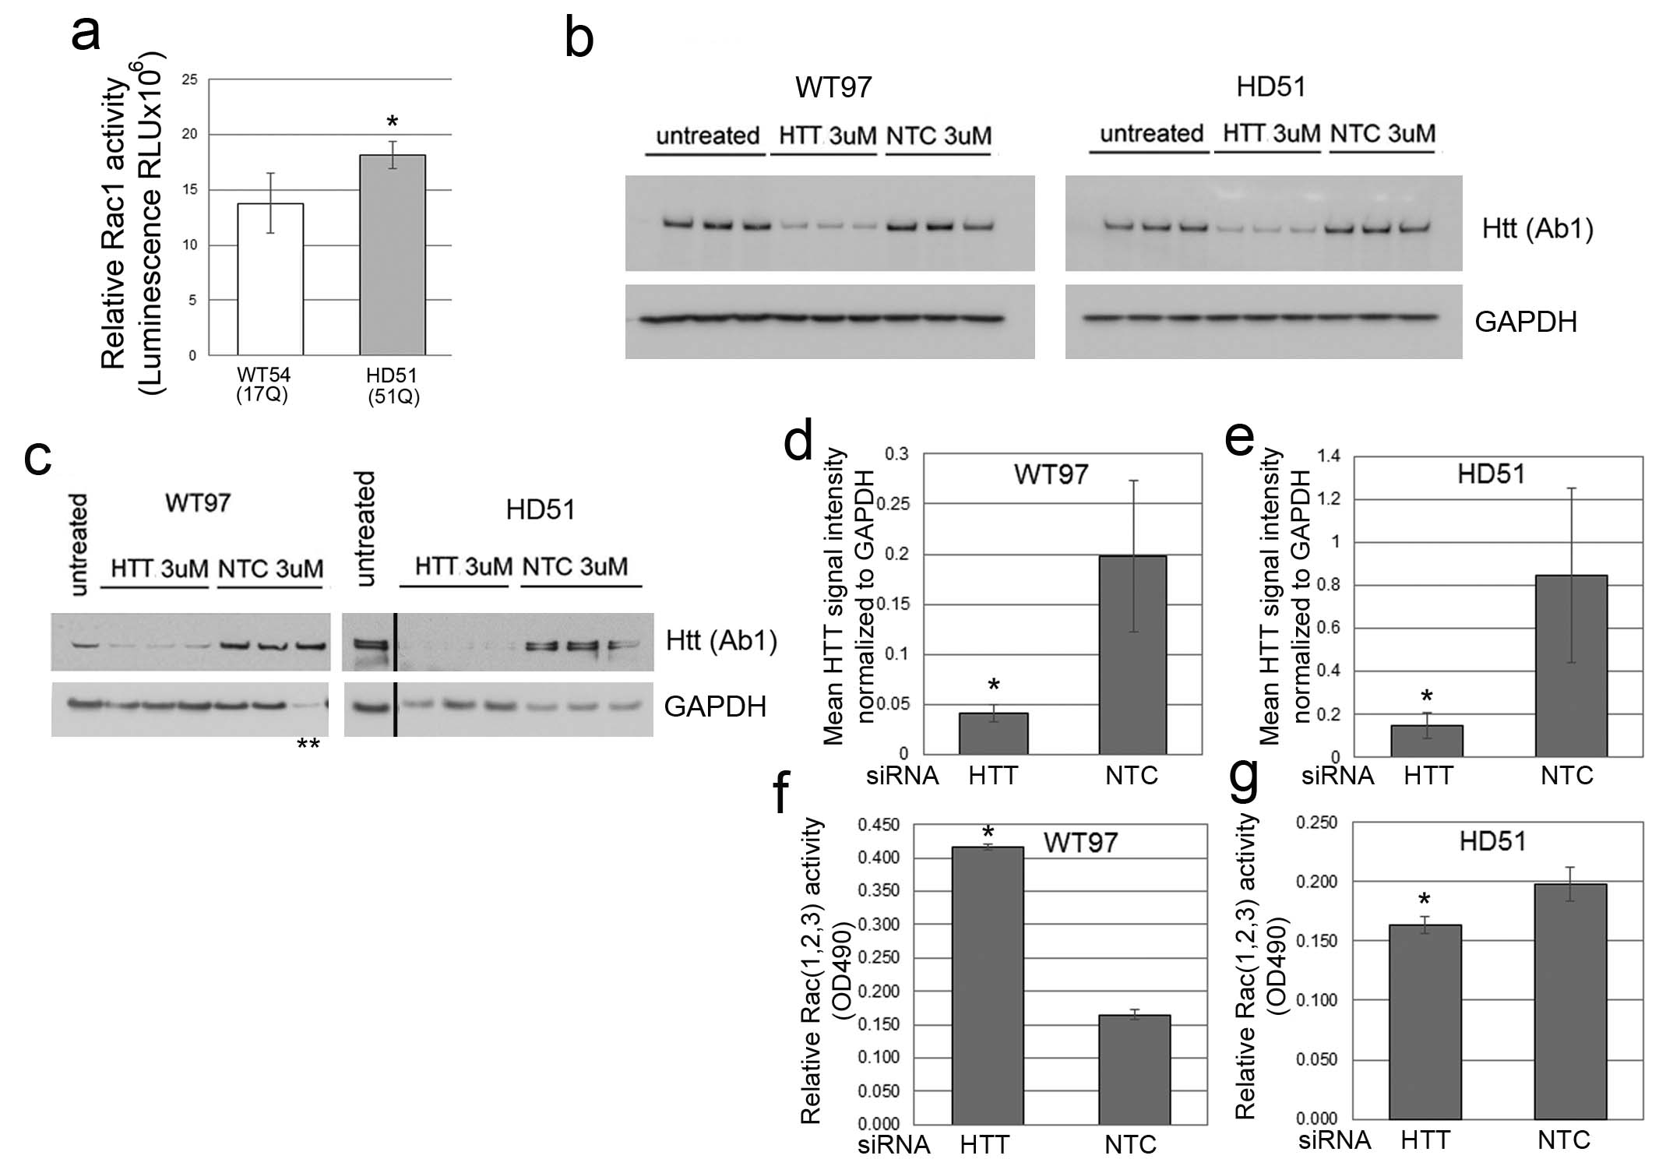

Supplementary Figure 3. Rac1 activation levels in human neuron cultures and effects of Huntingtin lowering on Rac 1,2,3 activation. (a) Basal Rac1 activity in human HD (HD51) neurons is increased compared to WT (WT57) neurons. Graph shows mean ± SD of relative Rac1 activity at DIV35 (*p<0.0007, unpaired t-test, n= 6 (WT97) and 4 (HD51) technical replicates). (b) Western blots show Huntingtin protein lowering with siRNAHTT10150 in human WT97 and HD51 neurons for experiment shown in Figure 2. Western blot analysis with anti-htt1-17 antibody Ab1 shows levels of protein reduction of Huntingtin in the neurons with different treatment conditions. The same lysates were run on 4-12% gels and probed with anti-GAPDH a control for toxicity. Pixel intensity quantification results are shown in Figure 2d and e.
(c-g) Lowering Huntingtin increases Rac 1,2,3 activity in WT neurons and reduces Rac1,2,3 activity to normal levels in HD neurons. (c)WT97 and HD51 were treated with siRNA HTT10150 targeting HTT mRNA or with a non-targeting control (NTC) and harvested for Huntingtin detection by western blot with antibody directed to htt1-17 (Ab1). **lane was loaded with one half protein concentration. (d, e) Bar graphs show results for mean Huntingtin signal intensity based on pixel intensity quantification and standardized to GAPDH. (f, g) Bar graphs show relative Rac1,2,3 activity using a peroxidase based ELSA assay in siRNA HTT10150 (HTT) treated and non-targeting control (NTC) treated cells (*p<0.05, ANOVA with Bonferroni’s Multiple Comparison test, n=3 technical replicates).

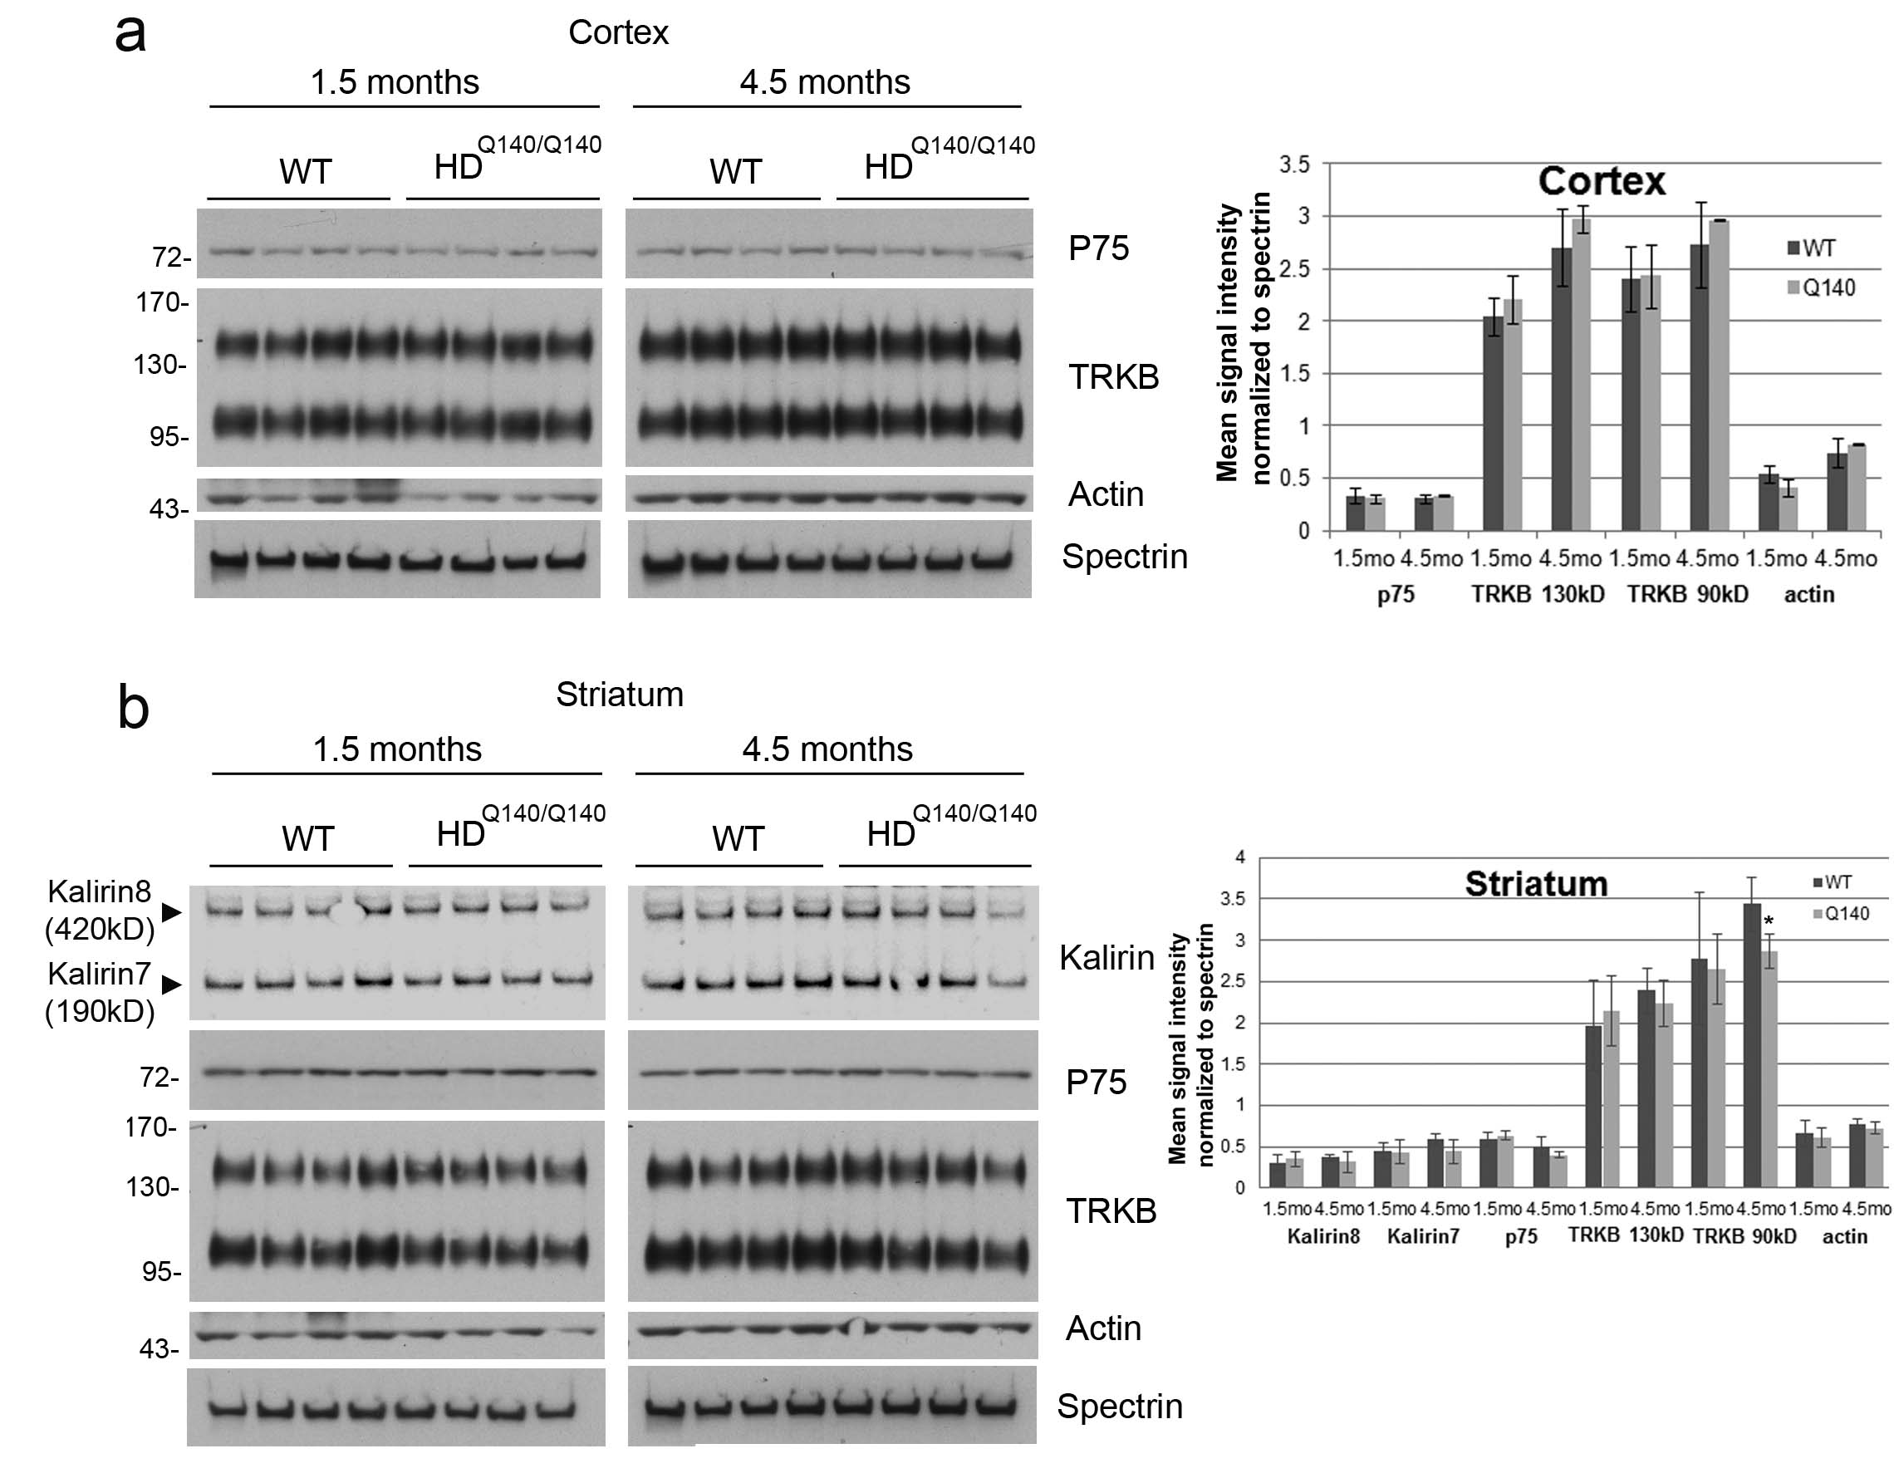

Supplementary Figure 4. Levels of receptor tyrosine kinase receptors, TRKB and p75, and Kalirins in wild-type (WT) and Q140/Q140 HD cortex and striatum. (a, b) Western blot analysis of lysates from cortex (a) and striatum (b) from WT and HD mice at 1.5 and 4.5 months. 20 μg protein was separated on 3-8% Tris-acetate SDS-PAGE, probed with anti-p75 antibody then re-probed with antibodies to TRKB, actin, spectrin, and Kalirin. Pixel intensity quantification results at right show less TRKB 90 kD in striatum of HD mice at 4.5 months compared to WT. Both Kalirin-7 (190 kDa) and Kalirin-8 (420 kDa) are detected in striatum by the antibody and are unchanged. Bars are mean ± SD, *indicates p<0.05, n=4 mice, unpaired t-test. Spaces in b, c, and d indicate different gels.

