Supplementary Figure 1. Morris water maze testing. (A) No significant differences were observed during the reversal task between Htt^{ΔQP/ΔQP} (ΔQP/ΔQP), Htt^{ΔN17/ΔN17} (ΔN17/ΔN17), and Htt^{+/+} (+/+) mice except for a decreased latency to the platform for Htt^{ΔQP/ΔQP} mice compared to controls (p=0.0049) at 18 months of age on the second day of the task (day 7 of water maze testing). Additionally, at 24 months of age, Htt^{ΔQP/ΔQP} and Htt^{ΔN17/ΔN17} mice were significantly different from one another (p=0.0316, 2-way ANOVA), but were not different from controls on day 7. (B) No differences were observed in the frequency of platform crosses during the probe trial between genotypes at 3 (p=0.0581), 6 (p=0.7238), 12 (p=0.1638), 18 (p=0.2633), and 24 (p=0.1334) months of age (1-way ANOVA). (C) Swim velocities of each mouse were determined during the probe trials. No significant differences were observed between genotypes at all ages tested (2-way ANOVA).

Supplementary Figure 2. Western blots of marker proteins in the nuclear (N), cytosolic (C), and microsomal (M) fractions isolated from the brains of Htt^{+/+}, Htt^{ΔQ/ΔQ}, Htt^{ΔQP/ΔQP}, and Htt^{ΔN17/ΔN17} mice. (A) Calnexin is located in the endoplasmic reticulum and on the nuclear envelope. Thus, it is detected in both the nuclear and microsomal fractions, but is absent from the cytosolic fraction. Lamin B1 is associated with the nuclear membrane and is only detected in the nuclear fraction. (B) LC3-I is detected in both cytosolic and microsomal fractions, but LC3-II, which is associated with autophagosomes, can only be detected in the microsomal fraction.

Supplementary Figure 3. Autophagic flux analyses of cortical neurons. Primary cortical neurons from the brains of P5 Htt^{+/+} (+/+), Htt^{ΔQ/ΔQ} (ΔQ/ΔQ), Htt^{ΔQP/ΔQP} (ΔQP/ΔQP), and Htt^{ΔN17/ΔN17} (ΔN17/ΔN17) mice were grown for 8 DIV, and then treated with 30 μM CQ for 4 or 8 hours before immunostaining with antibodies recognizing LC3, p62 and βIII tubulin. There was an increase in LC3⁺p62⁺ cargo-containing autophagosomes in neurons treated with CQ compared to neurons that were not treated (p<0.0001, F=200.1, D_{F}=2, 2-way ANOVA). However, there were no significant differences between genotypes either with or without CQ treatment (p=0.1063, F=2.071, D_{F}=3, 2-way ANOVA).

Supplementary Figure 4. Quantification of Vglut1⁺PSD95⁺ synapses in the brains of 24-month-old mice. (A) No differences in the number of corticostriatal synapses were detected between Htt^{ΔQP/ΔQP} (ΔQP/ΔQP), Htt^{ΔN17/ΔN17} (ΔN17/ΔN17) mice and Htt^{+/+} controls (+/+) in the dorsal striatum (p=0.6467, F=0.4380, D_{F}=2, 1-way ANOVA). (B) There was also no significant difference in the number of cortico-cortical synapses in the primary motor cortex between genotypes (p=0.1129, F=2.231, D_{F}=2, 1-way ANOVA).

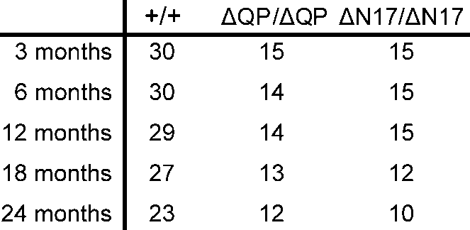

Supplementary Table 1. The numbers of Htt^{+/+}, Htt^{ΔQP/ΔQP}, and Htt^{ΔN17/ΔN17} mice used for behavioral testing at each age.

Supplementary Figure 1.

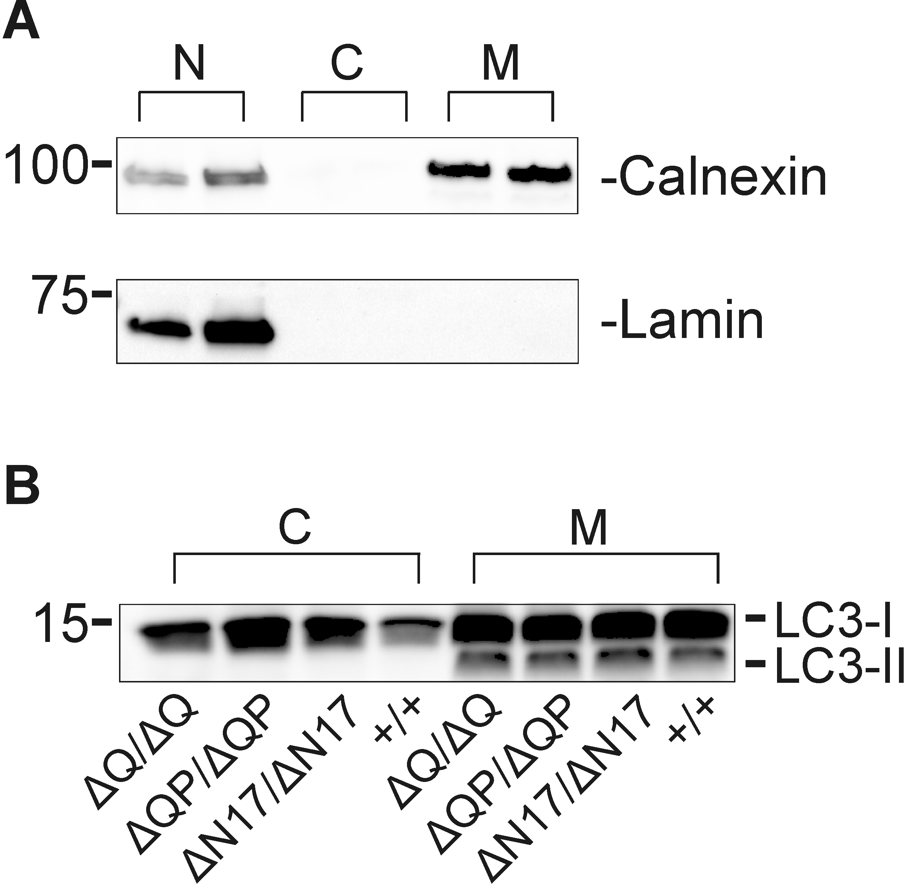

Supplementary Figure 2.

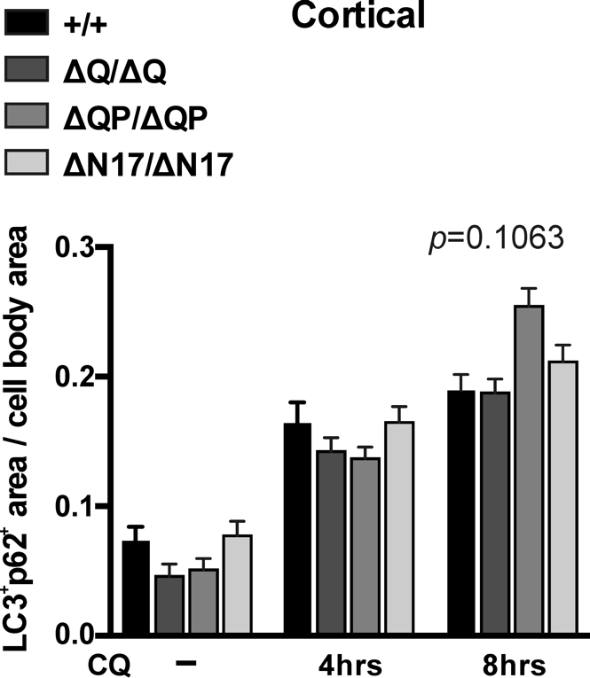

Supplementary Figure 3.

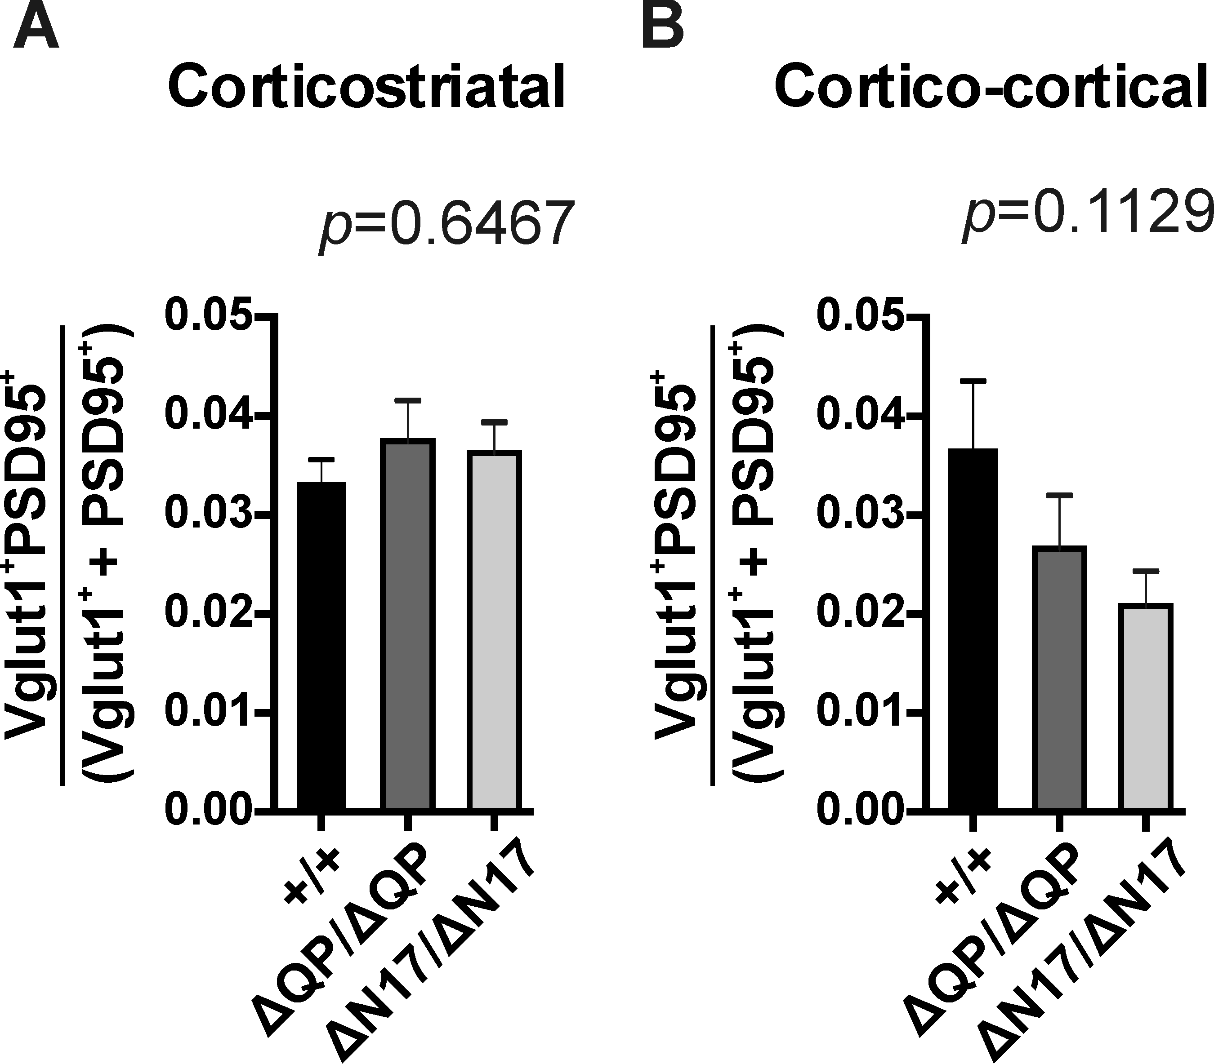

Supplementary Figure 4.

