Supplementary Table 1 Specific primers used for qPCR and qRT-PCR.

Gene name | Primer sequences (5’ to 3’)
Actin-7  qPCR | Forward:TCATTGGAATGGAAGCTGCTGGCATT  Reverse:CGACCTTAATCTTCATGCTGCTTGGA
Cutinase  qPCR | Forward:AAGAACCAGATCAAGGGCGTCGTG  Reverse:GCGTCCGCAATGTCGCAGTAGA
Fra a 5  qRT-PCR | Forward:AGATTGCACCTCAGGCAGTAAA  Reverse:GTGGTACTTGCTGGTGGTCTT
Fra a 1  qRT-PCR | Forward:GAAGGTGATGGAGGAGTTGGAA  Reverse:CTCCCTCGGATGCAATCAAC
Fra a 1.02  qRT-PCR | Forward:ACTTATGAAACCGAGTTTACATCTGT  Reverse:TTAACTGCTTGTGGAGCAATCTTT
CHP1  qRT-PCR | Forward:CACCGTCCTTTCTTCCATTT  Reverse:ACTTCTCATCCCAGGCACTC
GAPDH1  qRT-PCR | Forward:TCCATCACTGCCACCCAGAAGACTG  Reverse:AGCAGGCAGAACCTTTCCGACAG
Supplementary Table 2 Allergenicity prediction analyses of strawberry Bet v 1 homologous proteins in Allergen Online Database.

Abbreviated  protein name | 80mer Identity (%) |  | Full fasta Identity (%)
 | Full alignment | Best hit
Fra a 1.01 | 91.80 | 93.80 | 93.80
Fra a 1.02 | 90.60 | 92.50 | 90.60
Fra a 1.03 | 100 | 100 | 100
Fra a 1.04 | 100 | 100 | 100
Fra a 1.05 | 100 | 100 | 100
Fra c 1.01 | 84.30 | 88.78 | 84.30
Fra v 1.01 | 100 | 100 | 100
Fra v 1.02 | 43.90 | 57.52 | 45.70
Fra v 1.03 | 52.20 | 58.70 | 54.00
Fra v 1.04 | 50.60 | 62.50 | 52.50
Fra v 1.05 | 49.40 | 63.79 | 50.90
Fra v 1.06 | 83.10 | 90.00 | 86.90
Fra v 1.07 | 88.10 | 92.50 | 88.10
Fra v 1.08 | 100 | 100 | 100
Fra v 1.09 | 79.40 | 82.50 | 79.40
Fra v 1.10 | 91.90 | 93.80 | 91.90
Fra v 1.11 | 84.90 | 88.78 | 84.90
Fra v 1.12 | 87.50 | 91.20 | 87.50
Fra v 1.13 | 96.30 | 98.80 | 96.30
A criterion of >70% identity was set in our analyses.
Supplementary Table 3 Linear epitope prediction of strawberry Bet v 1 homologous proteins in IEDB Database.

Abbreviated protein name | Epitopes numbers | Blast Identity (>%)
Fra a 1.01 | 28 | 70
Fra a 1.02 | 27 | 80
Fra a 1.03 | 25 | 80
Fra a 1.04 | 12 | 90
Fra a 1.05 | 20 | 90
Fra c 1.01 | 36 | 80
Fra v 1.01 | 20 | 90
Fra v 1.02 | 3 | 70
Fra v 1.03 | 6 | 80
Fra v 1.04 | 6 | 70
Fra v 1.05 | 11 | 80
Fra v 1.06 | 15 | 90
Fra v 1.07 | 43 | 80
Fra v 1.08 | 25 | 80
Fra v 1.09 | 19 | 90
Fra v 1.10 | 20 | 90
Fra v 1.11 | 33 | 80
Fra v 1.12 | 21 | 80
Fra v 1.13 | 12 | 90

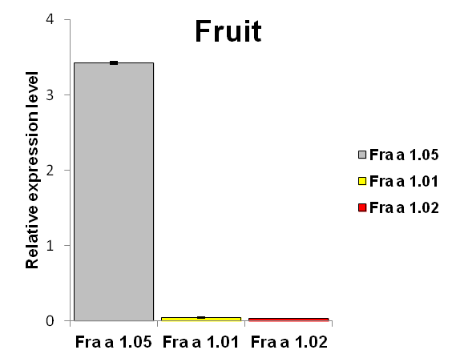
Supplementary Fig. 1 Comparative transcriptional level of Fra a 1.05, Fra a 1.01 and Fra a 1.02 genes in strawberry fruits. The mRNA level of Fra a 1.05 was about 100 fold higher compared with those of Fra a 1.01 and Fra a 1.02 genes. Although the relative comparison of gene transcriptional levels in one tissue may be not accurate considering the amplification efficiencies of RT primers, we still could conclude that Fra a 1.05 gene is the most abundant one from the striking trend. Data were shown as mean±standard deviation derived from three biological and three technical replicates.
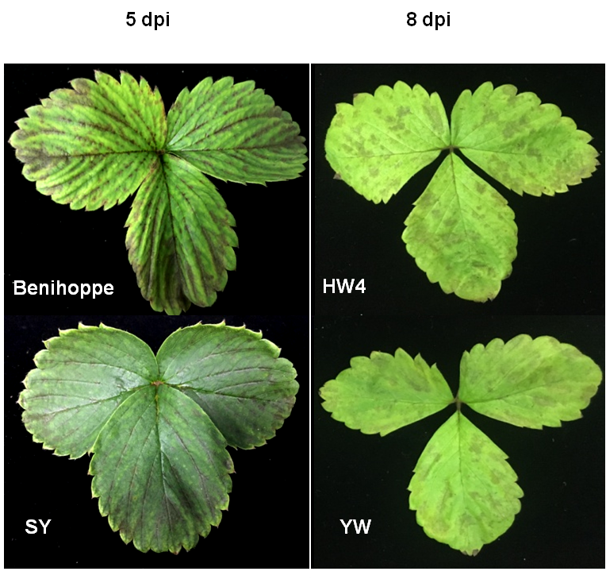
Supplementary Fig. 2 The susceptibility of Benihoppe, SY, YW and HW4 leaf tissues to C. fructicola. Four varieties were sprayed with the same concentration of C. fructicola conidia. Pictures were taken at 5 dpi for two cultivars and 8 dpi for two diploids. Anthracnose symptoms of Benihoppe and SY appeared 2 days earlier than those of HW4 and YW.

