SUPPLEMENTARY MATERIAL

SUPPLEMENTARY FIGURE 1

Rubus liebmannii Rubus palmeri
A
B
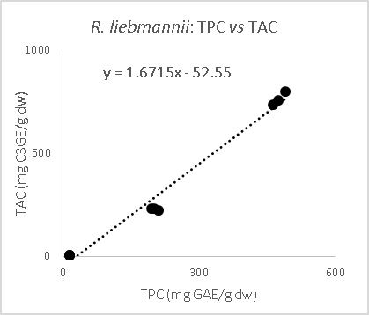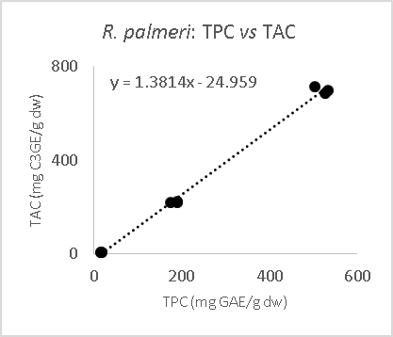
r=0.9857
r=0.9990

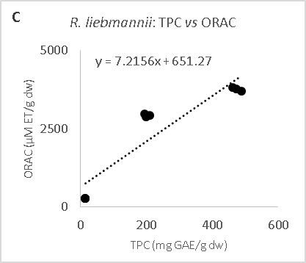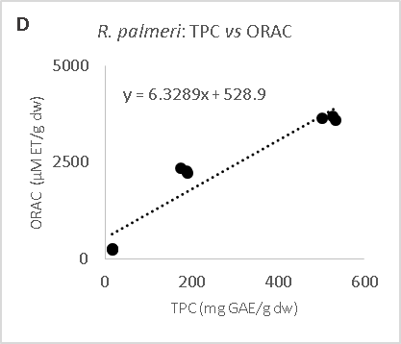
r=0.8470
r=0.9099

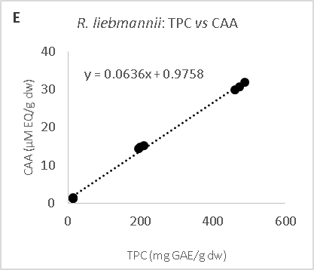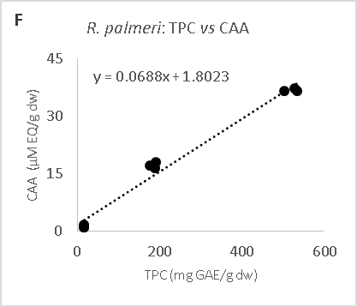
r=0.9958
r=0.9786

SUPPLEMENTARY FIGURE 1 (CONTINUED).
Rubus liebmannii Rubus palmeri
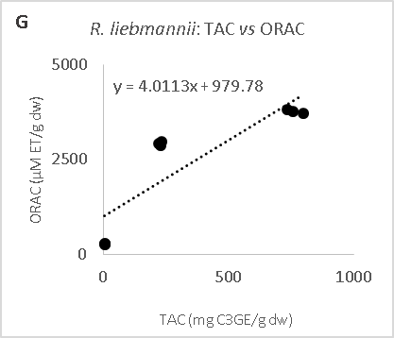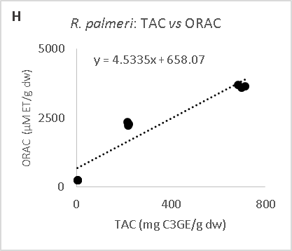
r=0.7514
r=0.8914

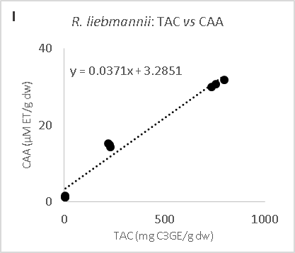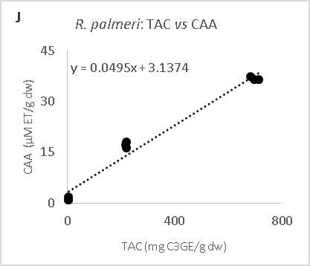
r=0.6513
r=0.7442
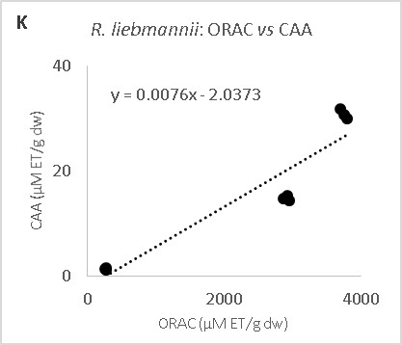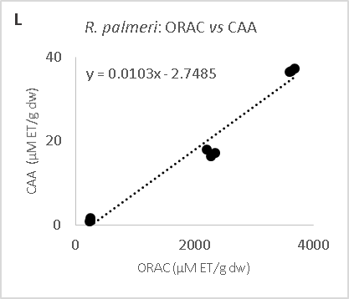
r=0.8905
r=0.9751

Supplementary FIGURE 1: Pearson’s correlations among total phenolic content (TPC), total anthocyanin content (TAC), ORAC anti-oxidant assay (ORAC) and cellular antioxidant activity (CAA) values from R. liebmannii and R. palmeri fractions. mg GAE/g dw, mg of gallic acid equivalents/g in dry weight; mg C3GE/g dw, mg of cyanidin-3-glucoside equivalents/g in dry weight; μM ET/g dw, μM equivalents of Trolox/g in dry weight; μM EQ/g dw, μM of quercetin equivalents/g in dry weight.

