Supplementary files
Table S1 Primer sequences used in this study.

Fig. S1 Multiple sequence alignments of V. corymbosum DNA methylation- and demethylation-related proteins with characteristic domains and motifs. a-d indicated the sequence alignment and conserved domains of VcMET1(a), VcDRM2 (b), VcCMT3 (c), and VcDME1 (d), respectively.

Fig. S2 Phylogenetic analysis of VcMET1, VcDRM2, VcCMT3, and VcDME1 from V. corymbosum and other plant species.

Fig. S3 Specific DNA methylation status in the VcCHS and VcANS promoters during anthocyanin accumulation. a: Specific DNA methylation changes in the VcCHS promoter region. b: Specific DNA methylation changes in the VcANS promoter region.

Table S1
Primer sequences used in this study.

Gene name | primer sequences (5'-3') | Comments | Predicted length (bp) | Tm (℃)
VcMET1 | F1: GGTACCATGTTATCTTACCCTTGGATGAAG  R1: GGATCCACTATGATTTTCATTTCGCTTCTCT  F2: TGTCAGAGAGTTTATTCTTTCGCAG  R2: CTAAGGGAAACAAGAACGGGTAG | gene isolation | 4,647 | 57.0
 |  | gene expression | 120 | 60
VcDRM2 | F3: AAGCTTATGGACCAGAATGCCTCTGGG  R3: GGATCCTCAAAGTGGCTTTGCCATAA  F4：CCGAAAAGGAAATTACTTGAGAATG  R4：CATTGGATTGGG AAGTCTGAGT | gene isolation | 1,821 | 63.0
 |  | gene expression | 111 | 60.0
VcCMT3 | F5: GGTACCATGGGAAAGCGGAAGTCGAGGTCA  R5: GGATCCAAGAAGATCATCCACTACTACAGGAGAAT  F6: AAGAAAGGGAGCCAACTACAGG  R6: GAACTGACTGTCGGTCTTTCAAT | gene isolation | 2,601 | 61.0
 |  | gene expression | 100 | 60.0
VcDME1 | F7: CCCTCGAGATGAATTCGAGGATGAATTAT  R7: CGGGATCCTTTGTCTTCATTTTTTGTCTTGG  F8: TTACAATGCAACCTGGGAGAATTTC  R8: AGGATCTGACTCTCTGATTGGAAC | gene isolation | 5,622 | 53.0
 |  | gene expression | 116 | 60.0
VcCHS | F9: CAGTGCTCCATAGTCTGTGCACTT  R9: TTATAGTGGAATCAAACATAGCCCA | gene expression | 117 | 60.0
VcF3'H | F10: AGTGAAATGTACAGGAGGAAGATGACC  R10: CAAAAATCTCCTTAATGGGCTTGG | gene expression | 108 | 60.0
VcDFR | F11: TACAGCTTGGAGGATATGTTCAGAG  R11: CGTTCCATTTCCATTTCCATTG | gene expression | 104 | 60.0
VcANS | F12: AGACCGAGCCGGCGAGGTAT  R12: TTAAGCCCCATTAAGTGCCTG | gene expression | 92 | 60.0
VcUFGT | F13: GAGGGAACAAACTGGAAAGTACAAA  R13: GTACCCTCTCACTAACTCCAGCAAT | gene expression | 106 | 60.0
VcGAPDH | F14: CGGCTACTTACGAGCAAATCAA  R14: TTCAGTGTAGCCCAAAATTCCTTT | reference gene | 80 | 60.0
VcCHSpro | F15: AACCCTTAGTCCAACAAATCTCC  R15: CTTCTCAAAATCGAATTCCGA | bisulfite sequencing | 1,330 | 60
VcANSpro | F16:TGTAATTATGGCTCCACAATGTCTTAG  R16:CTGATCAAGAATTGTTGGCAACT | bisulfite sequencing | 1,264 | 57

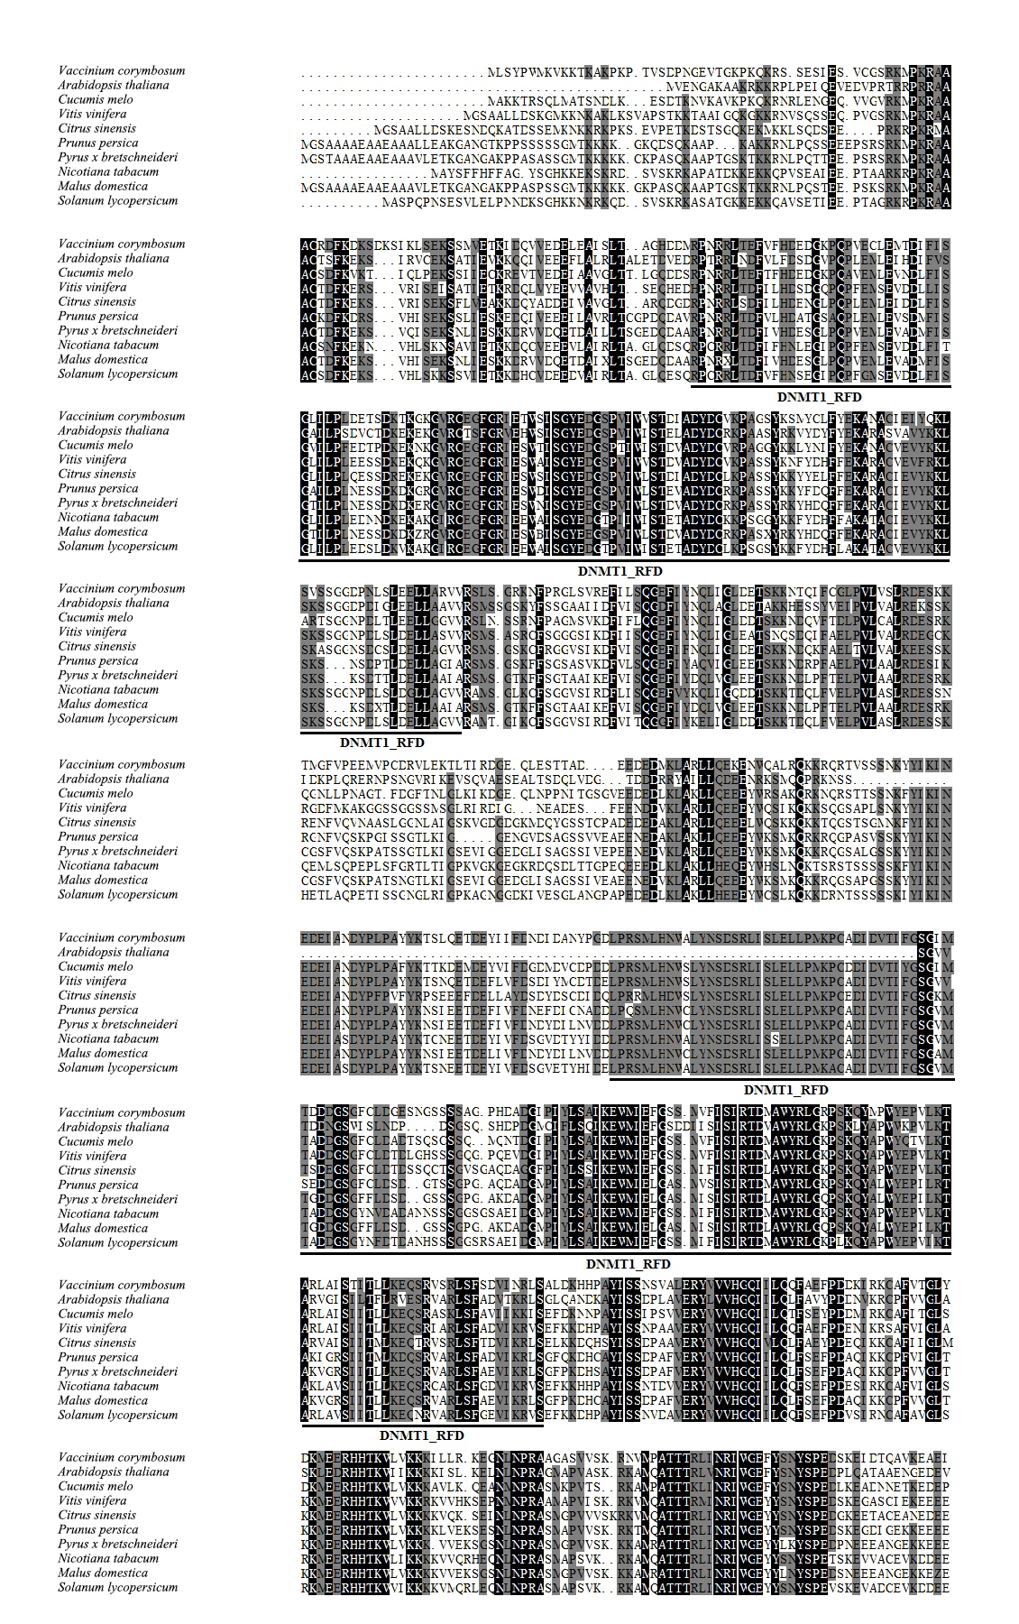
Fig. S1
(a)

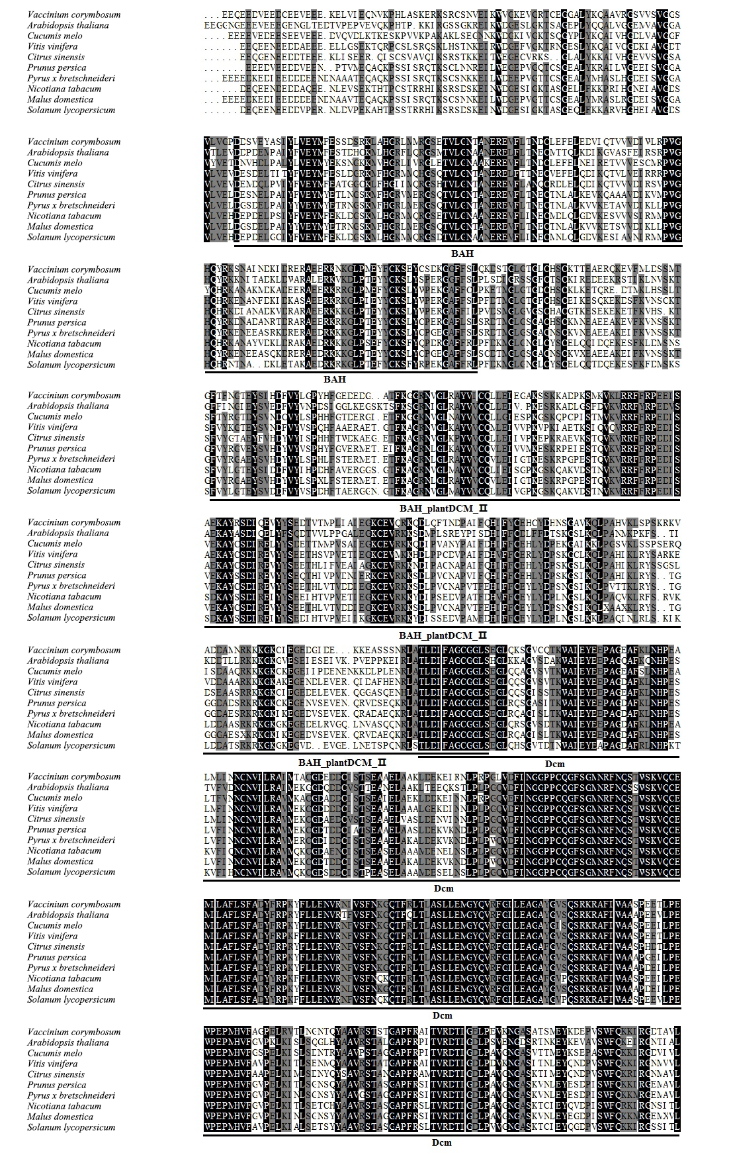

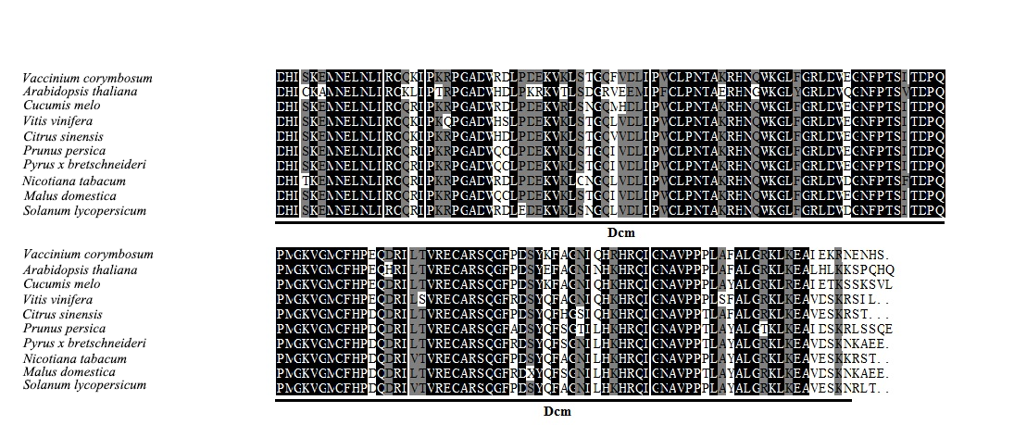

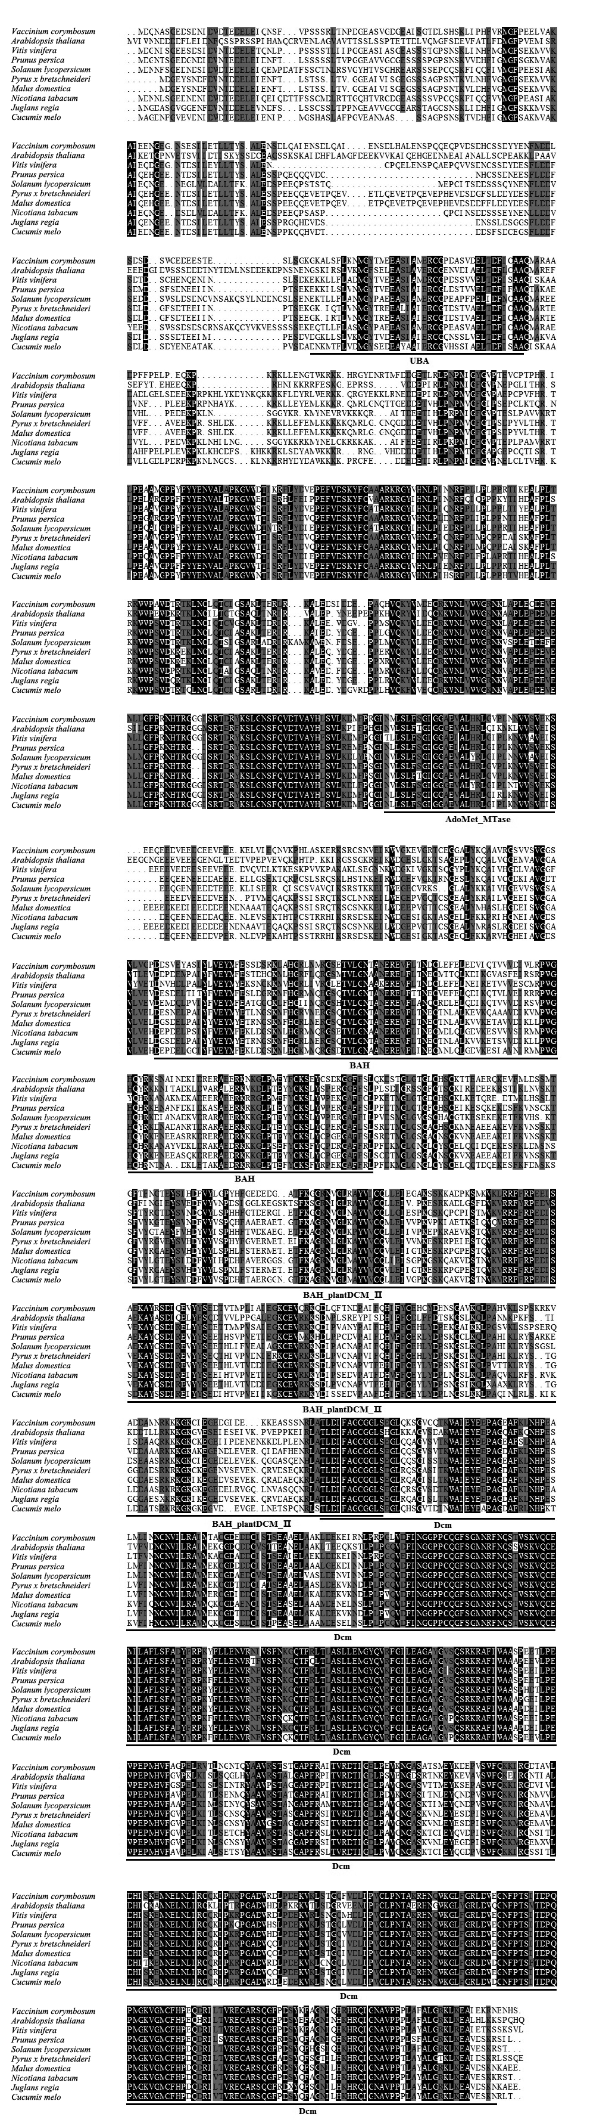
(b)

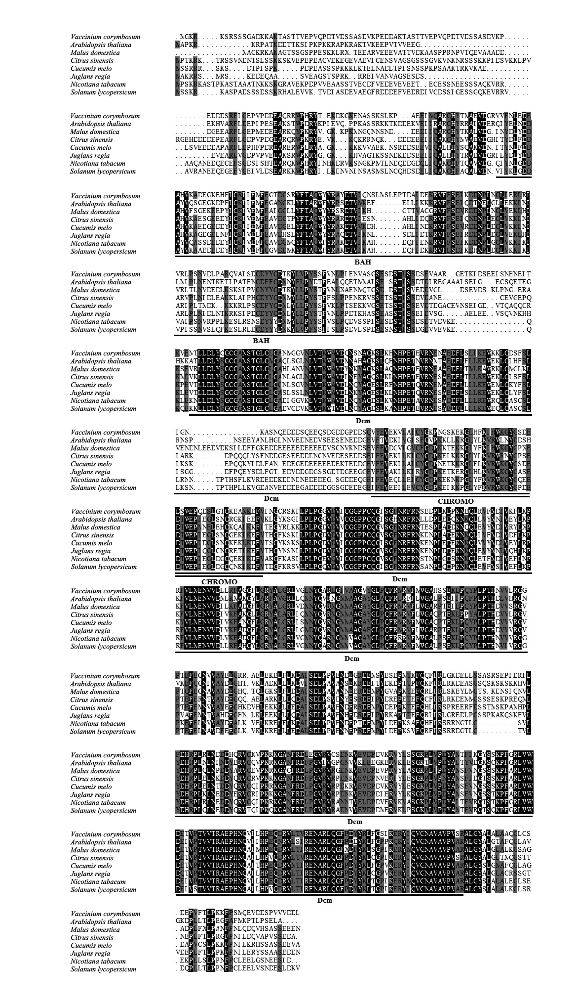
(c)

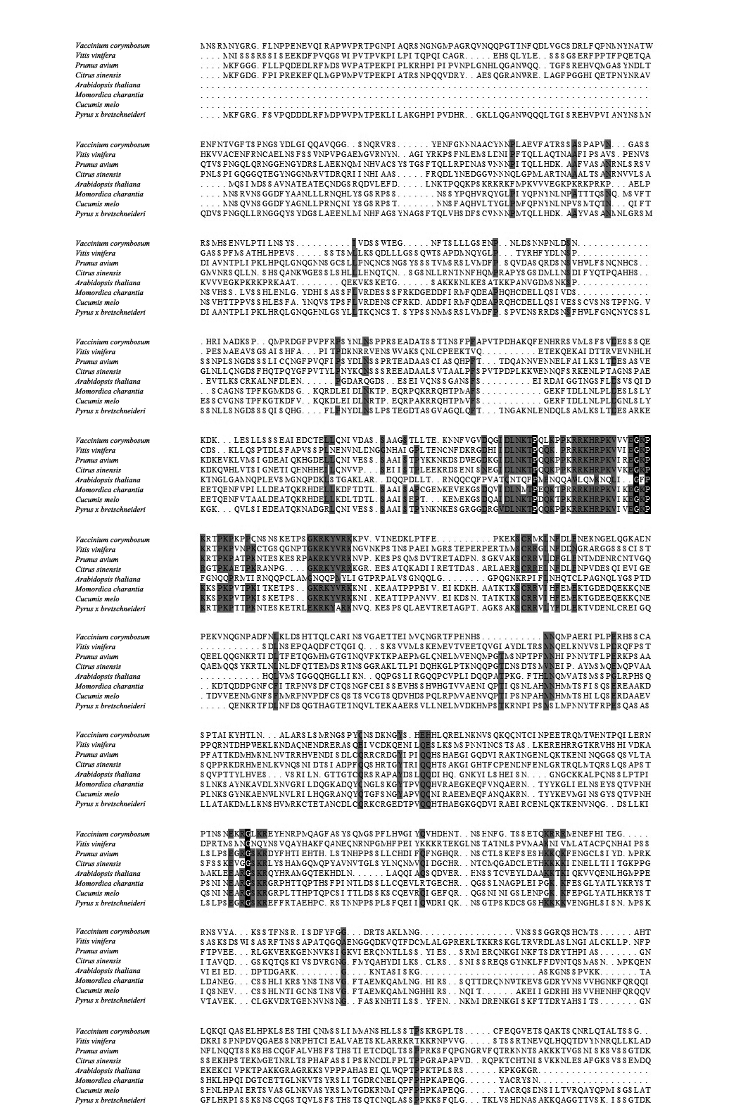
(d)

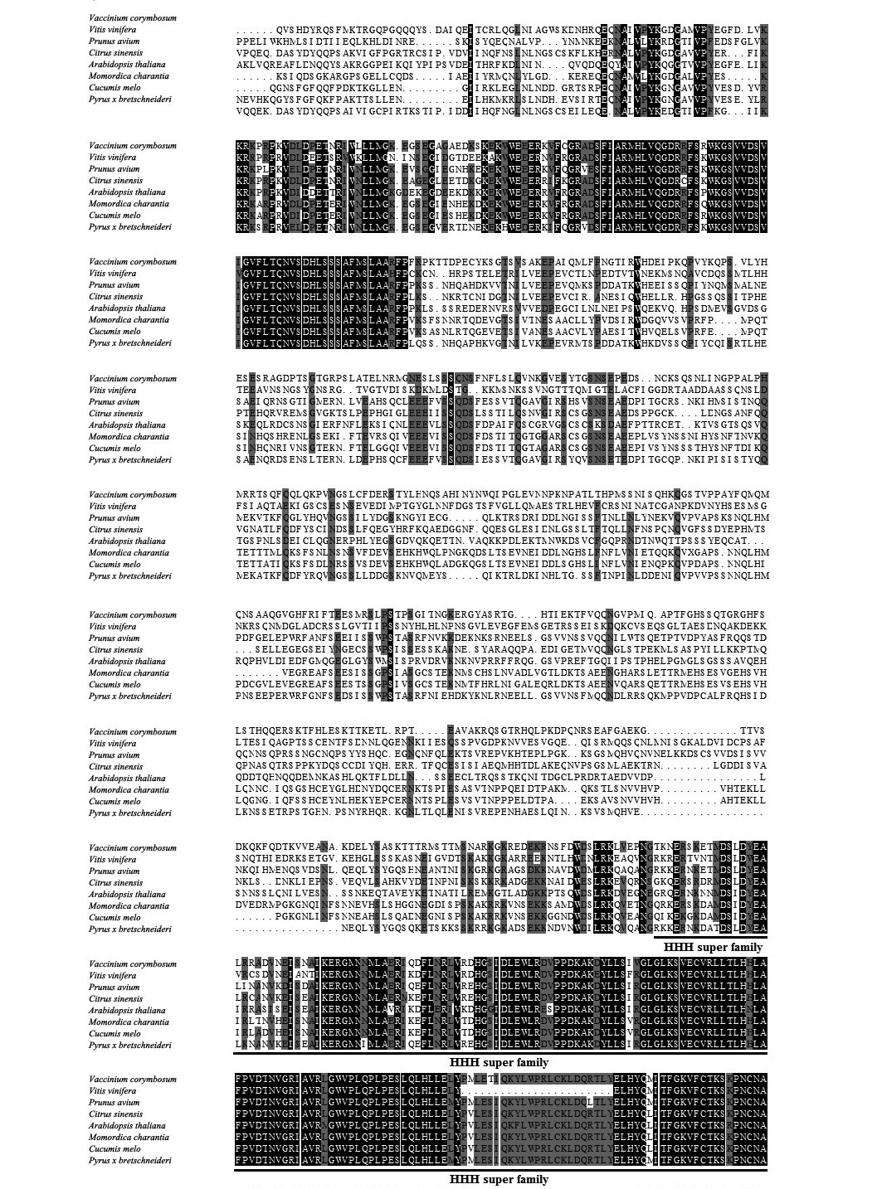

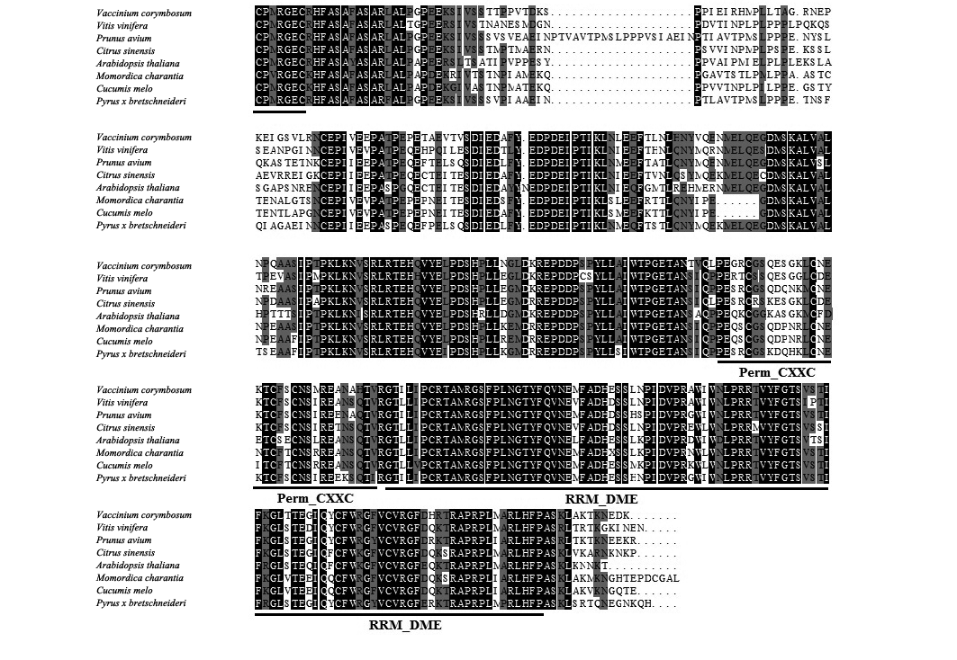

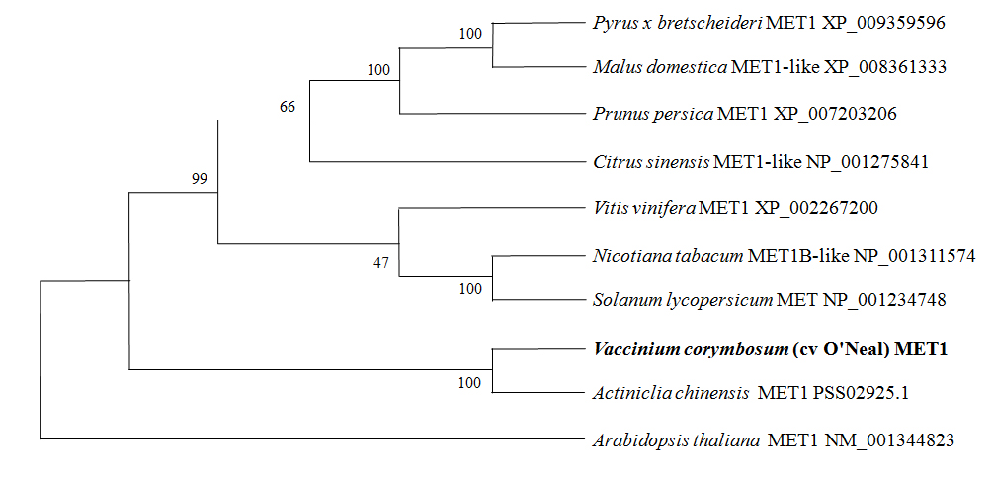
Fig. S2
(a)

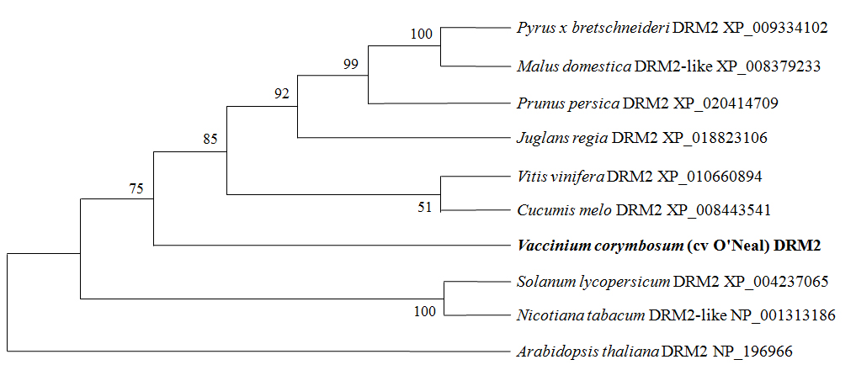
(b)

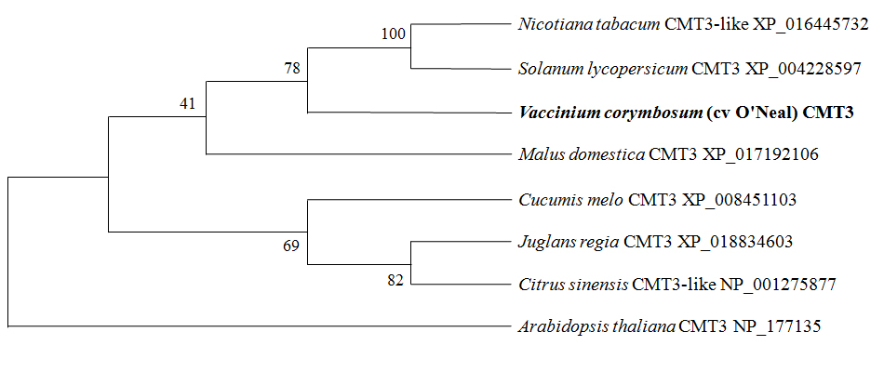
(c)

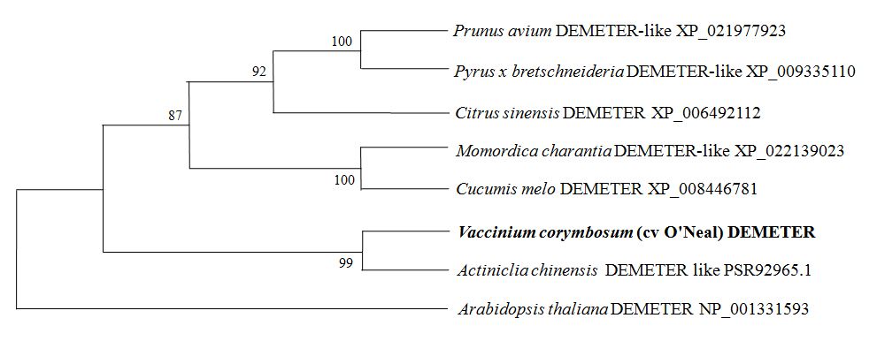
(d)

Fig. S3
(a)
VcCHSpro-S5 TACCCTTAGTCCACAAATCTCCCCCTCACACCCTTGCACGCACATACACACACTTCAACA 60
VcCHSpro-S6 TACCCTTAGTCCACAAATCTCCCCCTCACACCCTTGCACGCACATACACACACTTCAACA
VcCHSpro-Br TACCCTTAGTCCACAAATCTCCCCCTCACACCCTTACACGCACATACACACACTTCAACA
*********************************** ************************

VcCHSpro-S5 ATACCATTCTTTTGAGGTTGAAGGTAATATTCTTTTGAAAGCCAACAAATAGTTGACGGT 120
VcCHSpro-S6 ATACCATTCTTTTGAAATTGAAGATAATATTCTTTTGAAAGCCAACAAATAGTTGACGGT
VcCHSpro-Br ATACCATTCTTTTGAAATTAAAAATAATATTCTTTTAAAAACCAACAAATAGTTGACGAT
*************** ** ** ************ *** ***************** *

VcCHSpro-S5 TTAGTATATTTGTATATGCATTTTGCAAGTGCTTAGAGCATCTCCAACTGTTGGACCTCT 180
VcCHSpro-S6 TTAGTATATTTGTATATGCATTTTGCAAGTGCTTAGAGCATCTCCAACTGTTGGGCCTCT
VcCHSpro-Br TTAGTATATTTATATATGCATTTTACAAATGCTTAGAGCATCTCCAACTGTTGGGCCTCT
*********** ************ *** ************************* *****

VcCHSpro-S5 CCATCTCCATCTTGGAGAGAAAAAGGTGCTTTGGTTTGGTCCAAATACGTGCAAGAACCC 240
VcCHSpro-S6 CCATCTCCATCTTGGAGAGAAAAAGGTGCTTTGGTTTGGTCCAAATACGTGCAAGAACCC
VcCHSpro-Br CCATCTCCATCTTGGAGAGAAAAAGGTGCTTTGGTTTGGTCCAAATACGTGCAAGAACCC
************************************************************

VcCHSpro-S5 AGCAGCCTAGCCATTAGGCTCATTAAAAAAAAAAAATCCGACGTCAGCTTCTTCCTCAAA 300
VcCHSpro-S6 AGCAGCCTAGCCATTAGGCTCACCAAAAAAAAAAAACCCGACGTCAGCTTCTTCCTCAAA
VcCHSpro-Br AGCAGCCTAGCCATTAGGCTCACCAAAAAAAAAAAACCCGACGTCAGCTTCTTTCTCAAA
********************** ************ **************** ******

VcCHSpro-S5 CGGGCGCGTGTAACACACGCGCCACGAGTGCATCTAACGCTCTTGCACGCGCCTCCTTTG 360
VcCHSpro-S6 CGGGCGCGTGTAACACACGCGCTGCGAGTGCATCTAACGCTCTTGCACGCGCCTCCTTTG
VcCHSpro-Br CGGGCGCGTGTAACACACGCGCCGCGAGTGCATCTAACGCTCTTGCACGCGCCTCCTTTG
********************** ************************************

VcCHSpro-S5 GCTGGCGCGTGCGGCCTCCACGAGACTCCGTCGGCGACGAGTCTTCGACCAATCTCTTCG 420
VcCHSpro-S6 GCTGGCGCGTGCGGCCTCCACGAGACTCCGTCGGCGACGAGTCTTCGACCAATCTCTTCG
VcCHSpro-Br GCTGGCGCGTGCGGCCTCCACGAGACTCCGTCGGCGACGGGTCTTCGACCAATCTCTTCG
*************************************** ********************

VcCHSpro-S5 TCTCAACGAGATCTGTAATCTTCTTGTCTTAGAACGATTTTAGAACTCGTTTTCCGGTGA 480
VcCHSpro-S6 TTTCAACGAGATCTGTAATCTTCTTGTCTTAGAACGATTTTAGAACTCGTTTTCCGGTGA
VcCHSpro-Br TCTCAACGAGATCTGTAATCTTCTTGTCTTAGAACGATTTTAGAACTCGTTTTCCGGTGA
* **********************************************************

VcCHSpro-S5 CTGGTTTTTTCCGGCCAAAATCCGACCCACCATCACCGCCACCAACCACCATCAAAACAC 540
VcCHSpro-S6 TTGGTTTTTTCCGGCCAAAATCCGACCCACTATCACCGCCACCAACCACCATCAAAACAC
VcCHSpro-Br CTGGTTTTTTCCGGCCAAAATCCGACCCACCATCACCGCCACCAACCACCATCAAAACAC
***********************************************************
VcCHSpro-S5 ACACACACACGCACAGAGAGAGAGAGAGAGGAAGAGAGAGAGAGAGAGAAGGCTCAGATC 600
VcCHSpro-S6 ACACACACACGCACAGAGAGAGAGAGAGAGAGAGAGAGAGAGAGAGAGAAGGCTCAGATC
VcCHSpro-Br ACACACACACGCACAGAGAGAGAGAGAGAGAGAAAGAGAGAGAGAGAGAAGACTCAGATC
****************************** * ***************** ********

VcCHSpro-S5 TGTAATATCATCATCGCCTCGACCAAAATCCGGCCATGGCTGCAACCACGGTTGCCCGAA 660
VcCHSpro-S6 TGTAATATCATCATCGCCTCGACCAAAATCCGGCCATGGCTGCAACCACGGTTGCCCGAA
VcCHSpro-Br TATAATATCATCATCGCCTCGACCAAAATCCGGCCATGGCTGCAACCACGGTTACCCGAA
* *************************************************** ******

VcCHSpro-S5 GGCCCTCCGGGTTGCCCCGCCATGGAATCCGACCAAAACCCACTACAATCTGACCAAAAT 720
VcCHSpro-S6 GGCCCTCCGGGTTGCCCCGCCATGGAATCCGACCAAAACCCACTACAATCTGACCAAAAT
VcCHSpro-Br GGCCCTCCGGGTTGCCCCGCCATGGAATCCGACCAAAACCCACTACAATCTGACCAAAAT
************************************************************

VcCHSpro-S5 CCAGGTGGAGAAGAGGAGAGAGAGAGTAATTTTTCACCGGCCGGAGTAGTCGAACGACGG 780
VcCHSpro-S6 CCATGCGGAGAAGAGGAGAGAGAGAGTAATTTTTCACCGGCTGGAGTAGTCGAACGACGG
VcCHSpro-Br CCAGGCGGAGAAAAGGAGAGAGAGAGTAATTTTTCACCGGCCGGAGTAGTCGAACGACGG
*** * ****** **************************** ******************

VcCHSpro-S5 CAACGTTGCGGTGCAGTGATGGTGAGGGCTACAGTGCCTTGTCGAGACAGGAGAGGCAAA 840
VcCHSpro-S6 CAACGTTGCGGTGCAGTGATGGTGAGGGCTACAGTGCCTTGTCGAGACAGGAGAGGCAAA
VcCHSpro-Br CAACGTTGCGGTGCGGTGATGGTGAGAGCTACAGTGCCTTGTCGAGACAGGCGAGGCAAA
************** *********** ************************ ********

VcCHSpro-S5 AAGTGAAAAACCAAAATAGCGATGGAGAAGCGAGGCTGTTGGGTGCCATTTTTGGGGGAA 900
VcCHSpro-S6 AAGTGAAAAACCAAAATAGCGATGGAGAAGCGAGGCTGTTGGGTGCCATTTTTGGGGGAA
VcCHSpro-Br AAGTGAAAAACCAAAATAGCGATGGAGAAGCGAGGCTGTTGGGTGCCATTTTTGGGGGAA
************************************************************

VcCHSpro-S5 AACCTCTCCATTTTGGTCTCGCCGGAGCAATGGCGAGACTGATGGAGATGGTCTTACTAA 960
VcCHSpro-S6 AACCTCTCCATTTTGGTCTCGCCGGAGCAATGGCGAGACTGATGGAGATGGTCTTACTAA
VcCHSpro-Br AACCTCTCCATTTTGGTCTCGCCGGAGCAATGACGAGACTGATGGAGATGGTCTTACTAA
******************************** ***************************

VcCHSpro-S5 ACCTAGTGAAGAGTGTCTTGCCCCAACCTGTGACATCCTTCTAACTAGGCTAGTCCCGCA 1020
VcCHSpro-S6 ACCTAGTGAAGAGTGTCTTGCCCCAACCTGTGACATCCTTCTAACTAGGCTAGTCCCGCA
VcCHSpro-Br ACCTAGTGAAGAGTGTCTTGCCCCAACCTGTGACATCCCTCTAACTAGACTAGTCCCGCA
************************************** ********* ***********

VcCHSpro-S5 TTGGCTAGCATGGAAAGTATGGGGTAATATATAACGTTTGGCCCACTAACTATAGTTAAT 1080
VcCHSpro-S6 TCGGCTAGCATGGAAAGTATGGGATAATATATAACGTTTGGCCCACTAACTATAGTTAAC
VcCHSpro-Br TCGGCTAGCATGGAAAGTATGGGGTAATATATAACGTTTGGCCCACTAACTATAGTTAAC
* ********************* ***********************************

VcCHSpro-S5 TTAACGTTAATTTTTTGAACTGCATAATTAGGCTAACAGCTAGCAAGTCAGTTGTGGCGG 1140
VcCHSpro-S6 TTGACGTTAATTTTTTGAACTGCATAATTAGGCTAACAGCTAGCAAGTCAATTGTGGCGG
VcCHSpro-Br TTGACGTTAATTTTTTGAACTGCATAATTAGGCTAACAGCTAGCAAGTCAGTTGTGGCGG
** *********************************************** *********

VcCHSpro-S5 GTTTTTGCACAACCAGTGAGCCACTATAGTAAAACGATAATTCCTTCTGCATCGACGGGA 1200
VcCHSpro-S6 GTTTTTACACAACCAGTGAGCCACTATAGTAAAACGATAATTCCTTCTGCACCGACGGGA
VcCHSpro-Br ATTTTTACACAACCAGTGAGCCACTATAGTAAAACGATAATTCCTTCTGCACCGACGGGA
***** ******************************************** ********

VcCHSpro-S5 ATGCACCGAACGGCGTCGCCGTGAAATGGGGTGGTTTTGGATCGAGATCATACTGCCGTC 1260
VcCHSpro-S6 ATGCACCGAATGGCGTCGCCGTGAAATGGGGTGGTTTTGGATCGAGATCATACTGCCGTC
VcCHSpro-Br ATGCACCGAACGGCGTCGCCGTGAAATGGGATGGTTTTGGATCGAGATCATACTGCCGTC
********** ******************* *****************************

VcCHSpro-S5 CGATTGCCTTGATTCCCGCGTTGGCCCACTCGGAATTCGATTTGAGAAG 1309
VcCHSpro-S6 CGATTGCCTTGATTCCCGCGTTGGCCCACTCGGAATTCGATTTGAGAAG
VcCHSpro-Br CGATTGCCTTGATTCCCGCGTTGGCCCACTCGGAATTCGATTTGAGAAG
*************************************************

(b)
VcANSpro-Br CTGATCAGAATTGTTGGCACTAATACAAAATACAAAACGAATTTGATTGCTTTGAAATCT 60
VcANSpro-S6 CTGATCAGAATTGTTGGCACTAATACAAAATACAAAACGAATTTGATTGCTTTGAAATCT
VcANSpro-S5 CTGATCAGAATTGTTGGCACTAATACAAAATACAAAACGAATTTGATTGCTTTGAAATCT
************************************************************

VcANSpro-Br CAGATTCTGAAGTACCAGCTATGTGGGTTTGTGTTTGGTGTTTGAGGGGGGTTTTATATA 120
VcANSpro-S6 CAGATTCTGAAGTACCAGCTATGTGGGTTTGTGTTTGGTGTTTGAGGGGGGTTTTATATA
VcANSpro-S5 CAGATTCTGAAGTACCAGCTATGTGAGTTTGTGTCTGGTGTTTGAGGGGGGTTTTATATA
************************* ******** *************************

VcANSpro-Br GAACATTCAGACGTTGATTTCAAGTAAAACCATGGGCAGAAGTAATAGAAATAAATTGGT 180
VcANSpro-S6 GAACATTCAGACGTTGATTTCAAGTAAAACCATGGGCAGAAGTAATAGAAATAAATTGGT
VcANSpro-S5 GGACATTCAGACGTTGATTTCTAGTAAAACCATGGGCAGAAGTAATAGAAATAAATTGGT
* ******************* **************************************

VcANSpro-Br GATTGGACGGTAGTAAAATCTAGAACAATTTGAGGGAGGTGGCATGGGGTTAGGGCCACC 240
VcANSpro-S6 GATTGGACGGTAGTAAAATCTAGAACAATTTGAGGGAGGTGGCATGGGGTTAGGGCCACC
VcANSpro-S5 GATTGGACGGTAGTAAAATCTAGAAGAATTTGAGGGAGGTGGCATGGGGTTAGAGCCACC
************************* *************************** ******

VcANSpro-Br AACCAAACAAGAAGGGAGGAGAGAGAGTATCGGCCATTGATCACGTGTGAGAGGGATTTT 300
VcANSpro-S6 AACCAAACAAGAAGGGAGGAGAGAGAGTATCGGCCATTGATCACGTGTGAGAGGGATTTT
VcANSpro-S5 AACCAAACAAGAAGGGAGGAGAGAGAGTATCGGCCATTGATCACGTGTGAGAGGGATTTT
************************************************************

VcANSpro-Br ACCAGACTCGATGTTGAAGCTAAAGTGGAAGGTTAGTTTGAAGGGAGGGTTTGCGCACGA 360
VcANSpro-S6 ACCAGACTCGATGTTGAAGCTAAAGTGGAAGGTTAGTTTGAAGGGAGGGTTTGCGCACGA
VcANSpro-S5 ACCAGACTCGATGTTGAAGCTAAAGTGGAAGGTTAGTTTGAAGGGAGGGTTTGCGCACGA
************************************************************

VcANSpro-Br GGTACTCTAACCGTCATGGGAGATGCCTTCGCAATTCTTTCTATTTCTACTACTAATTAA 420
VcANSpro-S6 GGTACTCTAACCGTCATGGGAGATGCCTTCGCAATTCTTTCTATTTCTACTACTAATTAA
VcANSpro-S5 GGTACTCTAACCGTCATGGGAGATGCCTTCGCAATTCTTTCTAGTTCTACTATTAATTAA
******************************************* ******** *******

VcANSpro-Br TAGAAACAGGAAAGTCCGTTAGATTGACAAAATTTTTTAGGTCAATCAATCTACCAACCC 480
VcANSpro-S6 TAGAAACAGGAAAGTCCGTTAGATTGACAAAATTTTTTAGGTCAATCAATCTACCAACCC
VcANSpro-S5 TAGAAACAGGAAAGTCCGTTAGATTGACAAAAATTTTTAGGTCAATCAATCTACCAACCC
******************************** ***************************

VcANSpro-Br ACTTCGCACCTGTTTGGAATTATTAGGTGCGTAATGTGTACAATGTCCCAACTTTTTTCA 540
VcANSpro-S6 ACTTCACACCTGTTTGGAATTATTAGGTGCGTAATGTGTACAATGTCCCAACTTTTTTCA
VcANSpro-S5 ACTTCACACCTATTTGGAATTATTAGGTGCGTAATGTGTACAATGTTCCAACTTTTTTCA
***** ***** ********************************** *************

VcANSpro-Br CTTTTTCTGGGGACTTCTTTTCATTTAGATCCGGATTTTCTTCCGTCCATGGATTCGGGG 600
VcANSpro-S6 CTTTTTCTGGGGACTTCTTTTCATTTAGATCCGGATTTTCTTCCGTCCATGGATTCGGGG
VcANSpro-S5 CTTTTTCTGGGGACTTCTTTTCATTTAGATCCGGATTTTCTTCCGTCCATGGATTCGGGA
***********************************************************

VcANSpro-Br AGACGATCCACGTCTGGACCGTCGTTGGTGTATTTAATGGTTTGGTACATTCAATGGTTT 660
VcANSpro-S6 AGACGATCCACGTCTGGACCGTCGTTGGTGTATTTAATGGTTTGGTACATTCAATGGTTT
VcANSpro-S5 AGACGATCCACATCTGGACCGTCGTTGGTGTATTTAATGGTATGGTACATTCAATGGTTT
*********** ***************************** ******************

VcANSpro-Br CTTCGCCGTAAAAGTTTATGAACAAATTCAAACCATTTAATGTACCAATGGACGGTCCAG 720
VcANSpro-S6 CTTCGCCGTAAAAGTTTATGAACAAATTCAAACCATTTAATGTACCAATGGACGGTCCAG
VcANSpro-S5 CTTCTCTGTAAAAGTTTATGAGCAAATCCAAACCATTAAATGTACCAATGGACGGTCCAG
**** * ************** ***** ********* **********************

VcANSpro-Br ATGTGATTAGATCCGGATTTTCTTTGGATTGAAGGAGACGATTCAGGTCTGGACCGTCCA 780
VcANSpro-S6 ATGTGATTAGATCCGGATTTTCTTTGGATTGAAGGAGACGATTCAGGTCTGGACCGTCCA
VcANSpro-S5 ATGTGATTAGACCTGGATTTTCTTTGGATTGAAGTATACGATCCAGGTTTGGACCGTCCA
*********** * ******************** * ***** ***** ***********

VcANSpro-Br TTAGTGTATTTAATGGTTTGGTACATCTAATGGTTTCTTCTCCATAAGACGGTAAGAGTT 840
VcANSpro-S6 TTAGTGTATTTAATGGTTTGGTACATCTAATGGTTTCTTCTCCATAAGACGGTAAGAGTT
VcANSpro-S5 TTAGTGTATTTATAGGTTTGGTACATTTAATGGTTTCTTCTCCGTAAGGCGGTAAGAGTT
************ ************ **************** **** ***********

VcANSpro-Br TATAAGCAAATTCAAACCATTAAATGTACCAATGGACGGTCTAGATGTGAAATGTCACCT 900
VcANSpro-S6 TATAAGCAAATTCAAACCATTAAATGTACCAATGGACGGTCTAGATGTGAAATGTCACCT
VcANSpro-S5 TATGAGCAAATTCAAACCATTGAATGTACCAATGGACGGTCTAGATGTGAAATGTCACCT
*** ***************** **************************************

VcANSpro-Br CGAGTCCAAAGCAAAGACCGGAGAGGATCCACTTTCTTTTTGTTTTTACGAAGAAAAAAA 960
VcANSpro-S6 CGAGTCCAAAGCAAAGACCGGAGAGGATCCATTTTCTTTTTGTTTTTACGAAGAAAAAAA
VcANSpro-S5 CGAGTCCAAAGCAAAGACCGGAGAGGATCCATTTTCTTTTCATTTTTACGAAGAAAAAAA
******************************* ******** ******************

VcANSpro-Br TTTAGTTTGTGAACAAGTTTATTGAACATCGATTTATCTATACTGCATCCGTTTCAAAAT 1020
VcANSpro-S6 TTTAGTTTGTGAACAAGTTTATTGAACATCGATTTATCTATACTGCATCCGTTTCAAAAT
VcANSpro-S5 TTTTGTTTGTGAACAAATTTATTGAACATCGATTTATCTATACTGCATCCGTTTCAAAAT
*** ************ *******************************************

VcANSpro-Br GTTTGTTCGGTCTACGAAATAAAGACTTCCAAATAATAATGAAATTTTTCTAAGAAAAGT 1080
VcANSpro-S6 GTTTGTTCGGTCTACGAAATAAAGACTTCCAAATAATAATGAAATTTTTCTAAGAAAAGT
VcANSpro-S5 GTTTGTTCGGTCTGCGAAATAAAGACTTCCAAATAATAATGAAATTTTTCTAAGAAAAGT
************* **********************************************

VcANSpro-Br TCGATTTTCTTTCAACAATTTACCTAGATATCAATGAGTTATTGTAATTCATTTAAAAAA 1140
VcANSpro-S6 TCGATTTTCTTTCAACAATTTACCTAGATATCAATGAGTTATTGTAATTCATTTAAAAAA
VcANSpro-S5 TCGATTTTCTTTCAACAATTTACCTAGATATCAATGAGTTATTGTAATTCATAAAAAAAA
**************************************************** ******

VcANSpro-Br AAAAAAAGTGTGAATATTTTTTTGGCACAAATATTATATTTGTAAATTCTCATTTTGCGG 1200
VcANSpro-S6 AAAAAAAGTGTGAATATTTTTTTGGCACAAATATTATATTTGTAAATTCTCATTTTGCGG
VcANSpro-S5 ATAAAAAGTGTGAATATTTTTTTGGCACAAATATTATATTTGTAAATTCTCGTTTTGCGG
* ************************************************* ********

VcANSpro-Br ACCGAAGAAACATTCAGGACGCATAAGGGAGGATCACCTAAGACATTGGGAGCCATAATA 1260
VcANSpro-S6 ACCGAAGAAACATTCAGGACGCATAAGGGAGGATCACCTAAGACATTGGGAGCCATAATA
VcANSpro-S5 ACCTAAGAAACATTCAGGACGCATAAGGGAGGATCACCTAAGACATTGGGAGCCATAATA
*** ********************************************************

