Supplementary material
Online Resource 1. Binary plasmids used for F. x ananassa stable transformation or transient expression. A) pBIN19 harbors the gene expression marker sgfp (more soluble version of the protein GFP) under control of 35S promoter from cauliflower mosaic virus (p35S) and NOS terminator (tNOS) from the nopaline synthase (EC 1.5.1.19). B) pBICdsGFP contains self-complementary sgfp gene sequence separated by an Arabidopsis-derived intron (Int), under control of p35S and cauliflower mosaic virus terminator (tCaMV). C) pBIN61-P19 construct harbors the orf4 gene, codifying for the P19 silencing suppressor protein, under p35S and tCaMV. All the plasmids contain the selection marker gene nptII (neomycin phosphotransferase enzyme; EC 2.7.1.95) that confers resistance to the antibiotic kanamycin, under pNOS and tNOS.
Online Resource 2. In planta agroinfiltration of F. x ananassa leaves. Leaves appearance before and after agroinfiltration: A) ink-marked area of the abaxial side of a leaf before agroinfiltration, observed under bright (B) and UV (C) light. The same area after agroinfiltration (D) observed under bright (E) and UV (F) light. In (F) the infiltrated area is slightly more brilliant than the non-infiltrated tissue in (C), but no damages are observed. One representative image is used for illustration. Bars = 1 mm.

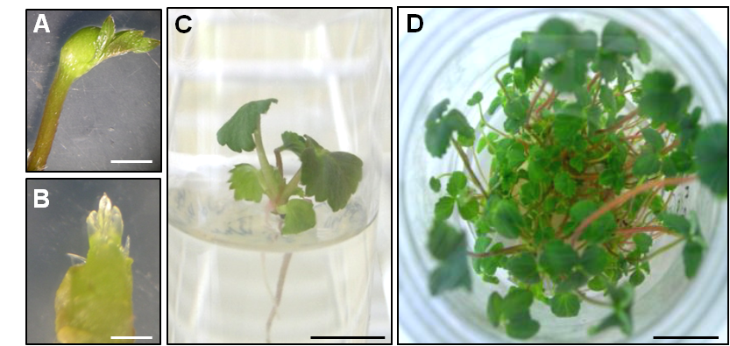
Online Resource 3. Micropropagation of F. x ananassa cv. ‘Pájaro’ plants. A) Runner collected from mother plant after local disinfection, bar = 4 mm. B) Apical meristem extracted from a runner, bar = 200 µm. C) One month-old micropropagated plant grown in initiation medium, bar = 4 mm. D) Micropropagated plants after 6 to 8 weeks since cultivated in multiplication medium, bar = 14 mm.
Online Resource 4. Regeneration of WT F. x ananassa leaf explants after one month. A) Small calluses formation from EHA105(pBIN19-sgfp) transformed explant grown in selective medium (SM, kanamycin 25 µg/ml). B) Prominent mass of calluses with incipient shoots from an explant grown in shoot regeneration medium (regeneration control). C) Necrotized non-transformed leaf disk grown in SM (selective control). Bars = 1.25 mm.

Online Resource 5. Visualization of sgfp expression in etiolated stably transformed GFP F. x ananassa plants. In vitro plant kept in darkness during one month to get rid of the chlorophyll; shoots and a root observed under bright (A, C) and UV light (B, D). Bars = 330 µm.

Online Resource 6. Visualization of sgfp expression in calluses regenerated from stably transformed GFP F. x ananassa non-fluorescent leaves. (A) Lack of fluorescence in those totally expanded leaves (marked with circles) of an in vitro-grown plant, and fluorescent young shoots and roots. Fluorescent calluses regenerated from non-fluorescent leaves marked in (A) with dash (B) and (C) continuous line. Bars (A) = 500 µm; bars (B, C) = 16 mm.

