Supplementary Material

Hippocampo-horn Percentage and Parietal Atrophy Score for Easy Visual Assessment of Brain Atrophy on Magnetic Resonance Imaging in Early- and Late-Onset Alzheimer’s Disease

Guide for Quick and Correct Determination of the Hippocampal Size Using Hip-hop on Brain MR Imaging or CT
Prof. Ales Bartos, MD, PhD, Olga Pashkovska, MD, Jana Mrzilkova, MD, PhD
Charles University, Third Faculty of Medicine, University Hospital Kralovske Vinohrady, Prague, Czech Republic, http://www.abadeco.cz

The purpose of this guide is to describe the determination of a hippocampal size on MR or on CT of the brain using a quick and easy scale named Hip-hop.

- What is Hip-hop?
Hip-hop is an abbreviation of the name of the method "HIPpocampo-Horn Percentage". It expresses the relative ratio of the hippocampal area to the common areas of the hippocampus and the adjacent temporal horn of the lateral ventricle in one selected coronal section of magnetic resonance (MR) or computed tomography (CT) of the brain. The proportion of these areas is estimated as a percentage by sight only. No complicated delineation of structures and calculations or specialized software is required.
Hip-hop is used for a quick semi-quantitative assessment of the size of the hippocampus on MR / CT of the brain. The result is expressed as a percentage, so at the same time it provides a quick idea of the extent to which the hippocampus is preserved.
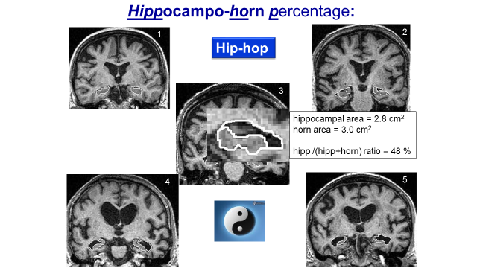

- How can you select optimal coronal slice for hip-hop assessment?
You are viewing through the coronal slices from front to back before the temporal lobe appears. The amygdala is located in the middle of it and is a gray spherical mass in the middle of the white mass of the temporal lobe. As it moves backwards, the ovoid gray area of the amygdala decreases and gradually gets smaller in the cranial direction. The hippocampus first appears together with the disappearing amygdala latero-caudally. After the nuclei of the amygdala disappear, we can see slices with the hippocampus (without amygdala) and with the horn of the lateral ventricle. The hippocampus appears as a twisting structure and truly resembling a seahorse horizontally.
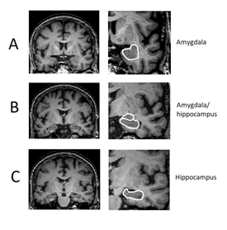
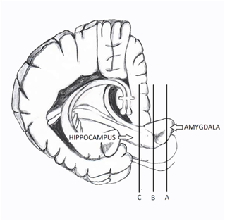
Supplementary Figure 1. Procedure showing how to choose coronal suitable slice for hippocampal area measurement. The left figure shows brain structures involving the hippocampus and amygdala. There are three sections through different parts of these structures. They are labelled A, B, and C which correspond to the right magnetic resonance imaging slices in the left MRI column: A – slice through amygdala, B – slice through amygdala and hippocampus and C – slice only through hippocampus, or suitable slice. Detailed views of structures of interest are displayed in the MRI right column (Zach et al., 2020 [1]).

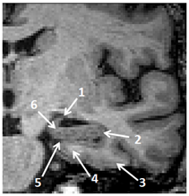
Supplementary Figure 2. A detailed view of left mediotemporal structures on the suitable slice of brain MRI. Anatomical structures are labeled as follows: 1 - hippocampal fimbria, 2 - alveus, 3 - parahippocampal gyrus, 4 - subiculum, 5 - hippocampal fissure, 6 - uncus of the parahippocampal gyrus (Zach et al., 2020 [1])

The suitable slice to rate Hip-hop has following characteristics:
1) when the amygdala disappears during viewing in the fronto-occipital direction, it is usually the first slice after the disappearance of the amygdala in the cranial part in the amygdalo-hippocampal junction;
2) when the fissura hippocampalis separating the hippocampus from the subiculum is caudally well visible (gray matter on the surface of the parahippocampalis gyrus);
3) when the hippocampus narrows cranially into the hippocampal fimbria and it is attached to the ceiling of the temporal horn of the lateral ventricle.
The basilar artery is often seen as a guide.

- How can you determine ratio of areas of the hippocampus relative to (hippocampus + temporal horn of the lateral ventricle) for visual assessment?
The ultimate goal is to estimate the percentage of Hip-hop with the naked eye.
In a suitably selected coronal slice, you can imagine the area occupied by the gray hippocampus relative to the common areas occupying both the gray hippocampus and either the white (T2- ) or black (T1- or FLAIR-weighted) temporal horn of the adjacent lateral ventricle. For small hippocampi, it is a good option to estimate how many times the area of the gray hippocampus will fit in the area of the white or black horn. When it fits, for example, twice, it means that the hippocampus occupies 33%, because the area of the ventricle is 2x33% = 66%, i.e., together 33 + 66 = 100% of the total area.
After estimating the ratio of areas by sight, we express Hip-hop as a number of percentages, usually in tens of percentages, e.g., 40%. Exceptionally, in case of ambiguity, you may express Hip-hop more precisely at 5%, e.g., 45%.
We recommend to write down the order of the sides as the text is usually read, i.e., from left to right. So first write the percentage of the right hippocampus (which is on the left in the brain images) and then the left hippocampus (on the right in images).
Hip-hop results are entered in the radiological or medical documentation as follows: Hip-hop: right 60% / left 30% or just "Hip-hop 60% / 30%".
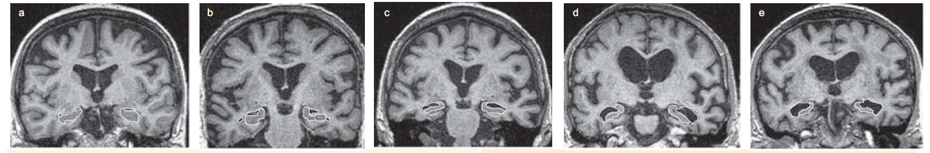
30%
30%
40%
40%
60%
80%
80%
90%
90%
60%
Supplementary Figure 3. Examples of different proportions between hippocampal and horn areas on brain MRI.

We wish you much benefit from our easily and quickly determined Hip-hop .
Ales Bartos, Olga Pashkovska, Jana Mrzilkova

REFERENCE
[1] Zach P, Bartoš A, Lagutina A, Wurst Z, Gallina P, Rai T, Kieslich K, Riedlová J, Ibrahim I, Tintěra J, Mrzílková J (2020) Easy identification of optimal coronal slice on brain magnetic resonance imaging to measure hippocampal area in Alzheimer's disease patients. Biomed Res Int 2020, 5894021.

Parietal Atrophy Score (PAS) on brain MRI
- All coronal slices need to be assessed from the anterior part of cerebellar hemispheres ventrally to the border between parietal and occipital lobe dorsally.
- Focus on three structures: 1) sulcus cingularis posterior (most important), 2) precuneus, 3) parietal gyri (see Supplementary Figure 5).
- Score each of these parietal structures on one side with degree 0 as a normal finding without atrophy (Supplementary Figure 4), or with 1 as a borderline finding (Supplementary Figure 5), or with 2 as a prominent atrophy (Supplementary Figure 6).
Supplementary Figure 6
Supplementary Figure 5
Supplementary Figure 4
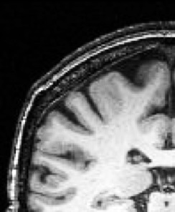
PAS 0
PAS 2
PAS 1

Precuneus
Sulcus cingularis posterior

0
2
2
0
Parietal gyri
1
1
0
2
1

4) Combine these three subscores into one hemispheral PAS according to the rules in Supplementary Table 1.

Supplementary Table 1.
Parietal atrophy score (PAS) on the right or left | Criteria
0  a normal size of parietal lobe without atrophy | the total sum of atrophy degrees of three evaluated structures is 0 or 1
1  a borderline finding | the criteria for rating PAS 0 or 2 are not met
2  a prominent atrophy of the lobe | a) precuneus is ranked 2  or  b) parietal gyri are ranked 2  or  c) sulcus cingularis posterior is ranked 2 and at least one other structure is ranked 1

5) Finally, combine two hemispheral PAS into one total score (PAS glob.) for the whole brain according to the rules in Supplementary Table 2.

Supplementary Table 2
Parietal atrophy score (PAS) on the right / left | Total score (PAS glob.)
0 / 0 | 0 - a normal size without atrophy
0 / 1 or 1 / 0 | 0 - a normal size without atrophy
1 / 1 | 1 - a borderline finding
2 / 0 or 0 / 2 | 2 - a prominent atrophy of one parietal lobe
2 / 1 or 1 / 2 | 2 - a prominent atrophy of one parietal lobe
2 / 2 | 3 - a prominent atrophy of both lobes

