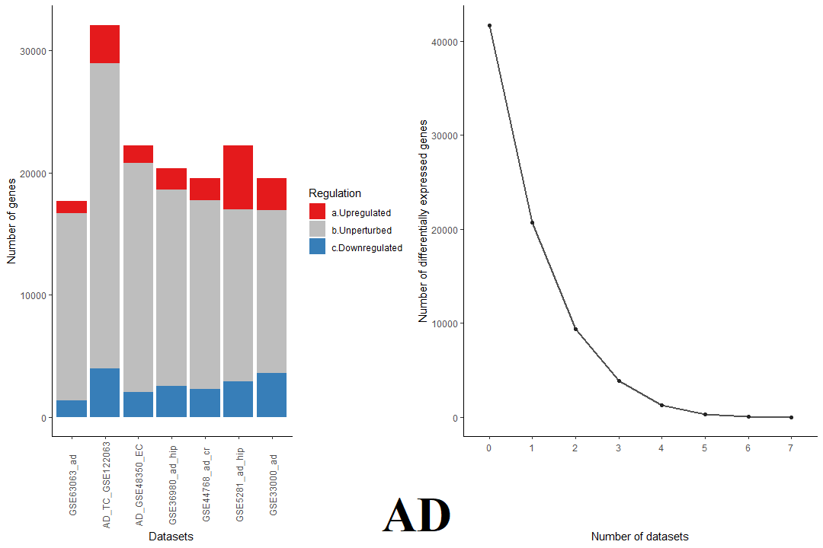
Supplementary File 7A. Meta-analysis results for AD datasets: The figure on the left shows the proportion of upregulated (red), downregulated (blue), and unperturbed genes (grey) across each of the AD gene expression datasets. The figure on the right shows the convergence pattern of consistently and differentially expressed genes yielded by the MetaVolcanoR package.
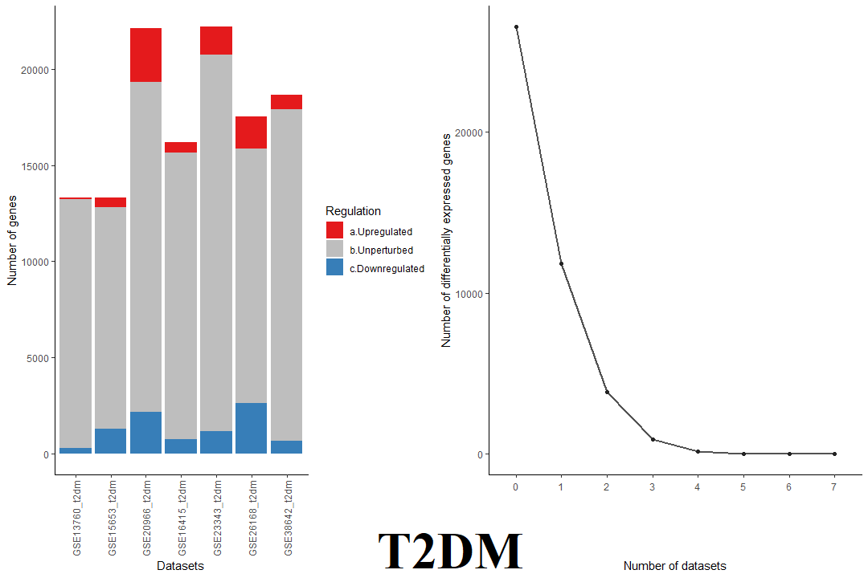
Supplementary File 7B. Meta-analysis results for T2DM datasets: The figure on the left shows the proportion of upregulated (red), downregulated (blue), and unperturbed genes (grey) across each of the T2DM gene expression datasets. The figure on the right shows the convergence pattern of consistently and differentially expressed genes yielded by the MetaVolcanoR package.

