Supplementary Material

Dual Bioorthogonal Labeling of the Amyloid-β Protein Precursor Facilitates Simultaneous Visualization of the Protein and Its Cleavage Products

Supplementary Figure 1. Inverse electron-demand Diels-Alder cycloaddition between TCO*K and mT-BDP-FL

Tetrazine ligation between the turn-on dye 6-methyl-tetrazine-BDP-FL and the ncAA TCO*K.

Supplementary Figure 2. Comparison of 10 different mutations in the Aβ region of AβPP by western blot

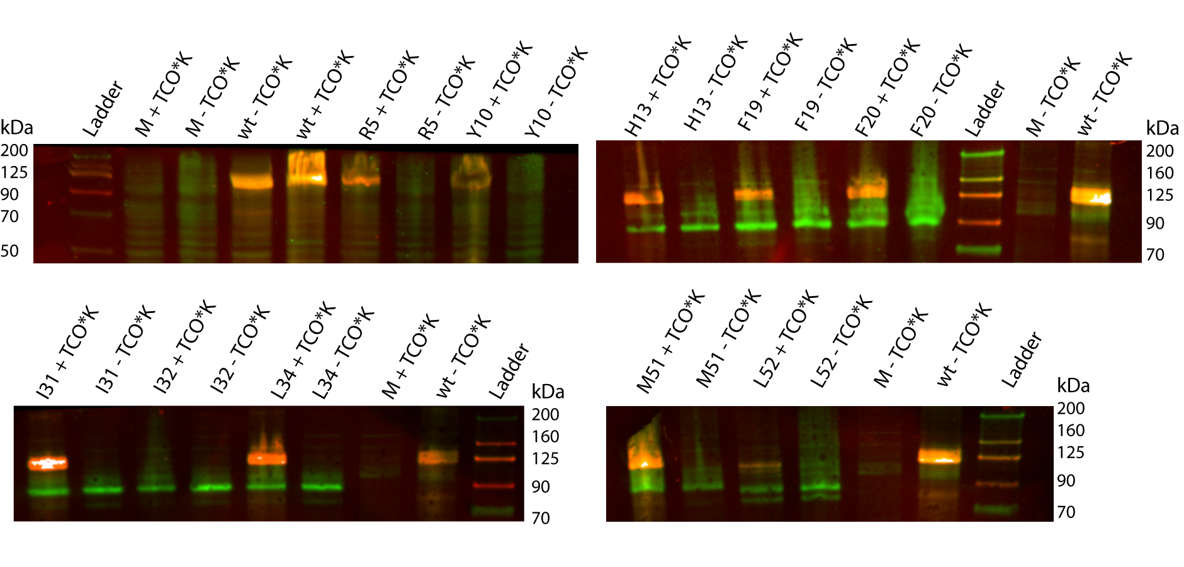

HEK293T cells were transfected with AβPP695-SNAP vectors with different mutations and the PylRS^{AF}. The mutations are labeled with the mutated AA number in Aβ. As a control we used non-transfected cells (M). TCO*K was used as ncAA. First Blot: AB 4G8 (green) and Anti-SNAP (red) were used. Other Blots: AB 6E10 (green) and Anti-SNAP (red) were used

Supplementary Figure 3. Supplementary western blot images to Figure 2

A 6E10 AB B SNAP-AB
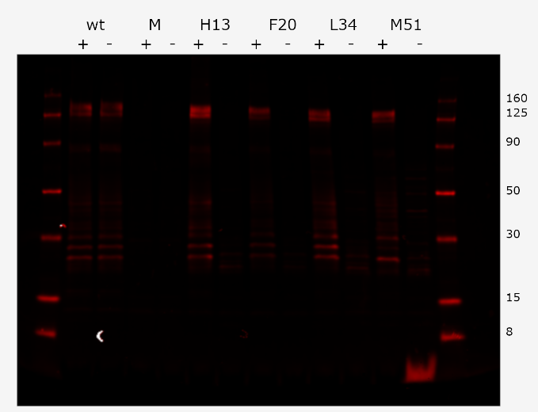
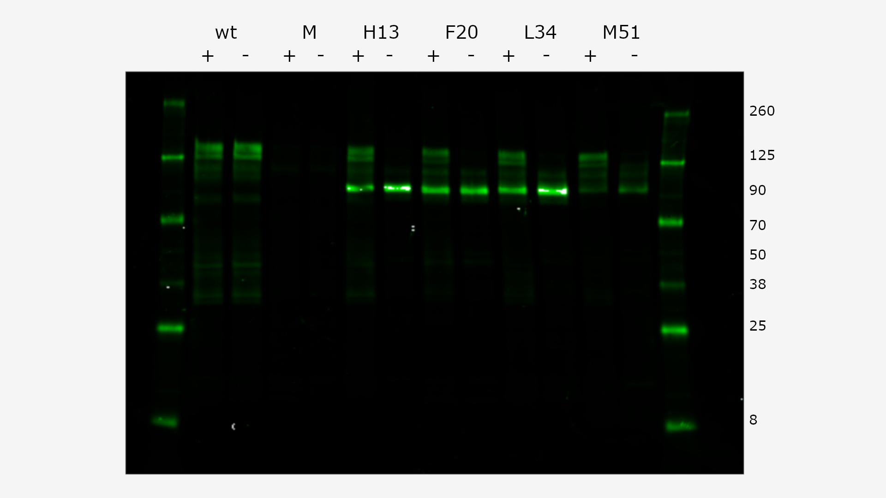

C Whole protein stain
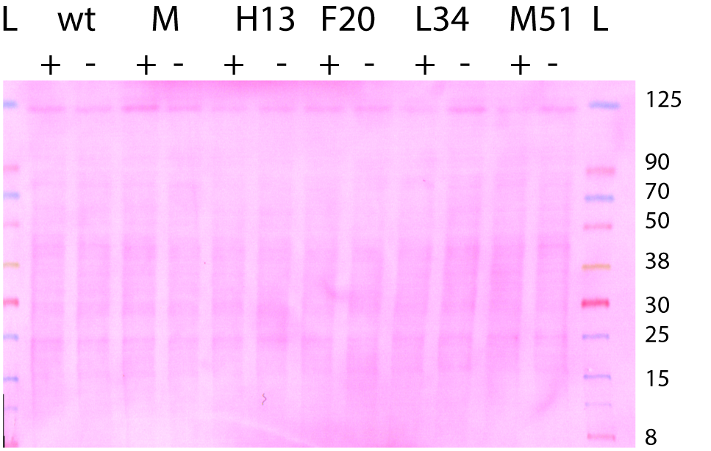

Supplementary blot images to Figure 1: HEK293T cells were transfected with AβPP695-SNAP vectors with different mutations and the PylRS^{AF}. The mutations are labeled with the amino acids number in Aβ. TCO*K was used as ncAA. AβPP-SNAP without mutation (wt) and non-transfected cells (M) were included as controls. A) AB 6E10 (green) and B) Anti-SNAP (red) were used. C) Afterwards the blot was stained with whole protein stain.

Supplementary Figure 4. Deglycosylation of amber-suppressed AβPP-SNAP variants

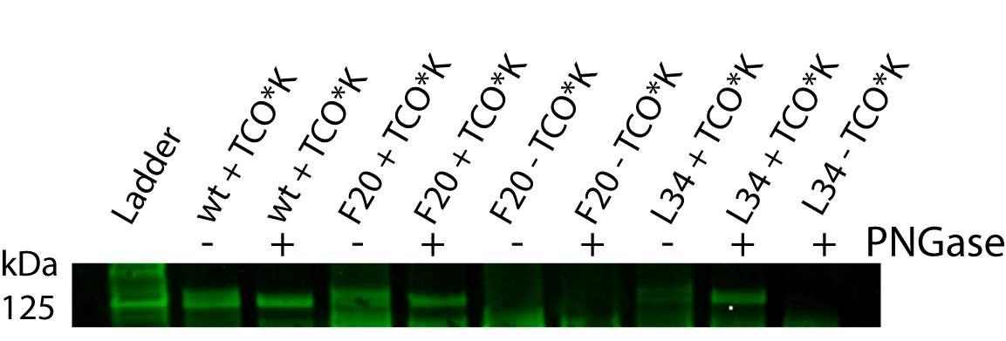

HEK293T cells were transfected with AβPP695-SNAP vectors with different mutations and the PylRS^{AF}. The mutations are labeled with the AA number in Aβ. TCO*K was used as ncAA. AB 6E10 was used. Lanes labeled with - are untreated controls, lanes labeled with + were loaded with lysate, which were incubated over night with Neuraminidase (0.1 units/µl), 1 µl O-glycosidase (100 units/µl) and 1 µl PNGaseF (25 units/µl).

Supplementary Figure 5. Changes of AβPP processing induced by γ-secretase inhibition

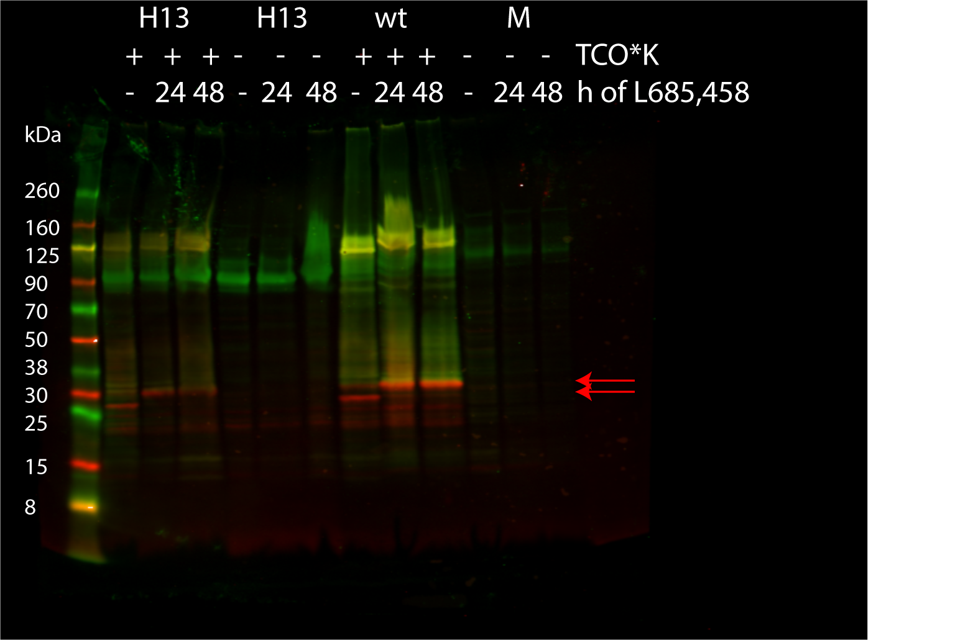

HEK293T cells were transfected with AβPP695-SNAP vectors with a mutation at the 13th AA in Aβ (H13) and the PylRS^{AF}. TCO*K was used as ncAA. As controls AβPP695-SNAP without amber codon (wt) and untransfected cells were used. AB 6E10 and SNAP were used. Lanes labeled with - are untreated controls, lanes labeled with 48 h were treated with the γ-secretase inhibitor L685,458 from the transfection till harvesting of the cells and samples labeled with 24 h were only treated with the γ-secretase inhibitor L685,458 for the last 24 h.

Supplementary Figure 6. Confocal images of TMR-Star and mT-BDP-FL-treated HEK293T cells
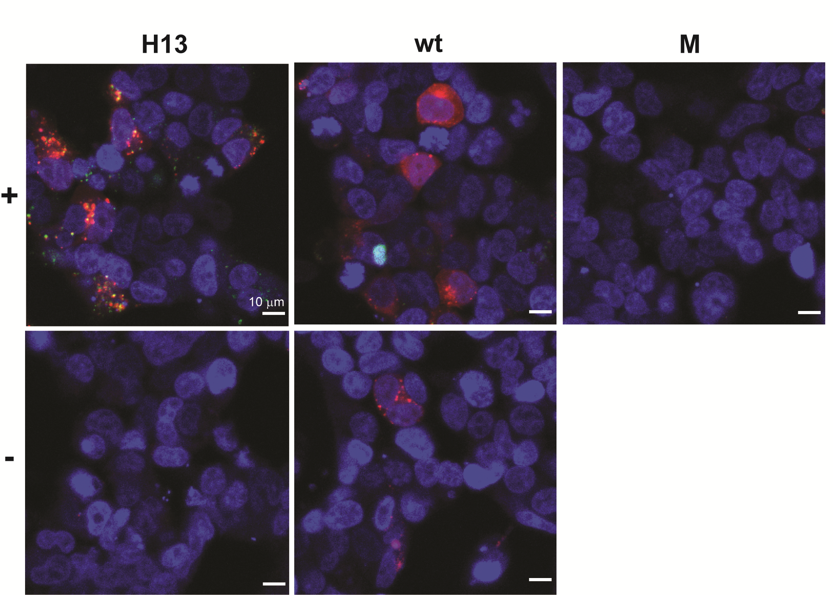

HEK293T cells were transfected with the amber codon machinery and AβPP695-SNAP with a mutation at the 13th AA in Aβ (H13) or wtAβPP (wt). As a further control, non-transfected cells were used (M). The living cells were labeled with TMR-Star (red) and BDP-FL, which reacts with the ncAA (green), followed by labeling of the nuclei with SiR-HOECHST. + and - indicates that the cells were grown in the presence or absence of TCO*K, respectively. Living cells were imaged by confocal microscopy with the two channels imaged in sequential mode (40x magnification).

