Supplementary Material

ABC Dementia Scale Classifies Alzheimer’s Disease Patients into Subgroups Characterized by Activities of Daily Living, Behavioral and Psychological Symptoms of Dementia, and Cognitive Function

# load “dataset.csv” where ADL, BPSD, CF scores of ABC-DS and Global-CDR of 1, 2, 3 are stored. Missing values are shown as “NA”.
clusdat<- read.csv("dataset.csv", header=T, na.strings="NA")
# Extract data of patients with Global-CDR of 1, for example.
clustdatd<- subset(clusdat, CDRBGL==1)
# Execute a hieralchial cluster analysis
clust.d1<-dist(clustdat)
hw<- hclust(clust.d1, "ward.D2")
# Show the result as a dendrogram
plot(hw, xlab="Patients with CDR 1")

Supplementary Table 1. Items of the ABC-DS
Item | Domain | Question
Q1 | Activities of daily living | Daily activities: When the patient changes his/her clothes, how is he/she?
Q2 |  | Motivation: How willingly does the patient undertake activities of daily life?
Q3 |  | Communication: When the patient wants to communicate with others, how easily can he/she do it?
Q4 |  | Complex acts: When the patient wants to use electric appliances such as a TV or an air conditioner, how well can he/she do it?
Q5 | Cognitive function | Recent event memory: How well can the patient recall the place where he/she put his/her belongings?
Q6 |  | Recent event memory: How long can the patient remember daily happenings?
Q7 | Behavioral and psychological symptoms of dementia | Restlessness: When the patient is required to sit still, how is he/she?
Q8 |  | Irritability: When the patient feels something is unsatisfactory, how is he/she?
Q9 |  | Cooperativeness: When caregivers ask the patient something, how is he/she?
Q10 | Cognitive function | Medication: When the patient takes medication, how much help does he/she need?
Q11 | Activities of daily living | Meals: When the patient takes meals, how is he/she?
Q12 |  | Toilets: When the patient uses the toilet, how much help does he/she need?
Q13 | Cognitive function | Care-burden: How frequently should caregivers see to the patient?

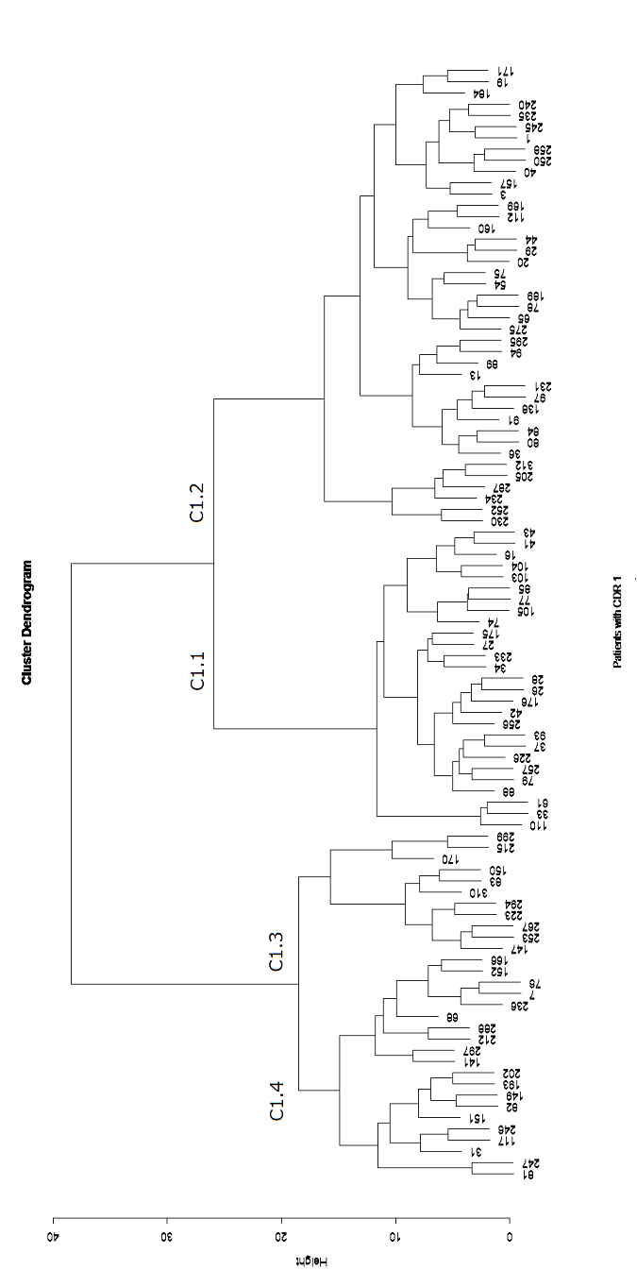

Supplementary Figure 1
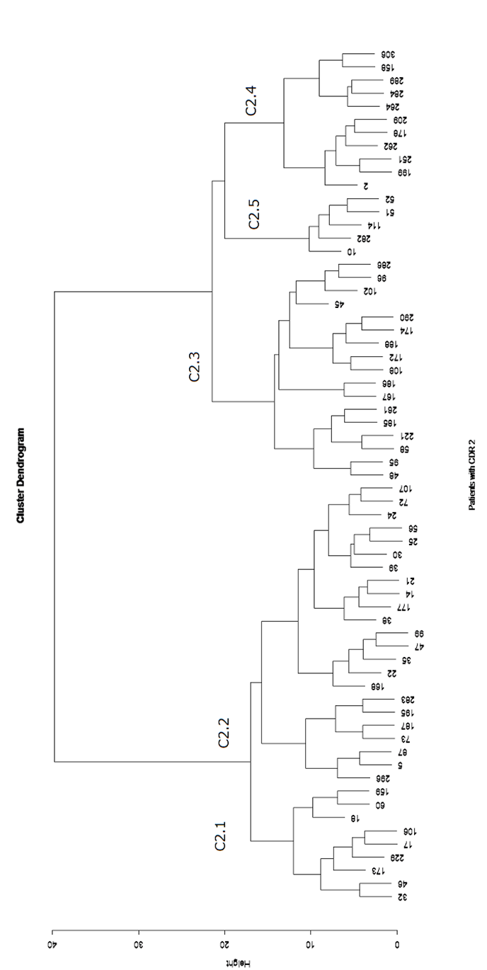

Supplementary Figure 2

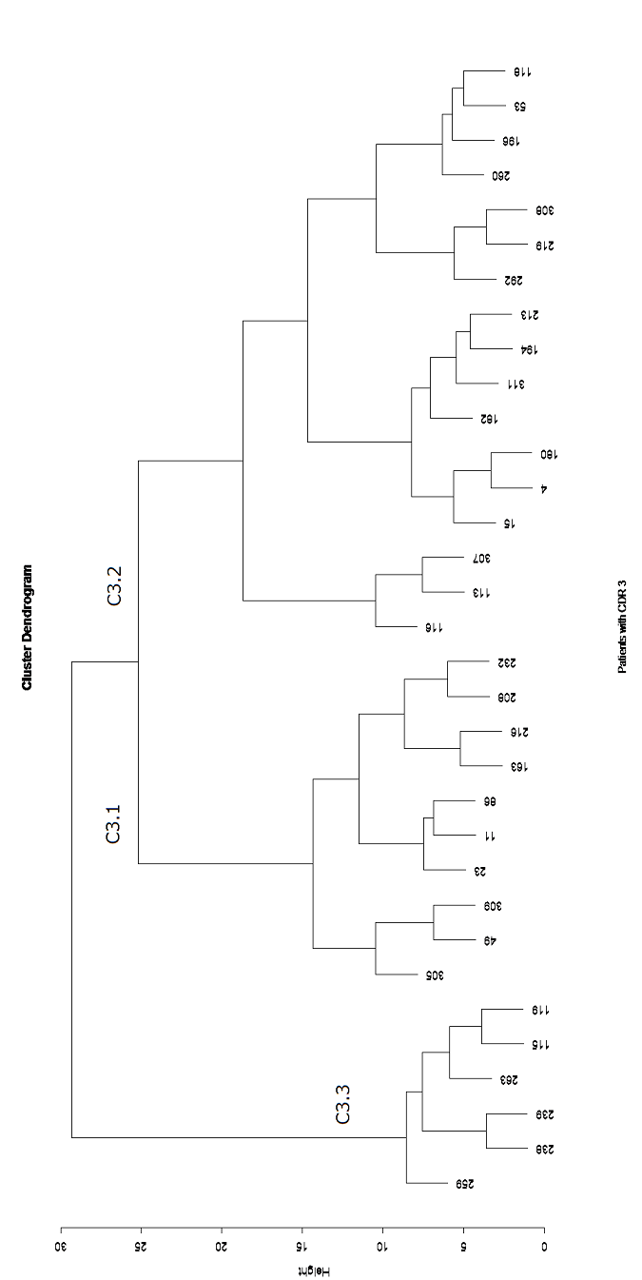

Supplementary Figure 3

