Supplementary Material

Florbetapir Regional Distribution in Cerebral Amyloid Angiopathy and Alzheimer’s Disease: A PET Study

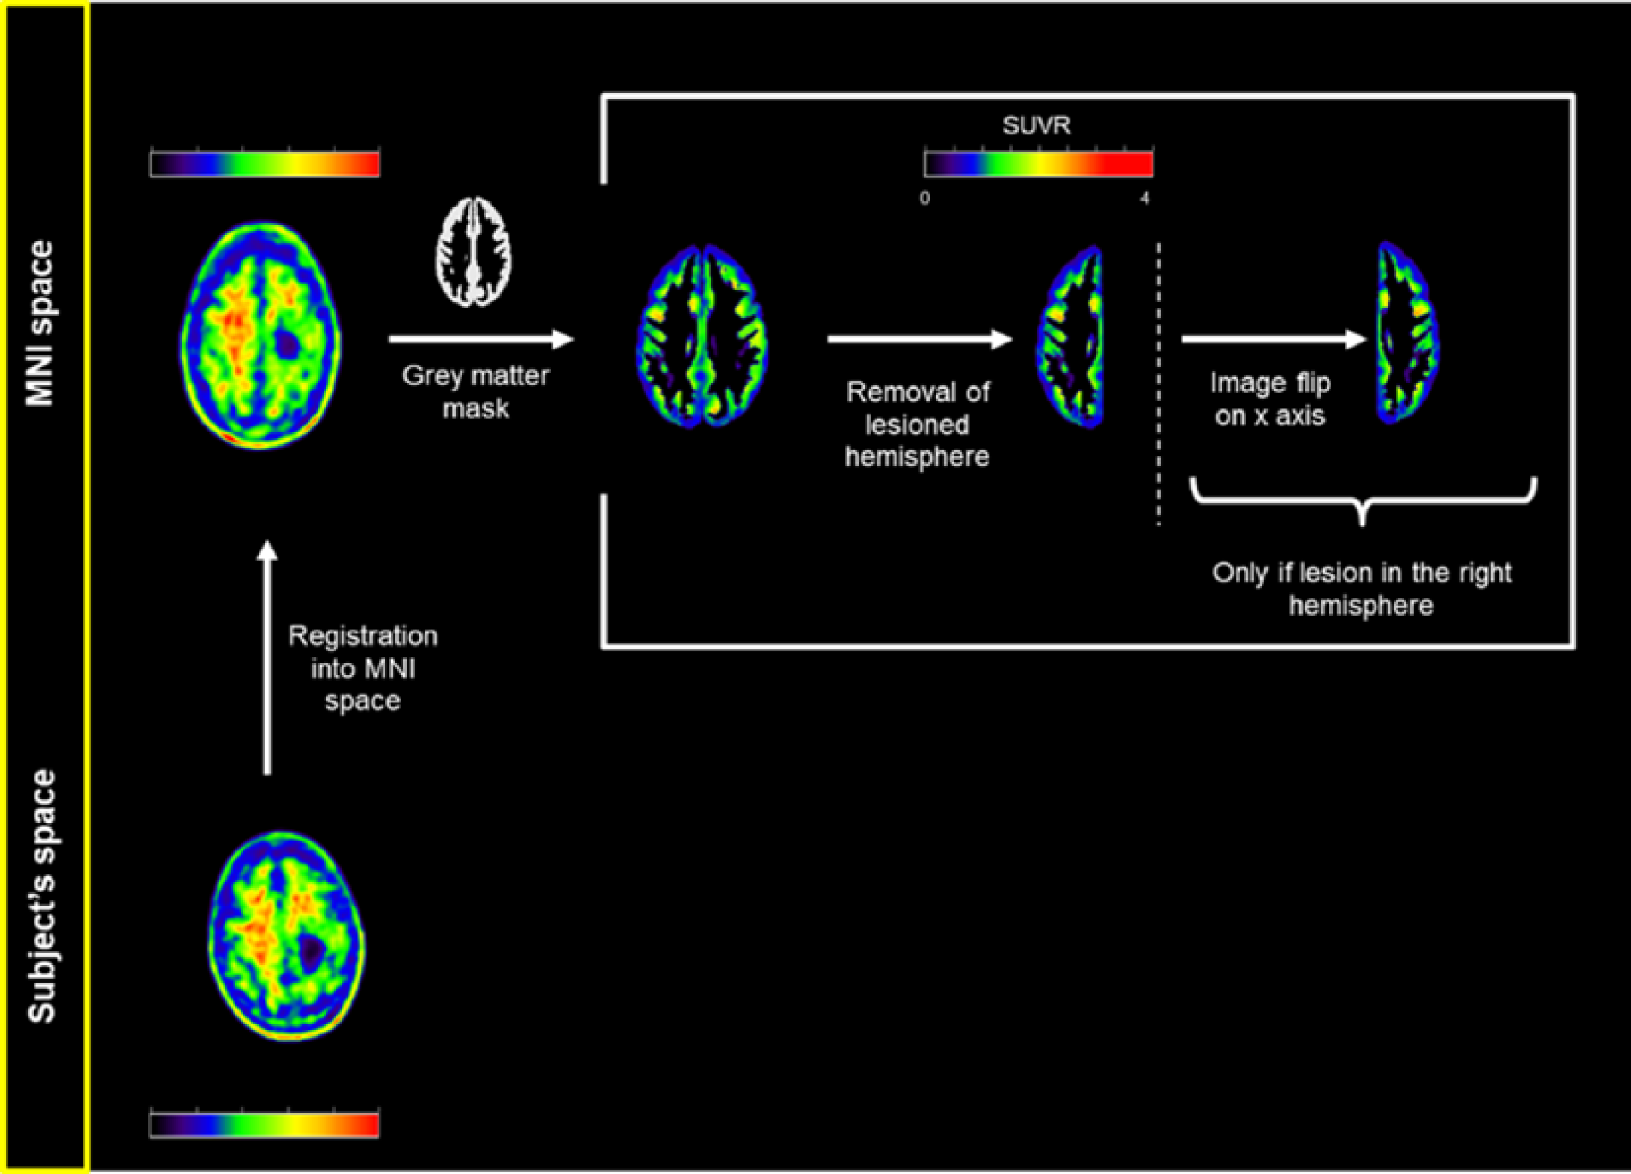
Supplementary Figure 1. Processing of the [¹⁸F]florbetapir-PET scan of a representative case from the CAA-ICH group with right fronto-parietal hematoma. The lesioned hemisphere is masked out and the left hemisphere is flipped along the x axis for group comparison purposes.

