**Supplementary Material**

**Long-Term Effects of Traumatic Brain Injury in a Mouse Model of Alzheimer’s Disease**



**Supplementary Figure 1. Schematic outline of the experimental setup.** Long-term impact of two different TBI models, controlled cortical impact (CCI) and midline fluid percussion injury (mFPI) was investigated in tg-ArcSwe mice at 12 and 24 weeks following the injury (A). The regions of interest, including cortex and hippocampus, are indicated in the illustration of a coronal brain section (B).

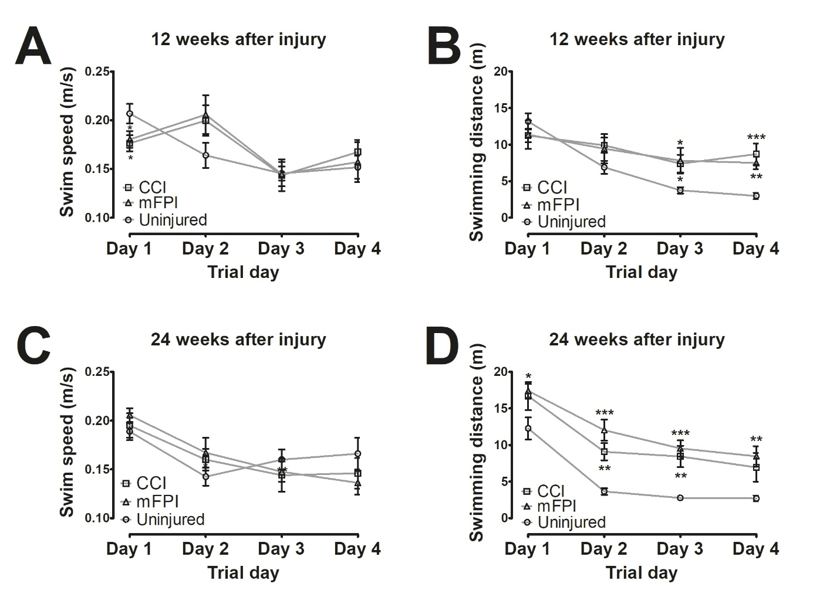

**Supplementary Figure 2.** **No effect on speed after TBI in the Morris water maze test**. The swim speed did not differ between the groups at week 12 (A) or week 24 (B). The swimming distance followed the latency to find the platform (shown in Fig. 10).