SUPPLEMENTARY MATERIAL
Fig. S1. PF-06751979 mean plasma concentration–time curves after single and multiple doses in studies B8271001 and B8271004.
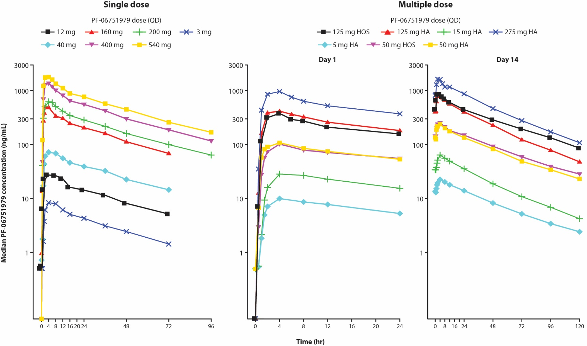
HA, healthy adults; HOS, healthy older subjects; QD, once daily.

Fig. S2. Predicted distribution of individual PD responses when PF-06751979 is administered at 30 mg QD, 75 mg QD, and 110 mg QD.
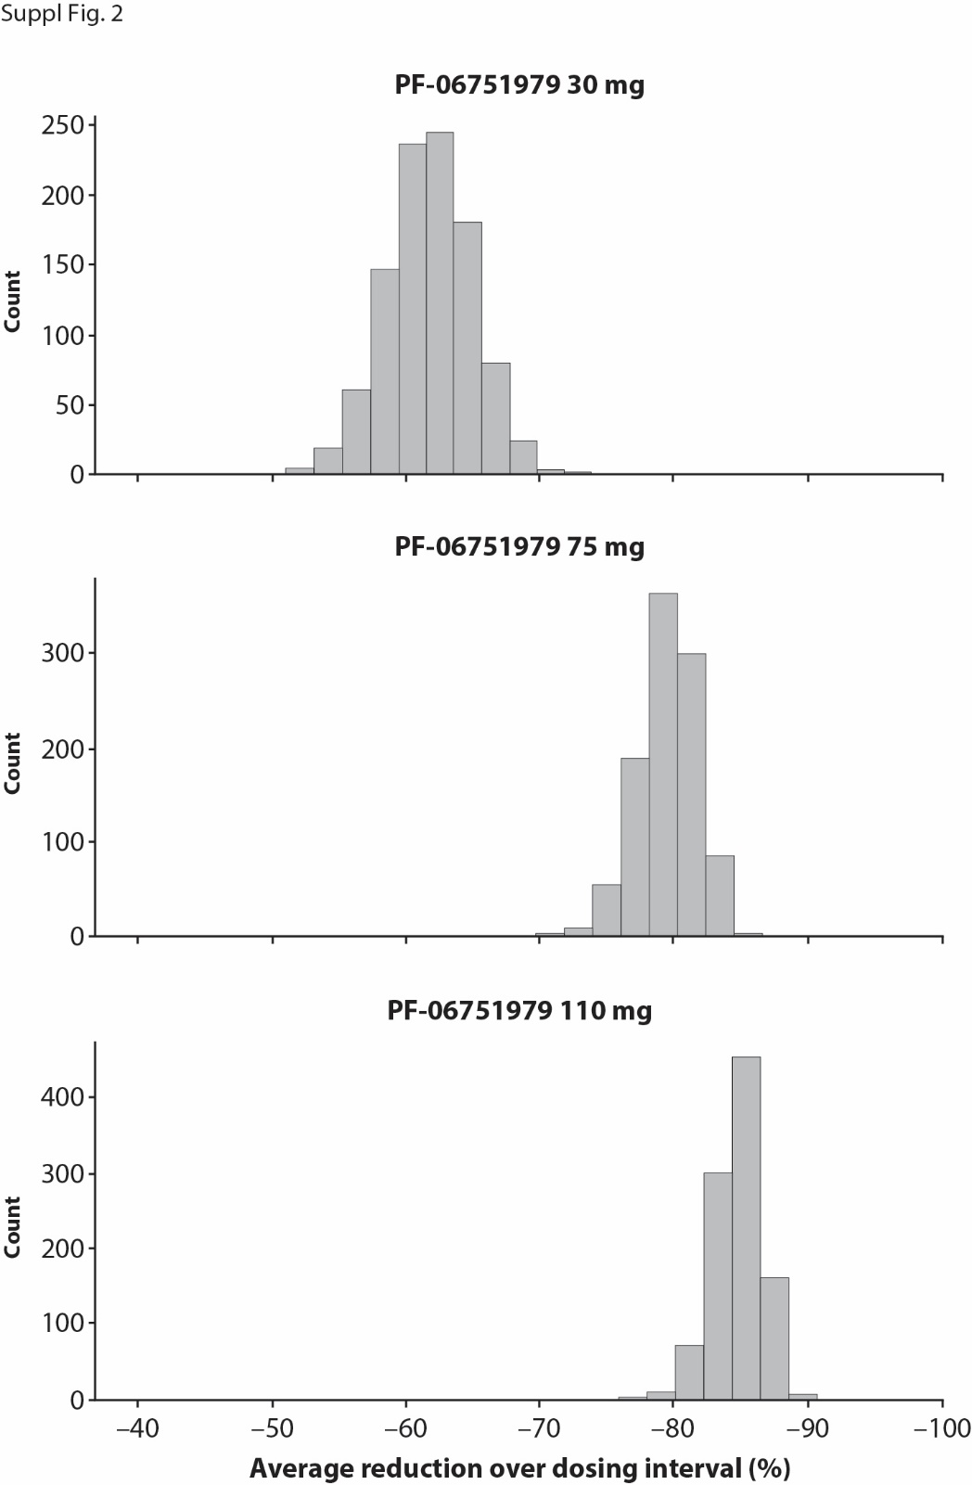
PD, pharmacodynamics; QD, once daily.

Table S1. Mean placebo-adjusted percent change from baseline (2-sided 80% CI) in plasma Aβ fragments in healthy adults treated with single- and multiple-ascending doses of PF-06751979 in studies B8271001 and B8271004
Part A: PF-06751979 single-ascending dose in healthy adults
Mean placebo-adjusted percent change from baseline (2-sided 80% CI)
PF-06751979 dose
Plasma fragment | Time  post-dose  (hours) | 3 mg  (N = 5) | 12 mg  (N = 6) | 40 mg  (N = 6) | 160 mg  (N = 6) | 200 mg  (N = 6) | 400 mg  (N = 6) | 540 mg  (N = 6) | 200 mg fed  (N = 6)
Aβ1-40 | 4 | –41.1  (–47.00, –34.62) | –57.5  (–61.62, –52.85) | –52.9  (–57.57, –47.79) | –61.6  (–65.44, –57.45) | – | – | – | –
 | 6 | – | – | – | – | –84.3  (–86.68, –81.52) | –78.2  (–81.53, –74.33) | –86.9  (–88.90, –84.57) | –77.1  (–80.54, –72.94)
 | 8 | –50.5  (–56.30, –44.05) | –67.0  (–70.76, –62.83) | –69.0  (–72.50, –64.99) | –80.9  (–83.08, –78.45) | –87.7  (–89.16, –85.94) | –82.4  (–84.52, –79.88) | –89.0  (–90.36, –7.47) | –80.7  (–83.07, –78.01)
 | 24 | –34.8  (–41.51, –27.41) | –61.0  (–64.91, –56.65) | –66.6  (–69.98, –62.85) | –84.0  (–85.63, –82.21) | –90.2  (–91.00, –89.35) | –84.9  (–86.13, –83.54) | –89.4  (–90.27,– 88.44) | –83.5  (–84.87, –82.00)
 | 48 | –28.0  (–35.50, –19.63) | –53.3  (–58.07, –48.02) | –57.4  (–61.76, –52.51) | –82.0  (–83.88, –79.98) | –90.2  (–91.11, –89.23) | –86.1  (–87.41, –84.71) | –90.3  (–91.17, –89.25) | –84.3  (–85.79, –82.70)
Aβx-40 | 4 | –34.1  (–39.27, –28.55) | –48.4  (–52.41, –44.12) | –39.6  (–44.26, –34.61) | –45.4  (–49.64, –40.89) | – | – | – | –
 | 6 | – | – | – | – | –65.1  (–68.23, –61.72) | –58.3  (–61.99, –54.27) | –63.3  (–66.59, –59.67) | –59.4  (–62.98, –55.41)
 | 8 | –39.8  (–44.23, –35.01) | –53.3  (–56.72, –49.62) | –51.6  (–55.08, –47.75) | –58.2  (–61.21, –54.85) | –66.9  (–69.85, –63.59) | –63.1  (–66.37, –59.45) | –68.3  (–71.19, –65.14) | –62.0  (–65.41, –58.24)
 | 24 | –25.1  (–31.97, –17.46) | –49.2  (–53.8, –44.2) | –46.6  (–51.39, –41.34) | –60.8  (–64.32, –56.92) | –69.7  (–72.21, –66.85) | –67.4  (–70.12, –64.40) | –72.2  (–74.60, –69.63) | –62.9  (–66.05, –59.50)
 | 48 | –18.0  (–25.44, –9.88) | –40.0  (–45.26, –34.13) | –38.8  (–44.18, –32.88) | –56.5  (–60.33, –52.28) | –70.0  (–72.76, –66.98) | –67.0  (–69.99, –63.66) | –72.9  (–75.45, –70.18) | –62.4  (–65.84, –58.60)
Aβ total | 4 | –29.8  (–35.01, –24.10) | –45.0  (–48.92, –40.73) | –36.8  (–41.46, –31.82) | –45.8  (–49.89, –41.46) | – | – | – | –
 | 6 | – | – | – | – | –51.8  (–59.59, –42.42) | –59.3  (–66.42, –50.67) | –57.6  (–64.49, –49.29) | –49.1  (–57.44, –39.23)
 | 8 | –36.4  (–42.06, –30.19) | –46.9  (–51.37, –41.92) | –47.8  (–52.35, –42.90) | –57.4  (–61.11, –53.29) | –59.1  (–65.70, –51.29) | –60.9  (–67.71, –52.72) | –66.8  (–72.19, –60.43) | –56.4  (–63.49, –48.05)
 | 24 | –27.7  (–36.81, –17.25) | –43.9  (–50.64, –36.21) | –49.1  (–55.30, –42.12) | –60.8  (–65.62, –55.40) | –64.2  (–70.68, –56.37) | –58.2  (–66.22, –48.36) | –69.4  (–74.94, –62.64) | –58.4  (–65.93, –49.21)
 | 48 | –19.0  (–26.33, –10.93) | –35.4  (–40.98, –29.26) | –33.0  (–38.87, –26.50) | –53.8  (–57.94, –49.31) | –62.0  (–68.40, –54.38) | –67.4  (–73.25, –60.24) | –65.2  (–71.09, –58.19) | –59.6  (–66.40, –51.41)

Part B: PF-06751979 multiple-ascending dose in healthy adults
Mean placebo-adjusted percent change from baseline (2-sided 80% CI)
PF-06751979 dose
Plasma fragment | Day | 5 mg  (N = 8) | 15 mg  (N = 8) | 50 mg  (N = 8) | 125 mg  (N = 12) | 275 mg  (N = 9)
Aβ1-40 | 1 | – | – | – | –87.7  (–88.27, –87.11) | –88.3  (–88.87, –87.69)
 | 2 | –45.2  (–49.54, –40.42) | –58.0  (–61.46, –54.23) | –83.7  (–84.98, –82.26) | – | –
 | 4 | –53.7  (–57.43, –49.74) | –67.1  (–69.77, –64.10) | –87.0  (–88.00, –85.83) | –87.4  (–87.84, –86.88) | –87.3  (–87.80, –86.79)
 | 7 | –58.2  (–61.54, –54.60) | –71.4  (–73.80, –68.89) | –87.1  (–88.10, –85.94) | –87.1  (–87.59, –86.63) | –87.1  (–87.55, –86.53)
 | 10 | –58.0  (–61.38, –54.40) | –68.9  (–71.43, –66.07) | –87.2  (–88.20, –86.07) | –86.8  (–87.07, –86.61) | –86.8  (–87.02, –86.53)
 | 14 | –58.7  (–61.95, –55.08) | –68.0  (–70.66, –65.16) | –86.2  (–87.26, –84.95) | –87.5  (–87.79, –87.14) | –87.4  (–87.75, –87.06)
Aβx-40 | 1 | – | – | – | –69.1  (–71.37, –66.57) | –70.4  (–72.73, –67.83)
 | 2 | –33.7  (–38.36, –28.77) | –43.9  (–47.87, –39.72) | –58.5  (–61.37, –55.37) | – | –
 | 4 | –40.5  (–44.66, –36.06) | –50.4  (–53.83, –46.61) | –63.5  (–66.07, –60.80) | –72.3  (–74.51, –69.82) | –73.8  (–76.02, –71.30)
 | 7 | –41.1  (–45.19, –36.67) | –56.5  (–59.58, –53.26) | –61.9  (–64.55, –59.04) | –71.0  (–74.16, –67.49) | –72.2  (–75.44, –68.64)
 | 10 | –41.7  (–45.79, –37.36) | –50.9  (–54.31, –47.17) | –62.3  (–64.93, –59.48) | –70.8  (–73.51, –67.80) | –74.1  (–76.63, –71.24)
 | 14 | –40.6  (–44.70, –36.10) | –51.4  (–54.78, –47.70) | –59.6  (–62.40, –56.56) | –71.7  (–74.18, –68.92) | –71.8  (–74.48, –68.91)
Aβ total | 1 | – | – | – | –59.6  (–67.75, –49.32) | –64.0  (–71.53, –54.54)
 | 2 | –29.33  (–38.00, 19.45) | –40.3  (–47.58, –32.00) | –56.8  (–62.16, –50.75) | – | –
 | 4 | –35.4  (–43.33, –26.37) | –45.8  (–52.44, –38.31) | –61.6  (–66.36, –56.22) | –58.1  (–68.12, –44.94) | –65.8  (–74.27, –54.50)
 | 7 | –35.6  (–43.48, –26.57) | –52.2  (–58.02, –45.55) | –63.0  (–67.55, –57.77) | –62.8  (–70.73, –52.72) | –67.3  (–74.50, –58.06)
 | 10 | –31.9  (–40.24, –22.36) | –48.7  (–54.94, –41.55) | –65.3  (–69.62, –60.47) | –62.1  (–71.31, –49.98) | –70.4  (–77.83, –60.40)
 | 14 | –37.4  (–45.06, –28.62) | –45.0  (–51.72, –37.38) | –61.8  (–66.51, –56.42) | –59.1  (–68.51, –46.80) | –69.0  (–76.40, –59.25)
Aβ, amyloid-beta; CI, confidence interval.

