Supplementary Material

Modifiable Risk Factors Discriminate Memory Trajectories in Non-Demented Aging: Precision Factors and Targets for Promoting Healthier Brain Aging and Preventing Dementia?

Supplementary Table 1.
Goodness of fit indexes for episodic memory model confirmatory factor analyses and latent growth models

Model | AIC | BIC |  | χ² |  | df | p |  | RMSEA |  | CFI |  | SRMR
CFA for One Factor Model: Invariance Testing
Configural | 43454.5 | 43684.1 |  | 83.0 |  | 42 | <0.001 |  | 0.033 (0.023-0.044) |  | 0.99 |  | 0.032
Metric | 43497.7 | 43684.2 |  | 144.2 |  | 51 | <0.001 |  | 0.046 (0.037-0.054) |  | 0.98 |  | 0.055
Scaler | 43796.7 | 43945.0 |  | 459.2 |  | 59 | <0.001 |  | 0.088 (0.080-0.095) |  | 0.90 |  | 0.120
Partial Scalerª | 43609.6 | 43786.5 |  | 260.1 |  | 53 | <0.001 |  | 0.067 (0.059-0.075) |  | 0.95 |  | 0.093
Model |  |  | AIC |  | BIC |  |  | -2LL |  | D |  | Δdf |  | p
Fixed Intercept |  |  | 5529.8 |  | 5549.0 |  |  | 5521.8 |  | - |  | - |  | -
Random Intercept |  |  | 3046.4 |  | 3070.4 |  |  | 3036.4 |  | 2485.4 |  | 1 |  | <0.001
Random Intercept, Fixed Slope |  |  | 2879.8 |  | 2908.5 |  |  | 2867.8 |  | 168.6 |  | 1 |  | <0.001
Random Intercept, Random Slope^{b} |  |  | 2543.8 |  | 2582.1 |  |  | 2527.8 |  | 340.0 |  | 2 |  | <0.001

Note. ª Best fitting model where only Word recall 1 was scalar invariant; χ² D=116.0, p<0.001; ΔCFI=0.03; ΔRMSEA=0.02. ^{b} Best fitting model compared to the more restricted previous model.

Supplementary Table 2.
Goodness of fit indexes for episodic memory latent class growth analysis (LCGA).
Class | AIC | BIC | -2LL | Entropy | Prob. | Prop. | n | intercept | slope
1 | 5206 | 5230 | 5196 | - | 1 | 1 | 882 | 0.001 | -0.043
1  2 | 4350 | 4388 | 4334 | 0.78 | 0.92  0.94 | 0.42  0.58 | 366 516 | -0.88  0.58 | -0.047  -0.030
1*  2  3 | 3897 | 3950 | 3876 | 0.80 | 0.90  0.90  0.92 | 0.31  0.47  0.22 | 276 415 191 | 0.93  -0.12  -1.34 | -0.026  -0.043  -0.056
1  2  3  4 | 3535 | 3601 | 3507 | 0.84 | 0.92  0.92  0.87  0.90 | 0.41  0.21  0.27  0.10 | 361  189  240  92 | 0.23  1.12  -0.66  -1.71 | -0.032  -0.024  -0.040  -0.053
1  2  3  4  5 | 3357 | 3439 | 3323 | 0.85 | 0.85  0.90  0.88  0.92  0.90 | 0.04  0.26  0.24  0.10  0.36 | 37  231  210  90  314 | 1.70  -0.71  0.89  -1.73  0.13 | -0.013  -0.040  -0.016  -0.053  -0.030

AIC, Akaike information criteria; BIC, Bayesian information criteria; -2LL, -2 log likelihood; Prob., probability of latent class membership; Prop., proportion for the latent classes based on estimate model. *Best fitting model based on good fit indexes, cell sizes, and a priori hypothesis.

Supplementary Table 3.
 | Stable memory | Normal memory | Declining memory | Total Sample
Young-old
Baseline (n) | 145 | 204 | 86 | 435
Age at baseline M (SD) | 63.9 (5.2) | 64.5 (5.2) | 63.5 (5.2) | 64.1 (5.2)
Wave 2 (n) | 129 | 143 | 48 | 320
Wave 3 (n) | 1155 | 122 | 47 | 284
Old-old
Baseline (n) | 131 | 211 | 105 | 447
Age at baseline M (SD) | 78.5 (4.1) | 79.0 (4.3) | 79.3 (5.3) | 78.9 (4.5)
Wave 2 (n) | 93 | 140 | 64 | 304
Wave 3 (n) | 67 | 72 | 26 | 169
Total (n) | 276 | 415 | 191 | 882
Distribution of Young-old and Old-old adults across class membership

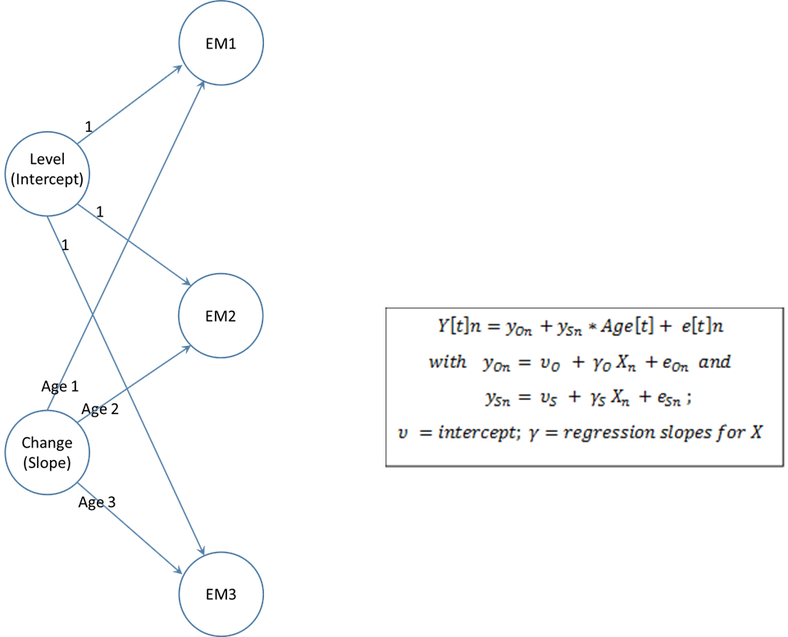

Supplementary Figure 1. Latent growth model of episodic memory (EM) confirmed a best fit model of random intercept, random slope. This model was used in the latent class growth analyses to identify subgroups within the population of normally aging older adults.

