Supplementary Material
Increased Insoluble Amyloid-β Induces Negligible Cognitive Deficits in Old App^{NL/NL} Knock-In Mice

Supplementary Fig. 1. No amyloid deposits in the prefrontal cortex from aged App^{NL/NL} mice. A) Representative images from prefrontal sections from 24-month-old WT or App^{NL/NL} mice stained with Thioflavin. n= 4 mice per group. Scale bar represents 200 µm.

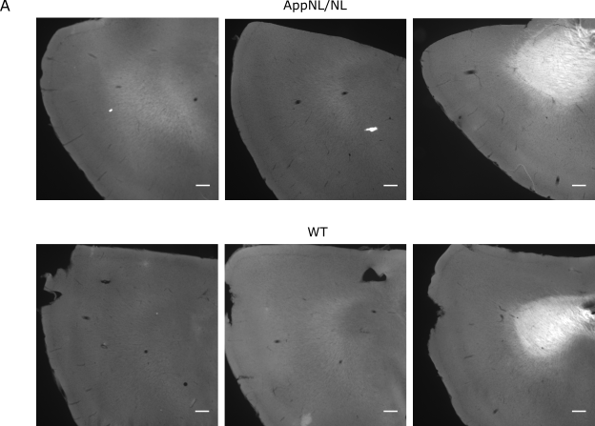
Supplementary Fig. 2. Morris water maze analysis shows no major cognitive differences between 24-month-old WT and App^{NL/NL} mice. A, B) Acquisition curve in the Morris water maze test compares the path length (A) and the average velocity (B) during the 10 training days between 24-month-old WT (n=10) and App^{NL/NL} (n=11) mice. C, D) Time spent swimming in the target quadrant during probe trial 1 (C) (after 5 days of training) and probe trial 2 (D) (after 10 days of training).
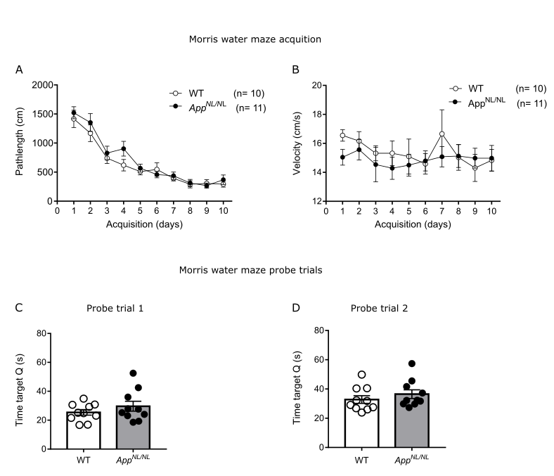

Supplementary Table 1. Correlation analysis between freezing responses in the cued test and Aβ levels. Table shows the Pearson correlation coefficient and the p values for the different Aβ species and the freezing responses during the cued fear test.

 | Pearson r | p values
Correlation with soluble Aβ₄₀ | -0.40 | 0.32
Correlation with soluble Aβ₄₂ | -0.28 | 0.50
Correlation with insoluble Aβ₄₀ | -0.35 | 0.40
Correlation with insoluble Aβ₄₂ | -0.43 | 0.29

