Supplementary Material

Pyk2 is a Novel Tau Tyrosine Kinase that is Regulated by the Tyrosine Kinase Fyn

Chuanzhou Li, Jürgen Götz

MATERIALS AND METHODS
Primary cell culture and cell lines
Hippocampal neurons from WT mouse embryos were obtained at embryonic day 17 (E17) and plated in 12-well plates on coverslips coated with poly-D-lysine (PDL) at a density of 80,000 cells/well. Neurobasal medium (Thermo Fisher Invitrogen) was used as the plating medium, supplemented with 5% fetal bovine serum (FBS; Hyclone), 2% B27, 2 mM GlutaMAX (Thermo Fisher Invitrogen) and 50 U/l penicillin/ streptomycin (Thermo Fisher Invitrogen). The medium was changed to serum-free Neurobasal medium 24 h post-seeding and half the medium was changed twice a week. Microfluidic chambers (SND450, Xonamicrofluidics) were dropped onto the PDL-coated coverslips to form non-plasma bonding with light pressure. Dissociated hippocampal neurons were suspended at a 4-5 × 10⁶ cells/ml density and seeded into one side of the device chamber. The medium was supplemented 10 min after the cells had settled and half of it was changed twice a week. Mature neurons (days in vitro (DIV) 14-28) with or without transfection were subjected to fixation and subsequent immunostaining, except that neurons grown in microfluidic chambers were treated on DIV 9-11 due to the relatively high cell density. Transfections of primary hippocampal neurons were performed using Lipofectamine 2000 (Thermo Fisher Invitrogen) as previously described [1].
Human embryonic kidney (HEK293T) cells were cultured in Dulbecco’s modified Eagle's medium (DMEM) (Thermo Fisher Invitrogen) supplemented with 10% FBS, 1% penicillin and L-glutamine at 37 °C, 5.0% CO₂ with saturated humidity. Prior to transfections, cells were cultured to 70-80% confluency. Transfection was done using Lipofectamine LTX (Thermo Fisher Invitrogen) according to the manufacturer’s instructions. Cells were collected in 1 × radioimmunoprecipitation assay (RIPA) buffer (Cell Signaling Technology) supplemented with a protease/phosphatase inhibitor cocktail (Cell Signaling Technology) or 2 × Laemmli sample buffer (Bio-Rad). They were then thoroughly lysed by sonication and heat denatured at 95°C for 5 min before loading onto gels for analysis.

Crude synaptosomal (P2) preparation
WT mouse brain was removed immediately after decapitation and transferred to 10 ml of ice-cold sucrose solution (0.32 M sucrose, 1 mM EDTA, 5 mM Tris-HCl pH 7.4). Brains were minced with scissors and immediately homogenized in a Teflon glass homogenizer. 100 µl of lysate was removed as homogenate control (Hm). The homogenate was centrifuged at 1,000 g for 10 min at 4°C, yielding a pellet (P1) and supernatant (S1). Fraction S1 was transferred to a fresh centrifuge tube and centrifuged at 14,000 g for 20 min at 4°C. The resultant pellet (crude P2) was resuspended in RIPA buffer (Cell Signaling Technology, #9806) for further analysis.

Preparation of recombinant proteins
Human tau expression and purification were performed as previously described [2]. The human Pyk2 cDNA was derived from the pDONR223-PTK2B vector and subcloned into the pET-DEST42 expression vector in frame with a C-terminal 6×His and V5 tag (Life Technologies). Plasmids were transformed in BL21 cells and recombinant protein expression was induced with 1 mM isopropyl β-D-1-thiogalactopyranoside (IPTG) for 3 h at 37°C. The bacterial suspension was pelleted at 4,000 g for 15 min at 4°C and then resuspended in IMAC buffer (300 mM KCl, 50 mM KH₂PO4, 5 mM imidazole, pH 8.0) containing Complete protease inhibitors and 0.1 mg/ml lysozyme (Sigma Aldrich), followed by incubation on ice for 20 min. The cells were then subjected to repeated freeze/thawing after which they were sonicated at a 60% amplitude for 1 min. The lysate was centrifuged at 16,000 g for 20 min at 4°C and filtered through a 0.22 μm syringe filter (Merck Millipore). The subsequent lysate was passed over a 1 ml Bio-Scale Mini IMAC cartridge (BioRad) equilibrated in IMAC buffer, and eluted in 300 mM KCl, 50 mM KH₂PO4, 250 mM imidazole, pH 8.0. Eluted proteins underwent buffer exchange into 137 mM NaCl, 2.7 mM KCl, 4.3 mM Na₂HPO4, 88 mM KH₂PO4, pH 7.4, using a Bio-Scale Mini Bio-Gel P-6 Desalting Cartridge (Bio-Rad) and were then subjected to size exclusion chromatography using an S200 10/30 GL column (GE Healthcare) equilibrated in PBS. Fractions corresponding to the protein of interest were combined and concentrated using an Amicon Ultra Filter with a 3,000 Da molecular mass cut-off (Merck Millipore). Purified recombinant proteins were resolved on SDS-PAGE gel followed by Coomassie staining or western blotting.

Real-time quantitative PCR
HEK293T cells were collected in TRIzol (Thermo Fisher Ambion) and total RNA was extracted, followed by reverse-transcription using a cDNA reverse-transcription kit (Thermo Fisher Invitrogen). The resulting cDNA was used for qRT-PCR using a SYBR Green Master mix (Bio-Rad) and analyzed using the CF96 Real-time System (C1000 Touch Thermo cycler). The following primers were used: total PTK2B forward, 5’-TCCCTGGACCCCATGGTTTA-3’; total PTK2B backward, 5’-CTGTGAACTCCAGGTAGCCG-3’; exogenous PTK2B forward, 5’-TTCTGGCCAATCTGGCCCA-3’; exogenous V5 backward, 5’-ACCGAGGAGAGGGTTAGGGAT-3’; GAPDH forward, 5’-TGCACCACCAACTGCTTAGC-3’; GAPDH backward, 5’-GGCATGGACTGTGGTCATGAG-3’.

REFERENCES
[1] Xia D, Li C, Götz J (2015) Pseudophosphorylation of Tau at distinct epitopes or the presence of the P301L mutation targets the microtubule-associated protein Tau to dendritic spines. Biochim Biophys Acta 1852, 913-924.
[2] Liu C, Song X, Nisbet R, Götz J (2016) Co-immunoprecipitation with tau isoform-specific antibodies reveals distinct protein interactions and highlights a putative role for 2N tau in disease. J Biol Chem 291, 8173-8188.

Supplementary Fig. 1. Body weight loss in pR5/Pyk2 double transgenic mice and validation of antibodies used for immunofluorescence staining. A) Body weight of 12-month-old WT, Pyk2, pR5 and pR5/Pyk2 transgenic animals. Mean ± s.e.m, n = 20, 26, 13, 10 mice per group, respectively; one-way ANOVA with post hoc Sidak’s tests, **p < 0.01. B) Weight of half brain hemisphere from 12-15-month-old WT, Pyk2, pR5 and pR5/Pyk2 transgenic animals. Mean ± s.e.m, n = 25, 27, 16, 9 mice per group, respectively; one-way ANOVA with post hoc Sidak’s tests, n.s., not significant. C) Representative immunofluorescence images for the indicated antibodies of brain sections from a 12-month-old pR5/Pyk2 mouse. Negative controls were performed without application of the respective primary antibodies, showing the same area as in the upper panel. Scale bar: 200 μm.

Supplementary Fig. 2. Transgenic Pyk2 and tau expression in transgenic brains. A) Representative full immunofluorescence images of the brain sections from a 12-month-old pR5/Pyk2 mouse. Magnified insets of the (i) cortex, (ii) amygdala, and (iii) hippocampus were shown in the lower panels. B) Representative immunofluorescence staining of total tau (DakoTau) in transgenic brains shown for the hippocampal region. Scale bar: 500 μm (A and B).

Supplementary Fig. 3. Pyk2 activity is not altered by tau overexpression. A) Representative immunoblots of hippocampi sequentially in RAB and RIPA from 12-15-month-old pR5 and pR5/Pyk2 mice. B) Quantification of immunoblots in (A). AT8, pS202/pT205-Tau; AT180, pT231/pS235-Tau. 'h' indicates human transgenic tau, and 'm' indicates endogenous murine tau. Normalization were performed using the upper band (‘h’) normalized to HT7 and total signal (‘h’+‘m’) normalized to the DakoTau signal. Mean ± s.e.m, n = 4-6 mice per group; Two-tailed t test; there are no differences between groups. C) Representative immunoblots of RAB lysates from 12-month-old Pyk2 and pR5/Pyk2 mice. D) Quantification of immunoblots in (A). Mean ± s.e.m, n = 5 mice per group; two-tailed t test; n.s., not significant.

Supplementary Fig. 4. Pyk2 staining in glial cells. Representative immunofluorescence staining of endogenous Pyk2 (A) and active form of Pyk2 (Y402-phosphorylated) (B) in primary hippocampal neurons (DIV4) and concomitant glial cells cultured on coverslips. Blue, DAPI-labeled nuclei. Scale bar represents 50 μm (A-B). C) WT hippocampal neurons (DIV16) stained with Pyk2, tau and MAP2. Presence of Pyk2 in tau-positive but MAP2-negative neuronal processes are indicated by arrowheads. Blue, DAPI-labeled nuclei. Scale bar: 50 μm.

Supplementary Fig. 5. Pyk2 and tau staining in young differentiating neurons and of transfected Pyk2 in adult neurons. A) Immunofluorescence staining of endogenous Pyk2 in tau-positive axon of primary hippocampal neuron (DIV4), with magnified inset shown on the right. Blue, DAPI-labeled nuclei. Scale bar represents 50 μm. B) Immunofluorescence staining of active form of Pyk2 in primary hippocampal neurons (DIV4), with magnified insets shown on the right. Blue, DAPI-labeled nuclei. Scale bar represents 50 μm. C) Pyk2-GFP-transfected hippocampal neuron (DIV16) stained for PSD95 and MAP2. Colocalization of Pyk2 and PSD95 is shown in spines as indicated by arrows. Scale bar: 20 μm.

Supplementary Fig. 6. Characterization of pY18-tau in purified recombinant tau. A) Immunoblot of increasing amounts of two batches of recombinant tau reacted with the pY18-tau antibody and the V5-tag antibody. Cell lysates from HEK cells co-transfected with Tau-V5 and Fyn-Myc used as positive control. B) Recombinant tau and pR5 lysate treated with lambda phosphatase (PP) and tested for multiple phospho-epitopes. Cell lysates from HEK cells co-transfected with Tau-V5 and Fyn-Myc used as positive control. AT180, pThr231-tau. Recombinant tau and pR5 lysate treated with alkaline phosphatase (C) and Antarctic phosphatase (D).

Supplementary Fig. 7. Transcriptional regulation of Fyn in Pyk2 overexpression and Fyn activation in Pyk2 transgenic mice. HEK293T cells were transfected and collected 16 h after transfection for Pyk2 immunoblotting (A) or RNA extraction and subsequent real-time quantitative PCR analysis (B). Mean ± s.e.m, n = 3 per group; two-tailed t test; **p < 0.01. C) Immunoblots of whole brain lysates obtained from 15-month-old Pyk2 transgenic (Pyk2 Tg) mice and littermate controls. D) Quantification of immunoblots in (C). Mean ± s.e.m, n = 4 per group, two-tailed t test, **p < 0.01.

Supplementary Fig. 1

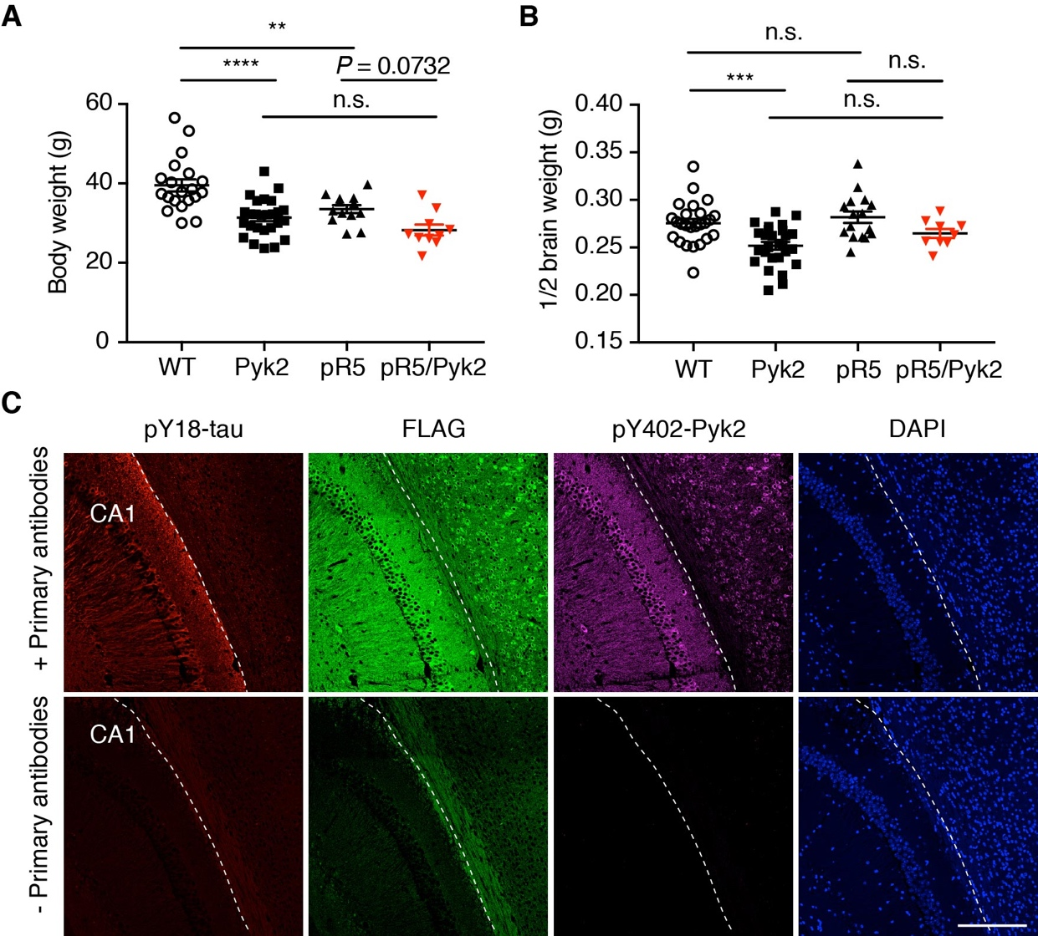

Supplementary Fig. 2

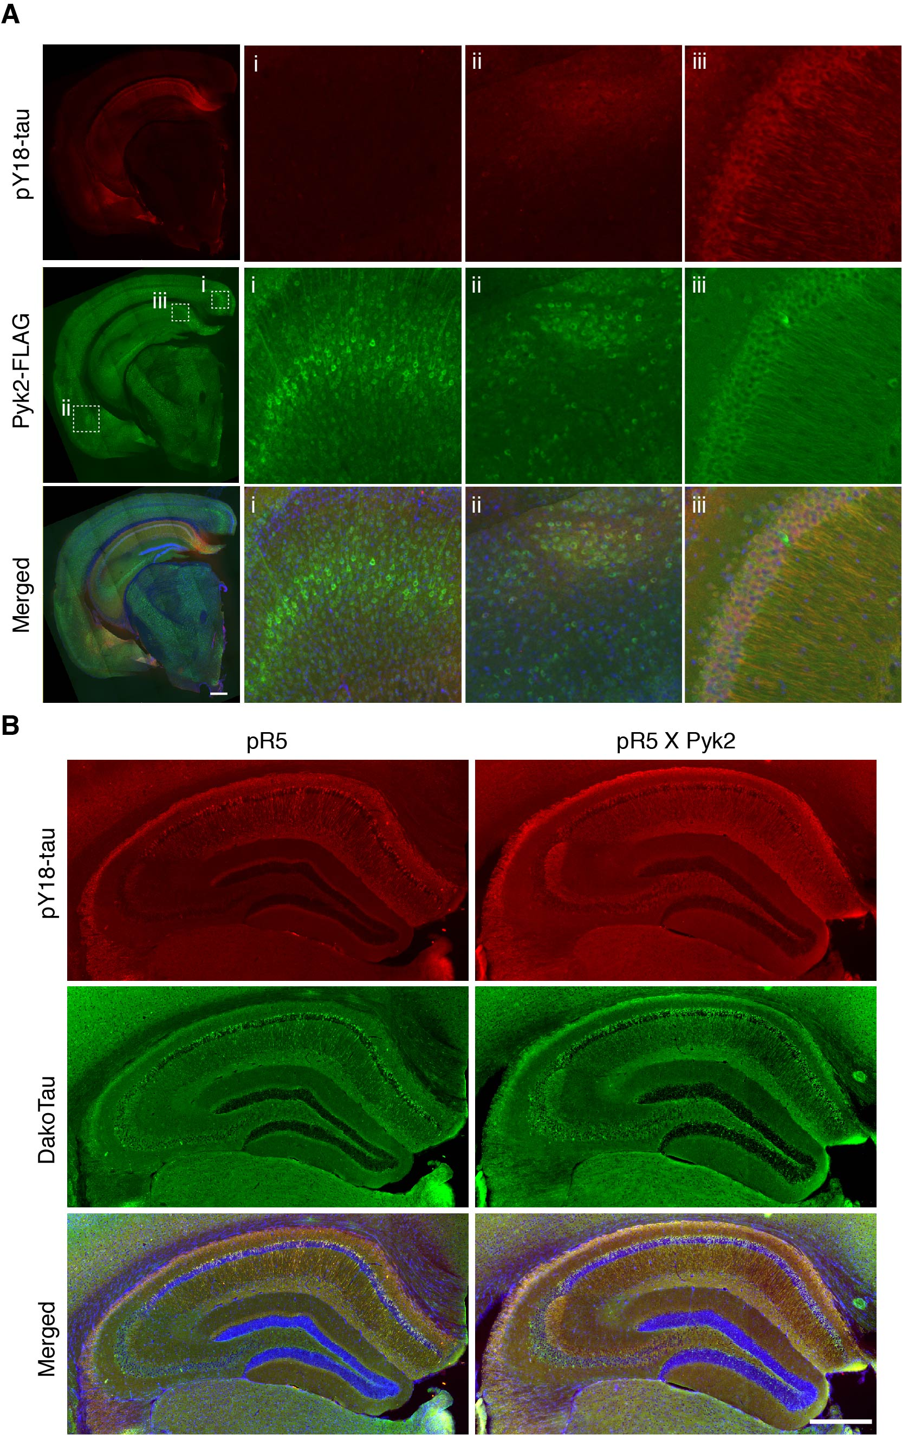
Supplementary Fig. 3

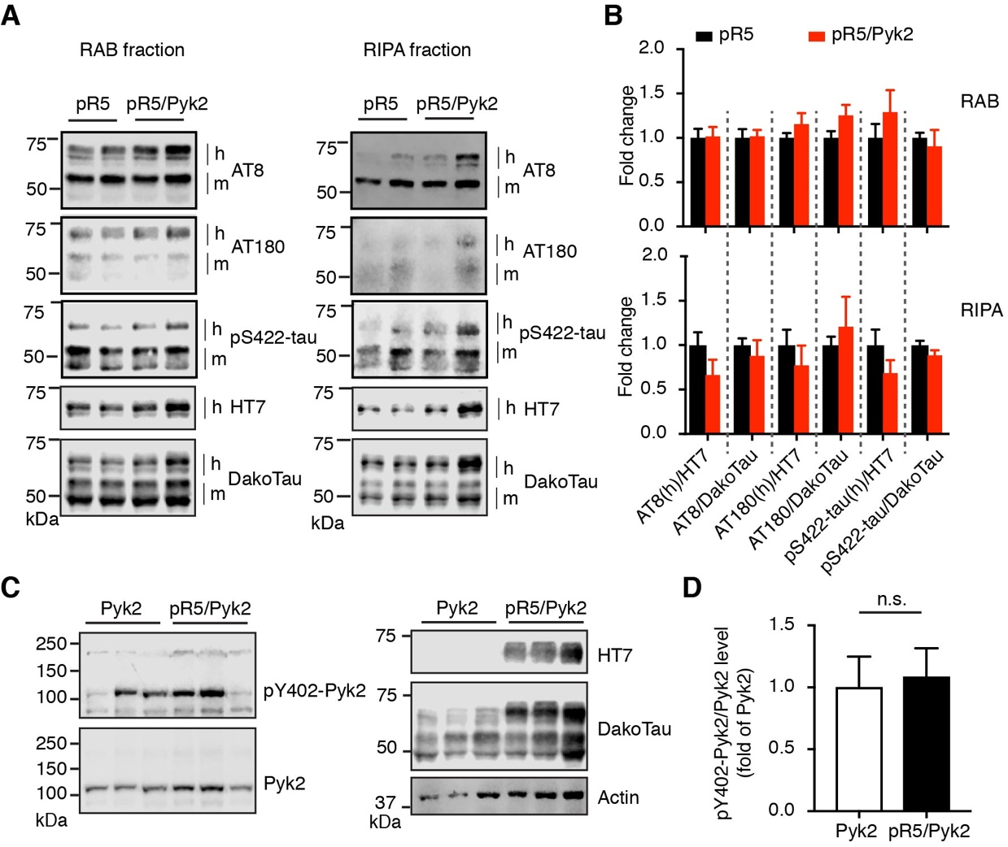

Supplementary Fig. 4

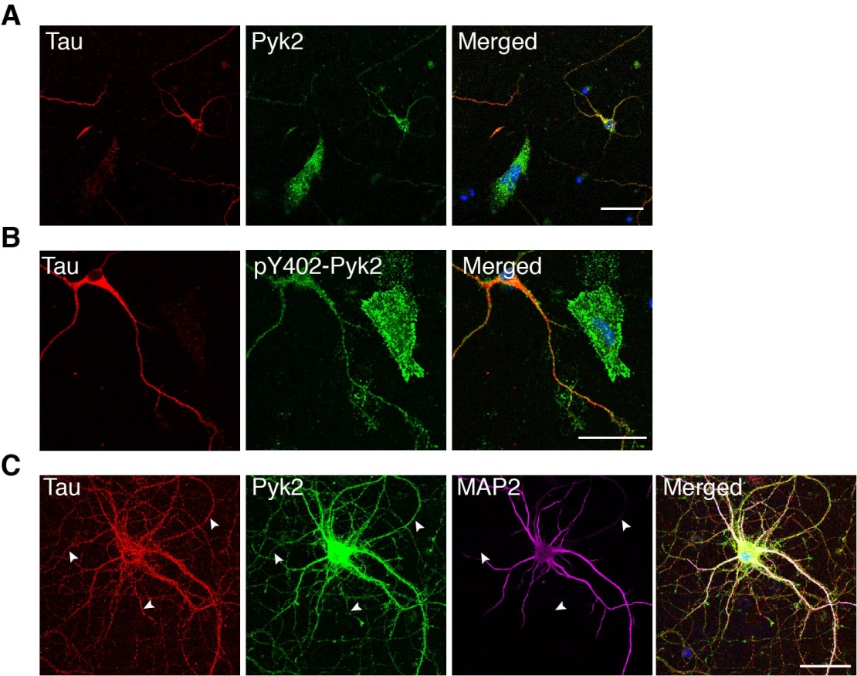

Supplementary Fig. 5

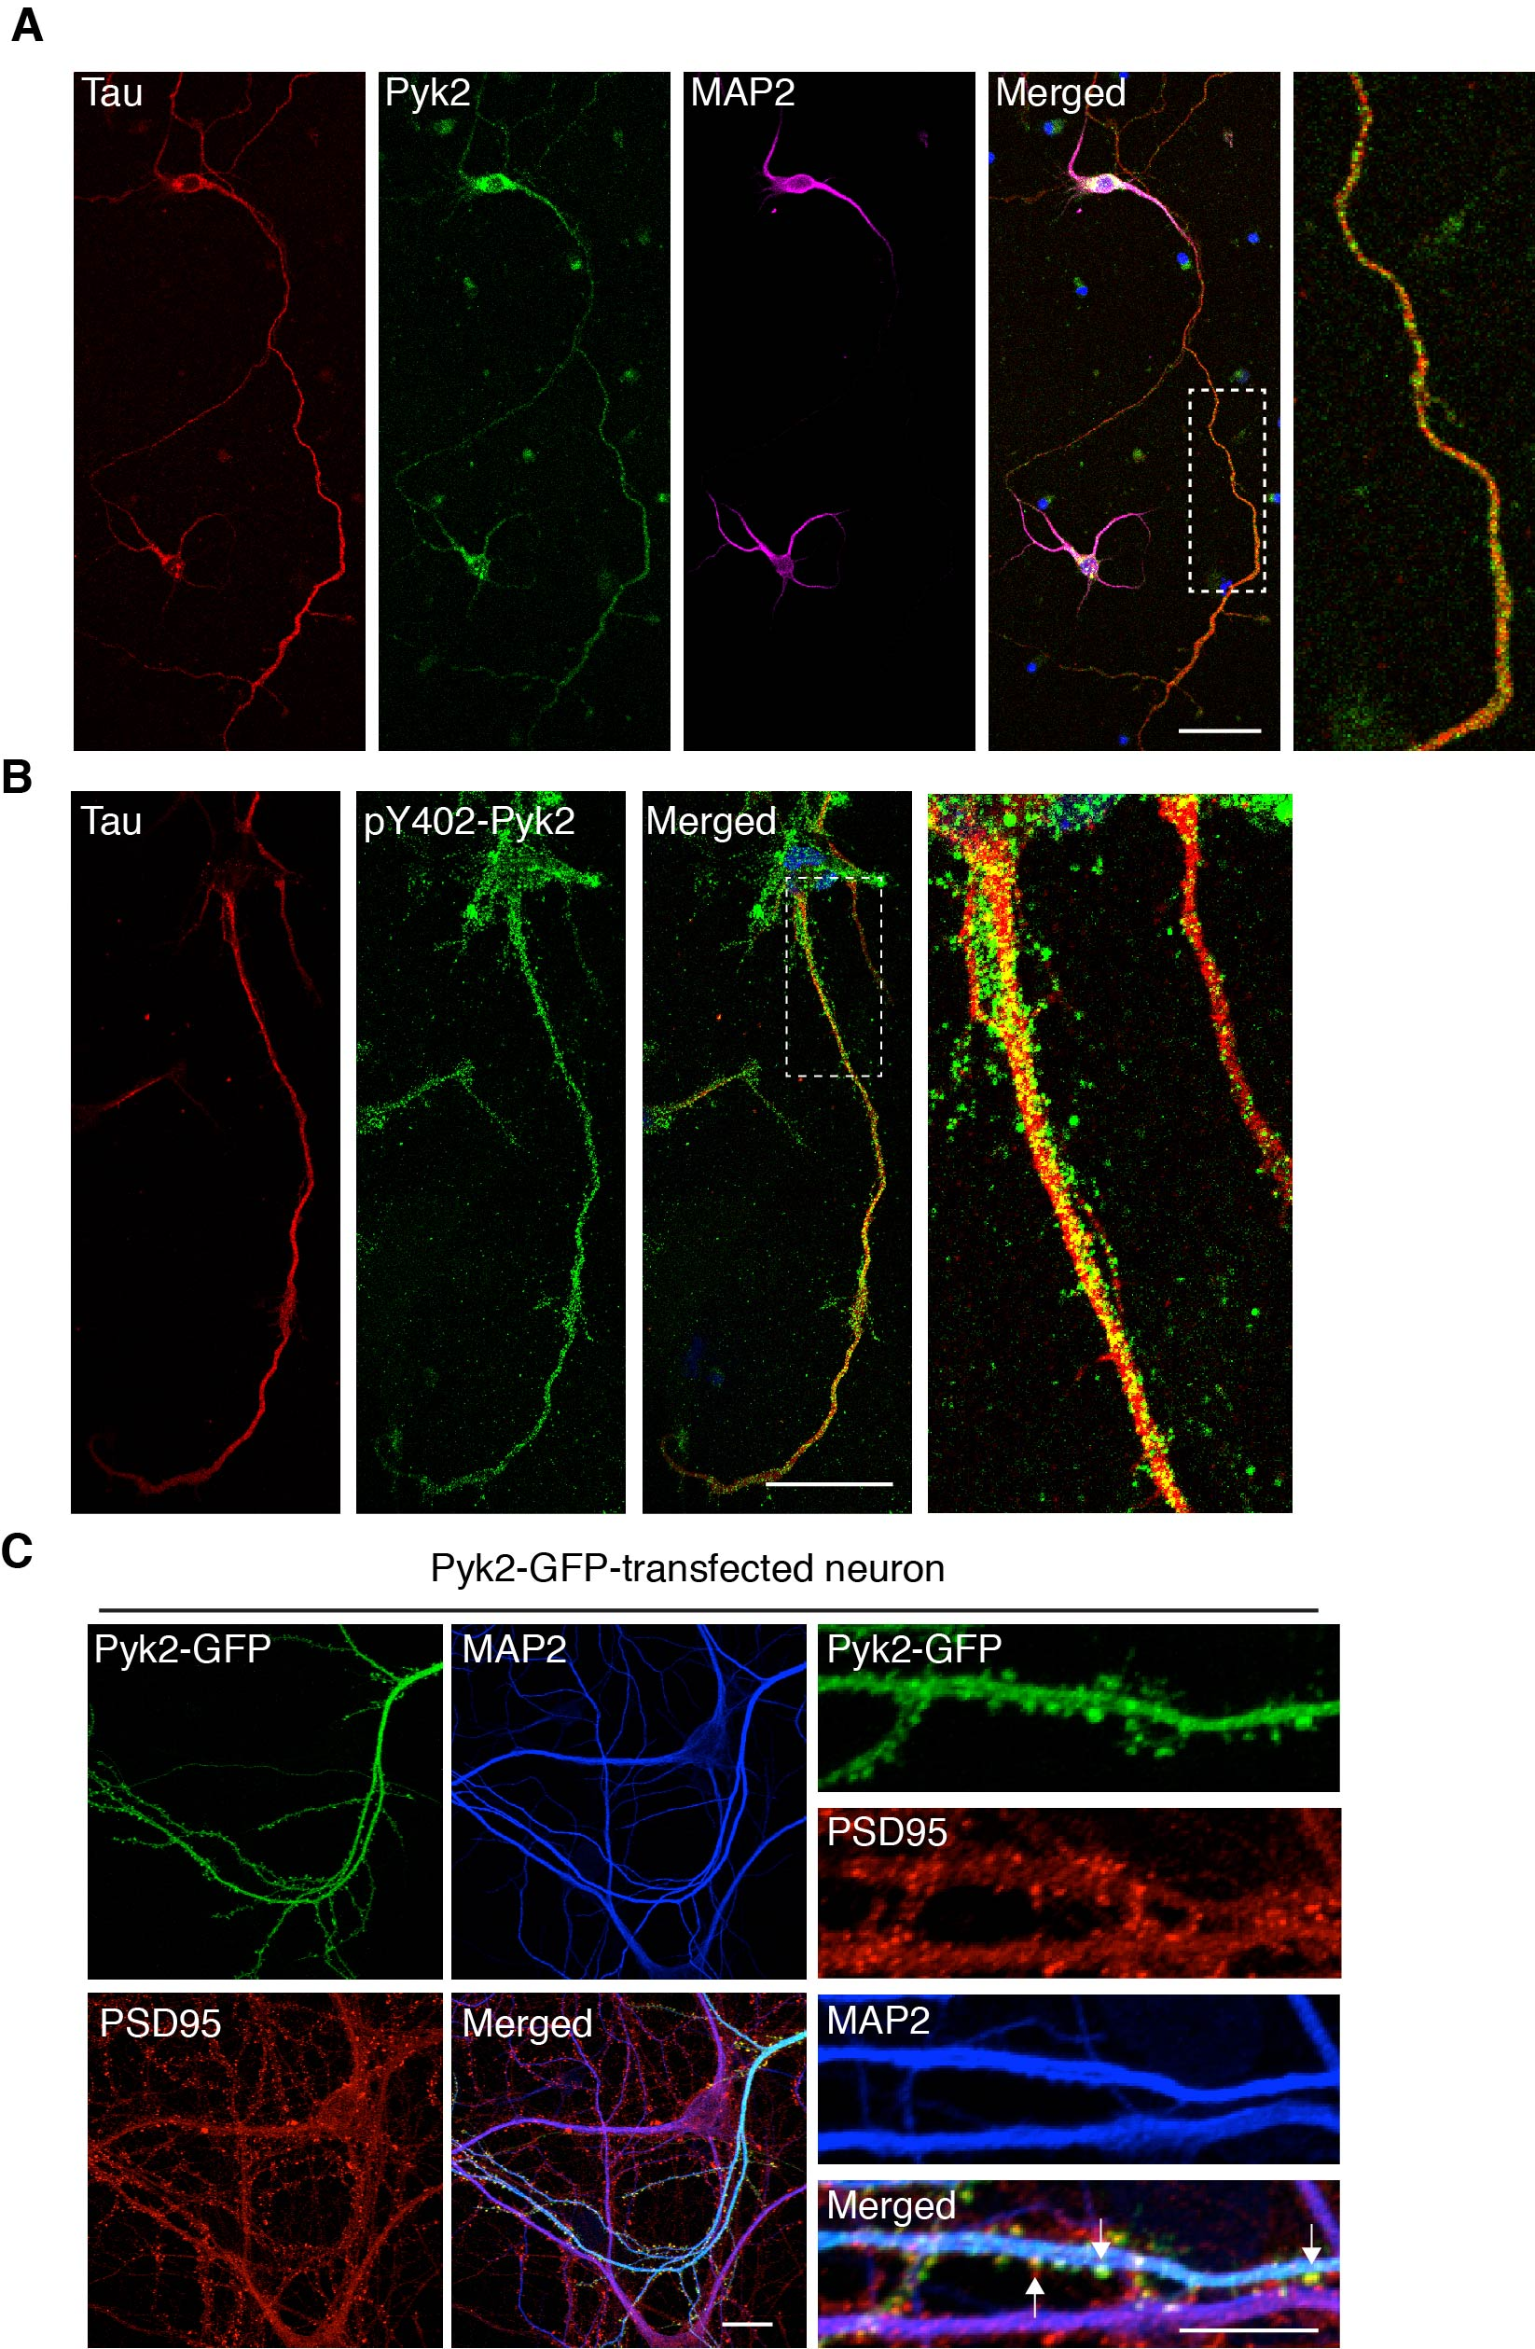

Supplementary Fig. 6

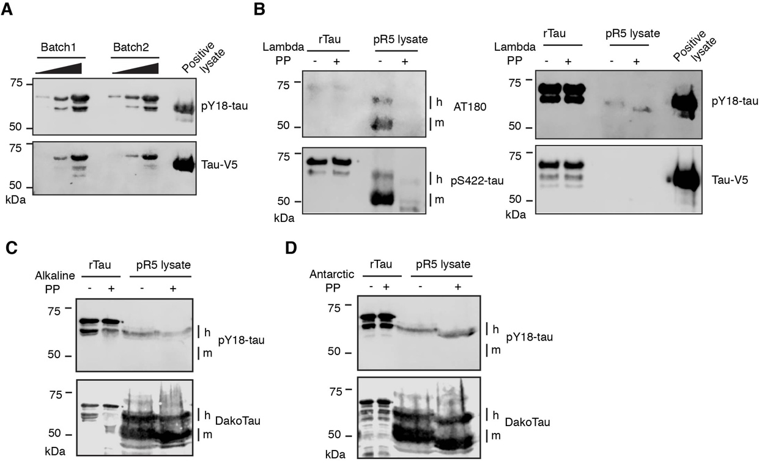

Supplementary Fig. 7

