Supplementary Materials

ENERGY DIAGRAMS
Energy diagrams may be helpful in comprehending many of the above concepts regarding the energetic nature of Aβ* in terms of the relative stabilities of the various molecules and intermediates. A vast majority of amyloid experiments have been conducted using quiescent solutions. Several studies have demonstrated that there are differences between both the fibril formation kinetics [1] and the fibril characteristics [2] in solutions that are quiescent versus those that experience liquid shear. From the point of view of energetics, how does one depict the possible relationships involved in the shear-induced reactions described above?
The simple energy fate of the non-productive shear-activated Aβ* is illustrated in Supplementary Fig. 1. The chemical reactions are written below the energy level diagrams, which show the relative energy levels of reactants and products.
When the Aβ molecule is sheared, it absorbs kinetic energy from its multiple neighboring layers of fluid, each layer flowing with a different speed than its neighboring layers above and below the molecule. This absorbed energy overcomes the resistance to distortion of the intramolecular bonds, producing a higher energy, distorted Aβ* molecule. The energy absorbed depends on the shear rate, which depends on the magnitude of the velocity differences among the different solvent layers that entrap the distorted Aβ molecule.

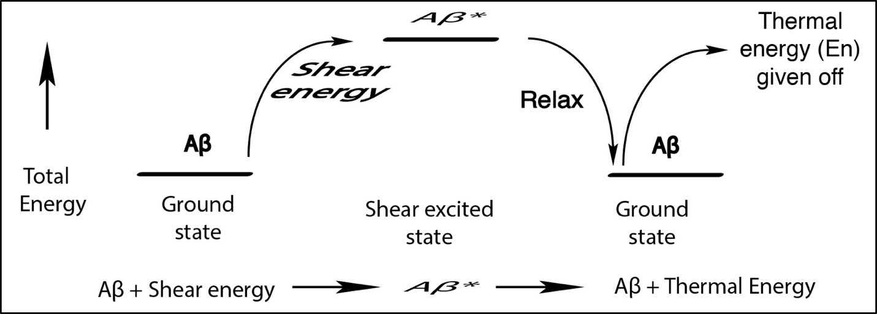

Supplementary Fig. 1. Free energy diagram for the production of the shear-induced Aβ* excited state and its decay through energy release back to the surroundings.

Every Aβ molecule also undergoes variable shear rates as it travels through various tortuous path ISF flow regions within the brain. Thus, in addition to being shear-excited, the molecule has opportunities to relax, possibly even to its original conformational state in the complete absence of shear, as illustrated in Supplementary Fig. 1. In doing so, it yields up to its solvent surroundings its excess shear energy in the form of thermal energy, but as it approaches another narrow brain flow passage, it is again shear excited, either to a higher or lower shear energy level, depending on the approaching flow channel dimensions and shape.
A critical factor in this discussion is the rate of relaxation. If it is fast, the energy will be released fast. However, if the lifetime of the excited state is long, it will enter the next increase in shear rate as a non-relaxed, comparatively high energy molecule and may even acquire additional energy, or it may not if it cannot stretch or distort any further, for example.
Supplementary Fig. 1 above represents the case of low Aβ concentrations where the probability of collision with another Aβ molecule is very low. Supplementary Fig. 2 represents the two possible cases of dimer formation: above - with two separately excited Aβ* molecules that collide; and below - with a single Aβ* colliding with an unexcited Aβ. Note that the product of the collision of two Aβ* molecules is an excited state of the (Aβ*)₂ dimer, which is still more stable—that is, of lower energy—than two separate unexcited Aβ molecules. However, (Aβ*)₂, the shear-stressed dimer, is less stable than (Aβ)₂, the unexcited ground state dimer, which is shown as the ultimate product in Supplementary Fig. 2. There is less total energy taken up and released in the bottom situation than in the top. The resulting products, designated (Aβ)₂ , may or may not be identical, since they differ with respect to the total energy of their excited state precursors. These two possible dimer pathways can be explored experimentally using the shear system and experiments proposed in reference [3].

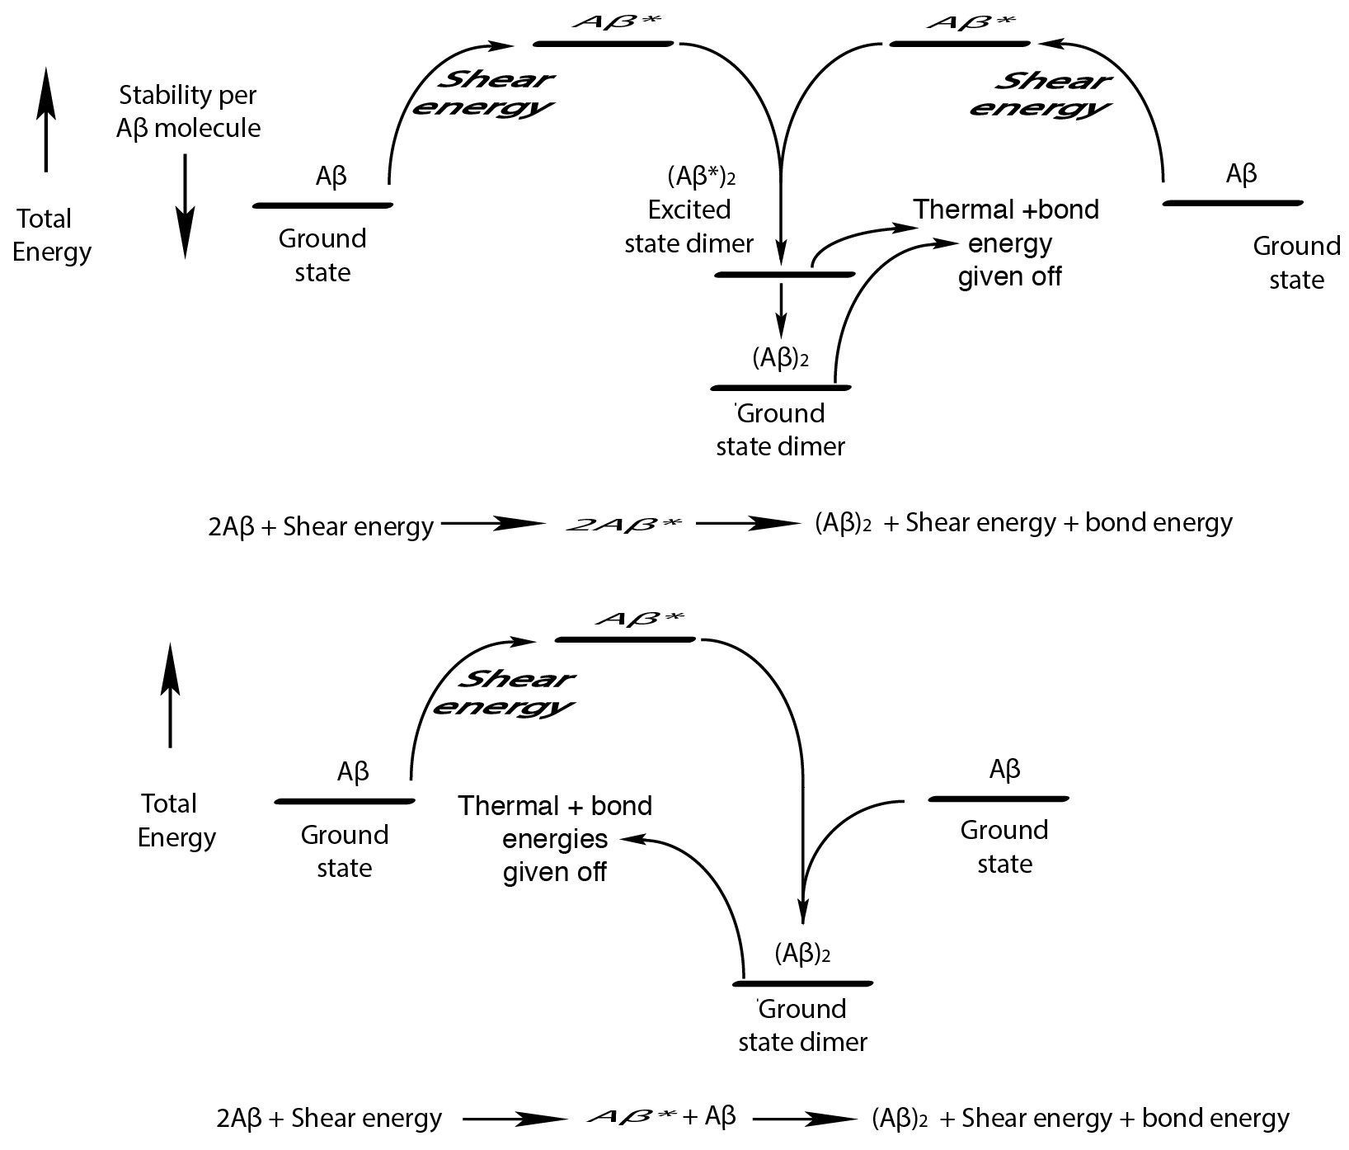

Supplementary Fig. 2. Two different paths to Aβ dimer formation: production of the shear-induced Aβ* excited state and subsequent reaction with: (Upper path) another Aβ* molecule; (lower path) a ground state, unexcited Aβ molecule.

Remembering the importance of the biological environment in which the amyloid monomer finds itself, the membrane environment must be considered, especially if the highest shear energy available would appear to be next to that membrane. The first paper of this series [4] proposed a Aβ concentration dependent mechanism involving the membrane as an adsorbent for the shear-stressed Aβ* molecule.
The energy states get more complicated when considering shear reactions involving low Aβ concentrations and membrane surfaces, as seen in Supplementary Fig. 3, another non-productive reaction. The shear energy imparted to an Aβ molecule next to a membrane surface is maximum for a given flow rate because the solvent layer wetting the surface of the membrane (M) generally does not move. However, for the layer next to the wall, even though it is not moving at the maximum speed in comparison with other layers further from the surface, the difference between the velocities of the two layers (at the surface and next to the surface) is greater than any velocity difference between two neighboring layers as one moves away from the wall. Thus, the shear rate at the membrane surface is maximum. Some part of this maximum shear energy is absorbed by an Aβ molecule trapped within solvent layers at or very close to the wall and is utilized to both stretch and flip the stretched and rotating Aβ molecule up against the membrane wall. This, in addition to the attractions between the now newly-exposed, previously interior hydrophobic regions of the molecule and the membrane surface, causes the Aβ* to adhere to the wall. Because of their momentum, parts of the rotating molecule possibly penetrate through the membrane surface and into the lipid bilayer. If a hydrophobic part of the Aβ penetrates, it may be plunged and then dragged into the hydrophobic interior because of attractive hydrophobic bonding. All of these adsorption forces lower the energy of the adsorbed, more stable, membrane-adsorbed Aβ*–M molecule.

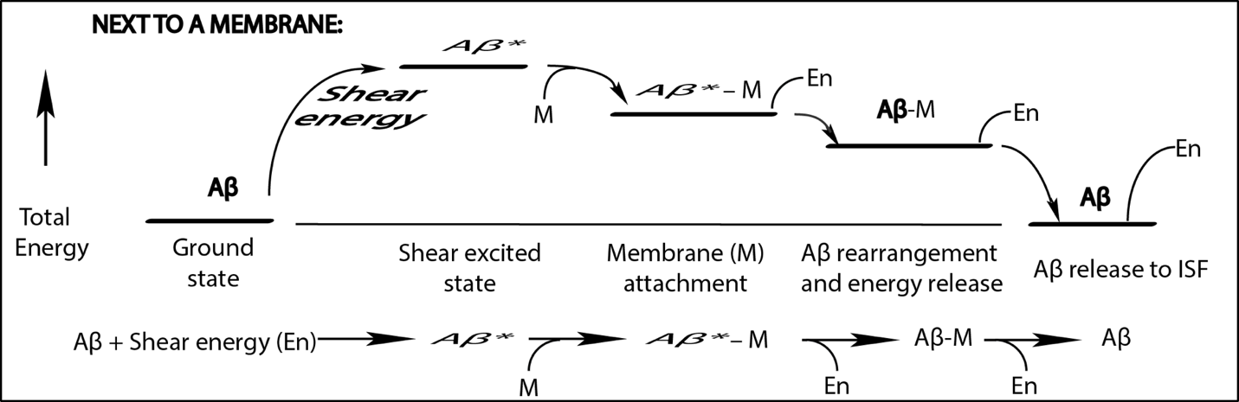

Supplementary Fig. 3. Free energy diagram for the production of the shear-induced Aβ* excited state, its interaction with a neighboring membrane in that excited state, its loss of some shear energy, and finally its return to ISF flow.
The question now is whether the adsorbed, stretched Aβ*–M molecule further loses its initial shear energy by a conformational change within the membrane to a more ground state Aβ-like conformation within the membrane. If it changes conformation, the Aβ molecule may be more likely to exit the membrane and join the ISF, releasing more energy—only to start the cycle again, that is, to be sheared again and be adsorbed by the membrane.
Note that while the Aβ*–M is on or within the membrane, it may not be recognized by any protein conformation monitoring system and therefore not be eliminated by enzyme action.
What is the response of the above membrane system to increasing Aβ? Again, there is a competition between two different processes involving a common reactant, in this case Aβ*–M.
In Supplementary Fig. 4, there is shown a competition between the adsorption/desorption cycle (first presented in Fig. 3) and the reaction of the membrane-adsorbed Aβ* with another Aβ* molecule, also membrane adsorbed. Because a membrane behaves in many ways as a two-dimensional fluid, these two adsorbed Aβ* molecules can randomly migrate within the membrane, sometime forming islands of proteins. The question now becomes, what is the lifetime of the Aβ*-membrane complex before it rearranges into a lower energy membrane trapped ground state Aβ molecule that is then attracted to and joins the passing ISF stream? Thus, if this proposed mechanism in Supplementary Fig. 4 is valid, it is a complex competition between (a) the adsorption/desorption cycle and (b) the in-membrane collision of two Aβ* shear-excited state molecules. Similar to the situation not involving the membrane, such a competitive membrane mechanism again predicts a very strong dependence of (Aβ)₂ formation rate on the Aβ concentration in the ISF next to the membrane surface. It is again assumed that the formation of (Aβ)₂ initiates the series of chemical reactions leading to the formation of toxic oligomers in the brain neuron membrane.

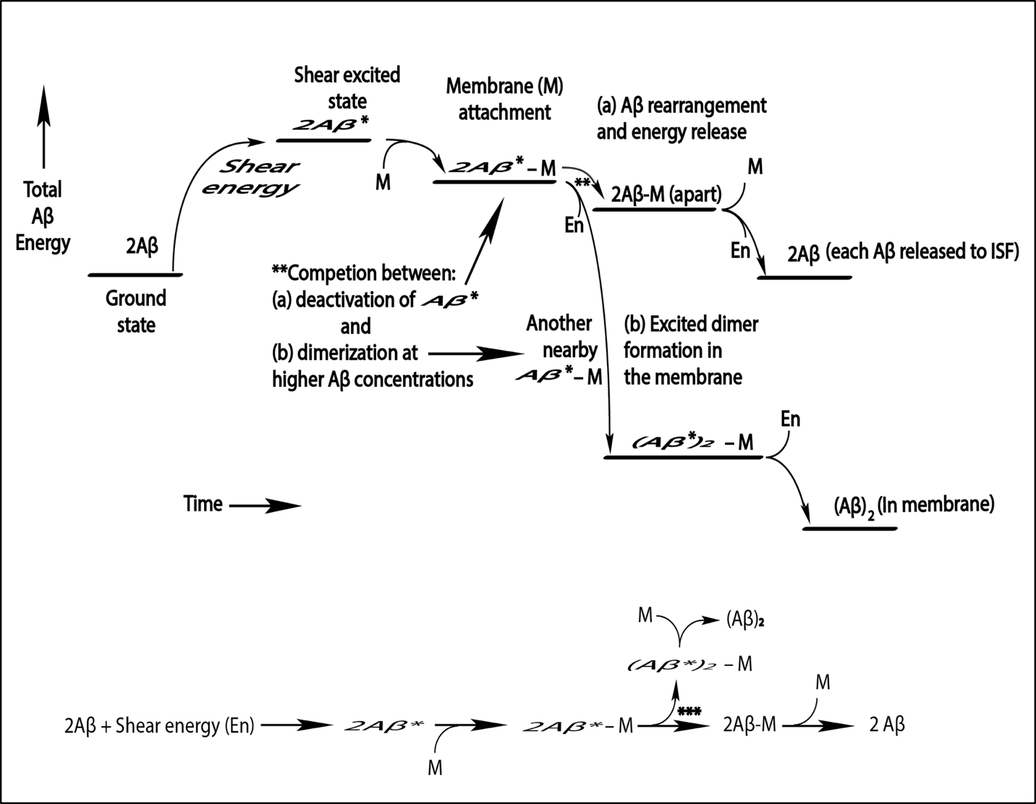Supplementary Fig. 4. Free energy diagram depicting the competition (**) between release of a shear-altered membrane-adsorbed Aβ molecule from the membrane back into the parenchymal ISF and reaction of this trapped, sheared molecule with another newly adsorbed, shear-stressed Aβ molecule to form a shear stressed dimer, which sheds its excess energy and is confined to the membrane.

SUPPLEMENTARY REFERENCES
[1] Cohen SIA, Linse S, Luheshi LM, Hellstrand E, White A, Rajah L, Otzen DE, Vendruscolo M, Dobson CM, Knowles TPJ (2013) Proliferation of amyloid-42 aggregates occurs through a secondary nucleation mechanism. Proc Natl Acad Sci U S A 110, 9758–9763.
[2] Qiang W, Kelley K, Tycko R (2013) Polymorph-specific kinetics and thermodynamics of β-amyloid fibril growth. J Am Chem Soc 135, 6860-6871.
[3] Trumbore CN (2017) Shear-induced amyloid formation in the brain II. An experimental system for monitoring amyloid shear processes and investigating potential spinal tap problems. J Alzheimers Dis 59, 543–557.
[4] Trumbore CN (2016) Shear-induced amyloid formation in the brain. I. Potential vascular and parenchymal processes. J Alzheimers Dis 54, 457–470.

