Supplementary Material

SUPPLEMENT A

Flow System Dynamics and Animations
The reader can observe an animation (http://contemporarychemistry.com/brain/a/CapillMovie2A2.html) of a short injected cylindrical sample distorted by a laminar mobile phase flow through a capillary tube. However, the aspect ratio dimensions of neither this animation nor Figs. 1 and 2 in the main paper resemble those of the typical capillary used in our research (0.25 mm internal diameter by 20-50 cm in length). At the detector end of this very small diameter tube, the leading edge of the sample profile within the capillary would be narrowed to look more like that in this animation (http://contemporarychemistry.com/brain/a/CapillMovie1.html) presented in slower motion so that the correlation between the developing sample profile and the chromatographic peak shape is evident.
In the following discussion, the agreement between theoretical treatments and published experimental results of our capillary experiments in which limited sample solute diffusion takes place are qualitatively justified. Consider the case of Time = B in Fig. 2 (main paper) and break up the gray, flow-distorted sample plug in the upper portion of Supplementary Fig. 1 into two regions: the left-hand trailing gray Wall Region and the right-hand gray Leading Edge.
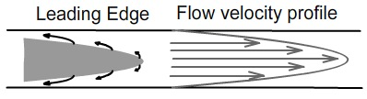
Suppl. Fig. 1. Diffusion away from sample profile leading edge.
The net diffusion of the solute away from the gray “no diffusion” concentration boundaries in both of these regions is essentially radial and one-way – toward the wall (Leading Edge) and toward the capillary center, away from the wall (Wall Region). The reason for this is that net sample diffusion is always from high solute concentration regions toward low concentration regions. In Supplementary Fig. 1, this would be toward the wall away from surface of the bullet shaped Leading Edge, as indicated by the curved arrows on the left side of Supplementary Fig. 1. Because of the laminar fluid velocity profile, indicated by arrows on the right side of Supplementary Fig. 1, molecules diffusing away from the centerline, where the velocity of the mobile phase is at its maximum, decrease their forward average velocity. That is, as any molecule diffuses away from the centerline toward the wall, it must decelerate in its net forward average velocity because as one travels from the center of the capillary to the wall, the forward velocity decreases.
This leading-edge animation (http://contemporarychemistry.com/brain/a/ConcentricShellsDifferentFlow.html) shows the above concept at the simplest possible level that if a molecule at the very tip of a Leading Edge sample bullet (green) moving through the capillary diffuses in any direction, except along the capillary axis (very low probability), its forward average velocity will decrease when compared with that in its original central position if it had not been able to diffuse. In this animation, we allow the molecule to diffuse away from the center of the capillary toward the capillary wall and then later to retreat to its central position in the forward sample progression, never being able to return by diffusion to that leading location at the tip. With increasing time for diffusion and opportunities for sampling other regions of the capillary space, this causes a diffusing solute concentration shift away from the front part of the sample bullet profile (http://contemporarychemistry.com/brain/a/ConcentShellsDifferentFlow.html) with respect to that of a non-diffusing solute as shown by the arrows in Supplementary Fig. 1. In this and the previous animation, the black bars represent the locations of a theoretical solute in the sample that is not able to diffuse.
On the other hand, when diffusion occurs in the Wall Region (Supplementary Fig. 2), again diffusion is limited in such a way that the net diffusion of solute molecules is again one-way – namely on average radially toward the capillary center. Thus, the velocity of all molecules diffusing away from the sample surface in the Wall Region is quickly increased, that is, these molecules are accelerated as they diffuse toward the center, when compared with that of a non-diffusing solute. This sudden increase in flow rate is because of the large differential in flow rates, ranging from zero at the wall to a maximum at the center, causing a forward shifting of diffusing solute molecules from the rear to the more central part of the flowing sample. However, the greatest acceleration is found in those molecules closest to the wall that diffuse away from the wall on the extreme left part of the Supplementary Fig. 2 gray sample profile. This also means that the greatest liquid molecular shear rates in the entire capillary is in those layers next to the wall!
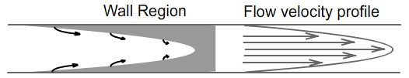
Suppl. Fig. 2. Diffusion away from the wall region
of the sample profile.
This animation (http://contemporarychemistry.com/brain/a/walldiffn.html) shows the early diffusion pattern of the molecules nearest to the wall at the solvent surfaces as the sample begins to be distorted. The accelerated migration from the rear part of the solute plug is from the wall to the central region, where the mobile phase speed is the fastest. This migration quickly fills the solvent bullet head (left side) with solute, causing the deceleration of this pure solvent front. The animation also shows the leading-edge part of the sample plug next to the wall, in which the bulk of sample molecules diffusing away from the developing leading edge surface have a net flow toward the wall, quickly filling with diffusing solute the pure mobile phase liquid initially without solute near the wall.
The sum of these two effects for a fast diffusing solute, after an initial sample plug distortion is, owing to differential diffusion rates, to distort the bulk of the sample back toward its cylindrical shape, however with much less sharply delineated solute boundaries than the initial injected sample plug. There develops, with time, an increasingly diffuse solute concentration gradient around the advancing formerly sharp boundaries. This is one of the reasons for the final resulting Gaussian peak shape in liquid phase chromatography after an extensive amount of radial diffusion in the liquid flow channels. But, we have already seen what happens in the case of limited diffusion. Both theory and experiment agree that the two diffusion rate extremes are: (1) with very little diffusion, a single very sharp peak, followed by an exponential decay in the little to no diffusion case (chromatogram a in Fig. 3) and (2) a Gaussian peak for cases of extensive diffusion (chromatogram d in Fig. 3). For the case of limited solute diffusion between these two extremes, there is a diffusion rate region in which there are two chromatographic concentration peaks or a peak and a shoulder for a single solute component. Both experiment ([1–3] and Trumbore et al., unpublished experiments) and theory [4-8] agree with this general concept and with the trends when capillary dimensions are varied and solutes with varying diffusivities are tested. This two-peaked chromatogram can be understood from the shape of the cross section solute profile that develops where there is limited diffusion.
The first peak is from the blunting and shortening of the Leading Edge bullet part of the sample. The second peak is from the diffusion-driven shortening of the Wall Region. To qualitatively summarize graphically, the following is what ultimately happens:

The gray regions above now represent the outer limits of solute concentration. Beyond this region, there is no solute. In the solute no-diffusion case, the concentration is the same throughout the entire gray region. In the limited-solute-diffusion case, the concentration is not uniform, but has a complex concentration gradient pattern.
The concentration plot below (Supplementary Fig. 3) is a purely qualitative estimated average cross sectional solute concentration as a function of the distance along the capillary with and without diffusion. The limited-diffusion curve is now more complicated, leading to a double peak later observed by the detector (sample has not yet reached the detector). It might be expected that the characteristics of these concentration shifts in the Leading Edge and Wall Regions are different because the two diffusion processes are not symmetrical.

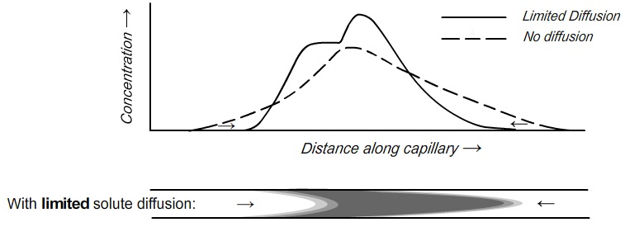
Suppl. Fig. 3

Supplementary Fig. 4 represents the expected distorted sample axial profiles curves, but without concentration gradients, showing only approximate solute concentration limits of the sample.
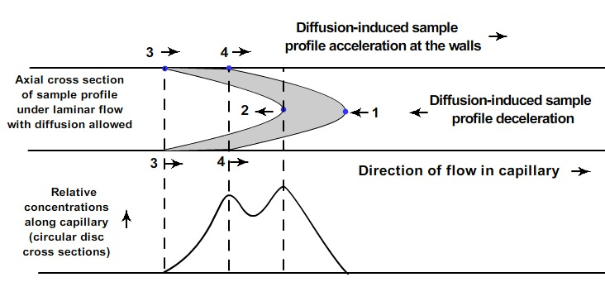
Suppl. Fig. 4. Simplified explanation for two-peak chromatograms for a single component

This qualitative animation (http://contemporarychemistry.com/brain/a/CapillMovie4_Thin.html) shows the development of a hypothetical Gaussian peak. If we had a variety of solutes with diffusion coefficients between those of the black and blue curves, we would observe each of the Fig. 3 (main paper) peak shapes (chromatograms d through a) because we would be allowing increasingly limited diffusion for the sample molecules. In such a case, the curve shapes with increasing diffusion coefficients would change from “d” to “c” to “b” and finally to “a.” At very fast flow rates, there would not be time for significant diffusion of most solutes and only “a” exponential decay curves would be observed. On the other hand, if the molecule were large and it could not diffuse very fast at most flow rates, its diffusion would be also limited and the chromatogram would show only type “a” curve in Fig. 3., because molecular Brownian motion is so slow.
Alternatively, the detector in the above animation could be moved to the left, closer to the injection port, giving less time for the blue solute to diffuse. Therefore, the resulting curve would be like either the “b” or “c” of Fig. 3. In this animation (http://contemporarychemistry.com/brain/a/CapillMovie4_ThinA.html), as the blue curve passes by the detector, it has the same general two-peaked profile as that of the upper curve of Supplementary Fig. 4 and therefore gives rise to the “b” curve of Fig. 3.

SUPPLEMENT B

Protein Wall Coating
In order to confirm the loss of protein molecules from protein solutions passed through our capillary tubing and aggregation of these proteins on the inside capillary wall, we milled off half of the capillary lengthwise, rinsed the inside wall carefully with distilled water, and took electron micrographs of the inside wall. Some of these micrographs are shown in our paper [9].
One of the stainless-steel capillaries used in our protein experiments was accidentally allowed to dry after a concentrated salt solution had been passed through it in an attempt to clear the walls of protein coating. This caused an etching with very small micro-pits in the capillary walls.

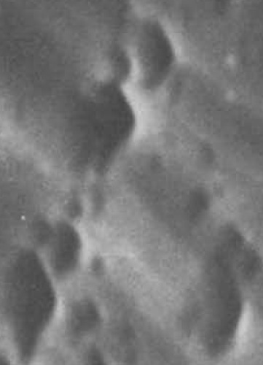
No protein injected
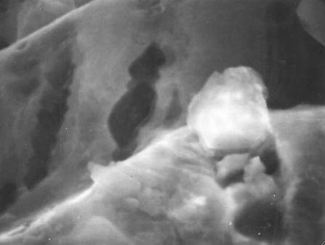
“Plaque” particles
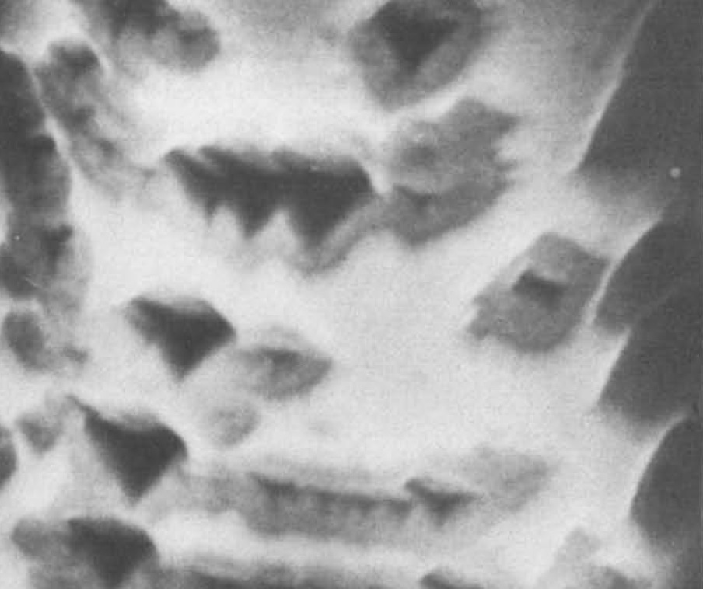
Suppl. Fig. 5 Pitted capillary wall coated
(white area) with injected protein.
n

The white protein coating in Supplementary Fig. 5 (left panel) appears in many cases to avoid the region immediately around these deep depressions. We propose that this is because the shear rate near these micro-pit walls drops off dramatically, lowering the shear stress on the protein molecules in that region, causing the coating process to fall off dramatically. Already stressed proteins probably migrate preferentially into the pits, following the thermodynamic explanations and experiments of Metzner et al. [10]. There is a downstream lag before the shear rate builds up and the coating proceeds again. Although this relatively thin coating is shown on the left image, there were also many large aggregated particles protruding from the capillary walls (Supplementary Fig. 5, center image). Lower resolution micrographs showed a variety of even larger particulates [9]. It is now believed that these may have been non-crystalline protein fibril aggregates. However, this is only speculation, since there was no other microscopic or chemical analysis performed on either the coating or the particles. Similar chromatographic results were obtained with pitted and non-pitted capillaries. The possibility of metal ions liberated from the stainless steel capillary surface reacting with proteins is nevertheless entirely possible, since metal ions have been shown to be involved as catalytic intermediates in the formation of amyloid solids [11, 12].
With many of the proteins that adhered to the capillary wall, when the mobile phase flow in the capillary column was turned off and then back on after a period of about ten minutes, without any injections, after pure mobile phase flow resumed at the previous flow rate during the previous sample runs, there would often appear “ghost peaks” in the chromatographic detector that nearly exactly mimicked the original protein peaks. This is interpreted as an indication of a shear-induced, metastable protein coating on the wall relaxing under zero flow conditions, with some portion of the solid protein coating becoming soluble again, and acting in the same manner as the original injected sample. This was again observed in our more recent work with amyloid beta capillary experiments. If the coating were shear-induced immediately next to the wall, much of the dissolving coating would be in the same injection region where the shear was greatest and solute concentration was the greatest following the start of the mobile phase flow and therefore act somewhat like the initially injected sample in its diffusion and therefore also generate a similar chromatographic profile (unpublished results of Leia M. Jackson).
One potential complication in dealing generally with polymer solutions confined to flowing in a capillary is that the conformational deformation resulting from the shear forces in the capillary increases the free energy of the protein molecules and thus can lead to shear-induced migration toward regions of lower shear stress and therefore lower free energy [13, 14]. In our capillary case, this means both induced migration toward the center of the capillary and toward the pits or low energy valleys in an undulating capillary wall that is seen in the electron micrographs of the capillary wall (Supplementary Fig. 5, center). Whether or not the migration toward the centerline of the capillary is significant depends on the residence time during the flow, since these proteins have relatively low diffusivity. The peak shapes in our work do correspond qualitatively to those predicted without any stress-induced flow considerations [13]. The undulations appear to be the areas that are coated at or near the peaks of these undulations, but the number of micrographic samples was too limited to confirm this.

SUPPLEMENT C

Shear-Stressed Aβ* and Energy Considerations
In computer studies of the conformation changes of linear protein chains undergoing the process of folding into the native protein, free energy surfaces have been reported [14] that show more than one minimum, indicating that a number of different stable or metastable conformations are possible for these proteins. This is especially interesting for IDPs such as Aβ. The theory suggests that when these free energy minima are separated by relatively small energy barrier differences, especially for IDPs, the protein is actually in equilibrium, depending on the temperature, shifting among the various low free energy minima states, with the equilibrium shifted toward the conformation with the lowest free energy. Furthermore, for allosteric proteins [14], the addition of a cofactor or signal molecule alters not only the molecule's conformation but also the relative depths of these minima causing a shift in the equilibrium in favor of one of these minima that changes the function of the protein, for example, shutting down an enzyme’s active site when the product of the enzymatic reaction reaches a critical concentration.
It is proposed here and elsewhere [13, 15, 16] that the application of relatively small shear forces to an Aβ molecule and other IDP molecules in solution is large enough to significantly alter their conformation. The shape of the free energy surface for a protein is also probably significantly altered when it is converted through shear forces into a new metastable conformational state, i.e., Aβ*. This state and its free energy surface stability status will be stable only when the protein is being subject to shear and yet may not be “unfolded” in the hydrogen-bond-breaking conventional sense, but merely be in a different conformational higher energy state, typical of an IDP, except that shear has been added as another variable factor in helping to maintain its altered free energy status. The author has been unable to find any multidimensional shear-altered molecular free energy surfaces in the literature. This is not surprising, since adding the variables of just two types of shear, laminar and extensional, adds great complexity to the problem of calculating or measuring such shear altered surfaces. Such surfaces would be presumably different from those calculated from normal folding free energy diagrams.
Aβ dimers, tetramers and hexamers, etc., are among the Aβ oligomers that have been observed experimentally by traditional analytical methods, suggesting that these oligomers have some thermodynamic stability in the absence of shear. There has been a suggestion [17] that there is a collapse from certain sized oligomers to a completely different cross beta structure that lends itself to the ultimate formation of an even more stable cross-beta structured protofilament. These filament precursors may be also formed from thermal motions without shear stress, but probably form faster with the additional shear stress energy available between closely spaced astrocyte and neuron wall membrane surfaces, but perhaps with a different chemical conformation.
According to current theories, in a free-energy folding diagram for a protein, there may be two or more different free energy minima representing comparatively stable protein conformations. If the free energy barrier between these two states is relatively low, depending on the temperature, there is a high probability that a single protein molecule will sample both states in a relatively short time. For example, in Supplementary Fig. 6 (taken from [14]), a single protein molecule, exposed to a high enough temperature, may be involved in an equilibrium between the two blue minima states. Thus, a single protein molecule of this type would sample the left hand minimum free energy conformation much more frequently than the right-hand state in this figure.

When a certain protein interacts with a cofactor such as a signal protein or metal ion, there may be enough energy released within the molecule by this interaction to modify the shape of this free energy diagram in such a way that the depths of the two peaks are reversed, and the equilibrium shifts to the right-hand conformation, as shown in Supplementary Fig. 7. The question now arises, can there be another source of energy, an energetic “signal” other than chemical to alter the shape of a free energy folding surface? It is suggested here that mechanical shear stress can and does provides such energy.
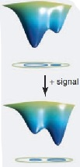
Suppl. Fig. 7. Effect of the addition of a signal molecule to the protein causing the equilibrium to shift to the right-hand conformation. Adapted from Fig. 1 in [14]. Permission granted by Science.

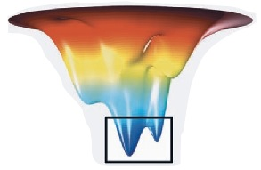
Suppl. Fig. 6 Free energy folding surface for a typical protein. Red: high-energy unfolded protein. Deep blue: folded, much more stable protein in equilibrium between two stable states, with a larger population within the black square box in the left hand folded conformation. Adapted from Fig. 1 in [14]. Permission granted by Science.
The experimental basis for this suggestion is the work of Ashton et al. [16]. Raman spectra were used in their research to monitor the effects of variable shear rates on six different types of proteins of different molecular mass and different structural properties. Shear rates were significantly lower than those necessary to denature the protein. Results of these experiments were interpreted in terms of “subtle conformational changes” that appear to be protein-specific. For globular proteins, the extent of conformational changes increased with protein size and the proportion of beta structure. Upon cessation of the shear forces, nearly all of the shear-induced conformational changes were reversed to their original conformations, as indicated by their return to their original Raman spectrum. This implies that shear-induced conformational changes from Aβ to Aβ* are also reversible. It could also imply that the proposed Aβ*-membrane complex could easily revert to dissolved Aβ* and membrane with oscillatory changes in shear at the membrane wall.
Yang and Teplow have carried out computer simulations including water molecules using fully atomistic molecular dynamics on both Aβ₄₀ and Aβ₄₂ molecules [18]. These calculations reveal a number of valuable insights about the differences between the two isoforms. They show significant differences in the character of the free energy surfaces between the two isoforms, revealing two overall types of structures, with predominantly alpha and predominantly beta structural free energy surface regions in both molecules. They each show a large number of free energy minima, confirming the classification of Aβ as an IDF protein. They reveal relatively low free energy barriers between these minima (lower in Aβ₄₂), indicating that there are probably a number of different conformations in equilibrium, supporting the idea that only small amounts of energy, including mechanical energy supplied by shear stress, are needed to alter the molecular conformation, especially in Aβ₄₂. However, shear processes probably alter the basic shapes of the entire free energy surfaces so that these previously calculated surfaces of Yang and Teplow may not be applicable when interpreting shear-induced conformation changes. There are probably qualitatively different free energy folding surfaces for extensional and laminar shear forces with the added complexity of dealing with various mixtures of these two types of shear in brain regions, thus complicating any contemplated calculations.
The top line of Supplementary Fig. 8 depicts purely hypothetical free energy diagrams that include shear for two Aβ molecules, Aβ₁ and Aβ₂. The state of an Aβ₁ molecule on the extreme left represents the normally quiescent state. The higher free energy, shear-conformationally-altered state Aβ₁* is represented to its immediate right (pointed to by the arrow in “Shear ”). Let us assume that the sheared molecule 1, represented by (Aβ₁*), is not the unfolded molecule that is postulated by nearly all amyloid fibroid formation kinetic models. Instead, Aβ₁* is postulated to be a different, shear-deformed conformational state. We can reasonably make the assumption that when shear force energy is applied to the Aβ₁ molecule to form Aβ₁*, the two valleys in the free energy curves both change depths, with the left well, higher free energy state now being the previously “unstressed” left hand Aβ state, as long as the shear is applied to the Aβ₁* molecule. One might represent the Aβ* dimerization process by a series of two-dimensional hypothetical free energy diagrams shown in the lower section of Supplementary Fig. 8 as a function of time. Note that every step in this process is reversible, as suggested in all amyloid kinetic models

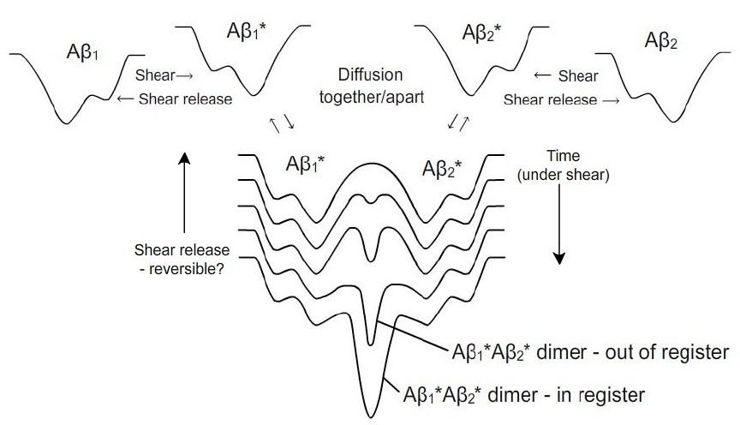
Suppl. Fig. 8. Purely hypothetical suggested qualitative two dimensional cross section of a three-dimensional free energy Aβ folding conformation diagrams representing (a) top row: changes caused by shearing two Aβ molecules 1 and 2 to form two higher energy Aβ₁ * and Aβ₂ * molecules, with shear stress-altered conformations; (b) bottom series of curves: looking down: time course while under shear of the cross sections of a free energy folding surface showing the reversible dimer formation from the encounter of two Aβ* shear-stressed Aβ molecules. The two deepest wells in the bottom two curves represent an out of- and an in-register (Aβ*)₂ isomer. If the shear were released, the question would be whether or not the dimer formation would be reversible. This would undoubtedly be dependent on the temperature and relative depth of the deepest valley in the dimer free energy diagram.

SUPPLEMENT D

Proposed Capillary Experiments
There are two types of intimately-related experiments proposed. The highest priority is for experiments with actual clinical needles that are used to extract spinal tap CSF samples for amyloid analysis. The aim here is to first determine whether there are indeed any amyloid deposits to the inner walls of the needle and shear-induced oligomer formation. If there are, then the goal of the experiments would be to at least minimize these systemic analytical errors and hopefully find conditions to eliminate them. The second type of experiment is the use of the modified capillary system described in the main paper for basic research on the effects of shear on various amyloid systems. It is anticipated that, for certain experiments, the capillary inner wall surface or diameter or even geometry may have to be modified to more closely approximate the types of shear forces thought to exist in the brain.

Spinal Tap Analysis Experiments
It is disturbing that the CSF flow drip rate from an active injected spinal tap needle open to the atmosphere is reported by practitioners to be greater than the flow rates used in our early capillary experiments in which proteins were deposited as solids on the inner walls of our capillaries. Our experiments had nearly identical inner diameters to those needles used for spinal taps. In order to study whether solid amyloid wall deposition and shear-induced oligomer formation are occurring in spinal tap needles, one needs to take into consideration in experimental planning the following experimental variables:
a) length and inner diameter of the needle (increasing length causes increasing molecular strain, a product of shear rate and the time extent of shearing);
b) CSF flow rate, pretreatment and cleaning of the needle (amyloid wall deposits are very difficult to clean; amyloid deposits appear to be autocatalytic);
c) temperature of the needle during sampling (wall deposit processes may be temperature dependent, probably with less deposits at higher temperature – however, reversible amyloid deposit formation and decomposition rates in CSF are also probably temperature dependent.
d) variable concentrations of CSF proteins other than amyloids with disease progression (there may be shear-dependent co-aggregation with these proteins on the walls along with amyloids);
e) existence of pulsed or oscillating flow in needle dripping in the open atmosphere (pulsed flow would significantly increase wall coating and oscillating flow might or might not encourage protein coating, depending on the relaxation time of the excited molecule and the frequency of the oscillation)

Clinical experiments
Certainly, one of the first experiments taking place in the clinic would be to apply fluid back pressure imposed by a closed syringe system to slow down the CSF flow rate and eliminate pulses and oscillations that may be present in the open to the atmosphere needle sampling. Sampling this fluid and comparing it with that obtained without the back pressure would help to determine quickly whether pulses and oscillations affect the analytical results. The slowing down of the CSF flow would also decrease the rate of any wall deposition and perhaps also oligomer formation in the liquid phase.

Laboratory experiments
These would be needed to see whether there is selectivity in the shear wall aggregation response for different amyloid monomers and oligomers. That is, experiments in which individual oligomers are injected, probably using multiple injections, to study the behavior of the second peak in the two peak chromatograms, using the needles as chromatographic capillary columns.

Basic Research Experiments on the Effects of Shear on Amyloid Systems
A critical refinement in the capillary system for future research efforts would be to ensure that the mobile phase pump provides chatter-free, steady, reproducible flow rates as well as variable speed oscillating and pulsed flow dynamic capabilities. Capillary tubing should be without major bends and have internal walls that are without blemishes or variable diameter over the entire capillary length, unless variable diameter is desired for experiments. Couplings and fittings need to be zero dead volume and injection valves should not induce turbulence or shear patterns that are significantly different from those generated in the column tubing. Small radius injection loops may introduce turbulence artifacts in the limited solute diffusion regime at high mobile phase flow rates. The detector ideally should be in line with the capillary tubing if at all possible and if a detector is used that mixes the capillary effluent in the detector, its volume should be minimized.

1. One of the most critical proposed experiments is to study the effects of increasing shear on Aβ with a refined version of our capillary system. Effluent from the detector end of the capillary during a highly diffusion limited chromatographic style run can be separated into aliquots of Aβ that have been subjected to continually increasing, calculable amounts of shear. This is because the aliquots collected during increasing time intervals following sample injections in the “a” type chromatogram of Fig. 3 (main paper) are those that have been residing closer to the wall, where the shear rate is maximum (1).

Different Aβ isoforms, e.g., Aβ₄₀ or Aβ₄₂ should be tested and results compared. Increasing shear rates provide larger amounts of conformation distortion energy, supplying increasing free energy to molecules to move over energy barriers between various conformation states more easily and shift equilibria toward higher-energy Aβ* conformations. These states may have lifetimes long enough such that they may possibly be isolated or at least characterized by various fast spectroscopic measurements, e.g., Fourier transform infrared, circular dichroism, ultraviolet and various types of mass spectroscopy. Stopped flow can be used so that samples that remain within the capillary detector region that have been exposed to known amounts of shear can be studied as a function of time to observe relaxation processes from shear-excited states to ground states.
(a) First, one can run the capillary experiment at sufficiently high flow rates, severely limiting the amount of time for diffusion, so that there is only one leading edge detector response peak with an exponential decay and no shoulder or second peak. In this type of experiment, there is no significant diffusion away from the wall during the experiment so that the effluent samples, when measured at the detector in stopped flow reactions or collected in small successive aliquots, will produce successive Aβ aliquots subjected to a wide range of increasing shear. It is anticipated that at these high flow rates, the large amount of shear near the wall will cause severe distortion of Aβ molecules and perhaps even produce an identifiable and/or isolatable Aβ* shear-stressed monomer species, especially when a fast optical detector is used. The wide spread of potential amounts of shear stress applied to Aβ molecules could even preferentially populate a variety of metastable free energy states that an energy-rich Aβ* molecule could possibly have, given the abundance of calculated different energy Aβ conformations shown to be present in the ground state molecule [18].
(b) Second, when the same experiment as in (a) above is run at lower flow rates, altering the detector output response to yield the anticipated limited diffusion, two-peak pattern, additional time is given for the maximum shear-stressed molecules to migrate (providing they don’t adhere to the capillary wall) and collide with other lesser stressed and even unstressed molecules. This additional diffusion time can allow the formation of stress-induced Aβ oligomers. Such formation should be Aβ concentration dependent, so varying Aβ concentration will be an important variable in repeat experiments. Again, effluent aliquots from the detector can be collected. Increasing the Aβ concentration also increases the local concentrations of Aβ* molecules. At very low Aβ concentrations, oligomers formed in the second peak will arise primarily from migration of longer-lived Aβ* molecules into regions containing Aβ molecules that have decayed to the ground conformational state or were in the ground state in the center but migrated into slower moving-mobile phase regions nearer the wall. Shear-induced Aβ dimer products, for example, from the lower Aβ concentration studies may have different structures from dimers identified in higher Aβ concentration experiments. At higher Aβ concentrations, the likelihood of two similarly energized Aβ* molecules colliding near the wall increases.
(c) What can the experimenter do with the detector-isolated or collected aliquots in (a) and (b) above?

1) Stopped flow experiments can be performed without sample collection. In these, the flow is stopped to isolate in the detection cell or region a small selected portion of the sample that has been previously subjected to a known shear rate before being stopped. Fast spectroscopic studies can then be performed on the paused sample. Kinetic studies following changes in Fourier transform infrared or circular dichroism spectra to investigate conformational changes in the amyloid resulting from the decay of Aβ* to Aβ, for example. If there is a relatively stable shear-induced product at higher Aβ concentrations, spectra may reveal this. If there are spectral changes, kinetic studies of these changes should reveal whether these are first order decay reactions of excited chemical species or Aβ concentration dependent second order bimolecular reactions. This type of experiment could also be used to study kinetic reactions between the sheared amyloid and a reagent added to the mobile phase that reacts with or is a catalyst for the amyloid reaction, e.g., a metal ion.

2) In conjunction with stopped flow experiments, study the effects of sample volume and amyloid concentration. Increasing sample volumes limit the fraction of surface available for diffusion away from the sample plug, encouraging Aβ* dimerization, as does increasing initial Aβ sample concentration.

3) Small collected aliquot samples can be tested for neuron toxicity and correlated with different regions of experimental detector response curves, especially in two-peak limited diffusion experiments.

4) Collected aliquot samples can be used in seeding experiments in which each aliquot is used to “seed” different quiescent Aβ solutions. In these seeding experiments, the Aβ* monomers or higher molecular weight oligomers may be able to initiate or accelerate an amyloid cascade reaction leading to the ultimate formation of amyloid fibrils. These experiments should be conducted in such a manner that the effluent aliquot from the capillary is fed directly into the quiescent Aβ solution so that the sheared solution is contacted directly with un-sheared Aβ. One can then repeat this seeding with varying stopped flow delay periods to see if metastable Aβ* monomers, dimers*, trimers*, etc., convert into species that are not capable of seeding Aβ solutions, or, possibly, become more efficient at seeding. The fibrils from such seeding experiments can be examined and trends in their structures compared with trends in shear rates of the aliquots.

5) Reagents that can be used to identify oligomers and different protofilament intermediates formed during the chemical cascade leading to the formation of amyloid fibrils can be added to these aliquots and followed as a function of time.

6) Aliquots collected from the above experiments can be reinjected into a clean capillary column, with various delay times for these injections to observe changes of diffusivity of aliquot products with time possibly due to chemical reactions producing increasing molecular weight products such as oligomers and/or protofibrils. This could be done in both the “single” and “double peak” diffusion regime, testing the effects original peak shapes on sequential aliquot injection chromatograms. Variation of Aβ concentration would be important in these and most other experiments.

7) The effects of added membrane surfaces could be tested, with capillary flow directly onto a moving membrane, especially in the two-peak mode. Test various aliquots with membrane samples, using solid state NMR as a tool for examining the interaction between aliquot samples and membranes.

8) Freeze trap the aliquot samples and study their structure [19].

9) Stabilize aliquot samples with detergent [20]

2. Experiments with very low Aβ concentration and fast flow rates can provide samples of the isolated, “misfolded,” possibly very unstable Aβ* proposed to be a short-lived precursor to Aβ dimers. Increasing Aβ concentrations in separate experiments at the same flow rate should test whether these short-lived precursors react with each other after being sheared, especially near the capillary wall, based on the alteration of the shapes of the profiles as the Aβ concentration is increased, being careful to make sure there is no buildup of polymer on the walls of the capillary as well as performing this experiment with both increasing and decreasing Aβ concentrations. If detector sensitivity is a limiting factor in Aβ concentration studies, extrapolation of results to zero Aβ concentration could be performed to demonstrate the behavior of the isolated Aβ molecules under shear.

3. Stopped flow experiments can allow reactions to occur between Aβ* molecules in a double capillary column (designated #1 and # 2 in Supplementary Fig. 9) experiments in which a very high shear rate is applied to a large volume sample in column #1 for a very short period of time, localizing the wall region of the stressed Aβ sample next to the injection valve, flushing away the leading edge to “Waste.” After allowing the remaining column #1 injector solution near the wall to equilibrate, and by waiting for various periods of time, one can inject small aliquots of column #1 into column # 2 and then collect a large number of samples, to follow potential seeding of Aβ molecules within column #1 from wall-stress-generated species. Alternatively, these injections could be used for stopped flow experiments of the type described above. These are just two of a number of types of experiments that can be performed in this 2-column configuration. Other more complex multi-column arrangements can be imagined.
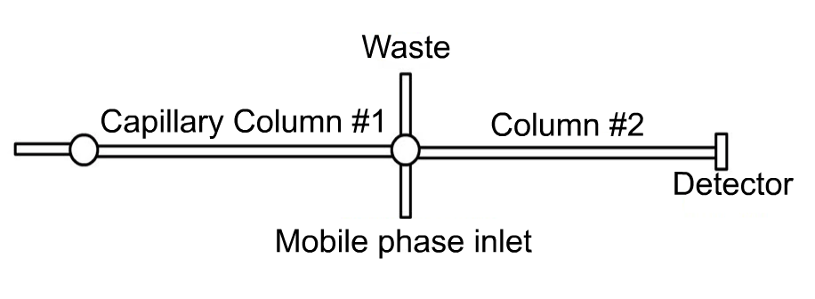Suppl. Fig. 9. Two capillary columns in which the left column subjects solutes to shear and, following various times, is used to provide samples at various times for analysis in the right column (#2). The center valve could either be more complex than shown, with an additional sample loop or could possibly use the valve itself as a sampling device.

4. Because the flow of Aβ-containing CSF into the brain is generated by the beat of the heart superimposed on the breathing cycle [21] and there are reports of oscillating movements of CSF and ISF at the blood-brain barrier [22, 23], one variation of the above experiment could be to oscillate forward and, possibly, backward flow in Supplementary Fig. 9, column #1, simulating the pulsating beats of the heart and/or the breathing cycle or blood-brain barrier flow, followed by analysis of peak shapes at different times in column #2. Times can be varied to resemble times under which ISF is periodically under shear stress in interstitial brain matter as it flows during periods of wakefulness and sleep.

5. The addition to the mobile phase and Aβ-containing samples of various drugs that have either been found to stall the progress of Alzheimer’s disease or that are to be tested for medical purposes might also be revealing. For example, antibody drugs, such as gantenerumab and solanezumab, as well as more recently developed drugs, which bind to amyloid proteins, might be candidates for competing solute addition experiments. These drugs could be added to the Aβ mobile phase, to sample aliquots from the capillary effluent, or the injected sample.

6. Since various isoforms of APOE, especially ε4, colocalize within plaques in the brain parenchyma and in cerebral amyloid angiopathy, experiments with APOE either in the Aβ sample or in the mobile phase, or both should be performed.

7. In the same vein as #6 above, one could test the addition of modified Aβ molecules, e.g., “trimmed” Aβ (e.g., with and without a dangling -COOH end) and other “designer” amyloid molecules, e.g., in-register versus out-of-register amyloid dimers, tested previously for their biological behavior.

8. Again similar to #6, the addition to the capillary mobile phase and/or sample solution of a reagent, e.g., Thioflavin T, that is an indicator of amyloid filament formation.

9. Critical also would be the addition of metal ions such as Cu, Zn, and Fe [11, 12] to the Aβ sample or mobile phase since plaque does contain metal ions and nearly all of our work has been with stainless steel capillary tubing, some with pits caused by a previous corrosion event. Although in our experience, experiments with capillaries constructed of materials other than stainless steel have failed because of extreme clogging, one other material that has been suggested is PEEK (polyether ether ketone).

10. Treatment of the inside of the capillary surface with different agents to alter the capillary surface. The most important challenge would be to design wall surfaces that will mimic the membrane surface on a neuron. This may require a redesign of the geometry of the confining “capillary” space; for example, using two flat plates with a very small separation between them, one or both of them coated with a membrane that can mimic the biological surfaces of the neurons and astrocyte feet in the brain. This is especially important in exploring the concept of Aβ₄₂* as a toxic species in that it probably adsorbs directly to the neuron surface, especially to that part containing embedded GM1 ganglioside molecules.

11. An interesting, but quite challenging, variation of #10 above would be to construct (3D print?) a sheath to surround a synthetic or real artery and, with Aβ-containing CSF fluid filling the space outside of the artery, but confined within the sheath, mimic the situation of the artery leading into the brain by pulsing a fluid inside the artery to drive the CSF fluid forward. Sampling the CSF fluid and the two walls exposed to CSF in such an experiment for amyloid oligomers as well as wall reaction products would pose some difficult challenges. In this case, it might be even easier to experiment with the actual model animal and artery systems.

12. Model the work of Metzner (polymer flow through wire mesh) [10] using a supported biological mesh sample, such as a brain cell slice, as a cylindrical frit through which the mobile phase sample would be pulsed with varying pressures and analyzed in our capillary system, and which would be analyzed for oligomer and plaque content.

13. In keeping with the Metzner theme above, model simple extensional shear forces. Start by injecting the sample plug into a length of capillary with a relatively wide diameter joined to a short section of capillary with a smaller diameter, causing extensional flow acceleration with additional sudden extensional shear similar to that in passage through the Metzner frit. One can then analyze the output from different lengths of the smaller capillary tubing. The next experiment would be to join another larger diameter capillary to the section of the smaller diameter capillary to study the effect of relaxation of shear.

14. Addition of a compound, e.g., serum albumin, known to inhibit amyloid aggregation, to the sample or mobile phase or both to study the effects of timing of prevention of aggregation. Blank albumin runs would be critical in studies with variable flow rates.

15. Vary the temperature in key experiments above, especially since this varies the rates of diffusion of different compounds as well as the ease of formation and stabilities of the shear induced products. Increasing temperatures, especially in the neighborhood of 37ºC, may alter the yields of shear-induced products and shorten the lifetimes of less stable amyloid oligomers and intermediates.

16. Given the very small flow channel dimensions in the brain parenchyma, it is strongly recommended that the influence of the size of the capillary be thoroughly explored, especially moving to much smaller dimensions, especially since the average width of the ISF flow channels are on the order 50 nm. Slower flow rates will need to be studied with very small diameter capillaries because of the probable slow ISF flow rates in these channels. Control of micro flow rates may be challenging. However, pumps are now available because of the move toward miniaturization of analytical techniques.

17. Finally, and no less important, the use of mass spectrometry and other detectors that do not depend on UV light absorbance can be substituted for the optical system and perhaps identify metastable molecules exiting the capillary and quantify the amounts of each of these molecular initiators of the amyloid cascade. Fourier transform infrared and circular dichroism can be used to examine characteristic FTIR and CD peaks associated with structural characteristics such as alpha helical and beta sheet structures.

REFERENCES

[1] Trumbore CN, Grehlinger M, Stowe M, Kelleher FM (1985) Further experiments on a new, fast method for determining molecular weights of diffusing species in a liquid phase. J Chromatogr 322, 443-454.

[2] Kelleher FM, Trumbore CN (1984) Dispersion of protein solutions in short, open capillary tubes as a method for rapid molecular weight determination. Anal Biochem 137, 20-24.

[3] Trumbore CN, Jackson LM, Bennett S, Thompson A (1989) High-speed analytical sensor for in-line monitoring of dissolved analytes flowing in a tube employing a combination of limited diffusion, laminar flow, and plug solvent injections. J. Chromatogr 481, 111-120.

[4] Atwood JG, Golay MJE (1981) Dispersion of peaks by short straight open tubes in liquid chromatography systems. J Chromatogr 218, 97-122.

[5] Shankar A, Lenhoff AM (1989) Dispersion in laminar flow in short tubes. AIChE J 35, 2048-2052.

[6] Shankar A, Lenhoff AM (1991) Dispersion in round tubes and its implications for extracolumn dispersion. J Chromatogr 556, 235-248.

[7] Lighthill MJ (1966) Initial development of diffusion in Poiseuille flow. J Inst Maths Applics 2, 97.

[8] Vrentas, JS, Vrentas CM (1988) Dispersion in laminar tube flow at low Peclet numbers or short times. AIChE J 34, 1423.

[9] Trumbore, CN, Tremblay RD, Penrose JT, Mercer M, Kelleher FM (1983) Unusual flow behavior and losses of proteins in high performance liquid chromatography capillary tubing. J Chromatogr 280, 43-57.

[10] Metzner AB, Cohen Y, Rangel-Nafaile C (1979) Inhomogeneous flows of non-newtonian fluids: generation of spatial concentration gradients. J Nonnewton Fluid Mech 5, 449-462.

[11] Ott, S, Dziadulewicz N, Crowther DC. (2015) Iron is a specific cofactor for distinct oxidation- and aggregation-dependent A beta toxicity mechanisms in a Drosophila model. Dis Model Mech 8, 657-667.

[12] Dong J, Joseph CA, Borotto NB, Gill VL, Maroney MJ, Vachet RW (2014) Unique effect of Cu(II) in the metal-induced amyloid formation of β‑2-microglobulin. Biochemistry 53, 1263−1274.

[13] Trumbore CN (2016) Shear-induced amyloid formation in the brain: I. Potential vascular and parenchymal processes. J Alzheimers Dis 54, 457–470.

[14] Smock RG, Gierasch LM (2009) Sending signals dynamically. Science 324, 198-203.

[15] Teoh CL, Bekard IB, Asimakis P, Griffin MDW, Ryan TM, Dunstan DE, Howlett GJ (2011) Shear flow induced changes in apolipoprotein C-II conformation and amyloid fibril formation. Biochemistry 50, 4046–4057.

[16] Ashton L, Dusting J, Imomoh E, Balabani S, Blanch EW (2010) Susceptibility of different proteins to flow-induced conformational changes monitored with Raman spectroscopy. Biophysical J 98, 707–714.

[17] Bernstein, SL, Dupuis NF, Lazo ND, Wyttenbach T, Condron MM, Bitan G, Teplow DB, Shea J-E, Ruotolo BT, Robinson CV, Bowers MT (2009) Amyloid-β protein oligomerization and the importance of tetramers and dodecamers in the aetiology of Alzheimer’s disease. Nat Chem 1, 326-339.

[18] Yang M, Teplow, DB (2008) Amyloid β-protein monomer folding: free-energy surfaces reveal alloform-specific differences. J Mol Biol 384, 450–464.

[19] Chimon S, Shaibat MA, Jones CR, Calero DC, Aizezi B, Ishi Y (2007) Evidence of fibril-like beta-sheet structures in a neurotoxic amyloid intermediate of Alzheimer's beta-amyloid. Nat Struct Mol Biol 14,1157-1164.

[20] Yu L, Edalji R, Harlan JE, Holzman TF, Lopez AP, Labkovsky B, Hillen H, Barghorn S, Ebert U, Richardson PL, Miesbauer L, Solomon L, Bartley D, Walter K, Johnson RW, Hajduk PJ, Olejniczak ET (2009) Structural characterization of a soluble amyloid beta peptide oligomer. Biochemistry 48, 1870–1877.

[21] Dreha-Kulaczewski S, Joseph AA, Merboldt K-D, Ludwig HC, Gärtner J, Frahm J (2015) Inspiration is the major regulator of human CSF flow. Neurobiol Dis 35, 2485-2491.

[22] Brinker T, Stopa E, Morrison J, Klinge P (2014) A new look at cerebrospinal fluid circulation. Fluids Barriers CNS 11,10.

[23] Hladky S, Barrand M (2014) Mechanism of fluid movement into, throgh and out of the brain: evaluation of the evidence. Fluids Barriers CNS 11, 26.

