**Supplementary Material**

**Methods**

To determine the recovery of [18F]-AV45, as well as the stability of the tracer during the workup, control experiments (n = 3) were performed using blood and brain spiked *in vitro* with 200 kBq of [18F]-AV45. Sample workup was identical as described for the main metabolite experiment. 96.7 ± 2.0% intact tracer was detected in the brain and 97.5 ± 1.1% intact tracer was detected in the plasma.

**Results**

*Employing cerebellar normalization and partial volume effects corrections improves the sensitivity of [18F]-AV45*

*Ex vivo* quantification of amyloid-β demonstrated appreciable amyloid deposition at 9 months and thus we used data from this time point to compare the effect of quantification methods on the sensitivity of [18F]-AV45. These comparisons are visualized in Supplementary Fig. 2A-D with the empirical data in Table 1. In the original data, minimal differences between genotypes were observed, and uptake values were lower in the striatum of TASTPM mice. PVEC increased the mean difference between WT and TASTPM in the cortex (+ 82.2%), thalamus (+ 143.8%), and hippocampus (+ 109.9%) but also increased the standard error and similarly demonstrated lower uptake in the striatum. Cerebellar normalization of the PVEC data further increased mean differences between WT and TASTPM mice in the cortex (+ 59.8% versus PVEC alone) and led to positive changes in the striatum. Normalization substantially reduced the standard error in comparison to both the original and PVEC data resulting in significant differences in most regions.

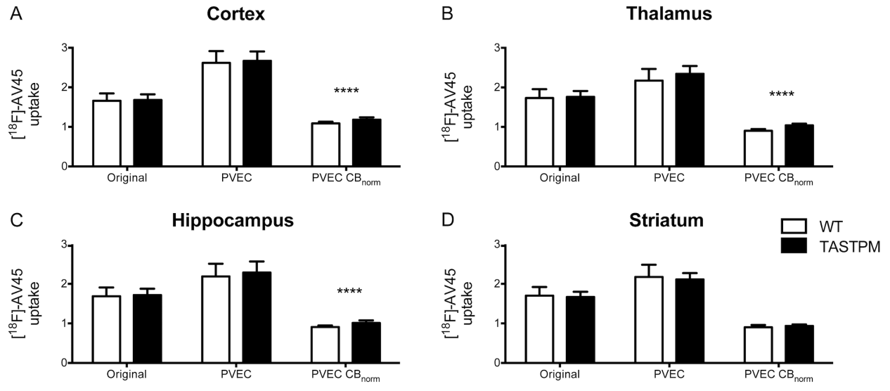

**Supplementary Fig. 1.** Graphical comparison of quantification methods for [18F]-AV45 uptake at 9 months of age. Differences between genotypes for each quantification method were evaluated with t-tests (with Sidak-Bonferroni correction), ****p < 0.0001



**Supplementary Table 1.** Changes in mean differences of [18F]-AV45 uptake between WT and TASTPM mice at 9 months of age dependent on quantification.

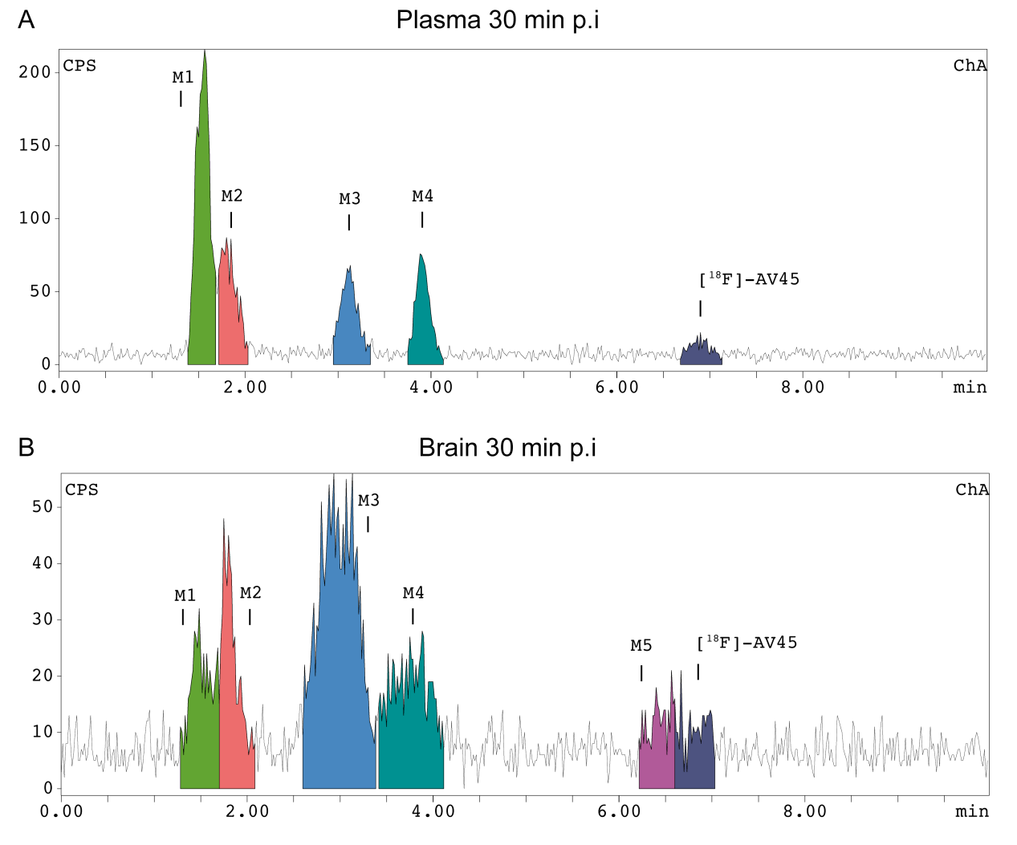

**Supplementary Fig. 2.** Representative chromatograms of (A) plasma and (B) brain samples at 30 min p.i. of [18F]-AV45 in young WT mice.

|  |  |  |  |
| --- | --- | --- | --- |
| Time pi | Young WT  (3 M) | Aged WT  (15 M) | Aged TASTPM  (15 M) |
| 5 | 27.1 ± 7.3 | 27.5 ± 0.9 | 28.48 ± 10.6 |
| 10 | 7.92 ± 0.7 | 14.66 ± 2.9 | 12.02 ± 3.6 |
| 30 | 3.03 ± 2.9 | 4.40 ± 3.9 | 5.97 ± 5.2 |
| 60 | 5.21 | 0 | 0 |

**Supplementary Table 2.** Levels of intact [18F]-AV45 in plasma at multiple time points p.i.



**Supplementary Fig. 3.** 4G8 immunostaining at 15 months in TASTPM mice in multiple brain regions and in the cerebellum of WT mice.