Supplementary Material

Supplementary Figure 1. Overview of factors that can affect the clinical accuracy of CSF biomarker analysis.ApoE, Apolipoprotein E; QC, quality control.
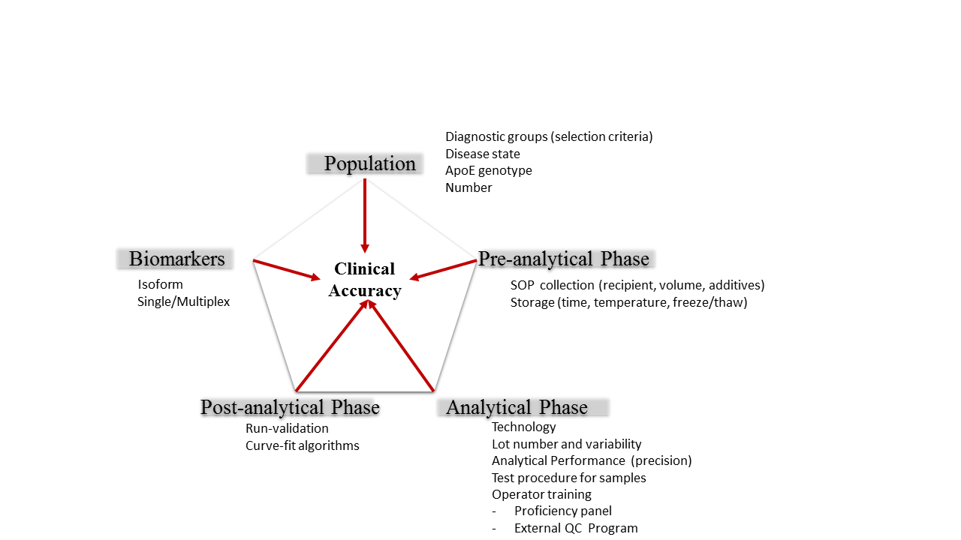

Supplementary Figure 2.Inclusion of a ‘pre-wash’ step of recipients in the test procedure.

MATERIALS AND METHODS
Since measurement of CSF Aβ₁₋₄₂ is affected by the selected recipients for sample handling, we performed an initial experiment in which three different types of recipient (PP-1: Greiner Code 650201; PP-2: Greiner Code 655185; Qiagen tubes: Code 19560) for pre-handling of CSF or run-validation control samples (= calibrator in phosphate-buffered solutions) were compared, either with or without a pre-wash step of the recipients with sample diluent from the commercial kit before addition of samples to antibody-coated plates.

RESULTS
For CSF samples (n=5), pre-treatment of recipients with sample diluent (pre-wash step) reduced adsorption to PP-1, PP-2, or Qiagen recipients significantly (Mean % (95%CI; p value)) by 32.1 (17.5-48.5; p=0.0006), 23.3 (10.3-37.7; p=0.0024), or 26.1 (15.1-38.1; p=0.0004), respectively. When CSF is added to the Qiagen tubes before analysis, levels were reduced compared to PP1 tubes by -19.5 (-31.7 - -5.1; p=0.0159) or -23.2 (-30 - -15.7; p=0.0002) for the no-wash or wash procedure, respectively.
For run-validationcontrol samples (n=5), slightly lower values were obtained with inclusion of the wash procedure of the recipients, amounting to -5.0 (-9.2 - -0.5; p=0.0325), -6.0 (-11.0 - -0.8; p=0.0294), and -5.1 (-10.2-0.4; p=0.0635) for PP-1, PP-2, and Qiagen, respectively. The use of Qiagen tubes reduced Aβ₁₋₄₂ levels compared to PP-1 by -12.1 (-16.4 - -7.7; p=0.0003) and -12.2 (-16.2 - -8.1; p=0.0002) for the no-wash and wash procedure, respectively. These observations were confirmed several times during the validation phase of the assay. As a result, all CSF biomarker studies were done according to the flow chart as presented in Supplementary Figure 3, including pre-wash steps whenever applicable.
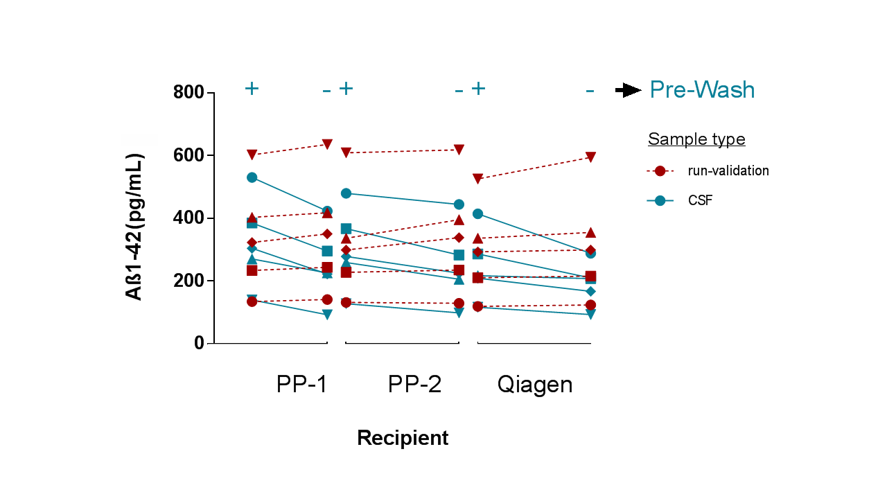
CSF, cerebrospinal fluid; PP, polypropylene.
Statistics
Effect sizes and p-values.
Sample Type | Tube type | Estimate  Wash - No Wash | 95%CI LL | 95%CI UL | p-value |  | Sample Type | Wash | Estimate  PP-1 - Qiagen | 95%CI LL | 95%CI UL | p-value
Run-validation | Qiagen | -5.1 | -10.2 | 0.4 | 0.0635 |  | Run-Validation | + | -12.2 | -16.2 | -8.1 | 0.00020
 | PP-2 | -6.0 | -11.0 | -0.8 | 0.0294 |  |  | - | -12.1 | -16.4 | -7.7 | 0.00030
 | PP-1 | -5.0 | -9.2 | -0.5 | 0.0325 |  | CSF | + | -23.2 | -30.0 | -15.7 | 0.00020
CSF | Qiagen | 26.1 | 15.1 | 38.1 | 0.0004 |  |  | - | -19.5 | -31.7 | -5.1 | 0.01590
 | PP-2 | 23.3 | 10.3 | 37.7 | 0.0024
 | PP-1 | 32.1 | 17.5 | 48.5 | 0.0006

Paper: 2016-Vanderstichele et al.

Supplementary Figure 3. Flow chart for sample handling. SD, sample diluent
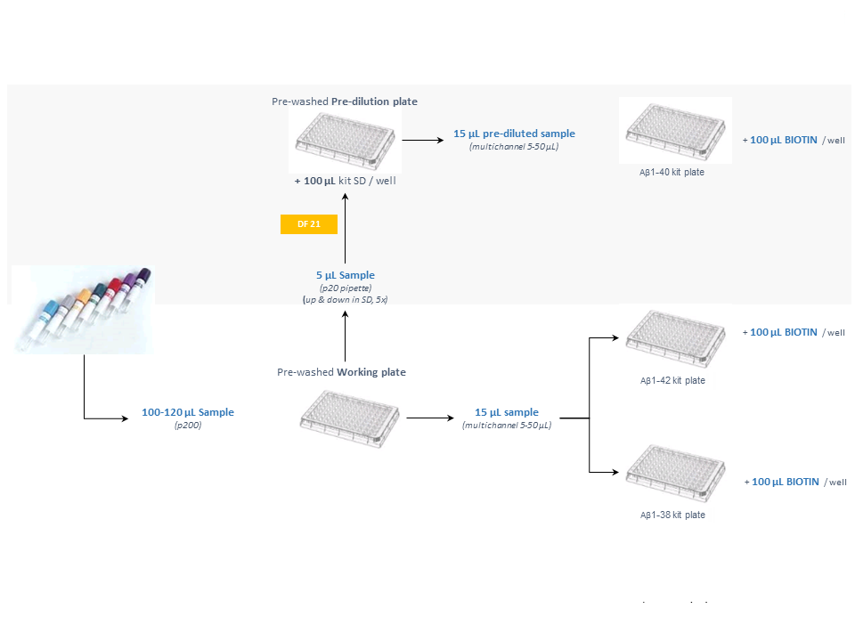
Supplementary Figure 4. Recovery of Aβ₁₋₄₂ by treatment of the stored CSF tubes with Tween-20.Extraction studies were done with the aim to recover Aβ₁₋₄₂ from recipients. Tubes with CSF, collected in the absence of detergent, were treated with different concentrations (0.002 - 0.05%) of Tw20. Aβ₁₋₄₂ recoveries were compared with CSF without the extraction procedure. Details of the test procedure are described in Materials and Methods.
