Supplementary Material
Supplementary Figure 1. Factors that influence the variability
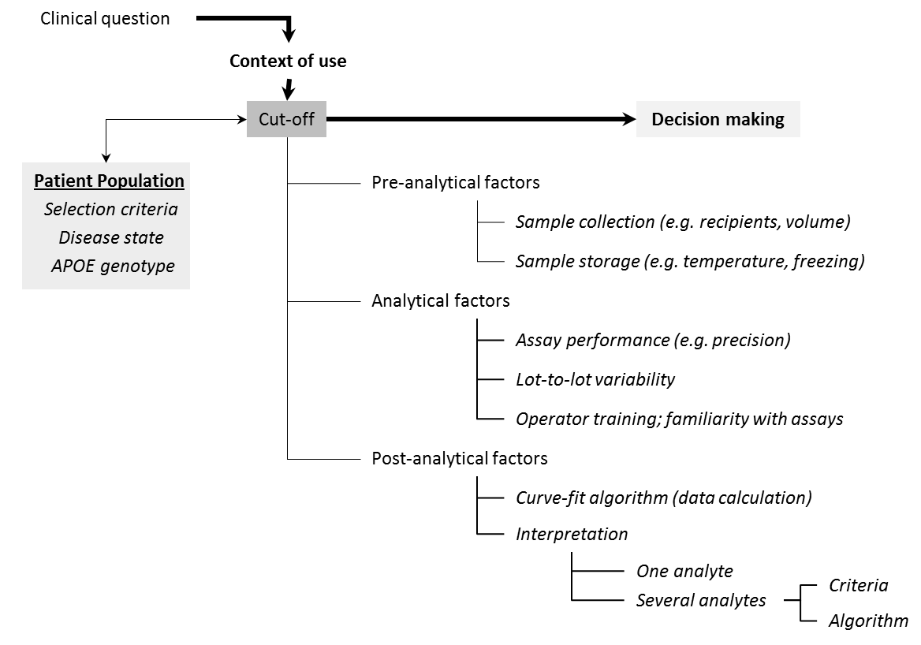

Supplementary Figure 2

Supplementary Table 1.Diagnostic performance of CSF biomarkers when a shift in concentration was inducedto Aβ₁₋₄₂ values in autopsy-confirmed AD patients and controls .

 | Sensitivity (%) | Specificity (%) | Diagnostic accuracy (%)
True data | 77.8 | 92.0 | 86.1
+5% Aβ₁₋₄₂; T-tau; P-tau_{181P} | 77.8 | 92.0 | 86.1
-5% Aβ₁₋₄₂; T-tau; P-tau_{181P} | 77.8 | 90.0 | 84.9
+10% Aβ₁₋₄₂; T-tau; P-tau_{181P} | 76.4 | 92.0 | 85.5
-10% Aβ₁₋₄₂; T-tau; P-tau_{181P} | 77.8 | 90.0 | 84.9
+20% Aβ₁₋₄₂; T-tau; P-tau_{181P} | 75.0 | 93.0 | 85.5
-20% Aβ₁₋₄₂; T-tau; P-tau_{181P} | 80.6 | 87.0 | 84.3
+30% Aβ₁₋₄₂; T-tau; P-tau_{181P} | 75.0 | 93.0 | 85.5
-30% Aβ₁₋₄₂; T-tau; P-tau_{181P} | 80.6 | 81.0 | 80.8
+40% Aβ₁₋₄₂; T-tau; P-tau_{181P} | 63.9 | 95.0 | 82.0
-40% Aβ₁₋₄₂; T-tau; P-tau_{181P} | 80.6 | 79.0 | 79.7
Aβ₁₋₄₂, amyloid-β of 42 amino acids; T-tau, total tau protein; P-tau_{181P}, tau phosphorylated at threonine 181

Supplementary Table 2.Diagnostic performance of CSF biomarkers when a shift in concentration was induced to T-tau values in autopsy-confirmed AD patients and controls.

 | Sensitivity (%) | Specificity (%) | Diagnostic accuracy (%)
True data | 77.8 | 92.0 | 86.1
Aβ₁₋₄₂; -5% T-tau; P-tau_{181P} | 77.8 | 93.0 | 86.6
Aβ₁₋₄₂; +5% T-tau; P-tau_{181P} | 81.9 | 92.0 | 87.8
Aβ₁₋₄₂; -10% T-tau; P-tau_{181P} | 76.4 | 93.0 | 86.1
Aβ₁₋₄₂; +10% T-tau; P-tau_{181P} | 83.3 | 91.0 | 87.8
Aβ₁₋₄₂; -20% T-tau; P-tau_{181P} | 72.2 | 93.0 | 84.3
Aβ₁₋₄₂; +20% T-tau; P-tau_{181P} | 84.7 | 91.0 | 88.4
Aβ₁₋₄₂; -30% T-tau; P-tau_{181P} | 72.2 | 93.0 | 84.3
Aβ₁₋₄₂; +30% T-tau; P-tau_{181P} | 87.5 | 90.0 | 89.0
Aβ₁₋₄₂; -40% T-tau; P-tau_{181P} | 69.4 | 93.0 | 83.1
Aβ₁₋₄₂; +40% T-tau; P-tau_{181P} | 87.5 | 87.0 | 87.2
Aβ₁₋₄₂, amyloid-β of 42 amino acids; T-tau, total tau protein; P-tau_{181P}, tau phosphorylated at threonine 181

Supplementary Table 3.Diagnostic performance of CSF biomarkers when a shift in concentration was induced to P-tau_{181P} values in autopsy-confirmed AD patients and controls.

 | Sensitivity (%) | Specificity (%) | Diagnostic accuracy (%)
True data | 77.8 | 92.0 | 86.1
Aβ₁₋₄₂; T-tau; -5% P-tau_{181P} | 77.8 | 92.0 | 86.1
Aβ₁₋₄₂; T-tau; +5% P-tau_{181P} | 79.2 | 92.0 | 86.6
Aβ₁₋₄₂; T-tau; -10% P-tau_{181P} | 77.8 | 92.0 | 86.1
Aβ₁₋₄₂; T-tau; +10% P-tau_{181P} | 79.2 | 92.0 | 86.6
Aβ₁₋₄₂; T-tau; -20% P-tau_{181P} | 76.4 | 92.0 | 85.5
Aβ₁₋₄₂; T-tau; +20% P-tau_{181P} | 80.6 | 90.0 | 86.1
Aβ₁₋₄₂; T-tau; -30% P-tau_{181P} | 76.4 | 92.0 | 85.5
Aβ₁₋₄₂; T-tau; +30% P-tau_{181P} | 81.9 | 90.0 | 86.6
Aβ₁₋₄₂; T-tau; -40% P-tau_{181P} | 76.4 | 92.0 | 85.5
Aβ₁₋₄₂; T-tau; +40% P-tau_{181P} | 84.7 | 88.0 | 83.1
Aβ₁₋₄₂, amyloid-β of 42 amino acids; T-tau, total tau protein; P-tau_{181P}, tau phosphorylated at threonine 181

Supplementary Table 4.Diagnostic performance of CSF biomarkers for discriminating progressive from stable MCI patients when a shift in concentration was induced to Aβ₁₋₄₂ values.

 | Sensitivity (%) | Specificity (%) | Diagnostic accuracy (%)
True data | 68.1 | 79.0 | 72.9
+5% Aβ₁₋₄₂; T-tau; P-tau_{181P} | 59.6 | 79.0 | 68.2
-5% Aβ₁₋₄₂; T-tau; P-tau_{181P} | 68.1 | 73.7 | 70.6
+10% Aβ₁₋₄₂; T-tau; P-tau_{181P} | 57.5 | 84.2 | 69.4
-10% Aβ₁₋₄₂; T-tau; P-tau_{181P} | 72.3 | 73.7 | 72.9
+20% Aβ₁₋₄₂; T-tau; P-tau_{181P} | 46.8 | 86.8 | 64.7
-20% Aβ₁₋₄₂; T-tau; P-tau_{181P} | 76.6 | 68.4 | 72.9
+30% Aβ₁₋₄₂; T-tau; P-tau_{181P} | 31.9 | 89.5 | 57.7
-30% Aβ₁₋₄₂; T-tau; P-tau_{181P} | 76.6 | 65.8 | 71.8
+40% Aβ₁₋₄₂; T-tau; P-tau_{181P} | 29.8 | 92.1 | 57.7
-40% Aβ₁₋₄₂; T-tau; P-tau_{181P} | 76.6 | 63.2 | 70.6
Aβ₁₋₄₂, amyloid-β of 42 amino acids; T-tau, total tau protein; P-tau_{181P}, tau phosphorylated at threonine 181

Supplementary Table 5.Diagnostic performance of CSF biomarkers for discriminating progressive from stable MCI patients when a shift in concentration was induced to T-tau values.

 | Sensitivity (%) | Specificity (%) | Diagnostic accuracy (%)
True data | 68.1 | 79.0 | 72.9
Aβ₁₋₄₂; -5% T-tau; P-tau_{181P} | 68.1 | 81.6 | 74.1
Aβ₁₋₄₂; +5% T-tau; P-tau_{181P} | 68.1 | 79.0 | 74.1
Aβ₁₋₄₂; -10% T-tau; P-tau_{181P} | 68.1 | 81.6 | 74.1
Aβ₁₋₄₂; +10% T-tau; P-tau_{181P} | 72.3 | 76.3 | 74.1
Aβ₁₋₄₂; -20% T-tau; P-tau_{181P} | 68.1 | 81.6 | 74.1
Aβ₁₋₄₂; +20% T-tau; P-tau_{181P} | 72.3 | 73.7 | 72.9
Aβ₁₋₄₂; -30% T-tau; P-tau_{181P} | 68.1 | 84.2 | 75.3
Aβ₁₋₄₂; +30% T-tau; P-tau_{181P} | 72.3 | 68.4 | 70.6
Aβ₁₋₄₂; -40% T-tau; P-tau_{181P} | 66.0 | 84.2 | 74.1
Aβ₁₋₄₂; +40% T-tau; P-tau_{181P} | 76.6 | 65.8 | 71.8
Aβ₁₋₄₂, amyloid-β of 42 amino acids; T-tau, total tau protein; P-tau_{181P}, tau phosphorylated at threonine 181

Supplementary Table 6.Diagnostic performance of CSF biomarkers for discriminating progressive from stable MCI patients when a shift in concentration was induced to P-tau_{181P} values.

 | Sensitivity (%) | Specificity (%) | Diagnostic accuracy (%)
True data | 68.1 | 79.0 | 72.9
Aβ₁₋₄₂; T-tau; -5% P-tau_{181P} | 66.0 | 81.6 | 72.9
Aβ₁₋₄₂; T-tau; +5% P-tau_{181P} | 72.3 | 76.3 | 74.1
Aβ₁₋₄₂; T-tau; -10% P-tau_{181P} | 66.0 | 81.6 | 72.9
Aβ₁₋₄₂; T-tau; +10% P-tau_{181P} | 72.3 | 76.3 | 74.1
Aβ₁₋₄₂; T-tau; -20% P-tau_{181P} | 66.0 | 81.6 | 72.9
Aβ₁₋₄₂; T-tau; +20% P-tau_{181P} | 76.6 | 73.7 | 75.3
Aβ₁₋₄₂; T-tau; -30% P-tau_{181P} | 66.0 | 81.6 | 72.9
Aβ₁₋₄₂; T-tau; +30% P-tau_{181P} | 76.6 | 65.8 | 71.8
Aβ₁₋₄₂; T-tau; -40% P-tau_{181P} | 66.0 | 81.6 | 72.9
Aβ₁₋₄₂; T-tau; +40% P-tau_{181P} | 78.7 | 60.5 | 70.6
Aβ₁₋₄₂, amyloid-β of 42 amino acids; T-tau, total tau protein; P-tau_{181P}, tau phosphorylated at threonine 181

Supplementary Table 7.Change in diagnostic classification of individual subjects based on combinations of CSF biomarkers (Aβ₁₋₄₂, T-tau, and P-tau_{181P}) using the IWG-2 criteria.

 |  | -5% (n) | -10% (n) | -20% (n) | -30% (n) | -40% (n) | 5% (n) | 10% (n) | 20% (n) | 30% (n) | 40% (n) | Total changed profile (n) | Unchanged abnormal profile (n) | Unchanged normal profile (n)
Aβ₁₋₄₂ | AD dementia | - | - | 2* | - | - | - | 1^ | 1^ | 3^ | 5^ | 12 | 47 | 13
 | Controls | 2* | - | 3* | 6* | 2* | - | - | 1^ | - | 2^ | 16 | 5 | 79
 | MCI progressive | - | 2* | 2* | - | - | 4^ | 1^ | 5^ | 7^ | 1^ | 22 | 14 | 11
 | MCI stable | 2* | - | 2* | 1* | 1* | - | 2^ | 1^ | 1^ | 1^ | 11 | 3 | 24
T-tau | AD dementia | - | - | 4^ | - | 2^ | 3* | 1* | 1* | 2* | - | 13 | 50 | 9
 | Controls | 1^ | - | - | - | - | - | 1* | - | 1* | 3* | 6 | 7 | 87
 | MCI progressive | 1^ | - | - | - | - | 1* | 1* | - | - | 2* | 5 | 31 | 11
 | MCI stable | 1^ | - | - | 1^ | - | - | 1* | 1* | 2* | 1* | 7 | 6 | 25
P-tau_{181P} | AD dementia | - | - | 1^ | - | - | 1* | - | 1* | 1* | 2* | 6 | 55 | 11
 | Controls | - | - | - | - | - | - | - | 2* | - | 2* | 4 | 8 | 88
 | MCI progressive | 1^ | - | - | - | - | 2* | - | 2* | - | 1* | 6 | 31 | 10
 | MCI stable | 1^ | - | - | - | - | 1* | 1* | - | 3* | 1* | 7 | 7 | 24
AD, Alzheimer’s disease; MCI, mild cognitive impairment. Classification of CSF AD biomarker profiles was subdivided into three groups: subjects who remained having an abnormal biomarker profile (unchanged abnormal profile), subject who remained having a normal biomarker profile (unchanged normal profile), and subjects who changed of diagnostic classification (completely changed diagnostic classification). Change in biomarker classification if concentration shifts were induced (from ±5% to ±40%) per biomarker and per disease category for each individual: *from normal to abnormal and ^from abnormal to normal

