Supplementary Material
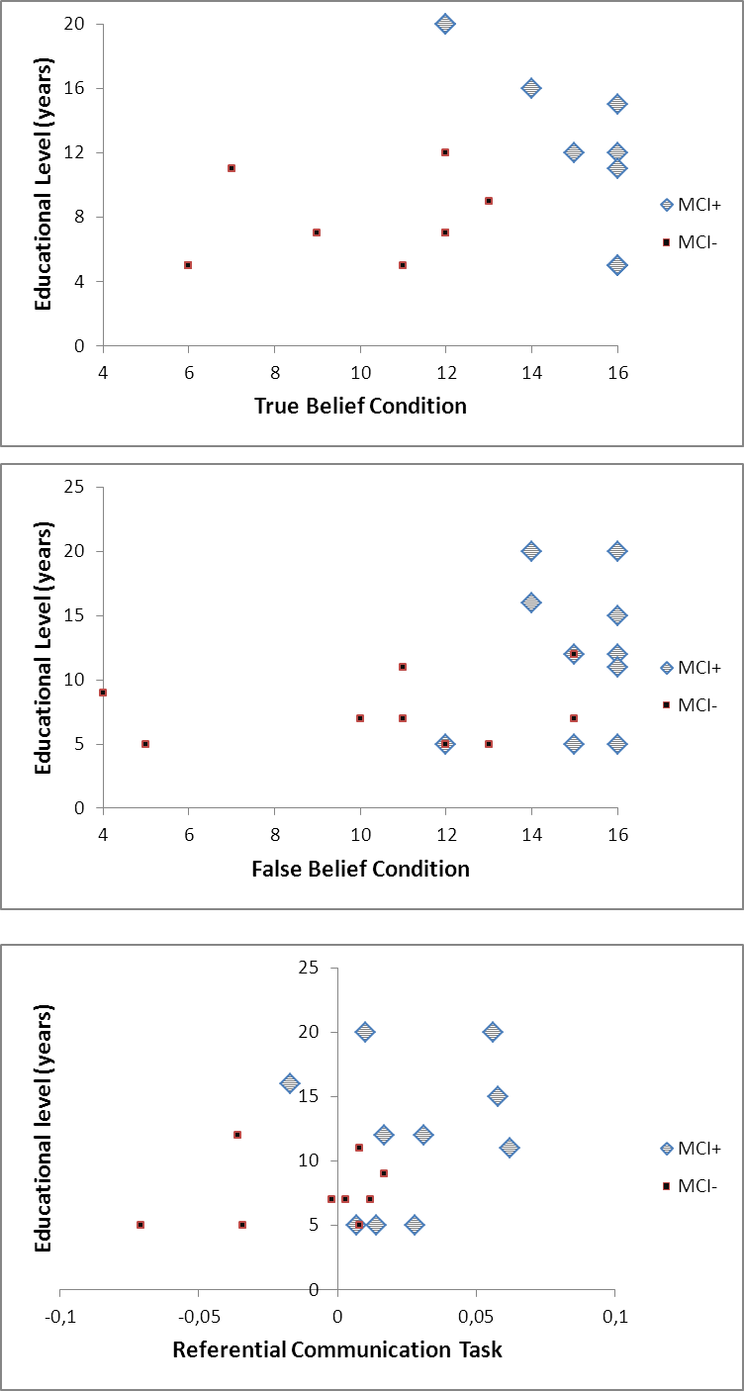

Supplementary Figure 1. Scatterplots of participants’ ToM performances according to the educational level. NB: for the Referential Communication Task, the variable used was calculated as follow: difference between the IND/word ratio of the first trial and the IND/word ratio of the third trial.

