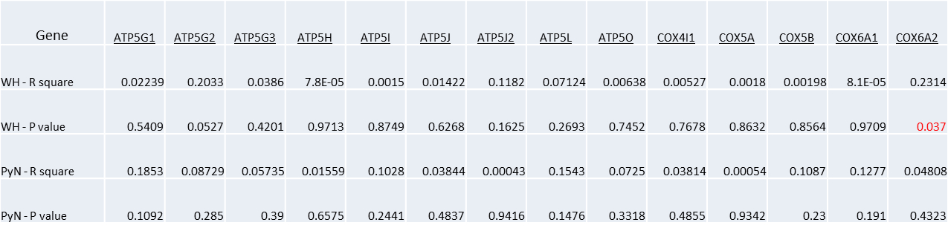
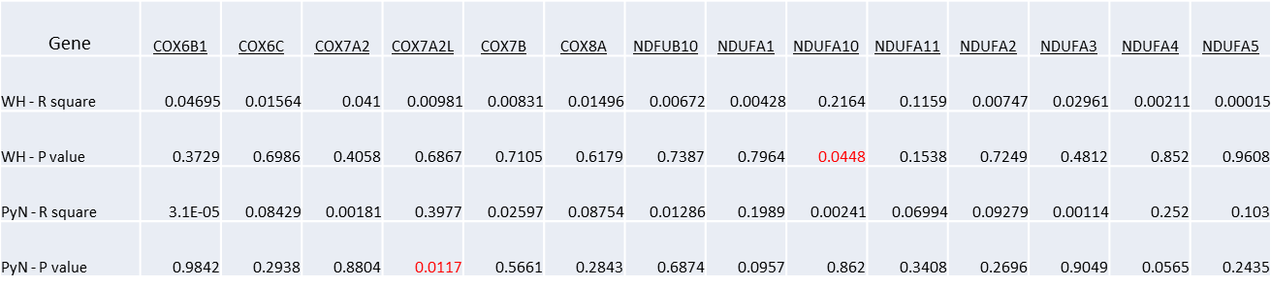
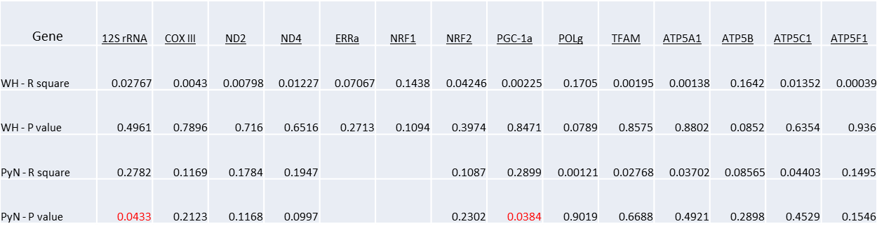
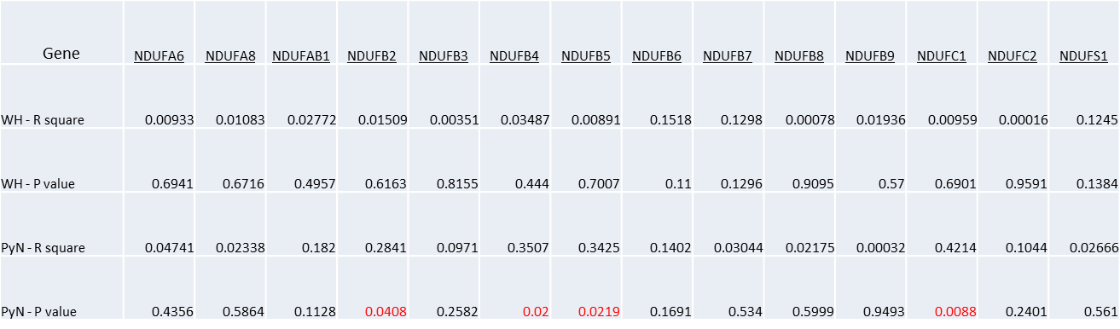
Supplementary Table 1. Correlation of age and gene expression levels.

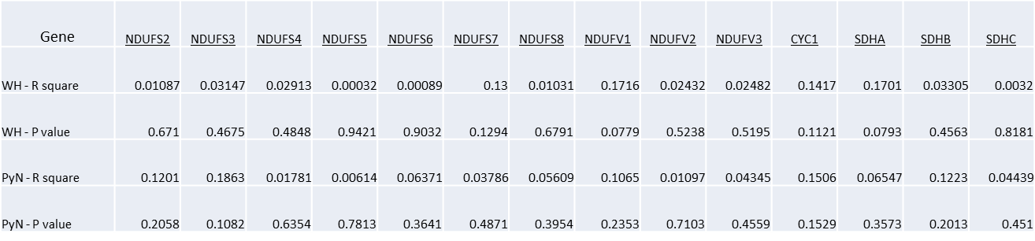

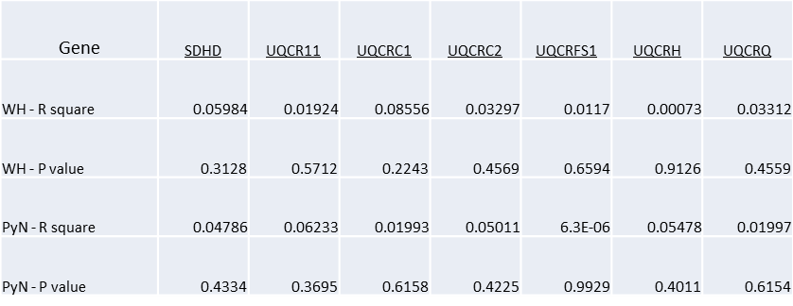

p-values < 0.05 are in red, WH, whole hippocampi; PyN, pyramidal neuron

