Additional file 1 — Supplementary materials

Supplementary Table 1: Tests of Disease×APOEε2 and Disease×APOEε3 interaction effects based on the single-SNP imaging QTL model (1). The analyses controlled for the effects of Age, Sex, APOEε4 genotype and population structure (via the principal components).

Phenotype | APOE  genotype | Disease×APOE Interaction  (Coefficient) | SE(Coef.) | p-value
Right Thalamus | APOEε2  APOEε3 | -0.073  -0.010 | 0.127  0.053 | 0.565  0.844
Left Thalamus | APOEε2  APOEε3 | -0.019  -0.005 | 0.125  0.052 | 0.881  0.923
Left Lateral Orbitofrontal | APOEε2  APOEε3 | -0.011  -0.030 | 0.029  0.012 | 0.715  0.013
Left Isthmus Cingulate | APOEε2  APOEε3 | 0.168  -0.088 | 0.150  0.062 | 0.263  0.016
Right Isthmus Cingulate | APOEε2  APOEε3 | 0.151  -0.085 | 0.146  0.060 | 0.300  0.179
Right Lingual | APOEε2  APOEε3 | 0.102  -0.085 | 0.140  0.052 | 0.468  0.144
Left Lateral  Ventricle | APOEε2  APOEε3 | -0.149  0.021 | 0.136  0.057 | 0.274  0.716
Brain Stem | APOEε2  APOEε3 | -0.060  0.056 | 0.144  0.060 | 0.678  0.352
Right Putamen | APOEε2  APOEε3 | -0.600  -0.712 | 0.147  0.061 | 0.682  0.245
CSF | APOEε2  APOEε3 | 0.044  -0.028 | 0.139  0.058 | 0.754  0.627

Quality control (QC) steps of genotype data

Supplementary Figure 1. Scatterplot of the first two PCs based on combined study samples and HapMap3 data. The black dotted lines represent the medians of the corresponding PCs based on the European (CEU, ADNI, and AddNeuroMed) samples. The red solid lines represent the 8×IQR from the median. We exclude all samples in ADNI and AddNeuroMed outside 8×IQR about the median.

Imaging data:

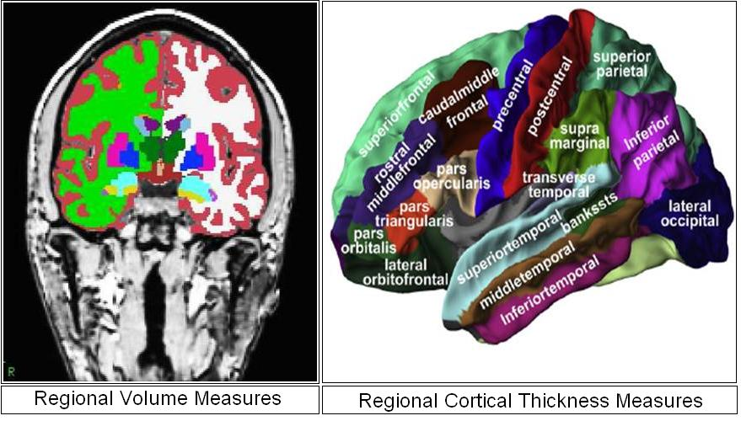

Supplementary Figure 2: Examples of regional volume (left) and regional cortical thickness (right).

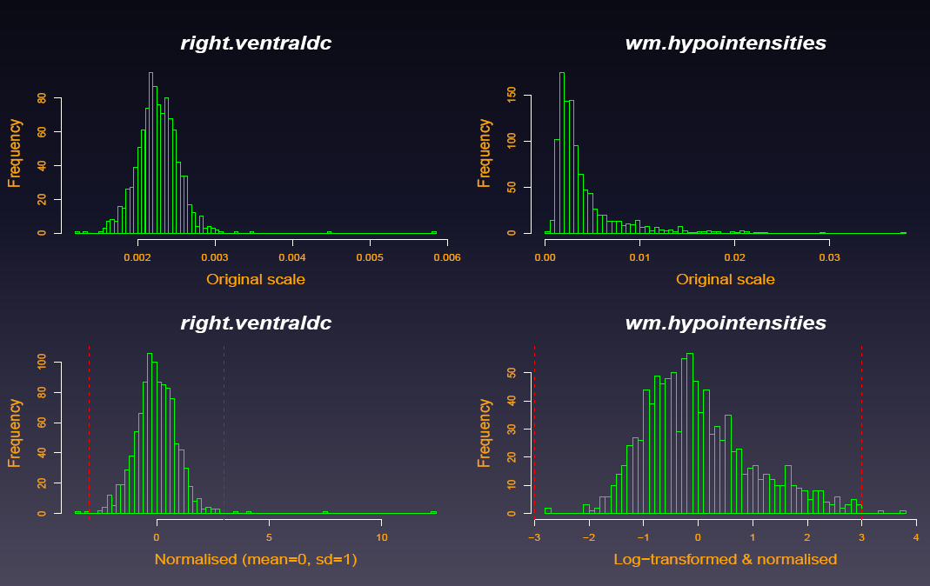

Supplementary Figure 3: Example distributions for the imaging phenotypes. Top row shows the distributions of original data and the bottom row shows the distributions for the transformed versions. All subjects outside the vertical dotted red lines (at ± 3) are removed as outliers.

