**Supplementary Material**

**Supplementary Method 1**

We used -1.0 SD instead of -1.5 SD, to define the objective memory decline in patients with amnestic mild cognitive impairment (aMCI). From 2007, it has published several papers in international journals using the same criteria for aMCI [1-18].

**References**

[1] Ahn HJ, Chin J, Park A, Lee BH, Suh MK, Seo SW, Na DL (2010) Seoul Neuropsychological Screening Battery-dementia version (SNSB-D): a useful tool for assessing and monitoring cognitive impairments in dementia patients. *J Korean Med Sci* **25**, 1071-1076.

[2] Ahn HJ, Seo SW, Chin J, Suh MK, Lee BH, Kim ST, Im K, Lee JM, Lee JH, Heilman KM, Na DL (2011) The cortical neuroanatomy of neuropsychological deficits in mild cognitive impairment and Alzheimer's disease: a surface-based morphometric analysis. *Neuropsychologia* **49**, 3931-3945.

[3] Chin J, Seo SW, Kim SH, Park A, Ahn HJ, Lee BH, Kang SJ, Na DL (2012) Neurobehavioral dysfunction in patients with subcortical vascular mild cognitive impairment and subcortical vascular dementia. *Clin Neuropsychol* **26**, 224-238.

[4] Im K, Lee JM, Seo SW, Hyung Kim S, Kim SI, Na DL (2008) Sulcal morphology changes and their relationship with cortical thickness and gyral white matter volume in mild cognitive impairment and Alzheimer's disease. *Neuroimage* **43**, 103-113.

[5] Kim MJ, Im K, Lee JM, Park A, Chin J, Kim GH, Kim JH, Roh JH, Seo SW, Na DL (2011) Cortical thinning in verbal, visual, and both memory-predominant mild cognitive impairment. *Alzheimer Dis Assoc Disord* **25**, 242-249.

[6] Kim SH, Park JS, Ahn HJ, Seo SW, Lee JM, Kim ST, Han SH, Na DL (2011) Voxel-based analysis of diffusion tensor imaging in patients with subcortical vascular cognitive impairment: correlates with cognitive and motor deficits. *J Neuroimaging* **21**, 317-324.

[7] Kim SH, Seo SW, Go SM, Chin J, Lee BH, Lee JH, Han SH, Na DL (2011) Pyramidal and extrapyramidal scale (PEPS): a new scale for the assessment of motor impairment in vascular cognitive impairment associated with small vessel disease. *Clin Neurol Neurosurg* **113**, 181-187.

[8] Kim SH, Seo SW, Yoon DS, Chin J, Lee BH, Cheong HK, Han SH, Na DL (2010) Comparison of neuropsychological and FDG-PET findings between early- versus late-onset mild cognitive impairment: A five-year longitudinal study. *Dement Geriatr Cogn Disord* **29**, 213-223.

[9] Seo SW, Ahn J, Yoon U, Im K, Lee JM, Tae Kim S, Ahn HJ, Chin J, Jeong Y, Na DL (2010) Cortical thinning in vascular mild cognitive impairment and vascular dementia of subcortical type. *J Neuroimaging* **20**, 37-45.

[10] Seo SW, Cho SS, Park A, Chin J, Na DL (2009) Subcortical vascular versus amnestic mild cognitive impairment: comparison of cerebral glucose metabolism. *J Neuroimaging* **19**, 213-219.

[11] Seo SW, Im K, Lee JM, Kim YH, Kim ST, Kim SY, Yang DW, Kim SI, Cho YS, Na DL (2007) Cortical thickness in single- versus multiple-domain amnestic mild cognitive impairment. *Neuroimage* **36**, 289-297.

[12] Seo SW, Lee JM, Im K, Park JS, Kim SH, Kim ST, Ahn HJ, Chin J, Cheong HK, Weiner MW, Na DL (2012) Cortical thinning related to periventricular and deep white matter hyperintensities. *Neurobiol Aging* **33**, 1156-1167.

[13] Seo SW, Lee JM, Im K, Park JS, Kim SH, Kim ST, Ahn JH, Kim MJ, Kim GH, Kim JH, Roh JH, Cheong HK, Na DL (2012) Cardiovascular risk factors cause cortical thinning in cognitively impaired patients: relationships among cardiovascular risk factors, white matter hyperintensities, and cortical atrophy. *Alzheimer Dis Assoc Disord* **26**, 106-112.

[14] Seo SW, Suh MK, Chin J, Na DL (2009) Mental confusion associated with scopolamine patch in elderly with mild cognitive impairment (MCI). *Arch Gerontol Geriatr* **49**, 204-207.

[15] Son SJ, Lee KS, Na DL, Seo SW, Kim CH, Kim JH, Oh BH, Hong CH (2011) Anemia associated with depressive symptoms in mild cognitive impairment with severe white matter hyperintensities. *J Geriatr Psychiatry Neurol* **24**, 161-167.

[16] Son SJ, Lee KS, Na DL, Seo SW, Kim CH, Kim JH, Oh BH, Hong CH (2012) The effect of anemia and white matter hyperintensities (WMH) on cognitive impairment in patients with amnestic mild cognitive impairment (MCI). *Arch Gerontol Geriatr* **55**, 251-256.

[17] Ye BS, Seo SW, Cho H, Kim SY, Lee JS, Kim EJ, Lee Y, Back JH, Hong CH, Choi SH, Park KW, Ku BD, Moon SY, Kim S, Han SH, Lee JH, Cheong HK, Na DL (2013) Effects of education on the progression of early- versus late-stage mild cognitive impairment. *Int Psychogeriatr* **25**, 597-606.

[18] Ye BS, Seo SW, Lee Y, Kim SY, Choi SH, Lee YM, Kim do H, Han HJ, Na DL, Kim EJ (2012) Neuropsychological performance and conversion to Alzheimer's disease in early- compared to late-onset amnestic mild cognitive impairment: CREDOS study. *Dement Geriatr Cogn Disord* **34**, 156-166.

**Supplementary Figure 1.** The Comprehensive Visual Rating Scale (CVRS) on a tablet computer (the iPAD version).

D:\DaumCloud\0분당서울대학교\VBM and Imaging\Visual rating\5JAD\CVRS screenshot\monitor2.tif

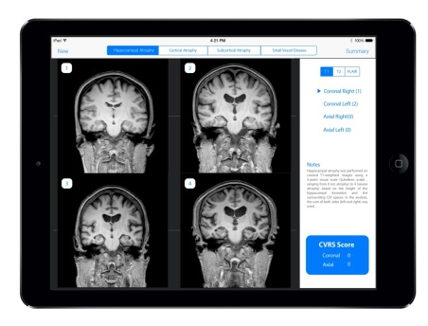

C:\Users\KNUH\AppData\Local\Microsoft\Windows\Temporary Internet Files\Content.IE5\M8AXPKGQ\MC900343747[1].wmfC:\Users\KNUH\AppData\Local\Microsoft\Windows\Temporary Internet Files\Content.IE5\M8AXPKGQ\MC900343747[1].wmf



The raters used a template-based scoring program on a tablet computer that summed the total score automatically by matching the closest template image to the real magnetic resonance imaging (MRI) finding of the subject. The main screenshot of this software is as follows.

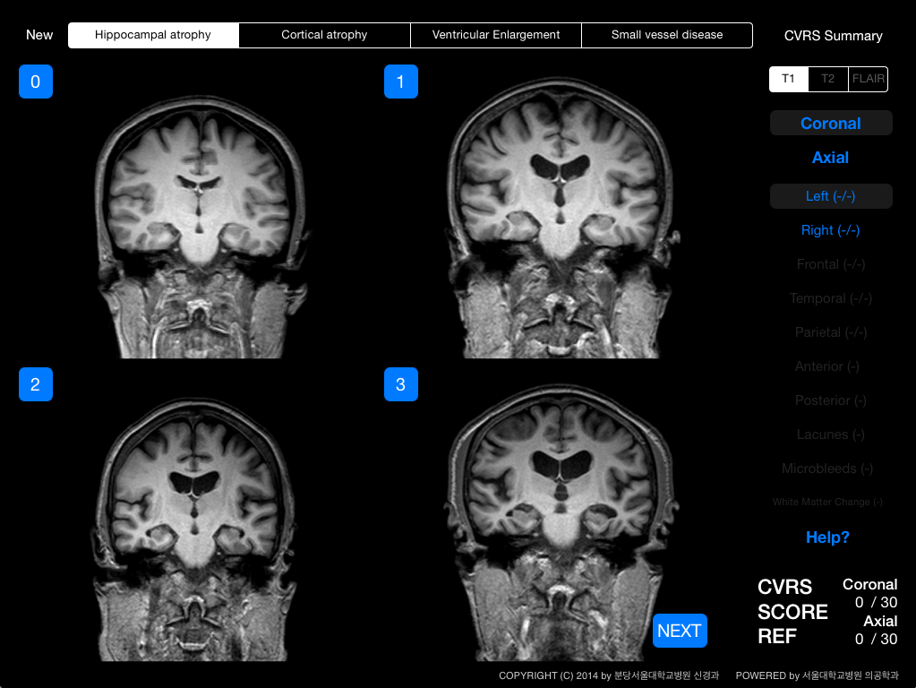

The upper menu bar indicates the 4 subscales (hippocampal atrophy, cortical atrophy, ventricular enlargement, and small vessel disease). The user can move to each of them by touching it. The right menu bar shows the summed score as well as the imaging modality. Although the CVRS is based on intuitive visual ratings, help buttons show the principles of each visual rating described in the methods section. Detailed screenshots of the CVRS follow.

1. 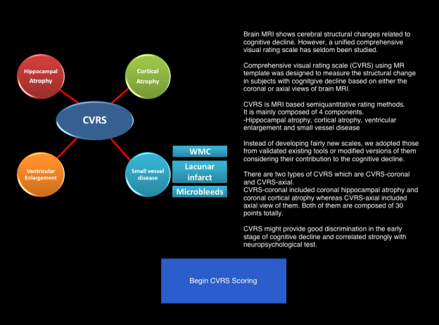The first screenshot for the CVRS. It includes the introduction. The user can move to the scoring section by touching the blue button labeled *Begin CVRS Scoring* at the bottom of the screen.

2. Hippocampal atrophy (coronal or axial views). By matching and touching the closest template image to the real MRI finding of the subject, the score for coronal or axial hippocampal atrophy is automatically calculated in the right menu bar. The user can move to the grade-4 image by touching the *next* button at the right lower side of the screen. Left and right hippocampal atrophy are measured separately by using the buttons labeled *left* and *right* in the right menu bar.

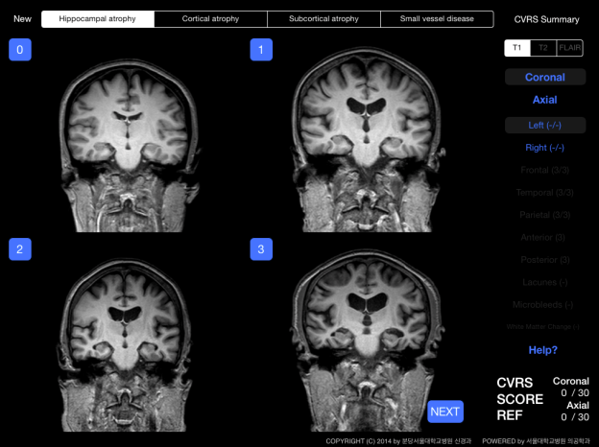 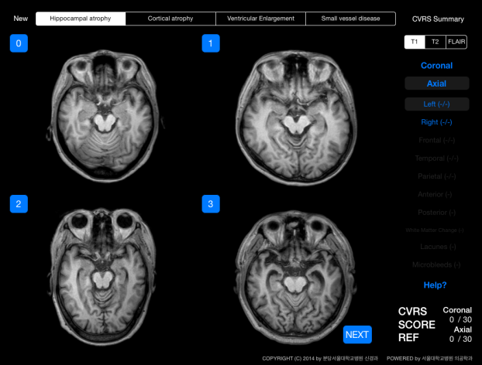

3. Cortical atrophy (coronal or axial views). Frontal, temporal, and parietal atrophy can be rated. The user can move to the image of each lobe by touching the buttons labeled *Frontal*, *Temporal*, or *Parietal* in the right menu bar. The ratings are done for the three lobes for the coronal or axial views.

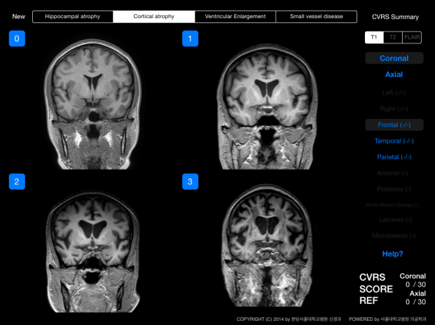 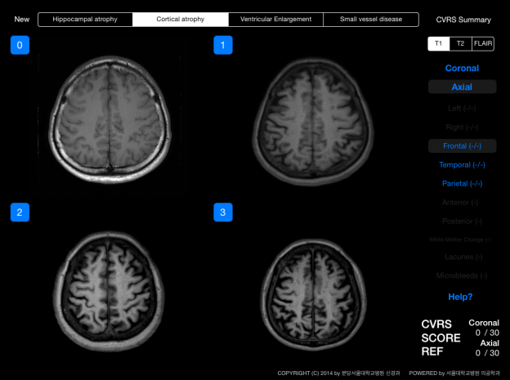

4. Ventricular enlargement. Ventricular enlargement was measured by rating the enlargement of the anterior and posterior lateral ventricles separately (Left figure).

5. The white matter change (WMC). WMC was measured according to the modified Fazekas and Scheltens scale (Right figure).

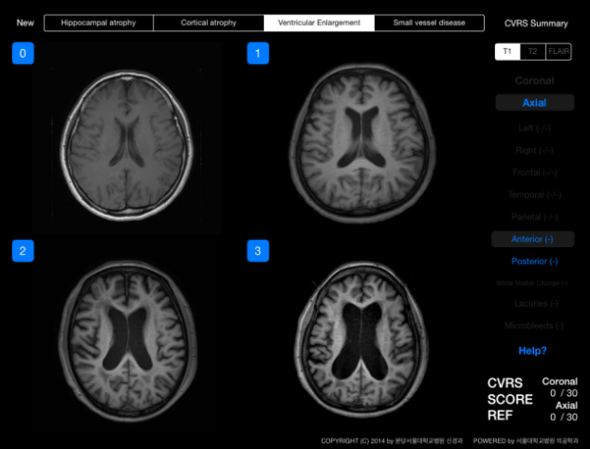 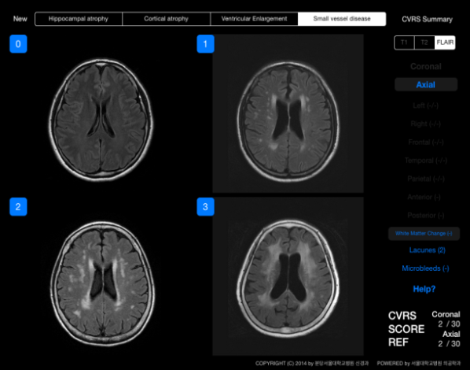

6. The number of lacunes and microbleeds are entered, and their scores are automatically calculated as grade 0 (no lesions), grade 1 (1–4 lesions), or grade 2 (5 or more lesions).

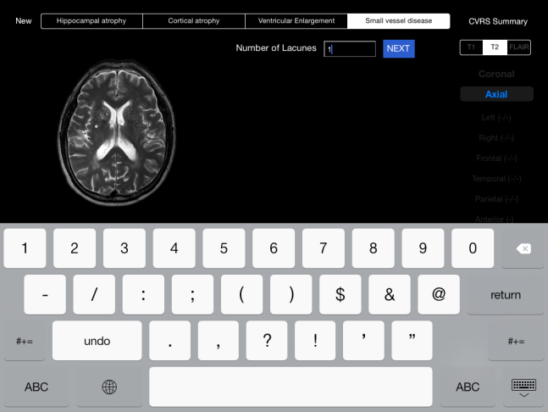 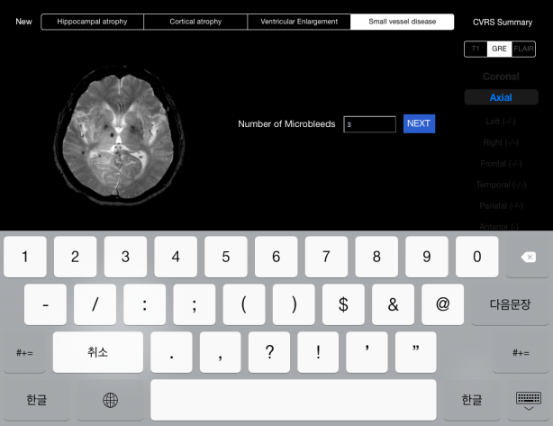

7. The summary of the scores. The summary shows the total summed score of the CVRS as well as the subscores of the subscales (left figure). Personal information can be entered for the subjects, and all of the data can be transferred to a server or individual E-mail (right figure).

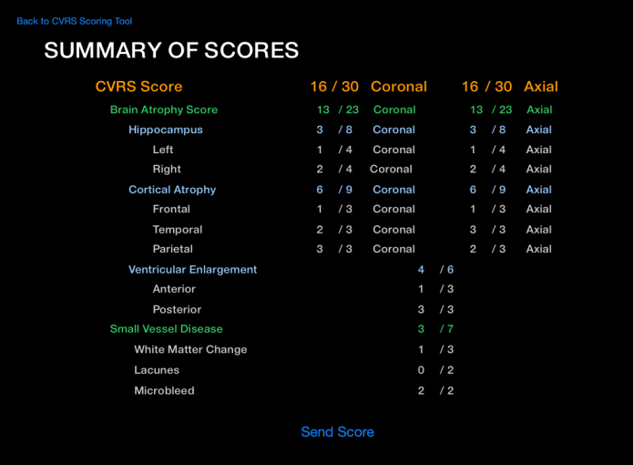 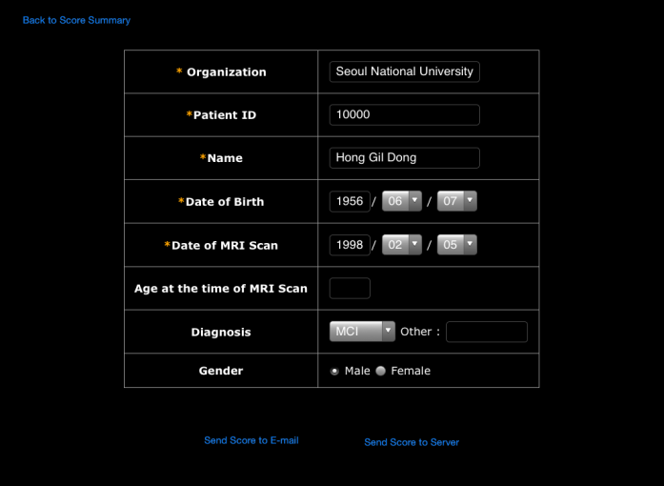

**Supplementary Table 1.** MR acquisition parameters

|  |  |  |  |  |  |  |  |  |  |  |
| --- | --- | --- | --- | --- | --- | --- | --- | --- | --- | --- |
| **Brain MRI scan parameter** | | | | | | | | | | |
|  | **T2** | | **FLAIR** | | **T1** | | **GRE** | | **3DT1** | |
| **1.5T** | **3T** | **1.5T** | **3T** | **1.5T** | **3T** | **1.5T** | **3T** | **1.5T** | **3T** |
| **TR (ms)** | 4844 | 3000 | 11000 | 11000 | 505 | 600 | 725 | 818 | 8 | 8.1 |
| **TE (ms)** | 100 | 80 | 140 | 125 | 11 | 9.5 | 23 | 18 | 3.7 | 4.6 |
| **TI (ms)** |  |  | 2500 | 2800 |  |  |  |  |  |  |
| **FA (°)** | 90 | 90 | 90 | 90 | 69 | 50 | 18 | 23 | 8 | 8 |
| **FOV** | 220 | 230 | 220 | 230 | 220 | 230 | 220 | 230 | 240 | 240 |
| **Matrix** | 320 | 400 | 256 | 352 | 256 | 256 | 256 | 256 | 240 | 240 |
| **The number of slices** | 24 | 24 | 24 | 24 | 24 | 24 | 24 | 24 | 175 | 175 |
| **slice thickness /gap** | 5 mm /1 mm | 5 mm /1 mm | 5 mm /1 mm | 5 mm /1 mm | 5 mm /1 mm | 5 mm /1 mm | 5 mm /1 mm | 5 mm /1 mm | 1 mm /0 | 1 mm /0 |

**Supplementary Table 2.** The scoring system and construction of the SNSB-D.

|  |  |  |  |  |
| --- | --- | --- | --- | --- |
| Cognitive domain | Score | % | Subtests | Maximal points |
| Attention | 17 | 6 | Digit span forward  Digit span backward | 9  8 |
| Language and  related function | 27 | 9 | Short form of K-BNT (A form)  Calculation  (3items each for addition, subtraction, multiplication, division) | 15  12 |
| Visuospatial function | 36 | 12 | RCFT copy | 36 |
| Memory | 150 | 50 | Orientation  SVLT free/delayed recalls  SVLT recognition  RCFT immediate/delayed recalls  RCFT recognition | 6  48  12  72  12 |
| Frontal /Executive function | 70 | 23 | Motor impersistence  Contrasting program  Go-no-go test  Fist-edge-palm  Luria loop  Category word generation (animal)  Phonemic word generation  Stroop test-color reading | 3  3  3  3  3  20  15  20 |
| GCF score | 300 | 100 |  |  |

K-BNT, Korean-Boston naming test; RCFT, Rey-complex figure test; SVLT, Seoul verbal learning test; GCF, global cognitive function

**Supplementary Table 3.** Scheltens’ visual rating scale.

|  |  |  |  |
| --- | --- | --- | --- |
|  | A: Hippocampus | C: Choroidal fissure | D: Temporal horn |
| Grade 0 | N | N | N |
| Grade 1 | N | ↑ | N |
| Grade 2 | ↓ | ↑↑ | ↑ |
| Grade 3 | ↓↓ | ↑↑↑ | ↑↑ |
| Grade 4 | ↓↓↓ | ↑↑↑ | ↑↑↑ |

↑,increase; ↓,decrease; N, normal.

G:\DaumCloud sync\DaumCloud\0분당서울대학교\VBM and Imaging\Visual rating\의공학과\Template\Brain atrophy\Hippocampus\coronal\T1\2\FILE00001.tif 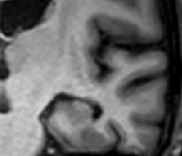

A

C

D

A, Height of hippocampus; C, Width of choroidal fissure; D, Width of temporal horn.

**Supplementary Table 4.** Axial hippocampal visual rating scale.

|  |  |  |  |
| --- | --- | --- | --- |
|  | A: Hippocampus | C: Cistern | D: Temporal horn |
| Grade 0 | N | N | N |
| Grade 1 | N | ↑ | N |
| Grade 2 | ↓ | ↑↑ | ↑ |
| Grade 3 | ↓↓ | ↑↑↑ | ↑↑ |
| Grade 4 | ↓↓↓ | ↑↑↑ | ↑↑↑ |

↑,increase; ↓,decrease; N, normal.

G:\DaumCloud sync\DaumCloud\0분당서울대학교\VBM and Imaging\Visual rating\의공학과\Template\Brain atrophy\Hippocampus\axial\T1\2\FILE00001_1.tif

A

C

D

A, Width of hippocampus; C, Width of Crural and ambient cistern; D, Width of temporal horn

**Supplementary Table 5.** The effects of subscales of CVRS on SNSB-D by multiple linear regression analysis.

|  |  |  |  |
| --- | --- | --- | --- |
| Visual rating scales | Standardized β coefficient | t value | p value |
| Hippocampal atrophy | -0.226 | -3.364 | 0.001 |
| Cortical atrophy | -0.207 | -3.682 | <0.001 |
| Ventricular atrophy | -0.231 | -3.296 | 0.001 |
| Small vessel disease | -0.167 | -3.279 | 0.001 |
| Adjusted R2 = 0.366 | | | |