Supplementary Figure 1. Genes whose expressions are statistically tied to BDNF expression in the ARACNe-derived whole brain transcriptional regulatory network. Edges shown are the subset involving BDNF and its immediate neighbors, extracted from a larger network inferred by the ARACNE algorithm from a compendium of 411 mouse whole brain microarrays. Certain transcription factor nodes are colored green.

Supplementary Figure 2. A top-scoring jActive module from the GENIE3-derived hippocampal network. RORA and RARG are highlighted in boxes. Also present in this module are several genes discussed in the report including NFIB, PLXNA2, NR2F1, and APP. Light blue nodes represent genes whose expressions are suppressed in the AD hippocampus; white nodes represent genes whose expressions are elevated in the AD hippocampus. Multiple lines between any given pairs of nodes indicate the genes involved are represented by more than one probe set on the microarray and that the same relationship is detected when alternate probe sets are used.

Supplementary Figure 3. An additional top-scoring jActive module from the GENIE3-derived hippocampal network. RORA and RARG are highlighted in boxes. Also present in this module are several genes discussed in the report including TIA1, PBX1, GNAQ, and APP. Light blue nodes represent genes whose expressions are suppressed in the AD hippocampus; white nodes represent genes whose expressions are elevated in the AD hippocampus. Multiple lines between any given pairs of nodes indicate the genes involved are represented by more than one probe set on the microarray and that the same relationship is detected when alternate probe sets are used.

Supplementary Figure 4. Genes directly regulated by RORA in the GENIE3-derived hippocampal network. Highlighted in boxes are RORA, IGF1R, IGF1, NR4A2 (via which RORA is linked to RARG and INS2), and MSX1 (via which RORA is linked to IGF2). Light blue nodes represent genes whose expressions are suppressed in the AD hippocampus; white nodes represent genes whose expressions are elevated in the AD hippocampus. Multiple lines between any given pairs of nodes indicate the genes involved are represented by more than one probe set on the microarray and that the same relationship is detected when alternate probe sets are used.

Supplementary Figure 5. Genes directly regulated by NR4A2 in the GENIE3-derived hippocampal network. Highlighted in boxes are NR4A2, RORA, and INS2. NR4A2 links RORA to RARG and INS2. Light blue nodes represent genes whose expressions are suppressed in the AD hippocampus; white nodes represent genes whose expressions are elevated in the AD hippocampus. Multiple lines between any given pairs of nodes indicate the genes involved are represented by more than one probe set on the microarray and that the same relationship is detected when alternate probe sets are used.
Supplementary Figure 1
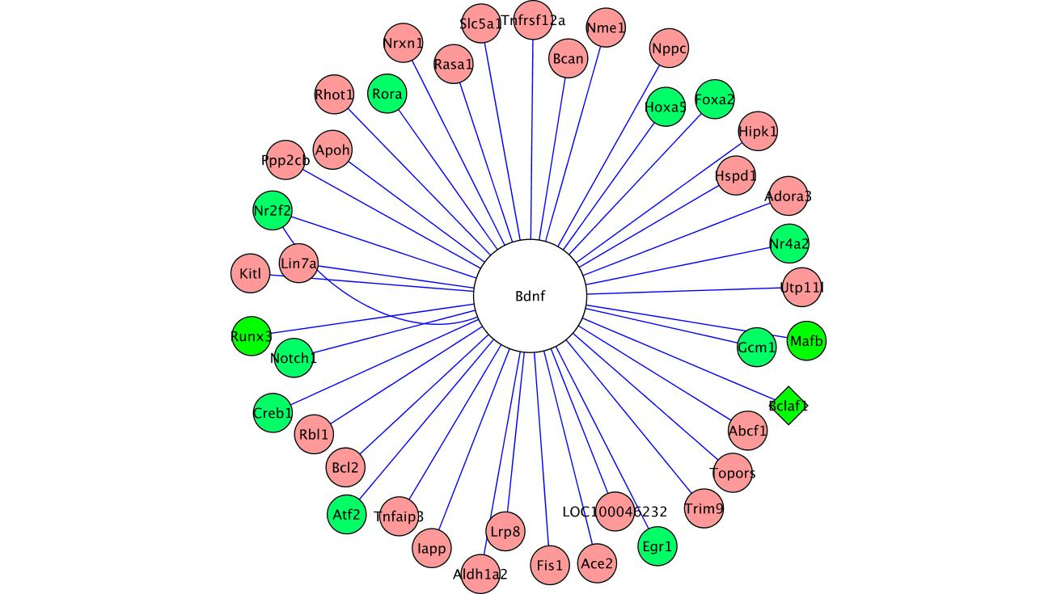
Supplementary Figure 2
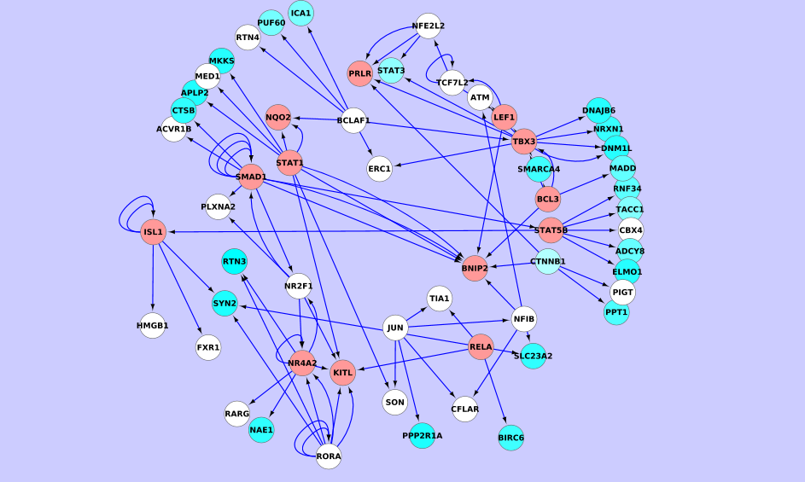

Supplementary Figure 3
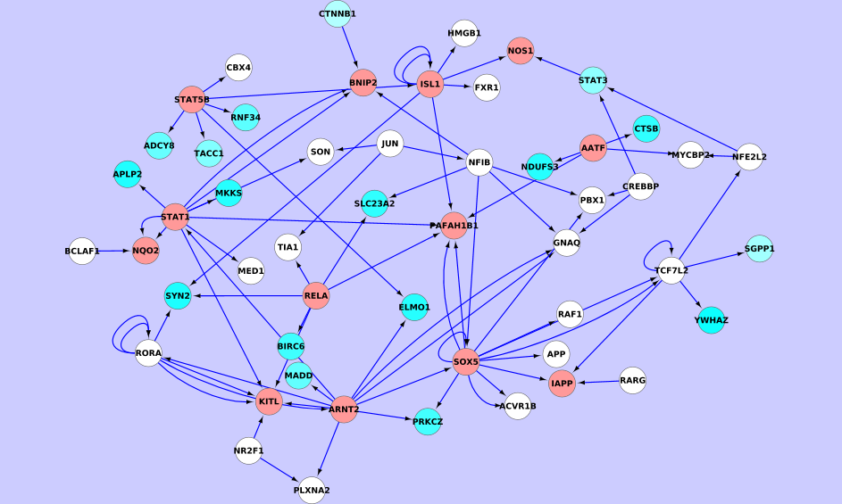

Supplementary Figure 4
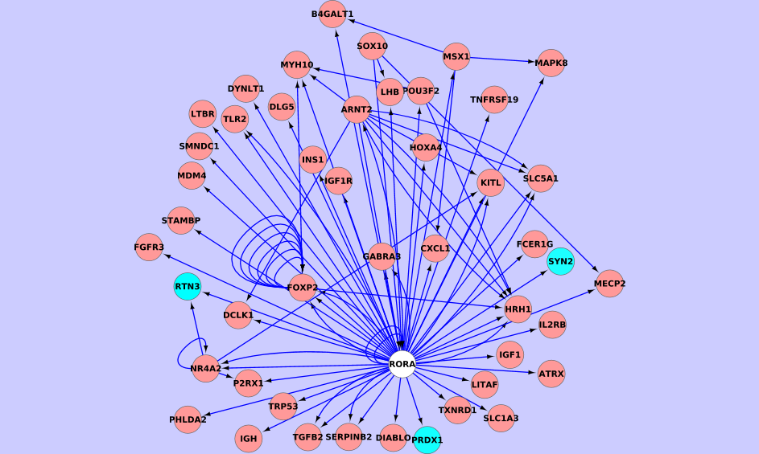

Supplementary Figure 5
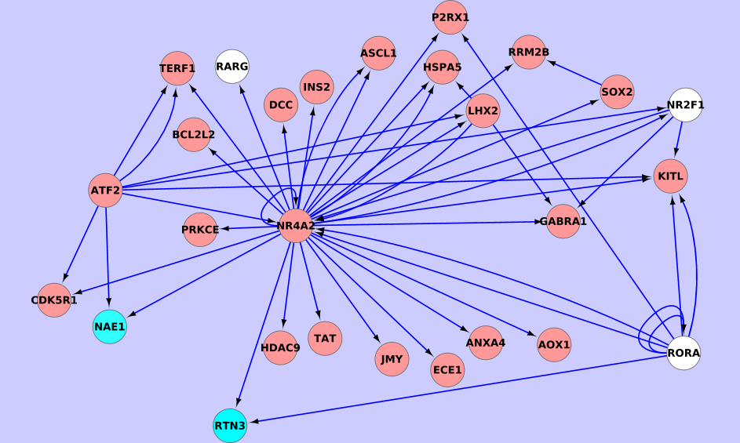

Supplementary Table 1. Evidence of involvement of RORA-associated genes/gene products in neurodegeneration/Alzheimer’s disease (AD).

Symbol | Name | Expression change* | RORA association | Neurodegeneration/AD association | Reference
DNM1L | Dynamin 1-like | suppressed | jActive Module, MCODE cluster (Figure 1) | Fusion/fission imbalances in the mitochondrion to which DNM1L is linked, associated with AD | [1]
 |  |  |  | Nitric oxide-induced S-nitrosylation of DNM1L associated with mitochondrial fission, synaptic loss, and neuronal damage | [2]
 |  |  |  | Nitric oxide-induced phosphorylation of DNM1L, activates it and recruits it to the mitochondrion | [3]
OPA1 | Optic Atrophy 1 (autosomal dominant) | suppressed | MCODE cluster (Figure 1) | a dynamin family member associated with mitochondrial fusion | [1][4]
 |  |  |  | loss of OPA1 function associated with mitochondrial fragmentation and diminished expression of mitochondrial respiratory complexes | [5]
TIA1 | TIA1 cytotoxic granule-associated RNA binding protein | elevated | MCODE cluster (Figure 1) | Under conditions of cellular stress, TIA1 promotes the aggregation of RNA-binding proteins to form stress granules | [6]
 |  |  |  | Mutations in stress granule components have been implicated in multiple neurodegenerative disorders | [7]
 |  |  |  | Stress granules positive for TIA1 are strongly associated with phospho- tau formation in a mouse model of AD | [8]
PDCD6IP | programmed cell death 6 interacting protein | elevated | jActive Module | expression is increased in a rodent striatal neurogeneration model that captures hallmarks of Huntington's disease | [9]
 |  |  |  | in a kainate-induced neurodegeneration model, PDCD6IP expression is induced in such areas as the hippocampal CA3 region and the piriform cortex | [10]
PTK2 | protein tyrosine kinase 2 | suppressed | jActive Module | tyrosine-phosphorylated (and activated) in response to amyloid beta peptide accumulation in neurons | [11]
 |  |  |  | Amyloid beta accumulation increases association of PTK2 with Fyn, probably modifying Fyn kinase activity | [12]
 |  |  |  | Fyn levels are decreased at synapses and increased in neuronal cell bodies where it is associated with neurofibrillary tangles | [13,14]
PLXNA2 | plexin A2 | elevated | jActive Module | PLXNA2-/- mice show increased axonal growth and behavioral recovery after injury | [15]
NFIB | nuclear factor I/B | elevated | direct link, jActive Module | association between NFIB and amyloid-beta deposition in the cerebral cortex | [16]
APP | amyloid beta (A4) precursor protein | elevated | jActive Module | APP itself, independent of its amyloid beta derivative, is of consequence in the AD etiology | [17]
 |  |  |  | role in cell death in the brain | [18-20]
CADM1 | cell adhesion molecule 1 | elevated | direct link, jActive Module | Mutations in CADM1 have been associated with autism spectrum disorder | [21]
BIRC6 | baculoviral IAP repeat containing 6 | suppressed | direct link, jActive Module | an inhibitor of apoptosis, is expressed in human brain cancer cells in which it inhibits anti-cancer drug-induced apoptosis | [22]
DAB1 | Dab, reelin signal transducer, homolog 1 (Drosophila) | elevated | jActive Module | DAB1 is part of the signaling process initiated by Reelin, a protein whose expression gets depleted early in the progression towards AD | [23]
RTN3 | reticulon 3 | suppressed | jActive Module | RTN3 inhibits the generation of beta-amyloid protein via its interactions with BACE1 | [24]
PBX1 | pre-B-cell leukemia homeobox 1 | elevated | jActive Module | PBX1 is essential for retinoic acid synthesis, which is important during neurodevelopment | [25]
NRXN1 | neurexin 1 | suppressed | jActive Module | Association studies link NRXN1 with AD | [26]
 |  |  |  | also linked with autism spectrum disorders and other neurodevelopmental disorders | [27][28]
RABEP1 | rabaptin, RAB GTPase binding effector protein 1 | elevated | jActive Module | RABEP1-specific IgG found in sera of a majority of AD patients but not in healthy subjects | [29]
GNAQ | guanine nucleotide binding protein (G protein), q polypeptide | elevated | direct link, jActive Module | Knockout mice lacking this gene have spatial memory deficits | [30]
DHCR24 | 24-dehydrocholesterol reductase | suppressed | direct link, jActive Module | DHCR24 is neuroprotective and anti-apoptotic, and is thought to be involved in AD as its expression is suppressed in relevant brain regions | [31-33]
NR2F1 | nuclear receptor subfamily 2, group F, member 1 | elevated | jActive Module | associates with RAN-binding protein-2, which when suppressed reduces neuronal apoptosis and oxidative stress | [34]

*in AD hippocampus

Supplementary Table 2. HEFalMp scores for genes linked to RORA in the ARACNe-derived network.

Gene | Score |  | Gene | Score
RORA | 1 |  | ZEB1 | 0.2099
UNC5C | 0.8954 |  | BTG1 | 0.2096
PRKG1 | 0.8889 |  | PURB | 0.2033
KCNMA1 | 0.8706 |  | RB1CC1 | 0.2013
GABRB1 | 0.8604 |  | RNF130 | 0.1986
BRAF | 0.8418 |  | BCL11B | 0.1944
GRIN2B | 0.8065 |  | ATRX | 0.1925
HTR2C | 0.757 |  | ROCK1 | 0.1907
PLXNA2 | 0.726 |  | LRP8 | 0.1742
GABRA2 | 0.7238 |  | PURA | 0.1712
SLC4A4 | 0.708 |  | PAFAH1B1 | 0.1508
SCN2A | 0.7069 |  | BBS4 | 0.1484
MBP | 0.6862 |  | RABEP1 | 0.1323
DCLK1 | 0.6757 |  | PTEN | 0.1152
S100B | 0.6515 |  | BIRC6 | 0.1125
CADM1 | 0.6512 |  | TRIM35 | 0.1106
NRXN3 | 0.6417 |  | GNAQ | 0.104
CACNA1A | 0.6381 |  | GSK3B | 0.09845
NEUROD1 | 0.6254 |  | SP1 | 0.09785
SYN1 | 0.5962 |  | BFAR | 0.09497
GABRG2 | 0.583 |  | ACTN4 | 0.08973
PEG3 | 0.5426 |  | CSDE1 | 0.07409
HOXA5 | 0.5308 |  | DHCR24 | 0.06744
PRKCA | 0.5273 |  | PIK3CA | 0.0644
KITLG | 0.5262 |  | SLTM | 0.05668
OTX2 | 0.4952 |  | CREB1 | 0.05579
STK4 | 0.4875 |  | HIF1A | 0.05495
ZEB2 | 0.4813 |  | SON | 0.04403
NFIB | 0.4781 |  | BPTF | 0.03993
DAB1 | 0.4517 |  | OPA1 | 0.03775
NF1 | 0.4391 |  | MAP3K7 | 0.0354
PBX1 | 0.4182 |  | PPP3CB | 0.03256
GABRA4 | 0.4148 |  | BCLAF1 | 0.02842
HIPK2 | 0.3859 |  | SH3GLB1 | 0.0175
LYST | 0.3855 |  | DNM1L | 0.01542
FOXO1 | 0.3505 |  | LIN7C | 0.01342
SYT1 | 0.3306 |  | TIA1 | 0.006623
LIN7A | 0.2962 |  | TXNRD1 | 0.005919
DIDO1 | 0.2707 |  | YWHAB | 0.005709
PIK3R1 | 0.2627 |  | CYCS | 0.00208
ECE1 | 0.244

Supplementary Table 3. Analysis of hippocampal differential expression** breakdown between genders.

 | Both Male and Female |  | Female Only |  | Male Only
 | Number of Genes | Top* Gene Enrichment Pathways | Number of Genes | Top* Gene Enrichment Pathways | Number of Genes | Top* Gene Enrichment Pathways
Increased Expression | 269 | Nuclear Receptor transcription pathway 3.17E-04  REV-ERBA represses gene expression 3.68E-04  RORA activates circadian gene expression 4.37E-04  BMAL1:CLOCK,NPAS2 activates circadian gene expression 0.002575  Circadian Clock 0.013807  YAP1- and WWTR1 (TAZ)-stimulated gene expression 0.014229  LRR FLII-interacting protein 1 (LRRFIP1) activates type I IFN production 0.025468  Cohesin Loading onto Chromatin 0.038247  Glycogen breakdown (glycogenolysis) 0.03832  Transcriptional regulation of white adipocyte differentiation 0.053043 | 195 | Attenuation phase 0.003885  Regulation of HSF1-mediated heat shock response 0.008709  HSF1-dependent transactivation 0.008709  HSF1 activation 0.016095  Regulation of gene expression in beta cells 0.016864  Translesion synthesis by Pol eta 0.021969  Cellular response to heat stress 0.028274  Repair synthesis for gap-filling by DNA polymerase in TC-NER 0.044462  Repair synthesis of patch ~27-30 bases long by DNA polymerase 0.044462  Regulation of beta-cell development 0.047037 | 1358 | Interleukin-6 signaling 0.011807  Regulation of cytoskeletal remodeling and cell spreading by IPP complex components 0.03422  Caspase-mediated cleavage of cytoskeletal proteins 0.036952  negative regulation of TCF-dependent signaling by DVL-interacting proteins 0.040956
Decreased Expression | 718 | Host Interactions of HIV factors 1.76E-04  HIV Infection 5.19E-04  degradation of DVL 7.77E-04  Membrane Trafficking 7.84E-04  S33 mutants of beta-catenin aren't phosphorylated 0.001012  TCF7L2 mutants don't bind CTBP 0.001012  phosphorylation site mutants of CTNNB1 are not targeted to the proteasome by the destruction complex 0.001012  AXIN mutants destabilize the destruction complex, activating WNT signaling 0.001012  APC truncation mutants are not K63 polyubiquitinated 0.001012  Degradation of beta-catenin by the destruction complex 0.001012 | 523 | Regulation of ornithine decarboxylase (ODC) 0.011489  Assembly of the pre-replicative complex 0.018948  Regulation of mRNA stability by proteins that bind AU-rich elements 0.018966  CDT1 association with the CDC6:ORC:origin complex 0.022758  Hedgehog ligand biogenesis 0.026171  Signaling by Hedgehog 0.026171  Processing-defective Hh variants abrogate ligand secretion 0.026171  Autodegradation of Cdh1 by Cdh1:APC/C 0.027056  Regulation of activated PAK-2p34 by proteasome mediated degradation 0.027198  Orc1 removal from chromatin 0.028245 | 2472 | Transport of Mature mRNA derived from an Intron-Containing Transcript 0.04718  RNA Polymerase II Transcription Termination 0.055363  Cleavage of Growing Transcript in the Termination Region 0.055363

*sorted by p-values
**postmortem Alzheimer Disease Dataset GSE5281 at a False Discovery Rate of 5%
(Males with no AD 10, males with AD 6; Females with no AD 3, Females with AD 4)

REFERENCES
[1] Wang X, Su B, Lee HG, Li X, Perry G, Smith MA, Zhu X (2009) Impaired balance of mitochondrial fission and fusion in Alzheimer's disease. J Neurosci 29, 9090-9103.
[2] Cho DH, Nakamura T, Fang J, Cieplak P, Godzik A, Gu Z, Lipton SA (2009) S-nitrosylation of Drp1 mediates beta-amyloid-related mitochondrial fission and neuronal injury. Science 324, 102-105.
[3] Bossy B, Petrilli A, Klinglmayr E, Chen J, Lutz-Meindl U, Knott AB, Masliah E, Schwarzenbacher R, Bossy-Wetzel E (2010) S-Nitrosylation of DRP1 does not affect enzymatic activity and is not specific to Alzheimer's disease. J Alzheimers Dis 20 Suppl 2, S513-26.
[4] Belenguer P, Pellegrini L (2013) The dynamin GTPase OPA1: more than mitochondria? Biochim Biophys Acta 1833, 176-183.
[5] Bertholet AM, Millet AM, Guillermin O, Daloyau M, Davezac N, Miquel MC, Belenguer P (2013) OPA1 loss of function affects in vitro neuronal maturation. Brain 136, 1518-1533.
[6] Gilks N, Kedersha N, Ayodele M, Shen L, Stoecklin G, Dember LM, Anderson P (2004) Stress granule assembly is mediated by prion-like aggregation of TIA-1. Mol Biol Cell 15, 5383-5398.
[7] Liu-Yesucevitz L, Bassell GJ, Gitler AD, Hart AC, Klann E, Richter JD, Warren ST, Wolozin B (2011) Local RNA translation at the synapse and in disease. J Neurosci 31, 16086-16093.
[8] Vanderweyde T, Yu H, Varnum M, Liu-Yesucevitz L, Citro A, Ikezu T, Duff K, Wolozin B (2012) Contrasting pathology of the stress granule proteins TIA-1 and G3BP in tauopathies. J Neurosci 32, 8270-8283.
[9] Blum D, Hemming FJ, Galas MC, Torch S, Cuvelier L, Schiffmann SN, Sadoul R (2004) Increased Alix (apoptosis-linked gene-2 interacting protein X) immunoreactivity in the degenerating striatum of rats chronically treated by 3-nitropropionic acid. Neurosci Lett 368, 309-313.
[10] Hemming FJ, Fraboulet S, Blot B, Sadoul R (2004) Early increase of apoptosis-linked gene-2 interacting protein X in areas of kainate-induced neurodegeneration. Neuroscience 123, 887-895.
[11] Zhang C, Lambert MP, Bunch C, Barber K, Wade WS, Krafft GA, Klein WL (1994) Focal adhesion kinase expressed by nerve cell lines shows increased tyrosine phosphorylation in response to Alzheimer's A beta peptide. J Biol Chem 269, 25247-25250.
[12] Zhang C, Qiu HE, Krafft GA, Klein WL (1996) A beta peptide enhances focal adhesion kinase/Fyn association in a rat CNS nerve cell line. Neurosci Lett 211, 187-190.
[13] Shirazi SK, Wood JG (1993) The protein tyrosine kinase, fyn, in Alzheimer's disease pathology. Neuroreport 4, 435-437.
[14] Ho GJ, Hashimoto M, Adame A, Izu M, Alford MF, Thal LJ, Hansen LA, Masliah E (2005) Altered p59Fyn kinase expression accompanies disease progression in Alzheimer's disease: implications for its functional role. Neurobiol Aging 26, 625-635.
[15] Shim SO, Cafferty WB, Schmidt EC, Kim BG, Fujisawa H, Strittmatter SM (2012) PlexinA2 limits recovery from corticospinal axotomy by mediating oligodendrocyte-derived Sema6A growth inhibition. Mol Cell Neurosci 50, 193-200.
[16] Ramanan VK, Risacher SL, Nho K, Kim S, Swaminathan S, Shen L, Foroud TM, Hakonarson H, Huentelman MJ, Aisen PS, Petersen RC, Green RC, Jack CR, Koeppe RA, Jagust WJ, Weiner MW, Saykin AJ; Alzheimer’s Disease Neuroimaging Initiative (2014) APOE and BCHE as modulators of cerebral amyloid deposition: a florbetapir PET genome-wide association study. Mol Psychiatry 19, 351-357.
[17] Robakis NK (2011) Mechanisms of AD neurodegeneration may be independent of Abeta and its derivatives. Neurobiol Aging 32, 372-379.
[18] Ewald CY, Li C (2012) The secreted Alzheimer-related amyloid precursor protein fragment has an essential role in C. elegans. Prion 6, 433-436.
[19] Kaiser DM, Acharya M, Leighton PL, Wang H, Daude N, Wohlgemuth S, Shi B, Allison WT (2012) Amyloid beta precursor protein and prion protein have a conserved interaction affecting cell adhesion and CNS development. PLoS One 7, e51305.
[20] Nizzari M, Thellung S, Corsaro A, Villa V, Pagano A, Porcile C, Russo C, Florio T (2012) Neurodegeneration in Alzheimer disease: role of amyloid precursor protein and presenilin 1 intracellular signaling. J Toxicol 2012, 187297.
[21] Fujita E, Dai H, Tanabe Y, Zhiling Y, Yamagata T, Miyakawa T, Tanokura M, Momoi MY, Momoi T (2010) Autism spectrum disorder is related to endoplasmic reticulum stress induced by mutations in the synaptic cell adhesion molecule, CADM1. Cell Death Dis 1, e47.
[22] Chen Z, Naito M, Hori S, Mashima T, Yamori T, Tsuruo T (1999) A human IAP-family gene, apollon, expressed in human brain cancer cells. Biochem Biophys Res Commun 264, 847-854.
[23] Herring A, Donath A, Steiner KM, Widera MP, Hamzehian S, Kanakis D, Kolble K, ElAli A, Hermann DM, Paulus W, Keyvani K (2012) Reelin depletion is an early phenomenon of Alzheimer's pathology. J Alzheimers Dis 30, 963-979.
[24] Murayama KS, Kametani F, Saito S, Kume H, Akiyama H, Araki W (2006) Reticulons RTN3 and RTN4-B/C interact with BACE1 and inhibit its ability to produce amyloid beta-protein. Eur J Neurosci 24, 1237-1244.
[25] Vitobello A, Ferretti E, Lampe X, Vilain N, Ducret S, Ori M, Spetz JF, Selleri L, Rijli FM (2011) Hox and Pbx factors control retinoic acid synthesis during hindbrain segmentation. Dev Cell 20, 469-482.
[26] Swaminathan S, Shen L, Kim S, Inlow M, West JD, Faber KM, Foroud T, Mayeux R, Saykin AJ, Alzheimer's Disease Neuroimaging Initiative, NIA-LOAD/NCRAD Family Study Group (2012) Analysis of copy number variation in Alzheimer's disease: the NIALOAD/ NCRAD Family Study. Curr Alzheimer Res 9, 801-814.
[27] Grayton HM, Missler M, Collier DA, Fernandes C (2013) Altered social behaviours in neurexin 1alpha knockout mice resemble core symptoms in neurodevelopmental disorders. PLoS One 8, e67114.
[28] Jiang YH, Yuen RK, Jin X, Wang M, Chen N, Wu X, Ju J, Mei J, Shi Y, He M, Wang G, Liang J, Wang Z, Cao D, Carter MT, Chrysler C, Drmic IE, Howe JL, Lau L, Marshall CR, Merico D, Nalpathamkalam T, Thiruvahindrapuram B, Thompson A, Uddin M, Walker S, Luo J, Anagnostou E, Zwaigenbaum L, Ring RH, Wang J, Lajonchere C, Wang J, Shih A, Szatmari P, Yang H, Dawson G, Li Y, Scherer SW (2013) Detection of clinically relevant genetic variants in autism spectrum disorder by whole-genome sequencing. Am J Hum Genet 93, 249-263.
[29] Delunardo F, Margutti P, Pontecorvo S, Colasanti T, Conti F, Rigano R, Profumo E, Siracusano A, Capozzi A, Prencipe M, Sorice M, Francia A, Ortona E (2007) Screening of a microvascular endothelial cDNA library identifies rabaptin 5 as a novel autoantigen in Alzheimer's disease. J Neuroimmunol 192, 105-112.
[30] Frederick AL, Saborido TP, Stanwood GD (2012) Neurobehavioral phenotyping of G(alphaq) knockout mice reveals impairments in motor functions and spatial working memory without changes in anxiety or behavioral despair. Front Behav Neurosci 6, 29.
[31] Swaminathan S, Shen L, Risacher SL, Yoder KK, West JD, Kim S, Nho K, Foroud T, Inlow M, Potkin SG, Huentelman MJ, Craig DW, Jagust WJ, Koeppe RA, Mathis CA, Jack CR,Jr, Weiner MW, Saykin AJ, Alzheimer's Disease Neuroimaging Initiative (2012) Amyloid pathway-based candidate gene analysis of [(11)C]PiB-PET in the Alzheimer's Disease Neuroimaging Initiative (ADNI) cohort. Brain Imaging Behav 6, 1-15.
[32] Feher A, Juhasz A, Pakaski M, Kalman J, Janka Z (2012) Gender dependent effect of DHCR24 polymorphism on the risk for Alzheimer's disease. Neurosci Lett 526, 20-23.
[33] Wisniewski T, Newman K, Javitt NB (2013) Alzheimer's disease: brain desmosterol levels. J Alzheimers Dis 33, 881-888.
[34] Cho KI, Yi H, Tserentsoodol N, Searle K, Ferreira PA (2010) Neuroprotection resulting from insufficiency of RANBP2 is associated with the modulation of protein and lipid homeostasis of functionally diverse but linked pathways in response to oxidative stress. Dis Model Mech 3, 595-604.

