Supplementary Material

LC Elution Conditions
For the nanoAcquity system, the samples were loaded into a 75 µm inner diameter, 1.7 µm particle size, 200 mm long, BEH130 C18 nanoAcquity UPLC® column (Waters) with column heating at 50°C. The linear gradient started elution from 7% buffer B to 30% buffer B in 40 min, then washed column with 99% buffer B for 5 min, re-condition the column with 7% buffer B for 5 min, and the total operation time was 55 min. For the Easy-nLC system, the samples were loaded into a home-packed 25 cm long C₁₈ column (New Objective) with a 60 min gradient (linear gradient increasing from 5% up till 50% buffer B in 40 min, then washing with 90% buffer B for 10 min, and finally with 10 min conditioning the column with 5% buffer B).

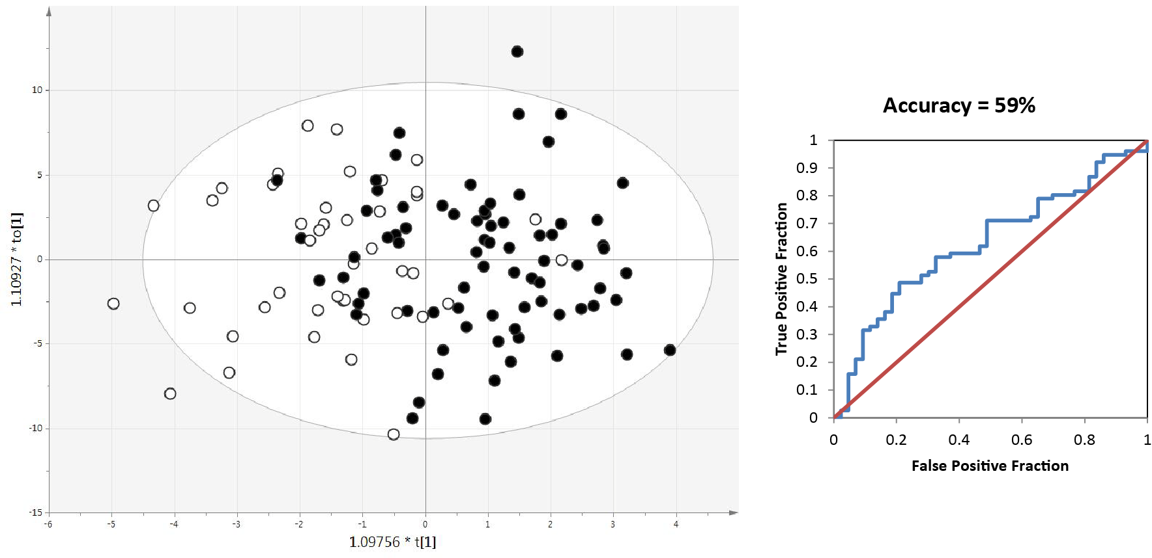
Supplementary Figure 1. Left: OPLS-DA model for the decoy discrimination of S-MCI and P-MCI patient samples. Right: ROC-curve based on seven-fold cross validation of the corresponding OPLS-DA model.

Supplementary Figure 2. Left: OPLS-DA model for the discrimination of male S-MCI and P-MCI patient samples. Open circles represent S-MCI samples, black dots represent P-MCI samples. Right: ROC-curve based on seven-fold cross validation of the corresponding OPLS-DA model.
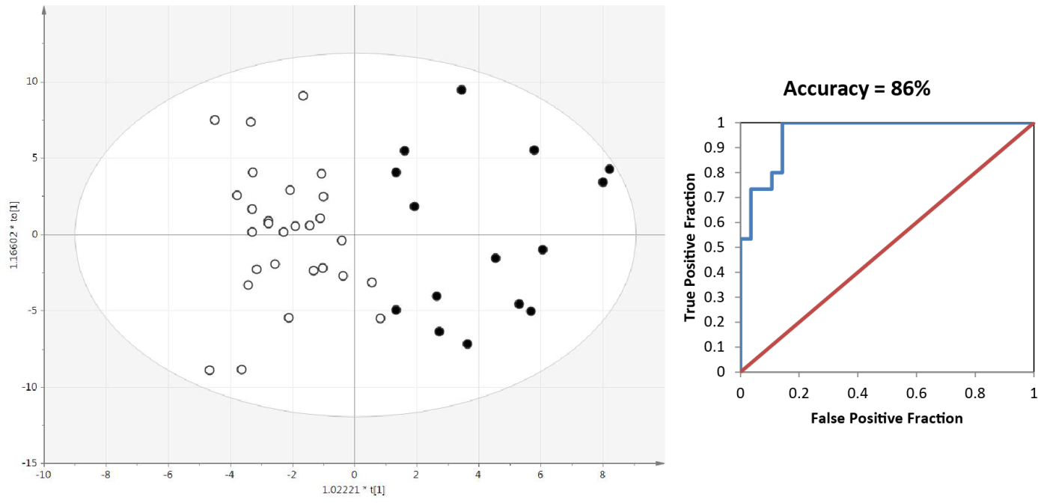

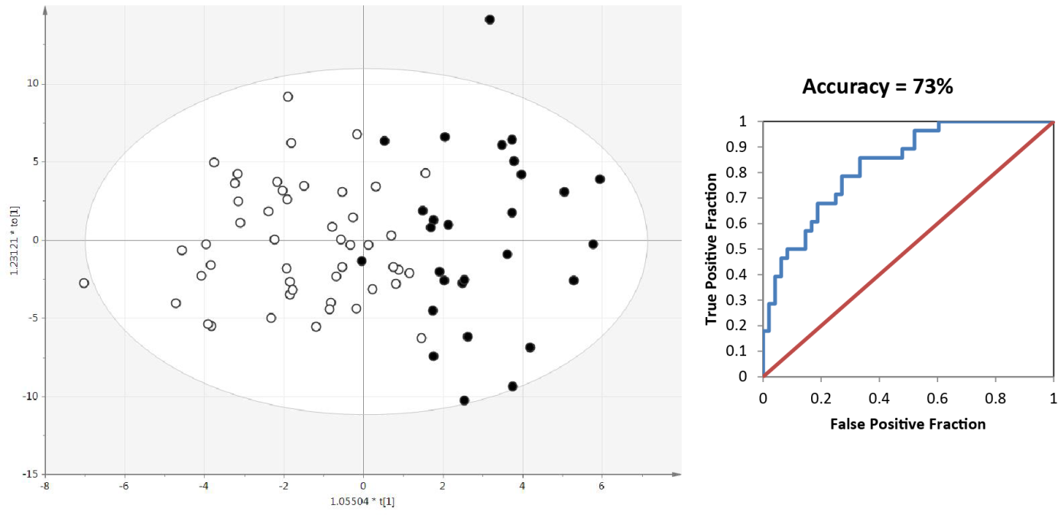
Supplementary Figure 3. Left: OPLS-DA model for the discrimination of female S-MCI and P-MCI patient samples. Open circles represent S-MCI samples, black dots represent P-MCI samples. Right: ROC-curve based on seven-fold cross validation of the corresponding OPLS-DA model.
Supplementary Table 1. Correlation factors for the 60 significant proteins significantly contributing to the S-MCI/P-MCI discrimination by the OPLS-DA model.

PROTEIN ID | DESCRIPTION | Corr for males | Corr for females | Corr for All
A1AG1_HUMAN | Alpha-1-acid glycoprotein 1 | -0.092548877 | -0.250086532 | -0.196954181
A1AG2_HUMAN | Alpha-1-acid glycoprotein 2 | -0.14665994 | -0.126559059 | -0.132964982
A2AP_HUMAN | Alpha-2-antiplasmin | -0.076014004 | -0.02823513 | -0.041652719
A2GL_HUMAN | Leucine-rich alpha-2-glycoprotein | -0.115481659 | 0.12017268 | 0.034805518
ALBU_HUMAN | Serum albumin | -0.070232879 | 0.09186929 | 0.029785776
ANGT_HUMAN | Angiotensinogen | 0.175265172 | 0.083215906 | 0.111596505
ANT3_HUMAN | Antithrombin-III | -0.294678499 | 0.002444251 | -0.081280471
APOA_HUMAN | Apolipoprotein(a) | -0.084858754 | -0.206698641 | -0.171383907
APOB_HUMAN | Apolipoprotein B-100 | 0.287438014 | 0.064899952 | 0.153049161
APOC2_HUMAN | Apolipoprotein C-II | 0.060821505 | -0.066523741 | -0.019232371
APOE_HUMAN | Apolipoprotein E | -0.168326913 | -0.106005053 | -0.131309362
BTBD6_HUMAN | BTB/POZ domain-containing protein 6 | 0.173922577 | 0.071999197 | 0.113903254
C1S_HUMAN | Complement C1s subcomponent | -0.29399272 | -0.304353592 | -0.299812683
C4BPA_HUMAN | C4b-binding protein alpha chain | -0.235197385 | -0.019624366 | -0.089731252
CERU_HUMAN | Ceruloplasmin | -0.59274697 | -0.346603349 | -0.411241455
CFAB_HUMAN | Complement factor B | -0.607343021 | -0.226194738 | -0.351520685
CFAH_HUMAN | Complement factor H | -0.490180851 | -0.23894315 | -0.327378912
CFAI_HUMAN | Complement factor I | -0.44613449 | -0.341789822 | -0.378556384
CO3_HUMAN | Complement C3 | -0.17093917 | -0.054338647 | -0.077369522
CO5_HUMAN | Complement C5 | -0.221513452 | 0.262757246 | 0.1324107
CO7_HUMAN | Complement component C7 | -0.022749369 | 0.238237182 | 0.152508298
CO8B_HUMAN | Complement component C8 beta chain | -0.35261981 | -0.022635056 | -0.12923237
FIBA_HUMAN | Fibrinogen alpha chain | 0.228375462 | 0.27664096 | 0.261029038
FIBB_HUMAN | Fibrinogen beta chain | 0.290934912 | 0.269370187 | 0.274982716
FIBG_HUMAN | Fibrinogen gamma chain | 0.35493514 | 0.252577157 | 0.275670215
FINC_HUMAN | Fibronectin | -0.079372932 | 0.218647782 | 0.153057425
GELS_HUMAN | Gelsolin | 0.245625893 | 0.013823946 | 0.087223064
HEP2_HUMAN | Heparin cofactor 2 | -0.174976378 | -0.132770373 | -0.145493766
HPT_HUMAN | Haptoglobin | -0.038243198 | -0.123799612 | -0.093576237
HV107_HUMAN | Ig heavy chain V-I region Mot | -0.193660264 | -0.126186785 | -0.137364226
HV207_HUMAN | Ig heavy chain V-II region NEWM | -0.284464068 | -0.084101344 | -0.161837713
HV208_HUMAN | Ig heavy chain V-II region SESS | -0.25434738 | -0.163682169 | -0.19922973
HV301_HUMAN | Ig heavy chain V-III region TRO | -0.31520644 | -0.182347943 | -0.230798787
HV305_HUMAN | Ig heavy chain V-III region BRO | -0.399193688 | -0.021506112 | -0.16281459
HV320_HUMAN | Ig heavy chain V-III region GAL | 0.278988519 | -0.033793469 | 0.085362649
IC1_HUMAN | Plasma protease C1 inhibitor | 0.199785447 | 0.177363716 | 0.183527299
IGHA1_HUMAN | Ig alpha-1 chain C region | -0.161957169 | -0.231386674 | -0.165376328
IGHA2_HUMAN | Ig alpha-2 chain C region | -0.110620052 | -0.120073232 | -0.097149627
IGHG3_HUMAN | Ig gamma-3 chain C region | -0.290659189 | -0.087586968 | -0.161347356
IGJ_HUMAN | Immunoglobulin J chain | -0.197890518 | -0.200781035 | -0.198795511
IGKC_HUMAN | Ig kappa chain C region | -0.348938038 | -0.134949527 | -0.216091629
IGLL5_HUMAN | Immunoglobulin lambda-like polypeptide 5 | -0.388746343 | -0.106873141 | -0.205594189
KNG1_HUMAN | Kininogen-1 | -0.030130868 | -0.048959642 | -0.042629872
KV106_HUMAN | Ig kappa chain V-I region EU | -0.280868635 | -0.034388722 | -0.105638231
KV116_HUMAN | Ig kappa chain V-I region Roy | -0.338109874 | -0.092068822 | -0.181673511
KV301_HUMAN | Ig kappa chain V-III region B6 | -0.28500601 | -0.007387048 | -0.099469691
KV305_HUMAN | Ig kappa chain V-III region WOL | -0.157567393 | -0.087628641 | -0.1104973
KV308_HUMAN | Ig kappa chain V-III region CLL | -0.402846167 | -0.034511962 | -0.152624615
KV404_HUMAN | Ig kappa chain V-IV region B17 | -0.375530033 | -0.142042296 | -0.234973384
LAC2_HUMAN | Ig lambda-2 chain C regions | -0.076308721 | -0.112214929 | -0.097450353
LV001_HUMAN | Ig lambda chain V region 4A | -0.435579922 | -0.149625007 | -0.254070256
LV102_HUMAN | Ig lambda chain V-I region HA | -0.369496423 | 0.09592106 | -0.066129819
LV302_HUMAN | Ig lambda chain V-III region LOI | -0.39356023 | -0.246978633 | -0.278807418
LV403_HUMAN | Ig lambda chain V-IV region Hil | 0.046919694 | 0.026061879 | 0.031369371
P63_HUMAN | Tumor protein 63 | -0.003699801 | -0.189709399 | -0.116860057
PROS_HUMAN | Vitamin K-dependent protein S | -0.265757903 | 0.00438148 | -0.093334279
TTHY_HUMAN | Transthyretin | -0.079655777 | -0.247222498 | -0.196104816
TTK_HUMAN | Dual specificity protein kinase TTK | 0.060375109 | -0.016151428 | 0.009283304
VTNC_HUMAN | Vitronectin | 0.11503627 | -0.109567987 | -0.041883724
XRCC2_HUMAN | DNA repair protein XRCC2 | 0.115815688 | -0.112117044 | -0.027630279

